Report: Expenses sharing app
- Task Description
Create an app that allows users to split and track shared expenses among a group.
- Task Output Screenshot
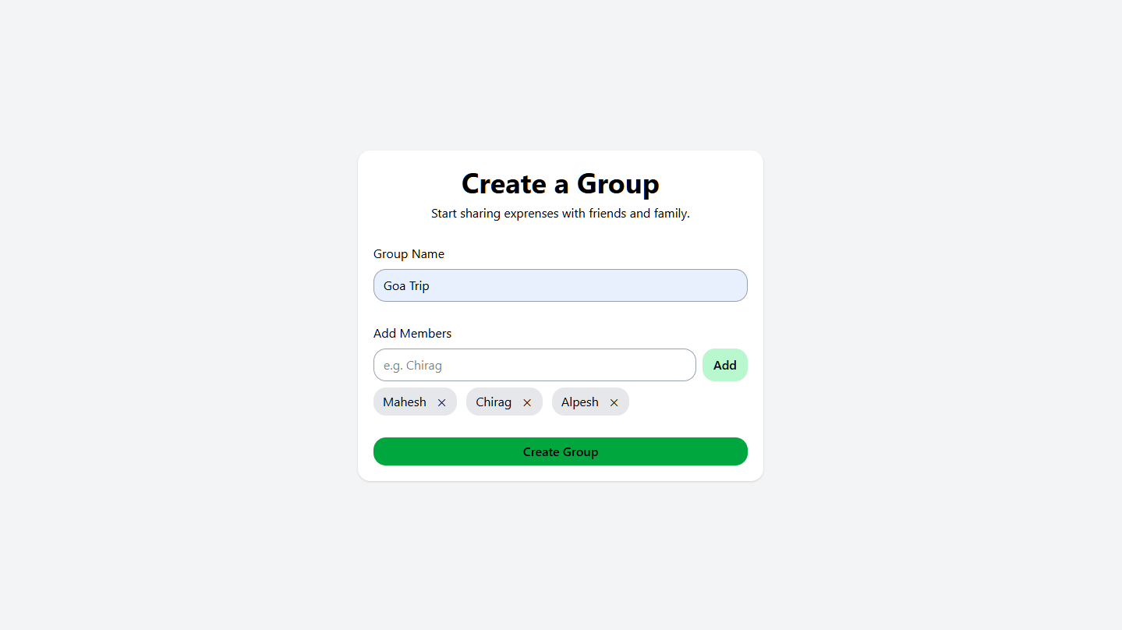
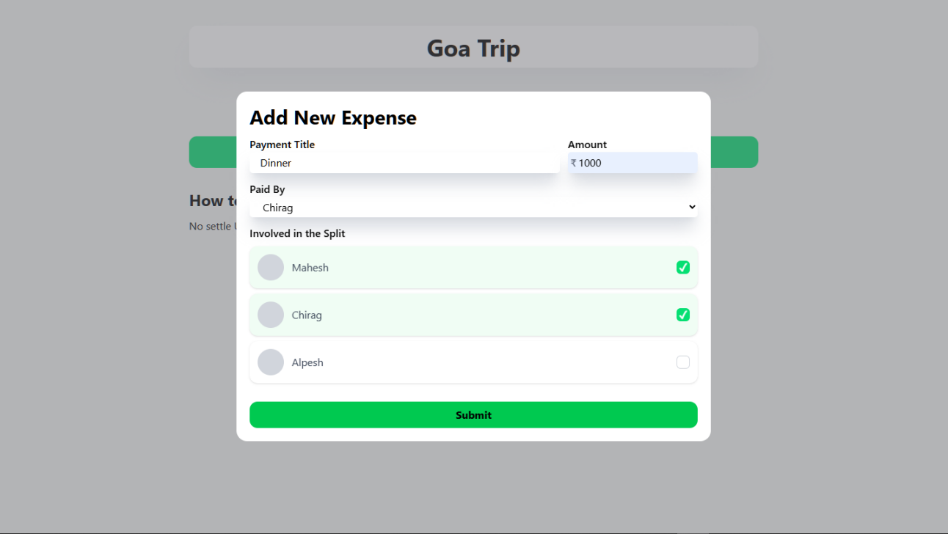
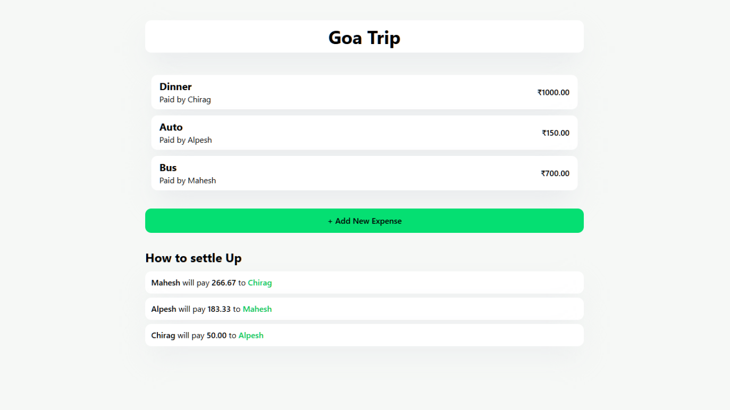
- Algorithm Used In Task
• Input Fields & Forms — for entering expense details (amount, description, date), selecting payer and participants, and submitting new expenses.
• Buttons & Action Controls — to trigger operations like “Add Expense”, “Create Group”, “Settle Up / Record Payment”, “Remove Expense” etc.
• Lists / Cards / Tables — to display expense history, groups & members, and user balances (who owes whom).
• Expense-Splitting Algorithm — logic to split an expense either equally or custom among selected participants; compute and assign each member’s share and who owes whom.

