Report: Nested routing
- Task Description
Set up nested routes using React Router for a multi-level menu.
- Task Output Screenshot
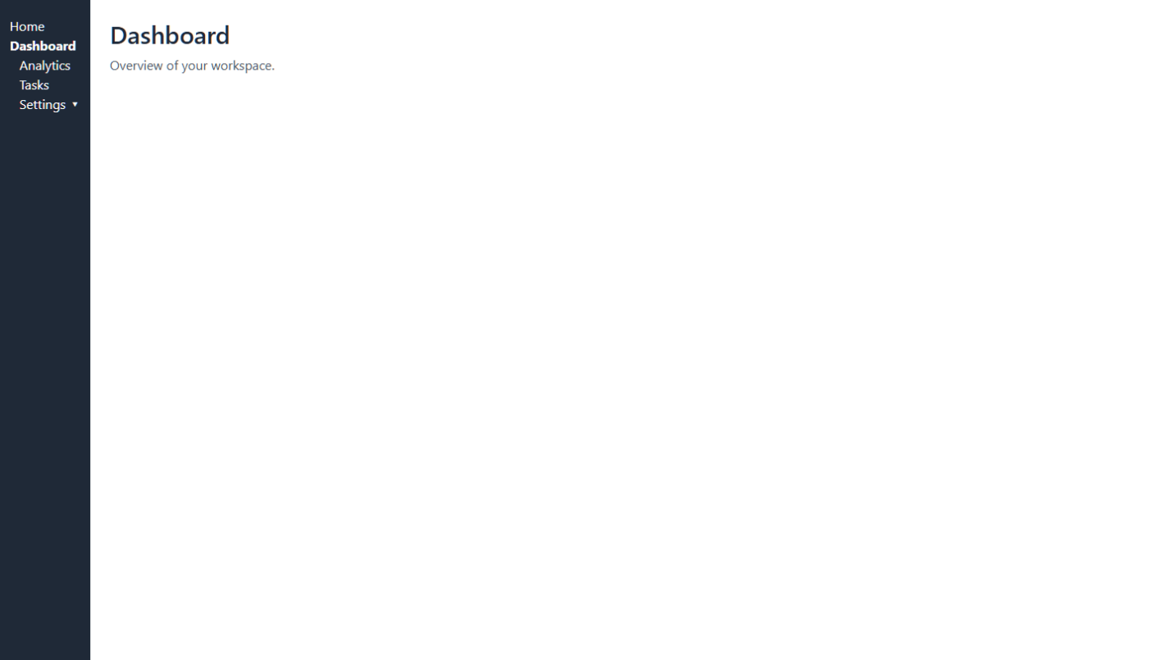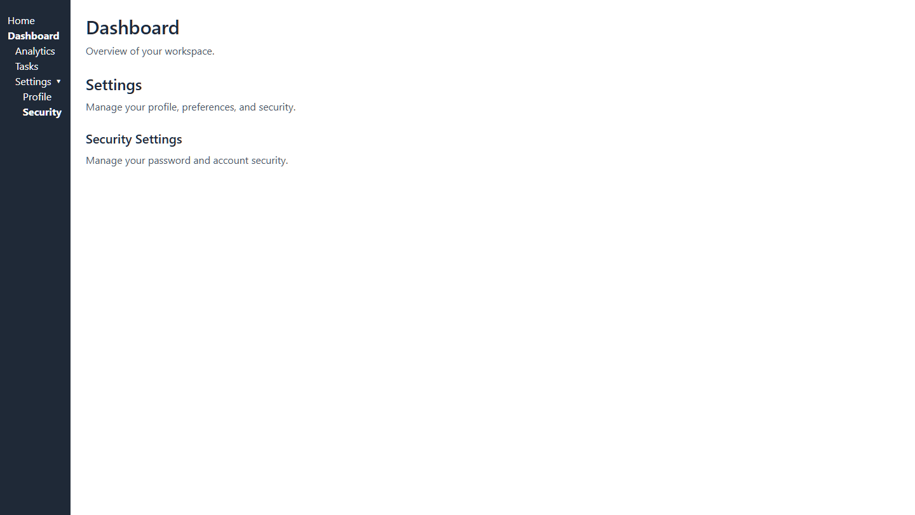
- Algorithm Used In Task
• Layout / Wrapper Components + Outlet — Use a parent layout component that includes a placeholder (via the Outlet component from react-router-dom) so that nested child routes render inside shared UI (e.g. header, sidebar, common layout) while preserving consistent layout across pages.
• Nested Routes Setup — Define routes such that some routes are “parent” routes and have “child” routes: e.g. /dashboard parent route, and /dashboard/settings/security or /dashboard/settings/profile as nested child routes. This provides hierarchical URL & content structure.
• Route & Navigation Controls — Use navigation links or menu controls (e.g. <Link> / <NavLink>) to allow users to navigate between parent and child routes; switching routes dynamically loads the corresponding components without reloading the whole page.
• Dynamic / Multi-level Views — Nested routing enables multi-level navigation (e.g. a section with its subpages), letting you build apps with sections & subsections (dashboards, user-profiles, sub-menus) where the layout remains intact but content changes based on nested route.

