Report: React hooks form
- Task Description
Create custom common component for the input using this library with all kind of validation
- Task Output Screenshot
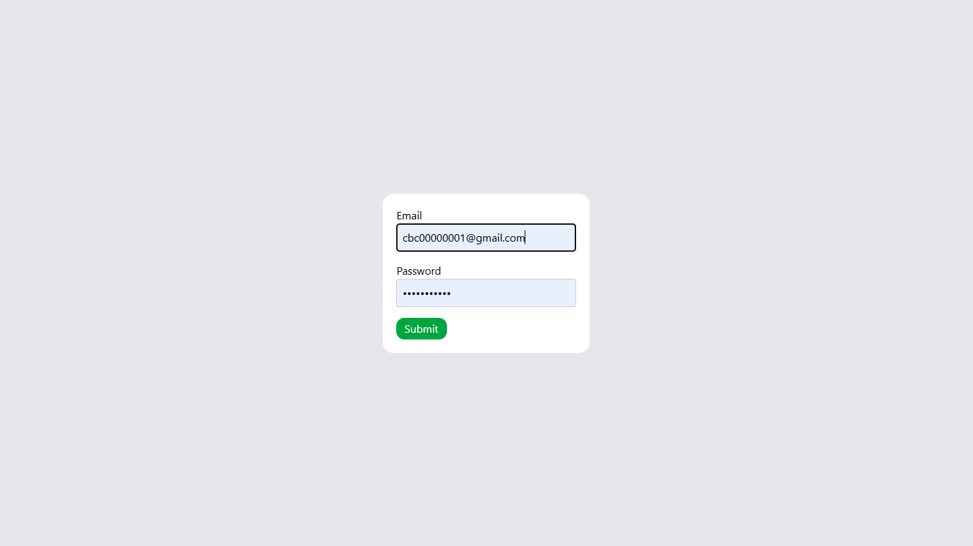
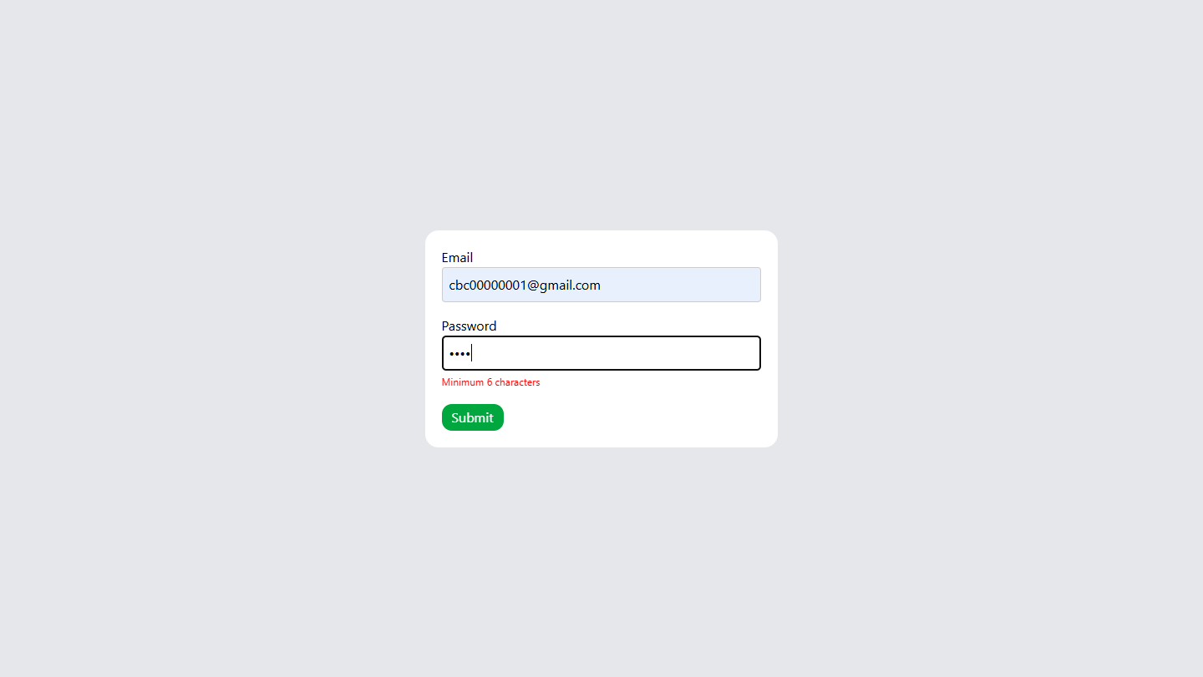
- Widget/Algorithm Used In Task
• register / useForm Hook — Provides a simple API (useForm, register, handleSubmit, etc.) to manage form state and handle form submissions with minimal boilerplate
• Uncontrolled inputs + minimal re-renders — By default it uses uncontrolled inputs (refs) rather than controlled React state for each form field. This reduces unnecessary re-renders and improves performance compared to many other form libraries.
• Uncontrolled inputs + minimal re-renders — By default it uses uncontrolled inputs (refs) rather than controlled React state for each form field. This reduces unnecessary re-renders and improves performance compared to many other form libraries.
• Support for complex/dynamic forms — Allows handling dynamic fields (arrays of inputs), nested inputs, and integration with third-party/custom UI components (via the Controller API) while preserving validation and state management.

