Report: Theme changer
- Task Description
Implement a global app theme switcher using context and local storage.
- Task Output Screenshot
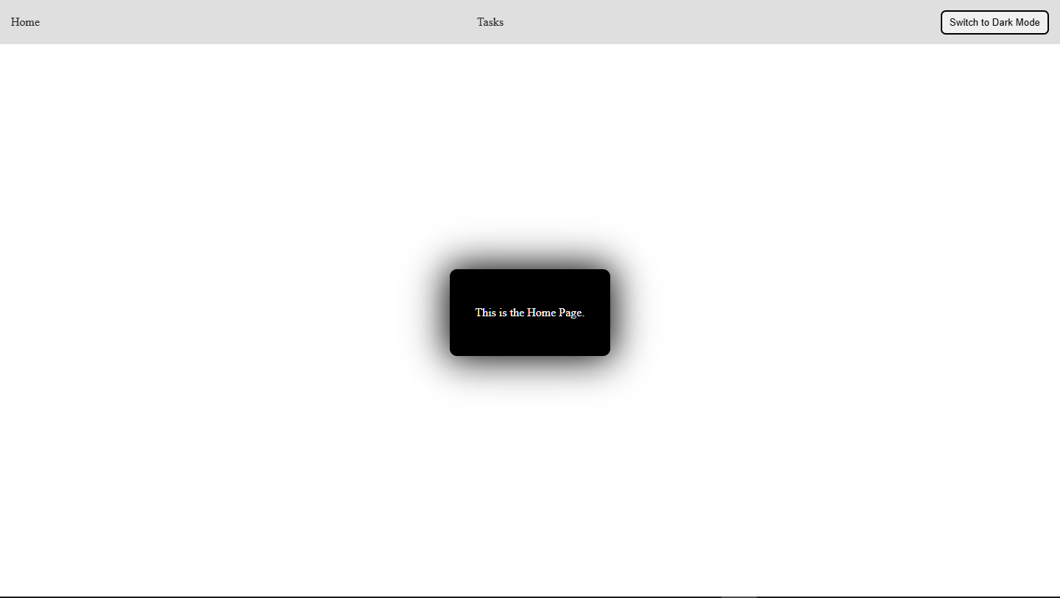

- Algorithm Used In Task
• Context API: Used to store and provide global theme state across the application.
• Local Storage: Saves the user's preferred theme so it is applied automatically on reload.
• useEffect Hook: Detects theme changes and syncs them with Local Storage.
• Custom ThemeProvider: Wraps the app and provides theme values to components.

