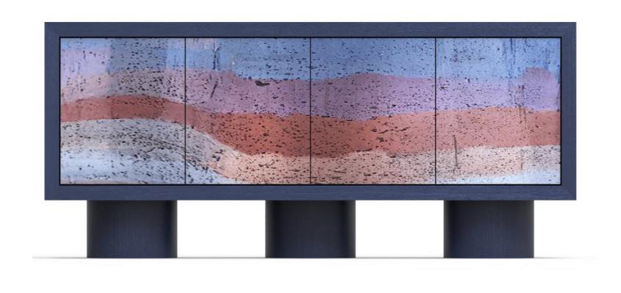
Figure 1 Concrete Material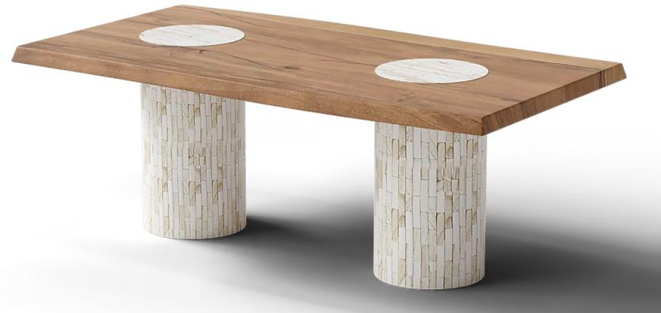
Figure 2Bone Inlay + Reclaimed Wood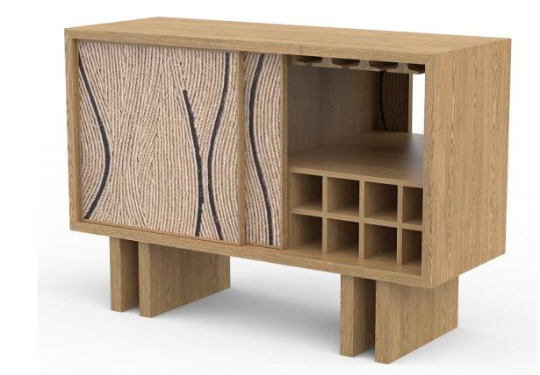
Figure 3 Oak Wood + Thread Design in front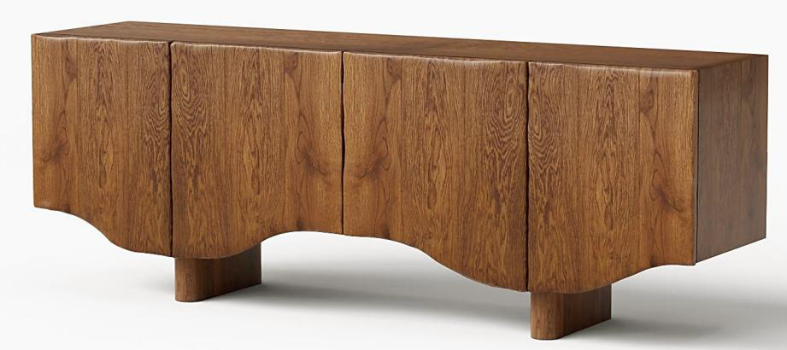
Figure 4 Acacia Live Edge
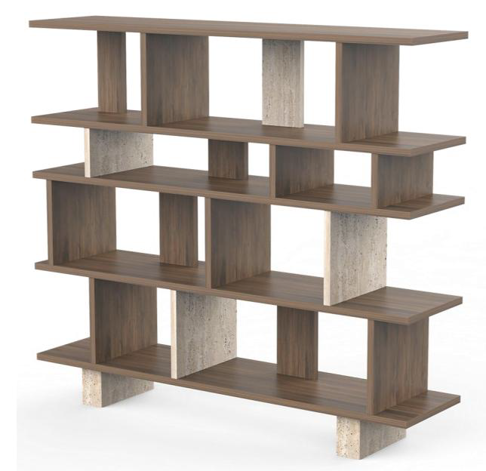
Figure 5Traventive Marble + Mango Wood
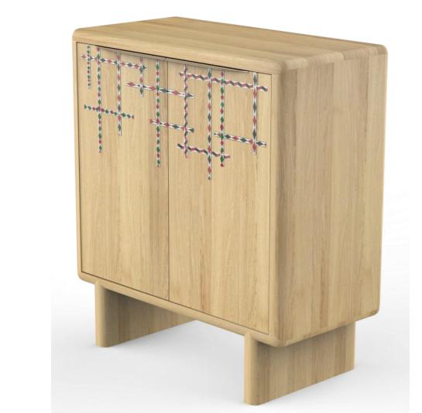
Figure 6Mango Wood + Marble Strip Inlay

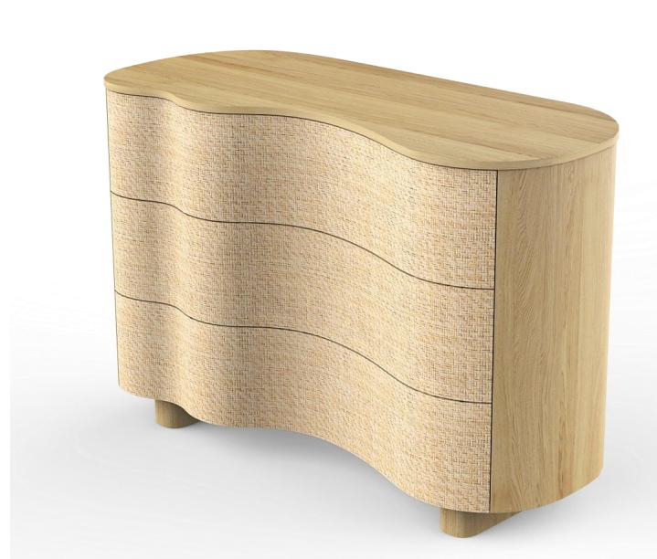
Figure 7Oak Wood + Grass Cloth

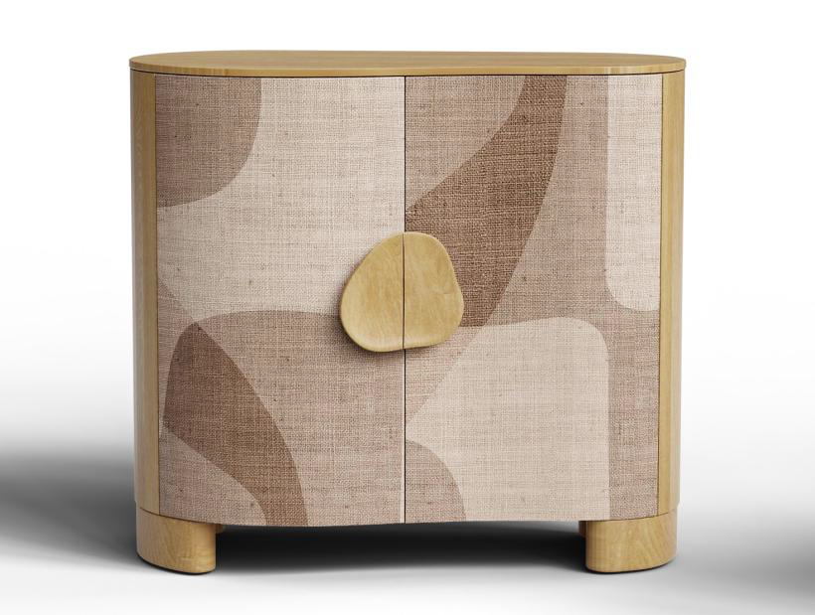
Figure 8Printed Cloth on Furniture

