**Lab-4**

**Heroku**

**Subject**: AIDI-2004 AI In Enterprise System

**Submitted By**: - Chirag Gandhi (100934830)

**Links: -**

GitHub: - <https://github.com/ChiragGandhi04/Lab-4>

Heroku: - <https://lab-4-d6e940e61418.herokuapp.com/>

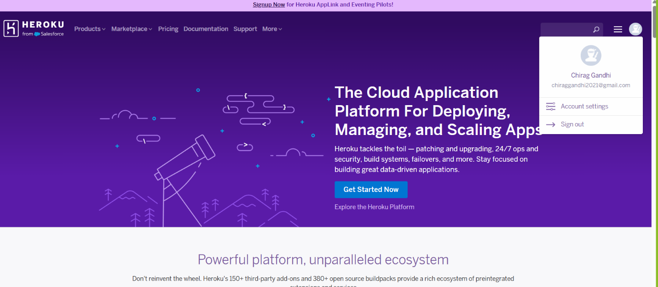

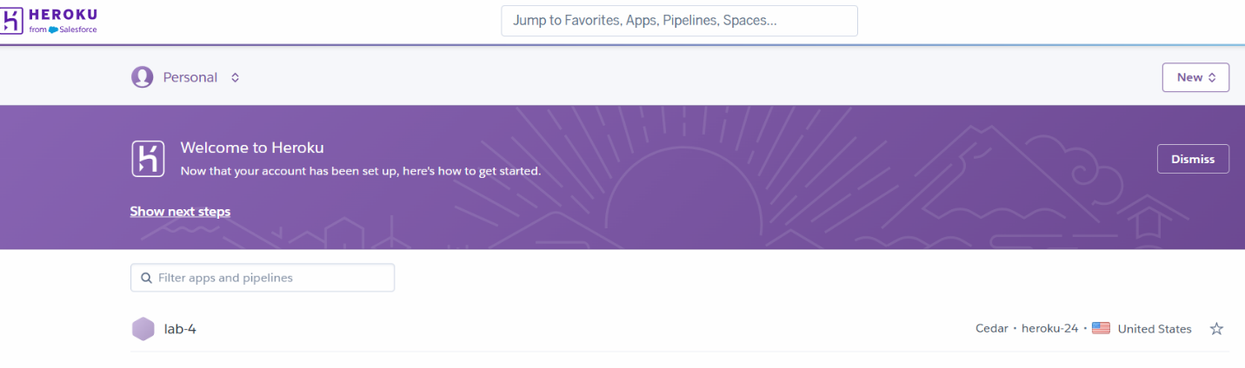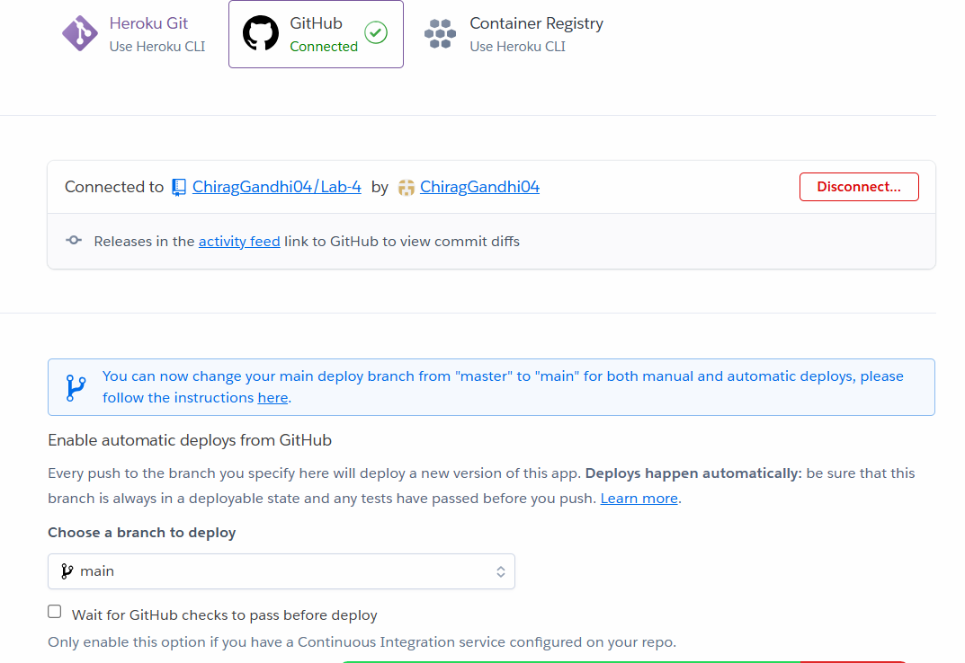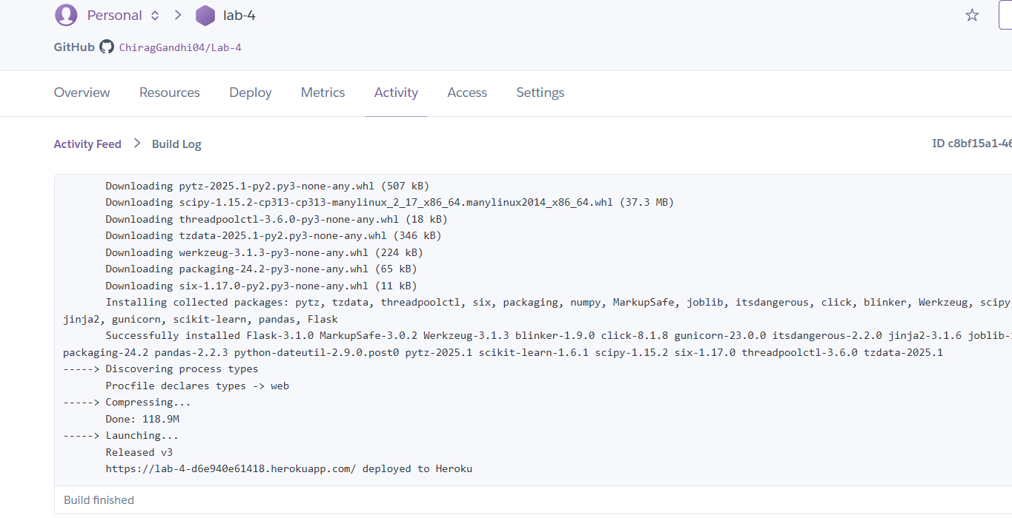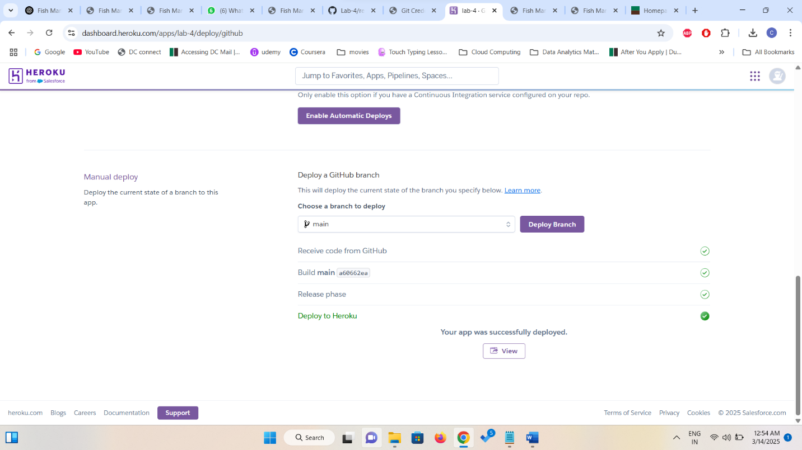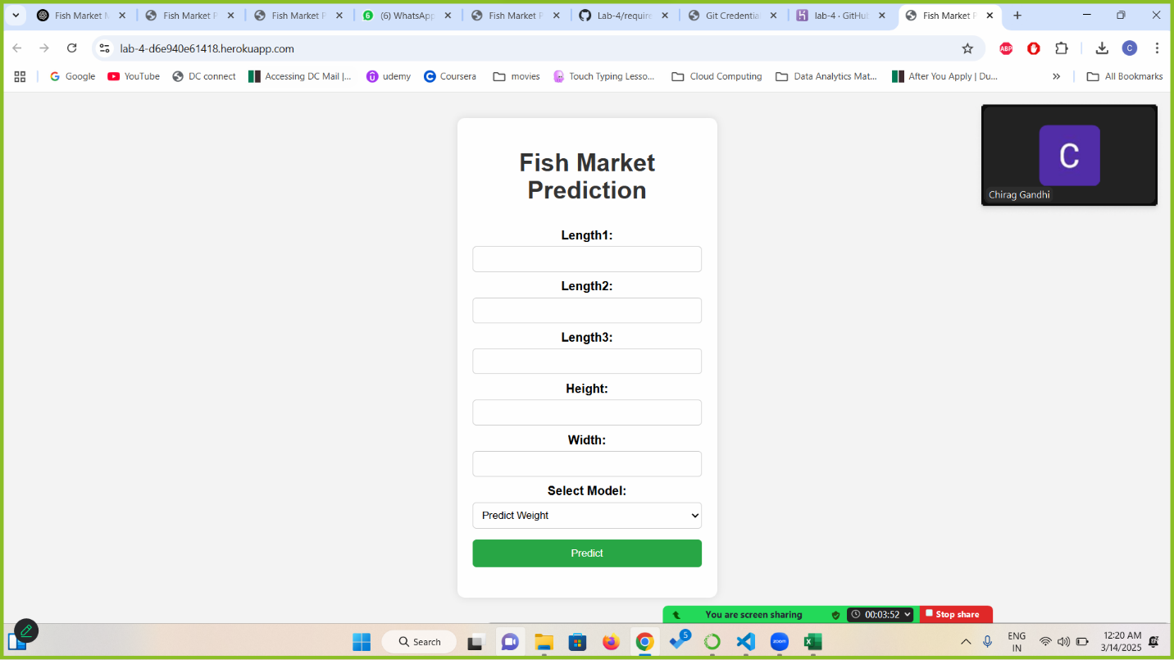

**GitHub setup: -**

