Name Chirag Rana
SE COMPS
2018130043

Experiment 1- HTML

AIM: To create a static profile page using HTML5.

THEORY:
HTML:
• HTML is the standard markup language for creating Web pages.
• HTML stands for Hyper Text Markup Language.
• HTML describes the structure of a Web page.
• HTML consists of a series of elements.
• HTML elements tell the browser how to display the content.
• HTML elements are represented by tags.
• HTML tags label pieces of content such as "heading", "paragraph", "table", and so on.
• Browsers do not display the HTML tags, but use them to render the content of the page.

HTML TAGS:
• HTML tags are element names surrounded by angle brackets.
• HTML tags normally come in pairs like <p> and </p>.
• The first tag in a pair is the start tag, the second tag is the end tag.
• The end tag is written like the start tag, but with a forward slash inserted before the tag name.
1. The declaration defines this document to be HTML5.
2. The element is the root element of an HTML page.
3. The element contains meta information about the document.
4. The <title> element specifies a title for the document.
5. The element contains the visible page content.
6. Heading tag: HTML headings are defined with the <h1> to <h6> tags. <h1> defines the most important heading. <h6> defines the least important heading.
7. HTML Paragraphs: HTML paragraphs are defined with the <p> tag.
8. HTML Links: HTML links are defined with the tag. The link's destination is specified in the href attribute.
Example:<a href=”https://www.google.com”> This is a link</a>
9. HTML Images: HTML images are defined with the tag. The source file (src), alternative text (alt), width, and height are provided as attributes.
Example: <img src=”image.png” alt=”www.w3hschool.com” widht=”104” height=”142”>

10. HTML Lists: HTML lists are defined with the <ul>(unordered/bullet list) or the <ol>(ordered/numbered list) tag, followed by <li> tags (list items).
11.<b> - Bold text
12. <strong> - Important text
13. <i> - Italic text
14. <em> - Emphasized text
15.<small> - Small text
16. <mark> - Marked text
17.<del> - Deleted text
18.<ins> - Inserted text
19. <sub> - Subscript text
20. <sup> - Superscript text
21. HTML iframe Tag: The <iframe> tag specifies an inline frame. An inline frame is used to embed another document within the current HTML document.
22. HTML Forms: The HTML <form> element defines a form that is used to collect user input.
I. The <input> element can be displayed in several ways, depending on the type attribute.
II. The <select> element defines a drop-down list.
IV. <input type=”radio”> defines a radio button.
V. <input type=”submit”> defines a button for submitting the form data to a form-handler.
23. HTML Tables: An HTML table is defined with the tag. Each table row is defined with the tag. A table header is defined with the <tr> tag. A table header is defined with the <th> tag. By default, table headings are bold and centered. A table data/cell is defined with the <td> tag.

HTML ATTRIBUTES:
• All HTML elements can have attributes
• Attributes provide additional information about an element
• Attributes are always specified in the start tag
• Attributes usually come in name/value pairs like: name="value"

1. HTML links are defined with the <a> tag. The link address is specified in the href attribute.
2. HTML images are defined with the <img> tag. The filename of the image source is specified in the src attribute.
3. HTML images also have width and height attributes, which specifies the width and height of the image.
4. The alt attribute specifies an alternative text to be used, if an image cannot be displayed.
5. The style attribute is used to specify the styling of an element, like colour, font, size etc.
6. A title attribute is added to the <p> element. The value of the title attribute will be displayed as a tooltip when you mouse over the paragraph.

HTML CODE:
<!DOCTYPE html>
<html>
<head>
<title>
Chirag home page
</title>
</head>
<body>
<iframe src="Header.html" frameborder="1" height="200" width="83.2%" align="top | left" overflow:auto></iframe>
<iframe src="picture.html" frameborder="1" height="200" width="16%" align="top | right" scrolling="no"></iframe>
<iframe src="navigation_right.html" frameborder="1" height="500" width="20%" align="left" ></iframe>
<iframe src="mainCenter_right.html" style="background-color: #b99dcf;" name="mainFrame"; frameborder="1"; height="500"; width="79.3%"; align="right"></iframe>
</body>
</html>

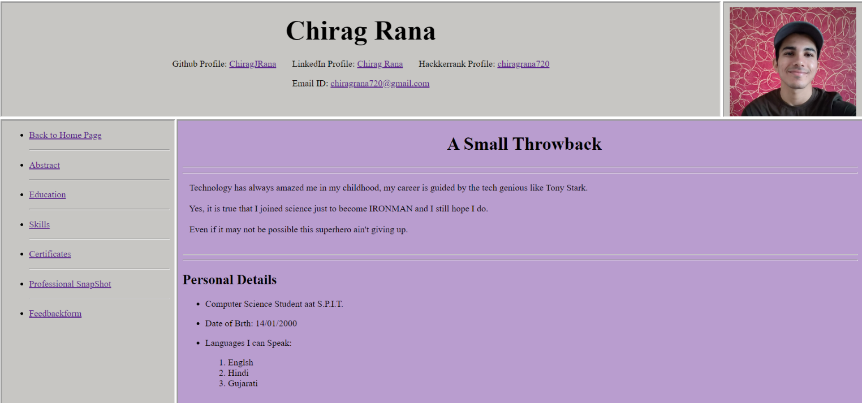
ScreenShot:

The links attached can View profile and other pages on the frame

HTML Code of the Header:

<!DOCTYPE html>
<html>
<head>
<title>Resume</title>
</head>
<body style="background-color: #c7c6c3;">
<div>
<div align="center">
<h1>
<font size="60px">
Chirag Rana
</font>
</h1>
</div>
<div align="center">
<p>
Github Profile: <a href="https://github.com/ChiragJRana/OOPProjectAndroid" target="mainFrame">ChiragJRana</a>
&nbsp;&nbsp;&nbsp;&nbsp;&nbsp;
LinkedIn Profile: <a href="https://www.linkedin.com/in/chirag-rana-562828133/" target="_blanck">Chirag Rana</a>
&nbsp;&nbsp;&nbsp;&nbsp;&nbsp;
Hackkerrank Profile: <a href="https://www.hackerrank.com/chiragrana720" target="mainFrame">chiragrana720</a>
</p>
</div>
<div align="center">
<p>
Email ID: <a href="https://mail.google.com/mail/u/0/?view=cm&fs=1&tf=1" target="_blanck">chiragrana720@gmail.com</a>
</p>
</div>
</div>
</html>

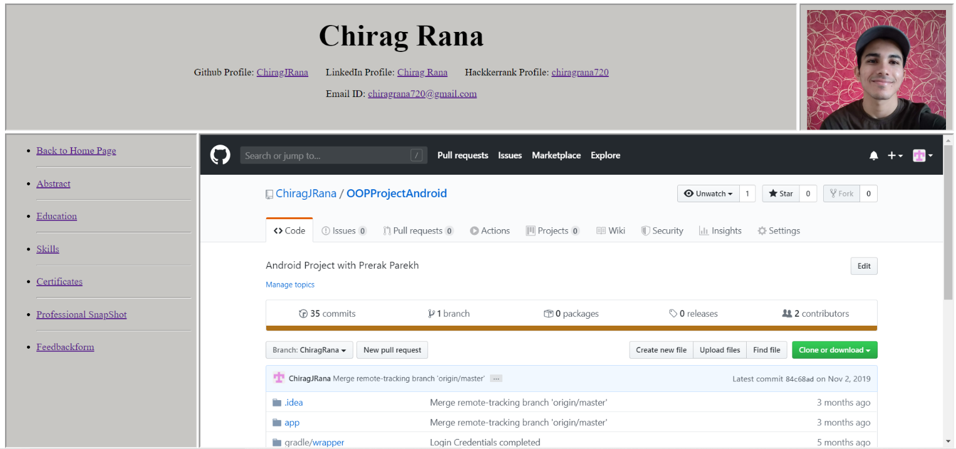
Screen Shots:

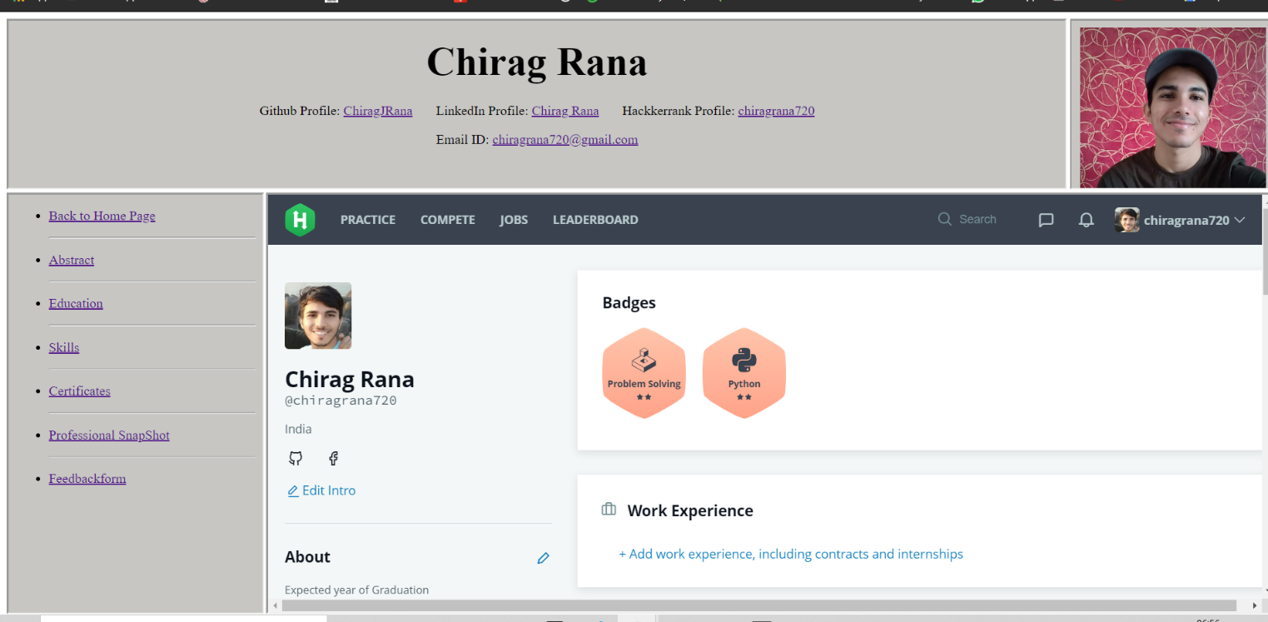
Gmail and LinkedIn opens in a different tab due to Security issues.

HTML CODE FOR ABSTRACT:
<!DOCTYPE html>
<html lang="en">
<head>
<meta charset="UTF-8">
<meta name="viewport" content="width=device-width, initial-scale=1.0">
<meta http-equiv="X-UA-Compatible" content="ie=edge">
<title>Document</title>
</head>
<body>
<div>
<div align="center">
<h1>Abstract</h1>
</div>
<hr>
<hr>
<div>

<p>
&nbsp;&nbsp;Student at S.P.I.T Second year Computer Department and approaching the field of Data Science through Online courses.<br><br>
&nbsp;&nbsp;I found Machine Learning and Deep learning to be the best fields for my future to approach.<br><br>
&nbsp;&nbsp;Though in this competitive market it is necessary to have ther skills as well So I have started Studying MERN stack development.<br><br>
</p>
</div>
<hr><hr>
</div>
<iframe src="footer.html" frameborder="1" width="100%" ></iframe>
</body>
</html>
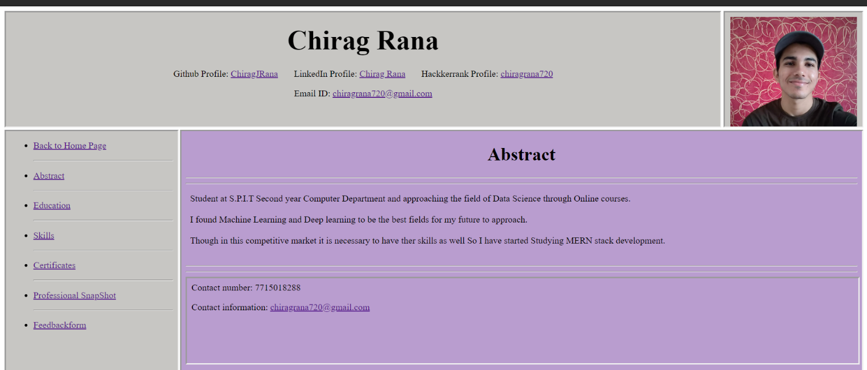
Screen Shots:

CODE FOR EDUCATION:

<!DOCTYPE html>
<html lang="en">
<head>
<meta charset="UTF-8">
<meta name="viewport" content="width=device-width, initial-scale=1.0">
<meta http-equiv="X-UA-Compatible" content="ie=edge">
<title>Document</title>
</head>
<body>
<div>
<div align="center">
<h1>Education</h1>
</div>
<hr>
<hr>
<div>
<ol>
<li>
<p>
SSC from The Blossoms S.T English High School<br>
Score: 91.2% passing year: 2016 <br>
</p>
</li>
<li>
<p>
HSC from KC college <br>
Score: 91.8% passing year: 2018 <br>
</p>
</li>
<li>
<p>
Computer Engineering from S.P.I.T.<br>
2nd year <br>
</p>
</li>
</ol>
<hr>
<hr>
</div>
</div>
<iframe src="footer.html" frameborder="1" width="100%" ></iframe>

</body>
</html>

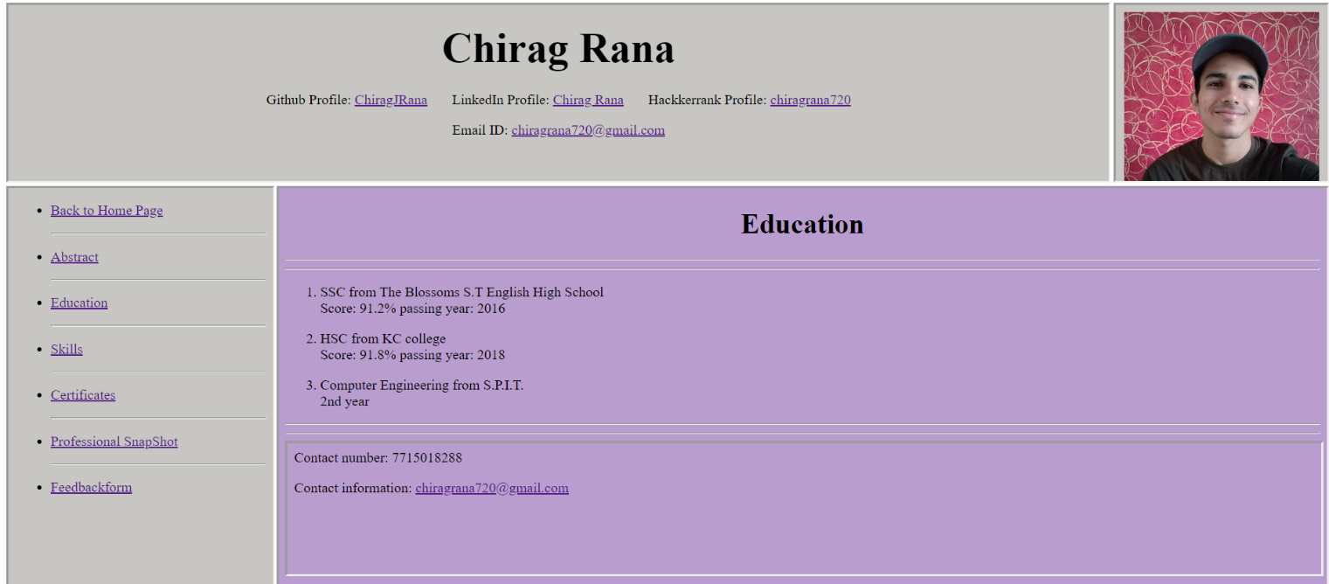
SCREENSHOT:

CODE FOR SKILLS:

<!DOCTYPE html>
<html lang="en">
<head>
<meta charset="UTF-8">
<meta name="viewport" content="width=device-width, initial-scale=1.0">
<meta http-equiv="X-UA-Compatible" content="ie=edge">
<title>Document</title>
</head>
<body>
<div>
<div align="center">
<h1>Skills and Area of Expertise</h1>
</div>
<div>
<hr><hr>
<ul>
<li>
<p>
C programming
</p>
</li>
<li>
<P>
Python Programming
</P>
</li>

<li>
<P>
Java Programming
</P>
</li>
<li>
<P>
C++ Programming
</P>
</li>
<li>
<P>
Object Oriented Programming
</P>
</li>
</ul>
<hr><hr>
</div>
</div>
<iframe src="footer.html" frameborder="1" width="100%" ></iframe>

</body>
</html>

SCREENSHOTS:

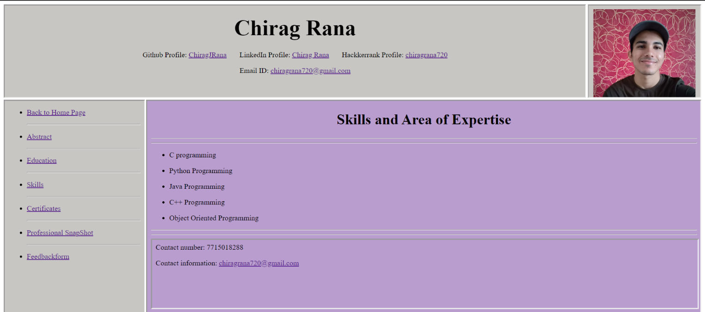

CODE FOR CERTIFICATES:
<!DOCTYPE html>
<html lang="en">
<head>
<meta charset="UTF-8">
<meta name="viewport" content="width=device-width, initial-scale=1.0">
<meta http-equiv="X-UA-Compatible" content="ie=edge">
<title>Document</title>
</head>
<body>
<div>
<h1>Certificates</h1>
<hr>
<hr>
<ul>
<li>
<p>
C++ Programming (NIIT)
</p>
</li>
<li>
<p>
java Programming (NIIT)
</p>
</li>
<li>
<p>
Speciallizarion in Python(Coursera)
</p>
</li>
<li>
<p>
State level Taekwondo (2018).
</p>
</li>
<li>
<p>
State Level takwondo (2016)
</p>
</li>
</ul>
<hr><hr>
</div>
<iframe src="footer.html" frameborder="1" width="100%" ></iframe>

</body>
</html>

SCREEN SHOT:
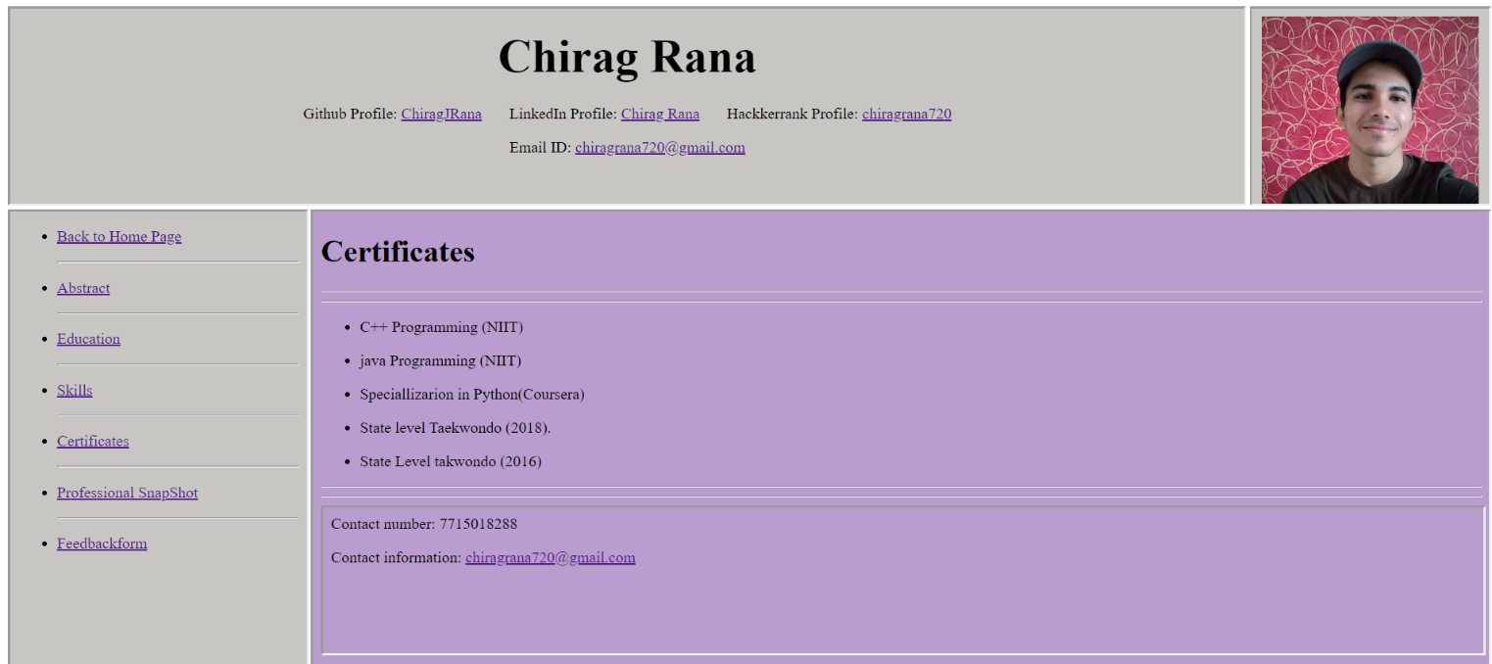

CODE FOR Professional snapshot:
<!DOCTYPE html>
<html lang="en">
<head>
<meta charset="UTF-8">
<meta name="viewport" content="width=device-width, initial-scale=1.0">
<meta http-equiv="X-UA-Compatible" content="ie=edge">
<title>Document</title>
</head>
<body>
<div>
<h1>Professional Snapshot</h1>
<div>
<p>
Participated in:
</p>
<table border="1" align="center" height="70%" width="70%" >
<font size="">
<tr>
<th>Events</th>
<th>Designation</th>
</tr>
</font>
<tr>
<th>Sargam</th>
<th>Finance Head</th>
</tr>
<tr>
<th>Agility</th>
<th>Tournament Admin</th>
</tr>
<tr>
<th>Spoorthi</th>
<th>Tournament Admin</th>
</tr>
</table>

</div>
</div>
<iframe src="footer.html" frameborder="1" width="100%" ></iframe>

</body>
</html>

SCREEN SHOTS:

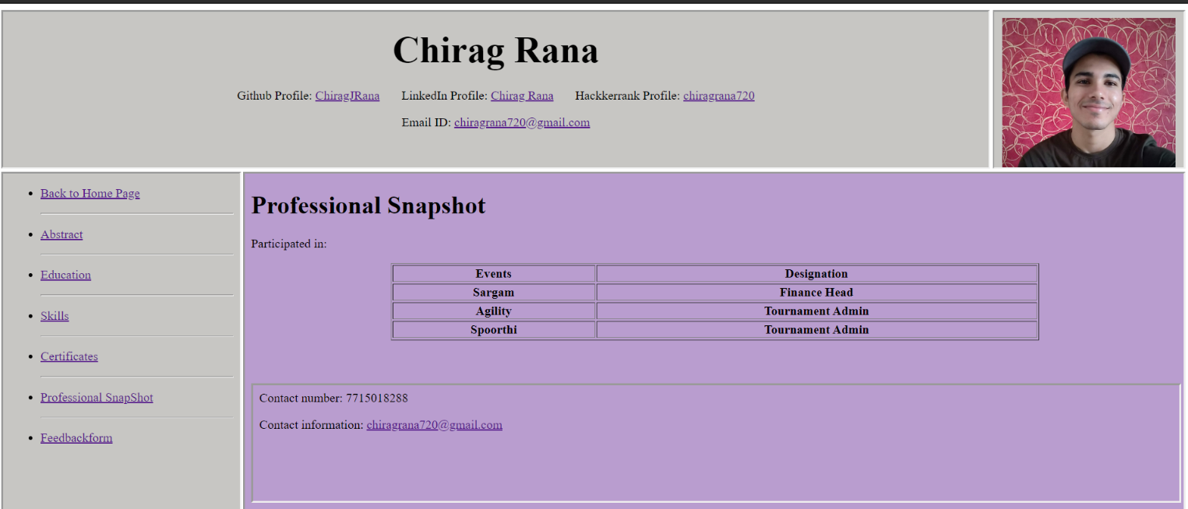

CODE FOR FEEDBACK FORM:
<html>
<head></head>
<body background = ""><br/>
<center>
<h1><u>FEEDBACK FORM</u></h1>
</center>
<form>
<h4>
<fieldset>
<legend>Personal Information</legend>
<div><br/>
<label>First name:</label>
<input type="text" name="firstname" size="40"
placeholder="Enter your first name">

<label>Last name:</label>
<input type="text" name="lastname" size="40"
placeholder="Enter your last name"><br/><br/>
</div><label>Age:</label>
<input type="number" name="age" size="30" value="30">
<label>Birthdate:</label>
<input type="date" name="birthdate" size="30">
</div>
<br/><br/>
<div>
<label>Gender:</label><br/>
<select name="gender">
<option value="male">Male</option>
<option value="female">Female</option>
<option value="other">Other</option></select>
</div>
</fieldset>
<br/>
<fieldset>
<legend>Contact Information</legend></br>
<label>Email id:</label>
<input type="text" name="emailid" size="50">
<label>Contact No:</label>
<input type="text" name="contact"
size="50"><br/><br/>
</fieldset><br/>
<div>
<fieldset>
<legend>Work Information</legend></br>
<label>Company Name:</label>
<input type="text" name="emailid" size="50">
<label>Job Title:</label>
<input type="text" name="contact"
size="50"><br/><br/>
</fieldset>
</div><br/>
<fieldset>
<legend>Rating</legend></br>

<p>How would you rate the appearance of the website?</p>
<input type="radio" name="rating" value="Excellent" checked>Excellent
<input type="radio" name="rating" value="Good">
Good
<input type="radio" name="rating"
value="Average"> Average
<input type="radio" name="rating" value="Not
satisfactory"> Not satisfactory</input>
<br/>
<p>How would you rate the content of the
website?</p>
<input type="radio" name="rating2"
value="Excellent" checked>Excellent
<input type="radio" name="rating2"
value="Good"> Good
<input type="radio" name="rating2"
value="Average"> Average
<input type="radio" name="rating2" value="Not
satisfactory"> Not satisfactory</input><br/><br/>
<label>Suggestions:</label><br/><br/>
<textarea name="message" rows="4" cols="120"
placeholder="Write any suggestions to
improve!!!"></textarea><br/><br/></fieldset>
<br/>
<input type="submit" value="Submit" align="center">
</h4>
</form>
<iframe src="footer.html" frameborder="1" width="100%" ></iframe>

</body>
</html>

SCREEN SHOT:
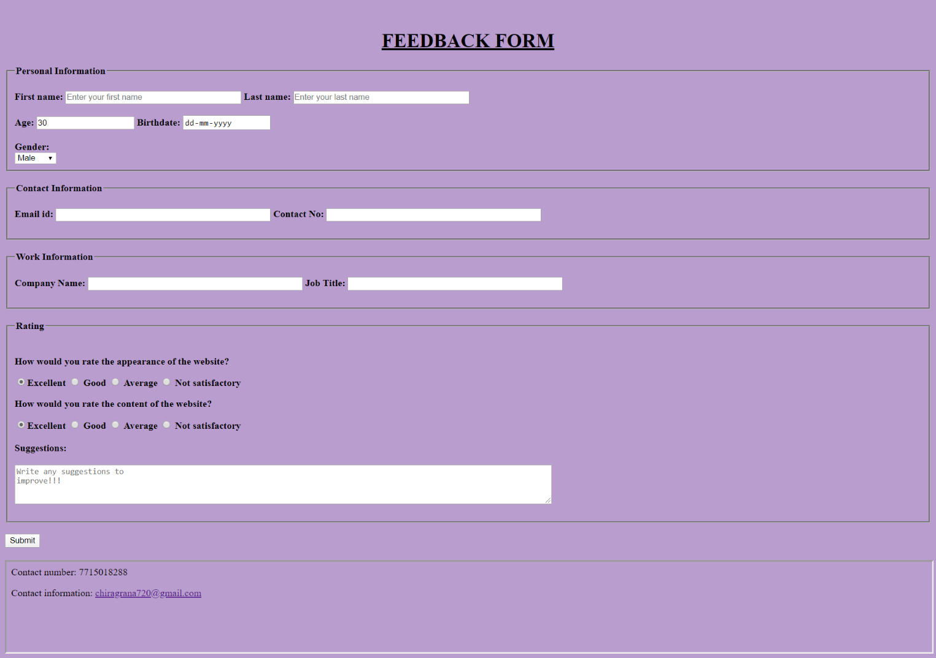

CODE for Navigation bar:
<!DOCTYPE html>
<html lang="en">
<head>
<meta charset="UTF-8">
<title>Title</title>
</head>
<body style="background-color:#c7c6c3;">
<div>
<ul>
<li>
<p>
<a href="mainCenter_right.html" target="mainFrame">Back to Home Page</a>
</p>
</li>
<hr>
<li>
<p>
<a href="Abstract.html" target="mainFrame">Abstract</a>
</p>
</li>
<hr>
<li>
<p>
<a href="education.html" target="mainFrame">Education</a>
</p>
</li>
<hr>
<li>
<p>
<a href="skills.html" target="mainFrame">Skills</a>
</p>
</li>
<hr>
<li>
<p>
<a href="cerificates.html" target="mainFrame">Certificates</a>
</p>
</li>
<hr>
<li>
<p>
<a href="snapshot.html" target="mainFrame">Professional SnapShot</a>
</p>
</li>
<hr>
<li>
<p>
<a href="feedbackform.html" target="mainFrame">Feedbackform</a>
</p>
</li>

</ul>
</div>
</body>
</html>

Screen Shot:
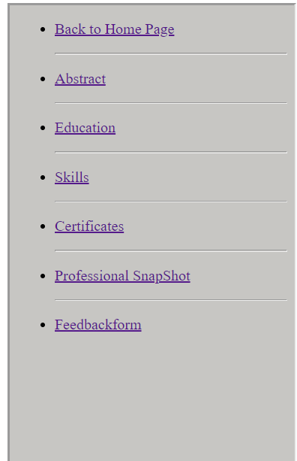

CODE for the picture:

<!DOCTYPE html>
<html lang="en">
<head>
<meta charset="UTF-8">
<title>Picture</title>
</head>
<body style="background-color: #c7c6c3;">
<div align="center">
<img src="IMG_20191212_074156.jpg" alt="My image"height="200" width="222">
</div>

</body>
</html>

Screen Shot:



Conclusion:
1] I implemented various tags of HTML and made a static web page.
2] On top of It I understood how to use frameset and iframes.

