Name: Chirag Rana

Class: SE Comps

Batch: C

UID: 2018130043

# EXPERIMENT – 4

AIM: To implement the concepts of JQuery.

THEORY:

jQuery:

jQuery is an efficient & fast JavaScript Library created by John Resig in 2006. The motto of jQuery is to write less, do more, because it’s functionality revolves around simplifying each and every line of code.

|  |  |  |
| --- | --- | --- |
| No. | Method | Description |
| 1) | animate() | performs animation. |
| 2 | clearQueue() | It is used to remove all remaining queued functions from the selected elements. |
| 3) | delay() | sets delay execution for all the queued functions on the selected elements. |
| 4 | dequeue() | It is used to remove the next function from the queue, and then execute the function. |
| 5) | fadein() | shows the matched elements by fading it to opaque. In other words, it fades in the selected elements. |
| 6) | fadeout() | shows the matched elements by fading it to transparent. In other words, it fades out the selected elements. |
| 7) | fadeto() | adjusts opacity for the matched element. In other words, it fades in/out the selected elements. |
| 8) | fadetoggle() | shows or hides the matched element. In other words, toggles between the fadeIn() and fadeOut() methods. |
| 9) | finish() | It stops, removes and complete all queued animation for the selected elements. |
| 10) | hide() | hides the matched or selected elements. |
| 11) | queue() | shows or manipulates the queue of methods i.e.  to be executed on the selected elements. |
| 12) | show() | displays or shows the selected elements. |
| 13) | slidedown() | shows the matched elements with slide. |
| 14) | slidetoggle() | shows or hides the matched elements with slide. In other words, it is used to toggle between the slideUp() and slideDown() methods. |
| 15) | slideup() | hides the matched elements with slide. |
| 16) | stop() | stops the animation which is running on the matched elements. |
| 17) | toggle() | shows or hides the matched elements. In other words, it toggles between the hide() and show() methods. |

FORM:

• HTML:

<!DOCTYPE html>

<html lang="en">

<head>

    <meta charset="UTF-8">

    <meta name="viewport" content="width=device-width, initial-scale=1.0">

    <title>JQuery Submission</title>

    <link rel="stylesheet" href="style.css" />

    <script src="https://ajax.googleapis.com/ajax/libs/jquery/2.1.1/jquery.min.js"></script>

    <script src="script.js"></script>

</head>

<body style="font-family:Verdana;">

    <div  class="image">

        <img id="image" src="" alt=""   >

    </div>

    <div class="white-box">

        <h1 style="text-align: center;">Welcome to your New Business </h1>

        <h3 style="text-align: center;">Add A Product</h3>

            <form action="">

                <div  class="rightpart">

                    Product Name: <input type="text" name="name" id="Pname" placeholder="Enter the prooduct name">

                    <span id="name"></span><br>

                    Product Details: <input type="text" name="details"  height="200px;"><br>

                    Product Worth($): <input type="number" name="" id="worth"><br>

                    Username: <input type="text" name="" id="username"><br>

                    Password: <input type="password" name="" id="Userpassword"><br>

                    Product Type: <select name="" id="selection">

                        <option value="electronics" >Electronics</option>

                        <option value="furniture" >Furniture</option>

                        <option value="clothes" >Clothes</option>

                    </select><br>

                    Enter the image:<input type="file" id="img" name="img" accept="image/*"><br>

                </div>

            <div  id="selected">

                <div class="clothes" id="types_of_colours">

                    <input type="checkbox" id="Black" name="Black">

                    <label for="Black"><strong>Black</strong></label><br>

                    <input type="checkbox" id="Blue" name="Blue">

                    <label for="Blue"><strong>Blue</strong></label><br>

                    <input type="checkbox" id="Green" name="Green">

                    <label for="Blue"> <strong>Green</strong></label><br>

                    <input type="checkbox" id="Yellow" name="Yellow">

                    <label for="Yellow"> <strong>Yellow</strong></label><br>

                    <input type="checkbox" id="Red" name="Red">

                    <label for="Red"><strong>Red</strong></label><br><br>

                </div>

                <div class="electronics" id="type_of_elctron">

                    <input type="checkbox" name="Mobile" id="mobile">

                    <label for="mobile"><strong>Mobile</strong></label><br>

                    <input type="checkbox" name="television" id="television">

                    <label for="television"><strong>Television</strong></label><br>

                    <input type="checkbox" name="latops" id="laptops">

                    <label for="laptops"><strong>Laptops</strong></label><br>

                    <input type="checkbox" name="software" id="software">

                    <label for="software"><strong>Software</strong></label><br>

                    <input type="checkbox" name="Misc" id="Misc">

                    <label for="Misc"><strong>Miscellaneous</strong></label><br><br>

                </div>

                <div class="furniture" id="types_of_furniture">

                    <input type="checkbox" name="sofa" id="sofa">

                    <label for="sofa"><strong>Sofa</strong></label><br>

                    <input type="checkbox" name="cupboard" id="cupboard">

                    <label for="cupboard"><strong>Cupboard</strong></label><br>

                    <input type="checkbox" name="chairs" id="chairs">

                    <label for="chairs"><strong>Chairs</strong></label><br>

                    <input type="checkbox" name="doors" id="doors">

                    <label for="doors"><strong>Doors</strong></label><br><br>

                </div>

            </div>

                <button type="submit">Submit</button>

            </form>

    </div>

    <div id="greetings" style="display : none">

        <h1>

            Congratulations!!

        </h1>

    </div>

</body>

</html>

• JS FILE:

function readURL(inputtag){

    if( inputtag.files && inputtag.files[0]){

        var reader = new FileReader();

        reader.onload = function(e){

            // console.log('The e is '+e);

            // console.log(e);

            $('#image').attr('src',e.target.result);

            var div = $("#image");

                div.animate({height: '80%', opacity: '0.4'}, "slow");

                div.animate({width: '80%', opacity: '0.8'}, "slow");

        }

        // console.log(inputtag.files);

        // console.log(inputtag.files[0]);

        reader.readAsDataURL(inputtag.files[0]);

    }

}

$(document).ready(function () {

    $('#img').change(function () {

        readURL(this);

        // console.log(this);

    });

    $('button').click(function(){

        $('form').replaceWith( function(){

            return '<h2 style=" color: rgb(112, 79, 9);"> Congratualations!! <br> The product is Added </h2>' ;

        });

    });

    $('select').change(function (e) {

        var newval = $('select').val();

        $('.clothes').hide();

        $('.electronics').hide();

        $('.furniture').hide();

        switch(newval)

        {

            case 'electronics':

            $('.electronics').slideToggle(1000);

            break;

            case 'furniture':

            $('.furniture').slideToggle(1000);

            break;

            case 'clothes':

            $('.clothes').slideToggle(1000);

            break;

        }

    });

    $('input , select, button').mouseover(function () {

        $(this).css('box-shadow', '0 8px 16px 0 rgba(0,0,0,0.2)');

    });

    $('input').mouseout(function () {

        $(this).css('box-shadow', 'none');

    });

    $("input").focus(function(){

        $("span").css("display", "inline");

      });

});

CSS FILE:

body{

    background-image: url('backgroundimage.jpg');

    background-repeat: no-repeat;

    background-size: cover;

    text-align: center;

    overflow: scroll;

}

div.image {

        border-radius: 10px;

        float: right;

        margin: 3em;

        text-align: center;

        background-color: bisque;

        height: 40rem;

        width: 80rem;

        box-shadow: 0 4px 8px 0 rgba(0,0,0,0.2);

        transition: 0.3s;

        width: 40%;

        margin-top: 0;

}

img{

    height: 80%;

    width:80%;

    margin-top: 15%;

    position: relative;

}

h1{

    color:rgb(136, 10, 10);

    font-size: 2rem;

    padding-top: 0.1em;

    text-align: center;

    font-family: Georgia, 'Times New Roman', Times, serif;

}

h3{

    color:rgb(136, 10, 10);

    text-align: center;

    font-family: Georgia, 'Times New Roman', Times, serif;

}

input[type=text],input[type=number],input[type=password], select {

    padding: 12px 20px;

    margin: 8px 0;

    display: inline-block;

    border: 1px solid #ccc;

    border-radius: 4px;

    box-sizing: border-box;

  }

  button[type=submit] {

    width: 80%;

    background-color: rgb(231, 205, 86);

    color: rgb(112, 79, 9);

    padding: 14px 20px;

    border: none;

    border-radius: 10px;

    cursor: pointer;

  }

  button[type=submit]:hover {

    background-color: #80510c;

    color: rgb(248, 205, 85);

  }

.white-box{

    /* align-items: center; */

    border-radius: 10px;

    margin: 3em;

    background-color: bisque;

    height: 40rem;

    box-shadow: 0 4px 8px 0 rgba(0,0,0,0.2);

    transition: 0.3s;

    width: 40%;

}

div.image:hover, .white-box:hover {

    box-shadow: 0 8px 16px 0 rgb(255, 255, 255);

}

div .clothes{

    display: none;

    text-align: left;

    padding-left: 3em;

    padding-bottom: 0em;

}

div .furniture{

    display: none;

    text-align: left;

    padding-left: 3em;

    padding-bottom: 0em;

}

div .electronics{

    display: none;

    text-align: left;

    padding-left: 3em;

    padding-bottom: 0em;

}

.rightpart{

    text-align: left;

    padding-left: 2rem;

    margin-bottom: 1em;

}

OUTPUT:

Nomal Screen Shot:

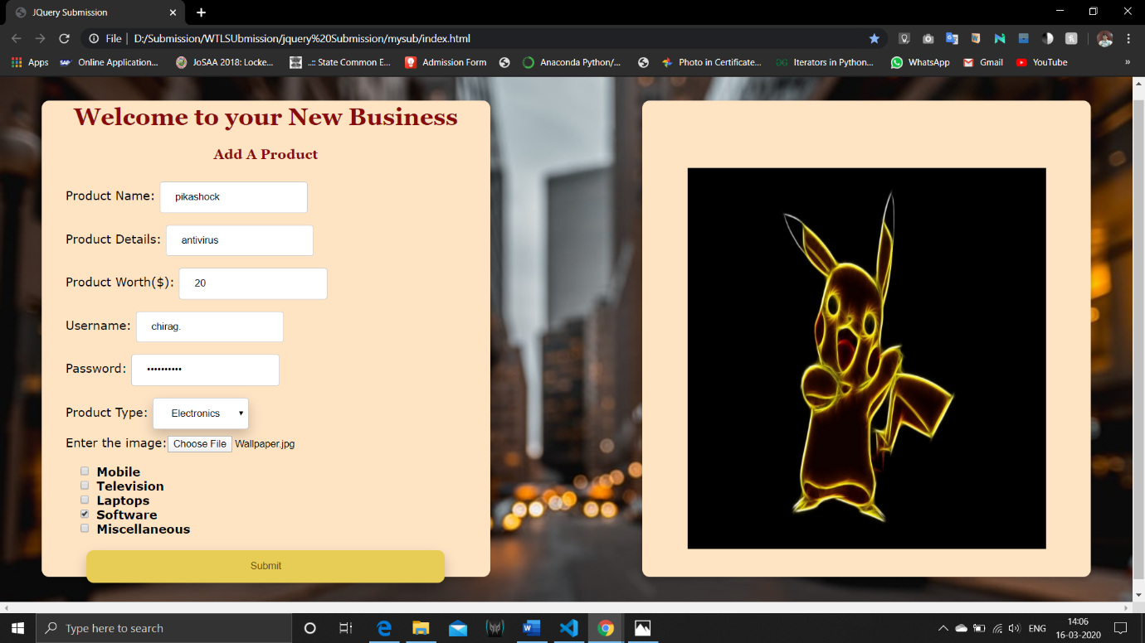

Animation onload of the file, hover :

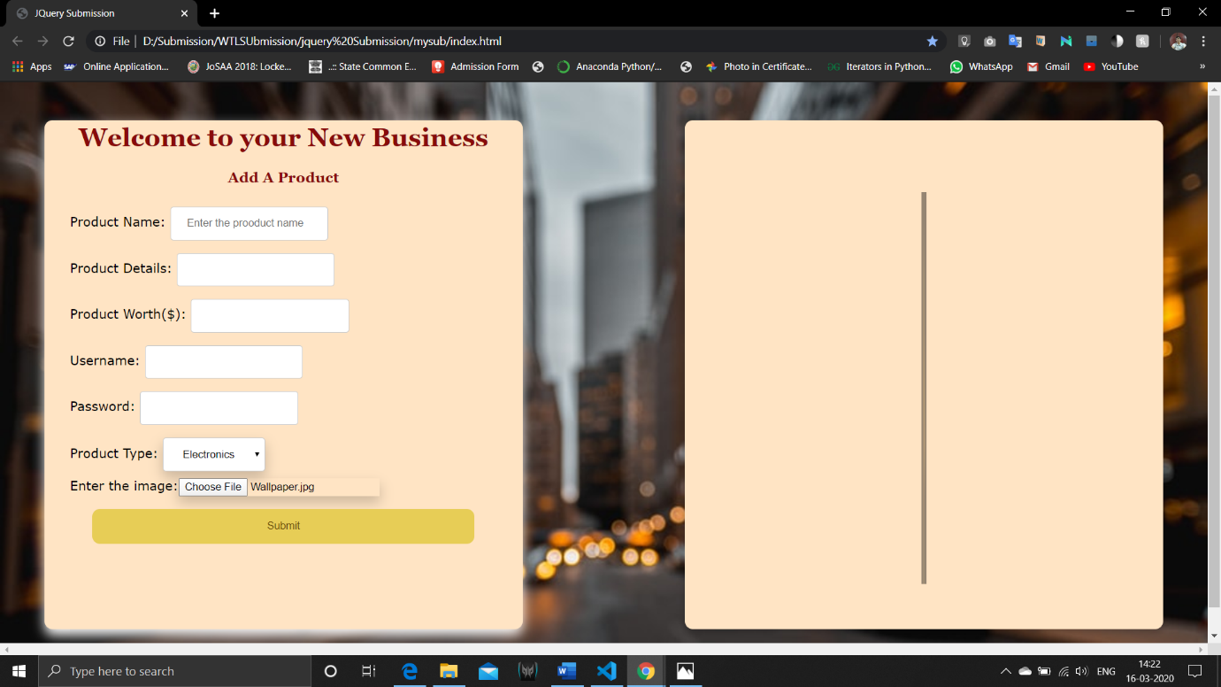

Toggling:

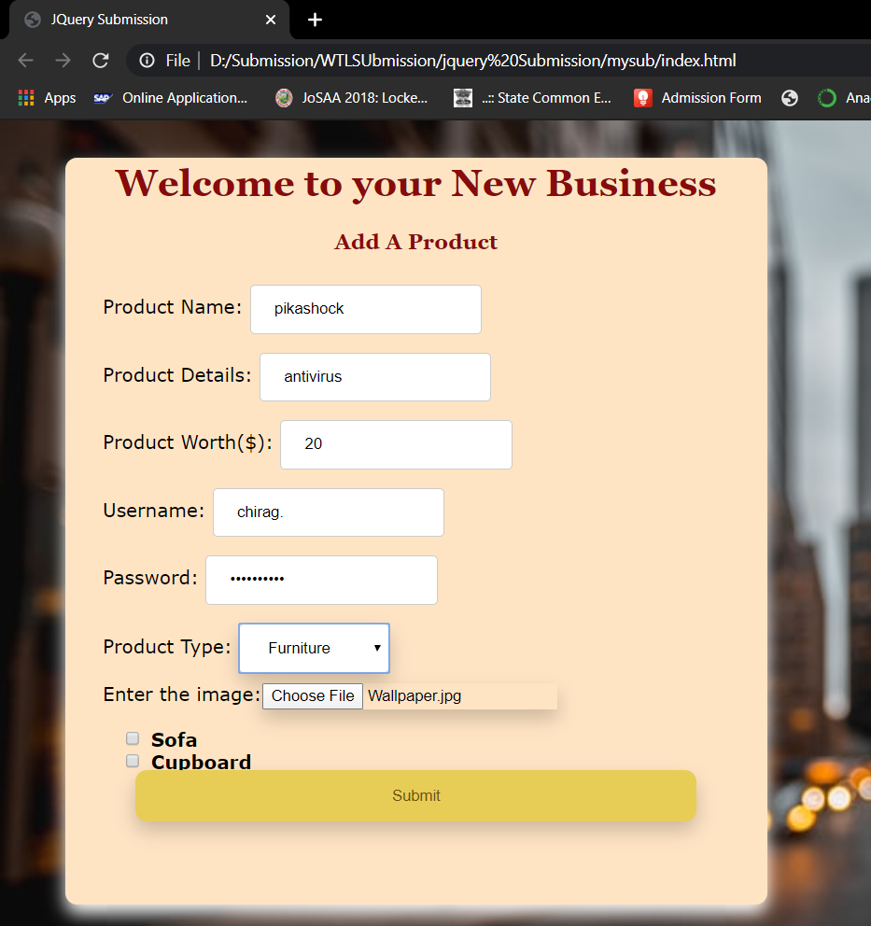

ON submit:

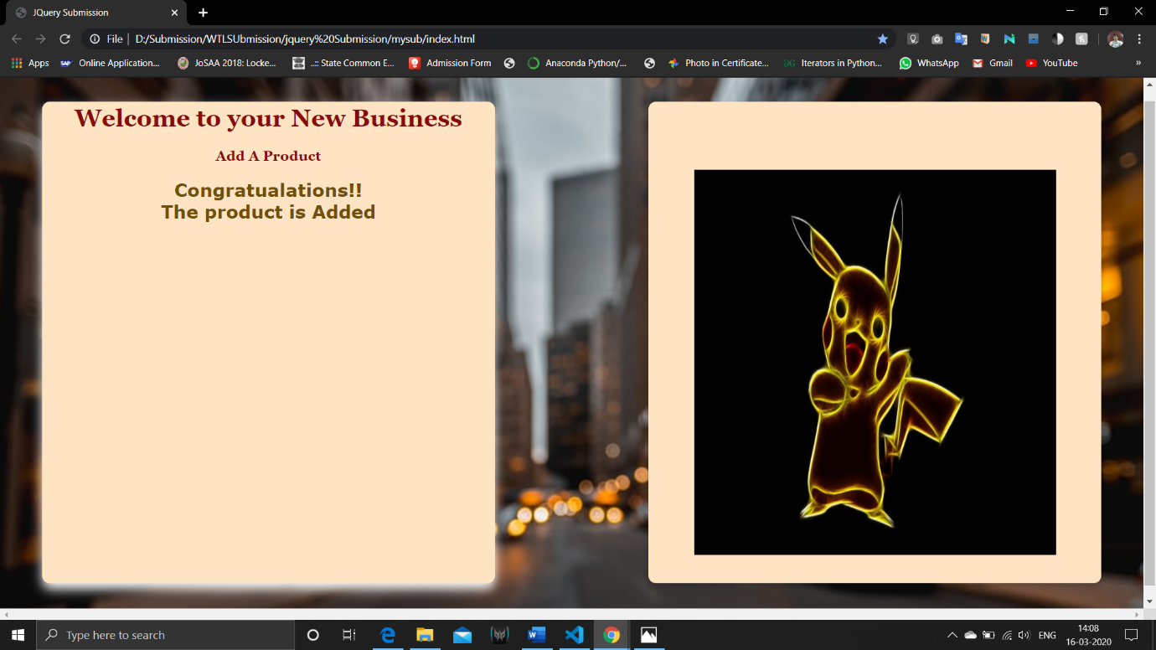

CONCLUSION:

1. I understood how to impelement jquery and use different methods of jquery to show ,hide, toggle, and do many more things.
2. I understood that a CDN should be placed before the actual script.
3. I understood the basic of web designing the pattern to build a website due to all the practice.