Contents
1 Preamble 1
2 Objective 1
3 Expected significance 1
4 Background 2
4.1 Climate Data Records 2
4.2 Sea-surface Temperature 3
4.2.1 Cloud screening algorithms 3
4.3 Atmospheric correction algorithm 3
5 Technical approach and methodology 5
5.1 Objectives 5
5.2 Methodology 5
5.2.1 Buoy data 6
5.2.2 Ship radiometers 7
5.2.3 Matchup Data Base 9
5.2.4 Algorithm performance 10
5.2.5 Algorithm improvements 10
5.2.6 Update retrieval uncertainties 10
5.2.7 Transition results to OBPG and the JPL PO.DAAC 11
5.2.8 Climate Data Records of SST 11
5.3 Critical Facilities and Resources 11
5.3.1 Marine-Atmospheric Emitted Radiance Interferometer (M-AERI) 11
5.3.2 ISAR 11
5.3.3 MODIS Matchup Data bases 12
5.4 Analysis approach 12
5.5 Assessment of accuracy 12
5.6 Work Plan 12
6 Impact of proposed work to the state of knowledge in the field 12
7 Related research 12
8 Relevance of proposed work to NASA programs 13
9 Data Management and stewardship. 13
10 References 16
11 Biographical Sketches 19
11.1 Peter J. Minnett, PhD 19
11.2 Guillermo Podestá PhD. 21
11.3 Malgorzata Szczodrak PhD. 22
12 Current and Pending Support 23
12.1 Current Support – Peter J. Minnett PhD 23
12.2 Current Support – Guillermo Podestá PhD 23
12.3 Current Support – Malgorzata Szczodrak PhD 23
12.4 Pending Support – P. J. Minnett 24
12.5 Pending Support – Guillermo Podestá 24
12.6 Pending Support – Malgorzata Szczodrak 24
13 Budget Details 25
14 Facilities and equipment 27

Preamble
This proposal is submitted in response to the ROSES 2017 component A. 37 “The Science of Terra, Aqua, and Suomi NPP (NNH17ZDA001N-TASNPP). We propose to continue the activities currently funded under grants NNX14AK18G “Continued maintenance and minor refinement of algorithms for deriving SST from MODIS” and NNX14AP79A “Sea-surface temperature from VIIRS - extending the MODIS time series for Climate Data Records.” We will build on equipment, computer code, experience gained over many years of research in this field. Our proposal includes continuing the excellent collaborations with NASA centers at Goddard Space Flight Center and at the Jet Propulsion Laboratory.
The proposed activity contributes to NASA's Earth Science objective to improve understanding of the role of the oceans in the climate system.

Objective
The objective is to establish a long time series of global skin sea-surface temperatures (SST_{skin}) from the start of the MODIS missions to the present, including data from the VIIRS on Suomi-NPP. Each retrieved SST_{skin} value will continue to have an estimate of its accuracy in terms of a bias error and an uncertainty derived in a transparent and justifiable method. Including SSTskin measurements from ship radiometers with SI-traceable calibration provides the basis of a credible Climate Data Record (Minnett and Corlett, 2012; NRC, 2000).

Expected significance
The required accuracy for satellite remote sensing of SST for climate research and applications is very stringent, but it is a good target as in striving to achieve it we will generate data sets that can contribute to many research activities. The target accuracy is ± 0.1 K with a decadal stability of 0.04 K (Ohring et al., 2005) is very challenging not only to achieve, but also to demonstrate convincingly whether these targets have been attained. Determining the accuracies of satellite-derived SST_{skin} by comparing then with independent measurements from using ship-board radiometers (Minnett et al., 2001; Jessup et al., 2002; Donlon et al., 2008; Donlon et al., 2014), by being a comparison of “like-with-like,” removes much of the error and uncertainty introduced by using subsurface temperature measurements taken from drifting or moored buoys (Interim Sea Surface Temperature Science Team, 2010; Minnett, 2003; Minnett and Smith, 2014). However, the number is ship-board radiometers is small, whereas the number of drifting and moored buoys is large, so that an optimal way forward to assess the accuracies of satellite derived SSTs is to use both (Minnett, 2010; Minnett and Corlett, 2012).
Our proposal dovetails with the activities in the recentgrant awarded by the NASA Participating Investigator Program “Sea-surface temperatures from Copernicus Sentinel-3s and EUMETSAT Polar System Second Generation (EPS-SG)” (NNX17AL69G) to this proposal’s PI. This grant extends resources and techniques developed in the expiring MODIS and VIIRS grants to the SST_{skin} retrievals of the Sea and Land Surface Temperature Radiometer (SLSTR) on the European Sentinel-3 satellites, and the METimage radiometer on the next generation EUMETSAT polar orbiting meteorological satellites.

Background
SST is a critically important geophysical parameter in the behavior of the Earth System. The global and regional distributions of SST, and their temporal evolution over days to decades, are relevant to specifying the “Natural Variability of the Earth System.” Interactions between the ocean and atmosphere, such as the exchanges of heat, moisture, gases, and momentum - for all of which the SST is a pivotal variable - are directly relevant to the “Forcing, Response, and Predictability of the Climate System,” and the redistribution of the SST, and the attendant air-sea exchanges, are an important part of assessing the “Consequences.” The Committee on Earth Observation Satellites (CEOS) has declared SST to be an Essential Climate Variable (ECVs) that has a high impact on the requirements of the UNFCCC (United Nation Framework Convention on Climate Change) and the IPCC (Intergovernmental Panel on Climate Change).
SST measured from satellites offers the best source of global, repeated fields, along with accompanying uncertainty characteristics. However, the scientific aspects of the atmospheric corrections applied to the MODIS infrared brightness temperatures to derive the SST are intimately linked to the applicability of the derived fields to the research directed at the NASA Earth Science Enterprise strategic questions.
In this proposal we next discuss some of the issues that underpin the generation of Climate Data Records, which serve as a very useful concept to establish the overarching scientific requirements of the satellite-derived SSTs. Then we present a brief discussion of the physical processes that influence variability relevant to the generation of heritage retrieval algorithms.

Climate Data Records
The generation of a Climate Data Record (CDR) poses the most stringent requirements on the accuracy of derived SST: an absolute temperature uncertainty of 0.1 K and a decadal stability of ~ 0.04 K (Ohring et al., 2005). The concept of a CDR was formally introduced in a National Academy of Sciences report (NRC, 2000) as being “a data set designed to enable study and assessment of long-term climate change, with ‘long-term’ meaning year-to-year and decade-to-decade change. Climate research often involves the detection of small changes against a background of intense, short-term variations…. The production of CDRs requires repeated analysis and refinement of long-term data sets, usually from multiple data sources.” The report emphasized the need for “Data Stability,” reasoning that “because natural signals are often small, it is difficult to ascribe particular events or processes to climate change….. [so that] long-term, high-quality measurements are needed to discern subtle shifts in Earth’s climate. Such measurements require an observing strategy emphasizing a strong commitment to maintaining data quality and minimizing gaps in coverage.” The Report states that “long-term studies such as those needed for documenting and understanding global climate change require not only that a remote sensing instrument be accurately characterized and calibrated but also that its characteristics and calibration be stable over the life of the mission. Data Continuity “includes the continuous and accurate characterization of the properties that affect the construction of the time series. The most useful data for climate research purposes are time series that are continuous and for which the characterization of error, in terms of precision and bias, is known. Such errors should be minimized as much as possible in order to detect the often small, climate-related signal.”
It is within the scope of these definitions and perspectives that this proposal is submitted.

Sea-surface Temperature
SST is an important parameter in the global climate system: it is a controlling variable in the exchange of heat, moisture, and gases between ocean and atmosphere; its patterns reveal subsurface oceanic variability; and long-term evolution of its global, regional and seasonal averages are potential indicators of climate change. The difficulty in making adequate estimates of SST can only be resolved by using satellite radiometers which provide self-consistent, global measurements on repeat cycles of hours to days. Long series of satellite measurements have great potential in climate research (e.g. Allen et al., 1994; Good et al., 2007). However, as stated in the National Research Council Report (2000), effective use of the measurements from these instruments, requires a clear understanding of the residual uncertainties in the derived SST fields.
Although generally referred to as ‘global warming,’ the response of the climate system in general, and SST in particular, to the changing radiative forcing at the surface and through the atmosphere is not necessarily a uniform, monotonic increase in SST. Instead, changes are likely in spatial and temporal SST patterns, with some regions warming and others cooling (e.g. Casey and Cornillon, 1999). Also “fingerprint papers.” The regional and seasonal aspects of the potential climate-change signal in SST underscores the profound need to ensure that satellite-derived SST fields have well-understood error distributions and that these are not unknowingly contaminated by residual instrumental errors (i.e. related to differential solar heating round the orbit, see Brown et al., 1985) or geographically or temporally coherent uncertainties in the atmospheric correction algorithms (i.e. tied to the distribution of atmospheric water vapor, see Minnett, 1990, or aerosols), both of which could lead to systematic regional and seasonal errors.

Cloud screening algorithms

Atmospheric correction algorithm
For SST retrievals in cloud-free conditions from a well-calibrated and well-characterized spacecraft infrared (IR) radiometer, the limit of the accuracy is imposed by the effectiveness of the atmospheric correction algorithm. Differential absorption (and re-emission) of IR radiation by atmospheric constituents at different spectral intervals (instrument “channels” or “bands”) leads to different brightness temperatures for collocated measurements in different bands at satellite altitudes. The essence of the atmospheric correction algorithm is the appropriate combination of these various brightness temperatures to compensate for the effects of the intervening atmosphere. This approach can only be applied to parts of the imagery that have been screened for the presence of clouds, as these modify or prevent the IR radiation propagating from the surface to the satellite radiometer.
The SST retrieval is based on measurements taken where the atmosphere is relatively transparent to infrared radiation, in so-called “atmospheric windows,” in the 3.5-4.1µm and 10-12µm spectral intervals. The shorter wavelengths are contaminated by sunlight reflected at the sea surface during the day (“sun glitter” or “sun glint”), or are scattered within the atmosphere, and therefore these measurements can only be used for SST retrieval during the night-time part of each orbit. Because of the small number of channels available in satellite-based IR radiometers, and the wide range of atmospheric variability, especially in the horizontal and vertical distribution of water vapor, a fully analytic atmospheric correction cannot be exact, even to within the limits imposed by the inherent noise in the radiometer measurements. As a result, a statistical approach has had to be adopted.
For nearly two decades the most effective and widely used atmospheric correction approach has been the Non-Linear SST algorithm (NLSST; Walton et al., 1998, 2016), which is based on the slightly non-linear combination of top-of-atmosphere brightness temperatures measured in the 10-12µm wavelength interval where the atmosphere is relatively transmissive. The non-linear effects of the changing atmospheric path-length across the swath are not fully compensated by the brightness temperature differences. An additional simple geometrical function accounts for these effects. The regionally and seasonally variations in the vertical distribution of atmospheric water vapor, the main constituent that interacts with the IR radiation leaving the sea surface, are approximated using a “first guess” SST in the algorithm which provides a correction based on the weak correlation between surface temperature and water vapor. This is a first-order change to correct for the fact that there is dispersion in the relationship between the temperature deficit in either of the channels (e.g. T₁₁ – SST) and the brightness temperature difference (T₁₁-T₁₂).
The form of the NLSST used for MODIS and VIIRS is:
SST = a₀ ₊ a₁ * T₁₁ + a₂ * (T₁₁ - T₁₂) * T_{sfc} + a₃ * (sec (θ) – 1.0) * (T₁₁ - T₁₂)
+ a₄ * (θ) + a₅ * (θ²) + a₆ * (mirror_side) (1)
where T_{n} are brightness temperatures measured in the channels at n μm wavelength, T_{sfc} is a ‘first guess’ estimate of the SST in the area, and θ is the satellite zenith angle. The a₆ term is for MODIS only and is a consequence of small differences in the reflectivity of the two sides of the paddle-wheel scan mirror (Xiong et al., 2008; Kilpatrick et al., 2015). For VIIRS, a₆ = 0.
While equation (1) can be used both during the day and night, more accurate night-time retrievals are feasible using measurements in the mid-IR transmission window, and the most effective algorithm for MODIS has been found to be:
SST4 = a₀ + a₁ * T_{3.95} + a₂ * (T_{3.95} – T_{4.05}) + a₃ * (sec (θ) - 1.0) (2)
where the symbols have the same meaning as in Equation 1, but coefficients a₀-a₃ are of course different. For VIIRS, the night-time algorithm is:
SST_{triple} = a₀ +a₁T₁₁ +a₂(T_{3.7}-T₁₂) T_{sfc} + a₃(sec(θ)-1) + a₄(θ) +a₅(θ²) (3)
There are two approaches for deriving the coefficients: numerical simulations of the brightness temperature measurements, and collocated and contemporaneous match-ups with in situ measurements.
The current coefficients for the MODIS and VIIRS SST_{skin} atmospheric correction algorithms have been derived using collocated subsurface temperature measurements from drifting and moored buoys, and validated using withheld buoy measurements and data from shipboard radiometers. The buoy and radiometer data, together with the coincident MODIS and VIIRS brightness temperatures and other related ancillary information are compiled by the Miami research group and NASA collaborators into three Match-Up Data Bases (MUDBs) for MODISs on Terra and Aqua, and VIIRS, respectively.
In previous work by the Miami group, the seasonally dependent bias errors in MODIS SSTs have been reduced by deriving algorithm coefficients on a monthly basis, which are estimated using a time-averaged window to avoid unphysical discontinuities at the change of the month. The between satellite-derived SST_{skin} and those from ship-based radiometers are shown as global statistics in Table 1.
Satellite and Algorithm | Mean | Median | St. Deviation | Robust St. Deviation | No. of matchups
Terra SST Day | 0.082 | 0.080 | 0.567 | 0.409 | 1025
Terra SST Night | 0.048 | 0.034 | 0.467 | 0.337 | 2454
Terra SST4 Night | 0.016 | 0.023 | 0.339 | 0.244 | 2467
Aqua SST Day | 0.105 | 0.107 | 0.666 | 0.480 | 910
Aqua SST Night | 0.020 | 0.027 | 0.489 | 0.353 | 1752
Aqua SST4 Night | -0.010 | 0.016 | 0.396 | 0.285 | 1858
SST is derived from measurements from MODIS bands 31 and 32 (λ = 11.03 and 12.02 µm) – Eq. 1.
SST4 is derived from measurements from MODIS bands 20 and 22 (λ = 3.95 and 4.05 µm) – Eq. 2.
Table 1: Statistics of differences between Terra and Aqua MODIS SST_{skin} retrievals and SST_{skin} values from ship radiometers (M-AERI and ISAR). Values are in K.

Technical approach and methodology

Objectives
Our overarching objective is to continue to ensure that the SST_{skin} fields derived from both MODISs on Terra and Aqua and VIIRS on Suomi-NPP are (i) accurate, (ii) have well defined uncertainties, (iii) are traceable to SI-standards, and (iv) are available to the broad science and operational communities through the NASA JPL PO.DAAC.
Our intention is to render the MODIS and VIIRS SSTs an important component of the SST Climate Data Record and be a significant contribution to the objectives of the NASA SST Science Team as stated in their White Paper (ISSTST, 2010).

Methodology
The methodology of the proposed project can be itemized as:
- Gather buoy measurements of near-surface temperature in near-real-time to be incorporated into the MUDBs for coefficient generation, and for the assessment of algorithms uncertainties.
- Deploy shipboard radiometers to measure the SST_{skin} to be incorporated into the MUDBs to assess uncertainties in algorithms, and to provide SI-traceability for the MODIS and VIIRS SST_{skin} retrievals; reformat ship radiometer data into GHRSST L2r and submit to GHRSST archive for distribution and stewardship.
- Extract MODIS and VIIRS data and ancillary information collocated with the buoy and shipboard radiometer SST_{skin} measurements.
- Merge satellite and in situ records to produce the MODIS and VIIRS MUDBs.
- Assess the performance of the satellite cloud screening and atmospheric correction algorithms by analysis of the MUDBs and global and regional fields.
- Perform incremental improvement of the algorithms’ formulations.
- Update MODIS and VIIRS SST_{skin} algorithm coefficients.
- Develop improved methods and metrics to assess MODIS and VIIRS SST_{skin} accuracies.
- Revise accuracy estimates.
- Sustain collaboration with OBPG for producing MODIS and VIIRS SST_{skin} fields.
- Monitor and validate SST_{skin} retrievals for MODISs and VIIRS with respect to in situ observations to enable calculation of a climate-quality data record.
- Develop detailed error budgets for the MODIS and VIIRS SST_{skin} including contributions from the validating sensors and the methods of comparison.
These items are elaborated below.

Independent SST? data

Buoy data
Most of the in situ measurements in the MODIS and VIIRS MUDB’s are from drifting buoys that transmit their position and observed SST to shore-based collection centers. Drifting buoys are numerous but large areas of the oceans remain under-sampled (Figure 1). We use drifting buoy data from the iQUAM (in situ SST Quality Monitor) server of NOAA/NESDIS/STAR. These buoy measurements have undergone quality assurance to remove data from drifters with thermometers that have lost calibration. As very few of the drifters are recovered after deployment, it has been difficult to assess directly the accuracy of the temperature measurements and possible calibration drift, but a “three-way” analysis involving buoy temperatures and two independent collocated satellite SST retrievals (AATSR and AMSR-E) allows a partition of the discrepancies in the SSTs among each data source (O'Carroll et al., 2008). This analysis included an estimate of the buoy uncertainties of 0.23K, which should be taken into account when assessing the accuracies of satellite SST retrievals by comparisons with buoy measurements. Despite these uncertainties the number of buoy measurements renders them very valuable for this project. Currently, there are over 1400 active drifters (Figure 1), but only about 12% of these will contribute to high-quality matchups (Figure 2Error: Reference source not found). A new generation of drifters is being deployed with better calibrated thermometers, accurate to 0.02K. In collaboration with Scripps Institution of Oceanography and NOAA/AOML we have begun an experiment with a cluster of drifters moored close to the RSMAS pier to monitor the degradation of the thermometer calibration in realistic deployment conditions. We will also explore the use of near-surface measurements of ARGO profiling floats (e.g. Castro et al., 2014).
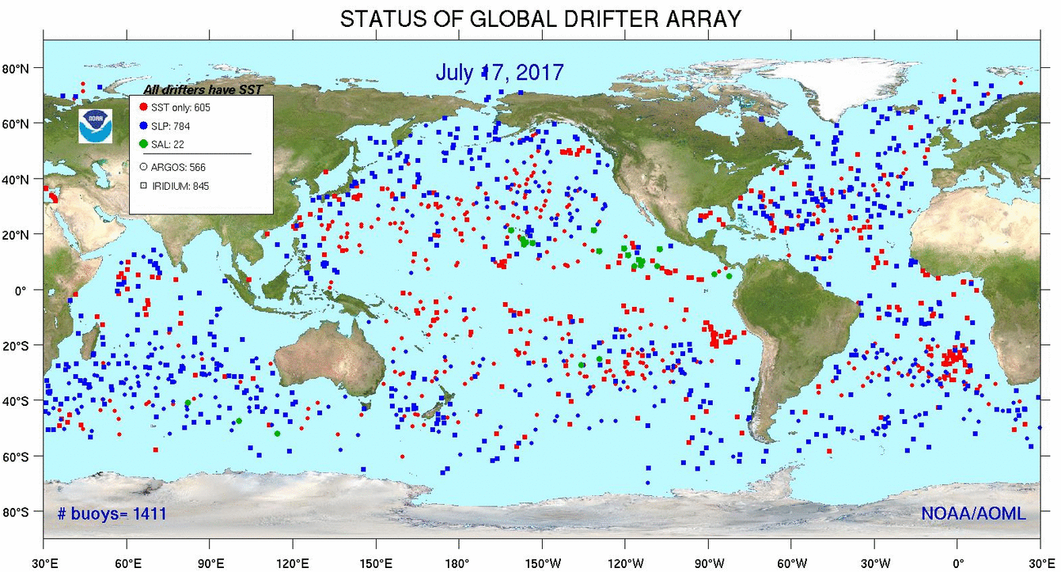
Figure 1. Distribution of drifting buoys on 17 July 2017. Taken from http://www.aoml.noaa. gov/phod/dac/gdp_maps. php.

Ship radiometers
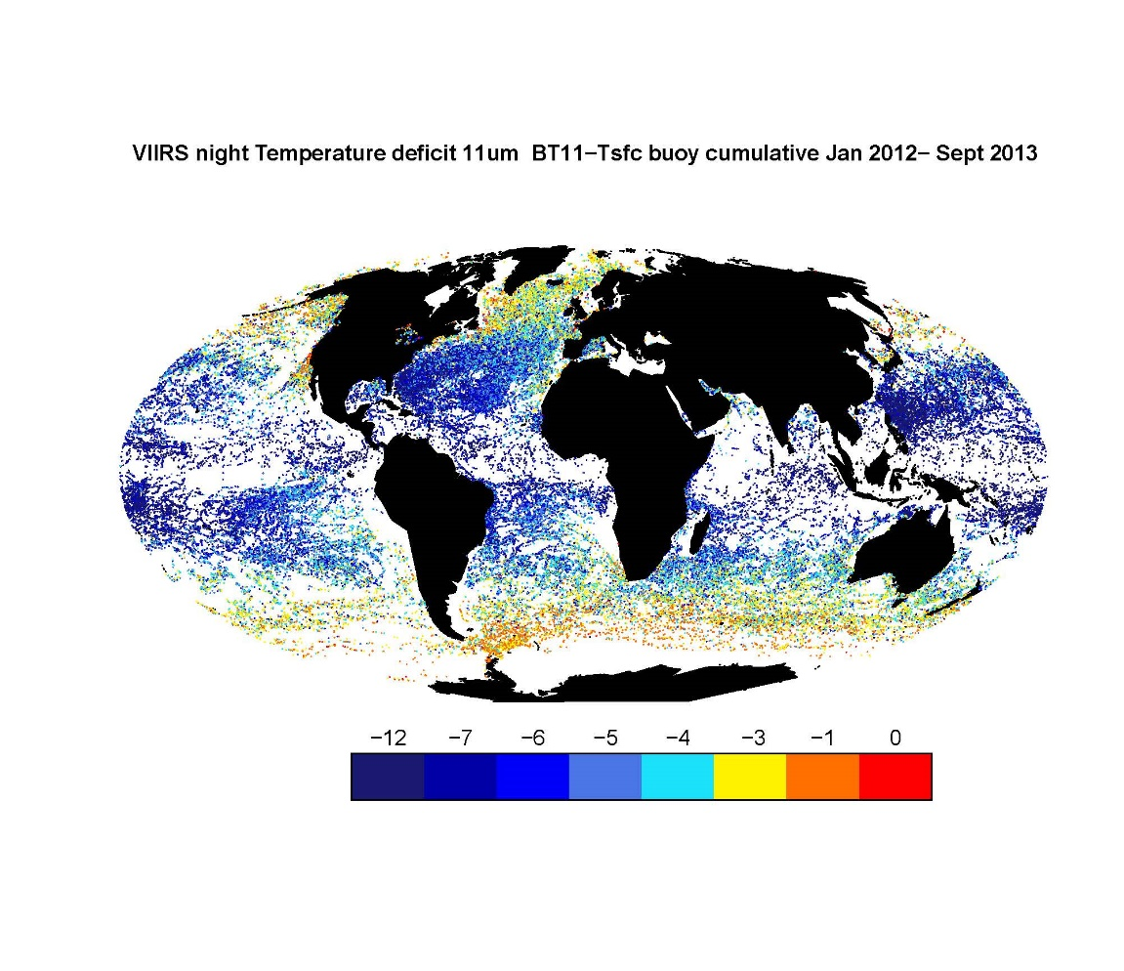
Self-calibrating ship-based radiometers provide a skin SST_{skin} that is more directly comparable to the satellite skin SST retrieval. We propose to continue use two types of ship-board radiometers for the validation of MODIS and VIIRS SST_{skin} (Minnett, 2010; Kilpatrick et al., 2015.). These instruments are a hyperspectral interferometric instrument, the Marine-Atmospheric Emitted Radiance Interferometer (M-AERIs; Minnett et al., 2001), and a filter radiometer, the ISARs (Infrared Sea-surface temperature Autonomous Radiometers; Donlon et al., 2008).
Figure 2. Distribution of VIIRS-buoy matchups for January 2012 to September 2013. Note the absence of points in many equatorial regions, high latitudes, major upwelling areas, and in the western Indian Ocean. Matchups in much of the Equatorial Pacific Ocean are limited to those with moored buoys - linear arrays of dots at the mooring positions. These are night-time, clear sky matchups, and the colors indicate the difference between the VIIRS top-of-atmosphere brightness temperatures measured in the 11µm channel (VIIRS M15) and the subsurface buoy measurements, given in K as denoted in the color bar.

The shipboard radiometers are calibrated in the laboratory before and after each deployment. Moreover, each radiometer contains two internal blackbodies, at ambient and heated temperatures, that provide a two-point calibration as part of each measurement of the sea surface and sky infrared emission. The sky emission is used to correct the sea-viewing measurement for surface-reflected sky radiance:
SST_{skin} = B⁻¹ ((R_{water}(λ,θ) – [1-ε(λ,θ)]R_{sky}(λ,θ) – R_{h}((λ,θ))/ε(λ,θ)) (4)
where R_{water}, R_{sky} and R_{h} are the spectral radiance emitted by the sea surface, the atmosphere above the height of the instrument, and the atmosphere below the instrument, λ is the wavelength of the measured radiance, θ is the angle from vertical of the measurement, and ε is the surface emissivity. B is the Planck function.
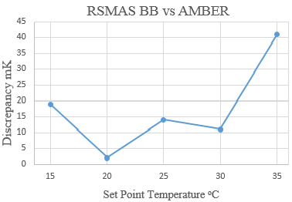
We assess uncertainties in the internal calibration of the shipboard radiometers by calibrating the radiometers in the laboratory against a NIST-characterized water-bath blackbody target (Rice et al., 2004), built to a NIST design (Fowler, 1995). As part of the Fiducial Reference Measurements for Surface Temperatures (FRM4STS), an ESA-funded project to establish and maintain SI-traceability of global Fiducial Reference Measurements (FRM) for satellite-derived surface temperature product validation, an international workshop was held at the National Physical Laboratory (NPL) in the UK in June 2016. We participated with an M-AERI (see below) which was calibrated against an NPL reference blackbody target, and with our laboratory water-bath blackbody that was characterized by the NPL infrared radiometric calibration system, AMBER (Absolute Measurements of Black-body Emitted Radiance; Theocharous et al., 1998). Figure 3 shows the AMBER measurements of the RSMAS water-bath blackbody target. These, and other results of the NPL workshop (Barker-Snook et al., 2016; Theocharous et al., 2016) confirm our laboratory measurements in providing confidence that the SI-traceable SSTskin measurements of the M-AERI are accurate to much better than 0.1K. Thus, ship radiometers have SI-traceability for the skin SST measurements; this is a prerequisite for the generation of SST Climate Data Records from the satellite measurements (Minnett and Corlett, 2012).
Figure 3. Example of the difference between the emission from the RSMAS water bath blackbody target and the AMBER radiometer at a temperature set point of 20ºC (left). The blue block is the uncertainty in the AMBER measurement, and the black error bar is the uncertainty in the water bath temperature measurements. The mean differences at a range of set points are shown at right. The differences all lie in the range of the AMBER uncertainties.

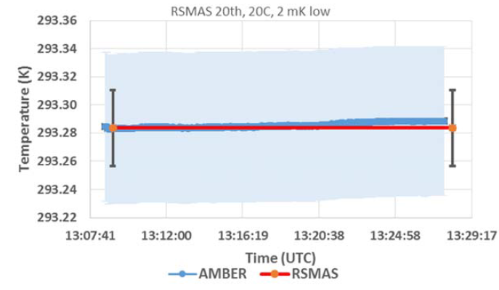
Figure shows the tracks of M-AERI deployments on research vessels that have provided matchups in a wide range of environmental conditions. In addition we have installed a sequence of M-AERIs on the Royal Caribbean Cruise Lines ships Explorer of the Seas (2000-2007) Allure of the Seas (xxxx – present), Celebrity Equinox (xxxx – present), with a planned deployment on Allure of the Seas in early 2018.
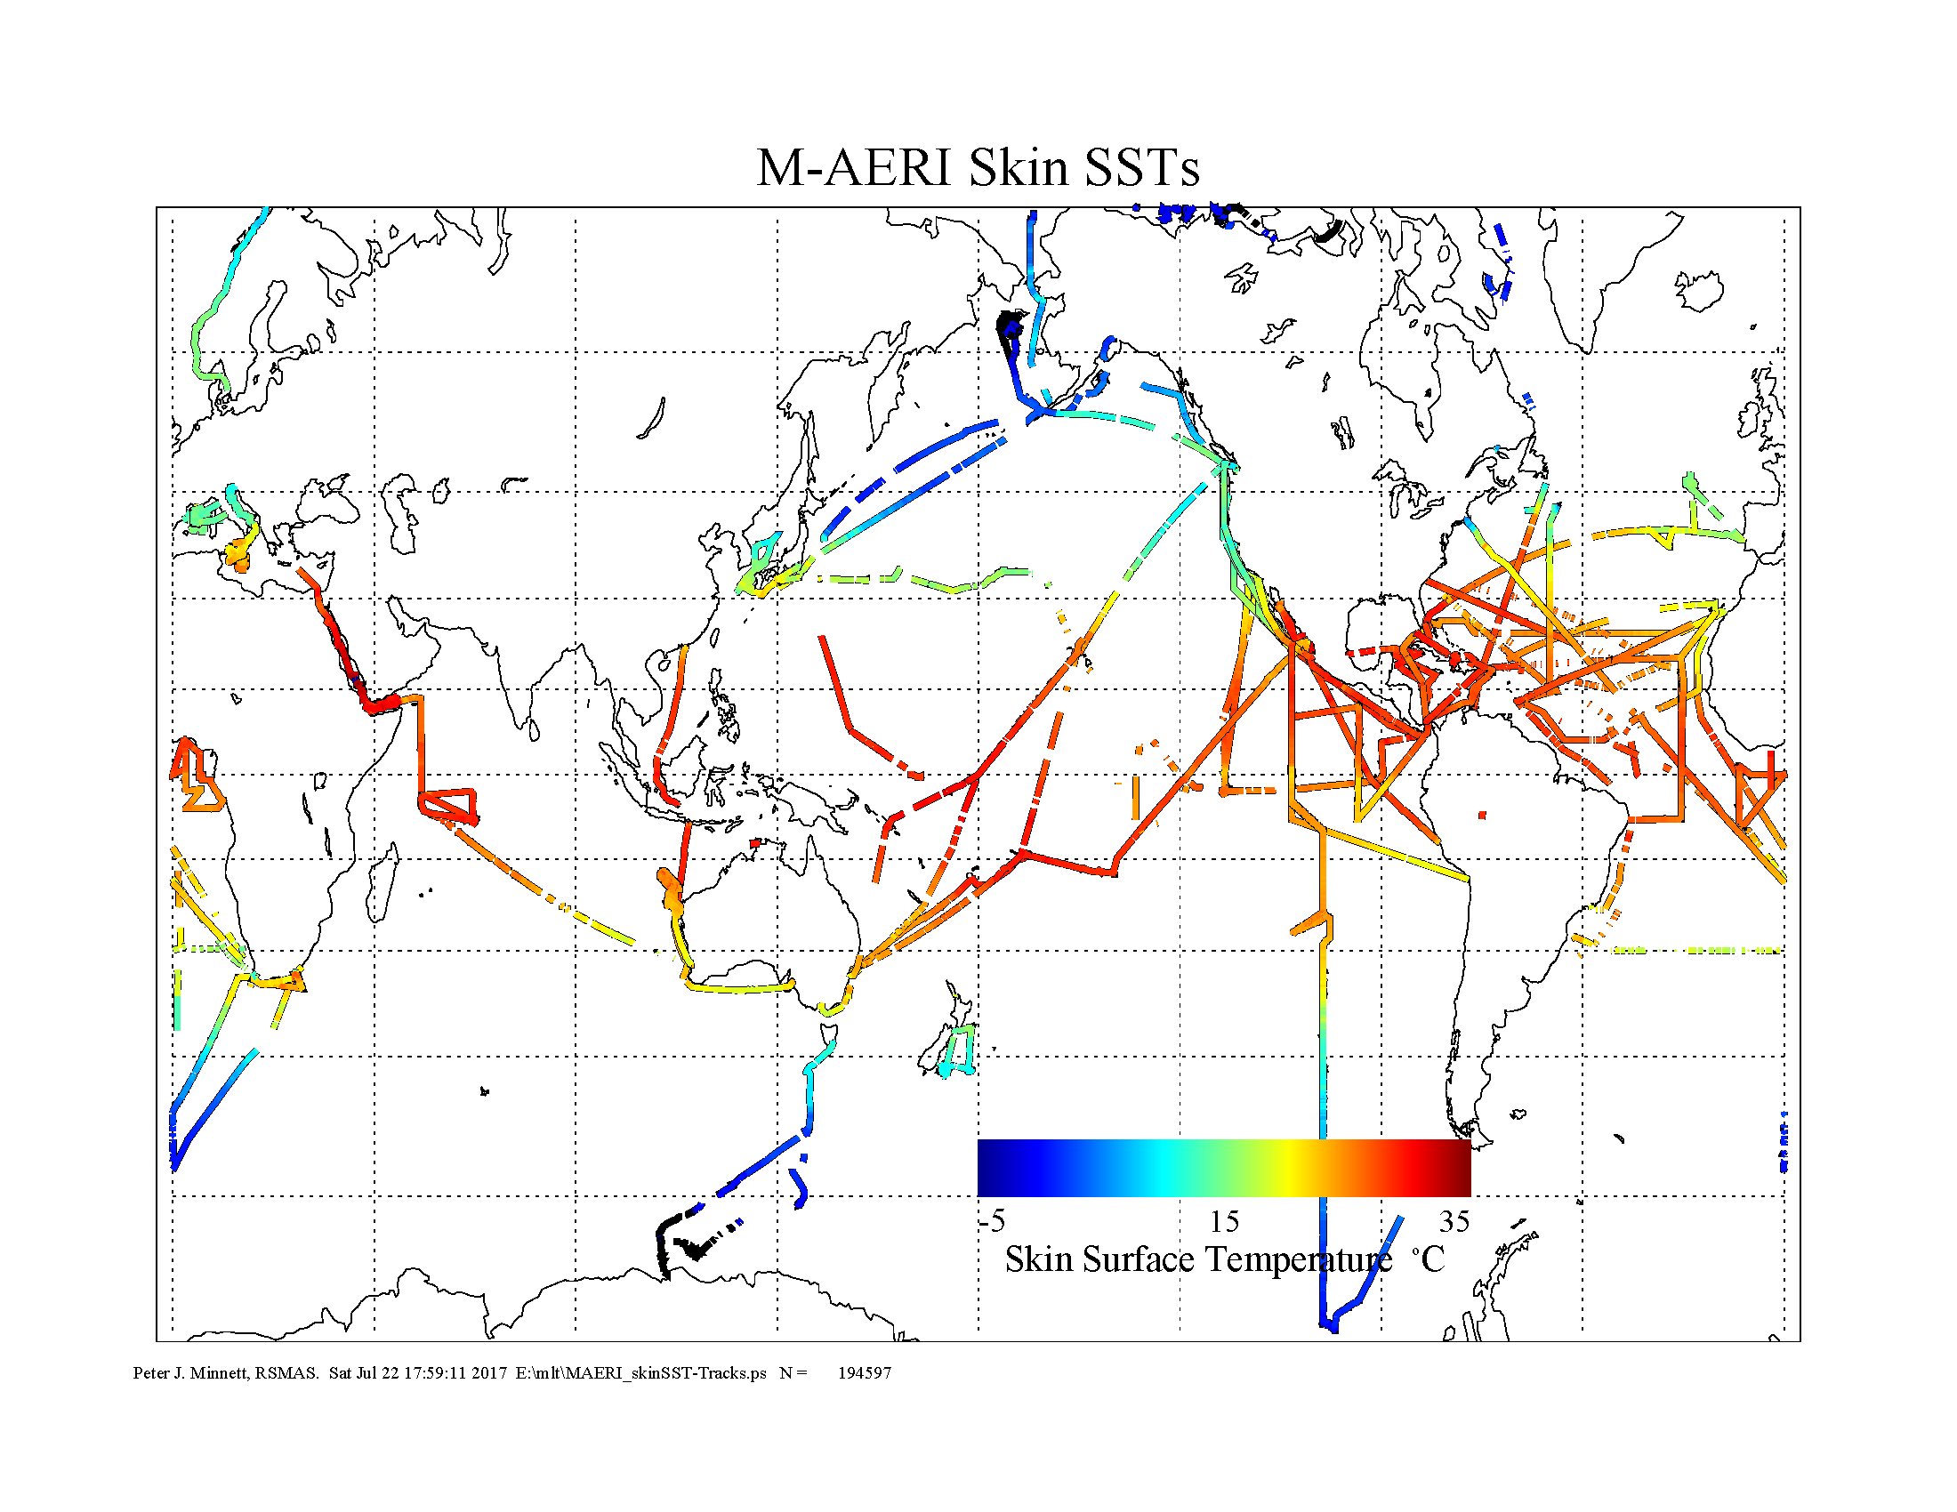
Figure 4. M-AERI data taken on research cruises from 1998 to 2017. The tracks are colored by the measured SST_{skin}. There are 194,597 data points.

ISARs use two precision calibration blackbody cavities to maintain the radiance calibration of a modified Heitronics KT15.85D pyrometer in the spectral range of 9.6 to 11.5 μm. ISARs have been deployed for several years on three commercial vessels - two from NYK Lines (M/V Jingu Maru and M/V Andromeda Leader) and the M/V Horizon Spirit, and on research vessels as opportunities arise (Figure ). Typical deployments on commercial vessels are for three months.
Both M-AERIs and ISARs can be run autonomously without the need of a scientist to monitor their performance. M-AERI deployments on RCCL ships are monitored from RSMAS via a satellite internet link.
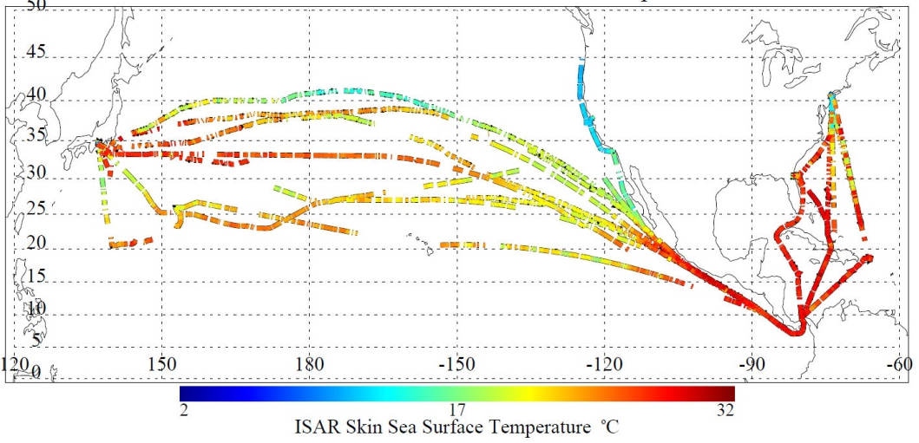
Figure 5. Examples of ISAR skin SST measurements from multiple trans-Pacific voyages of the NYK vessel Andromeda Leader between July 2010 and September 2011. The tracks are colored by the measured SST_{skin}. (update)

Matchup Data Base
Maintaining the MODIS and VIIRS SST Matchup Databases (MUDB) is a collaborative activity with the OBPG. The OPBG extracts the MODIS and VIIRS brightness temperatures (BTs) corresponding to a set of in situ times and locations provided by RSMAS. Typically our updates are related to those of the Look-Up Tables (LUTs) produced by the MODIS and VIIRS Calibration and Support Team (MCST & VCST) that provide revised corrections for changes in the instrumental behavior. The extracted BT’s are delivered to RSMAS for combination with in situ measurements from M-AERI’s, ISAR’s and buoys. A subset of the buoy matchups are used in the derivation of the form and coefficients of both the cloud screening and atmospheric correction algorithms, specific to each satellite radiometer. A withheld set is used to predict the accuracies of the SST_{skin} retrievals. Because the buoy measurements are of a sub-surface temperature, a correction has to be applied for the effects of diurnal heating between the buoy thermometer depth (about XX cm?) and the surface, and the thermal skin effect (Minnett, 2003). Although both near-surface gradients are dependent on surface forcing, primarily wind and insolation for diurnal heating (e.g.Gentemann et al., 2008; Gentemann et al., 2009), and wind for the skin effect (Donlon et al., 2002; Minnett et al., 2011), a simple offset of -0.17K is used to convert the subsurface temperature to SST_{skin}. The ship radiometer measurements are used to provide matchups to assess the accuracies of the MODIS and VIIRS SST_{skin} retrievals; the matchups are independent of the buoy data and the algorithm development.
The MUDBs are used to populate the Uncertainty Hypercube for MODIS and VIIRS SST_{skin} retrievals (see below).

Algorithm performance
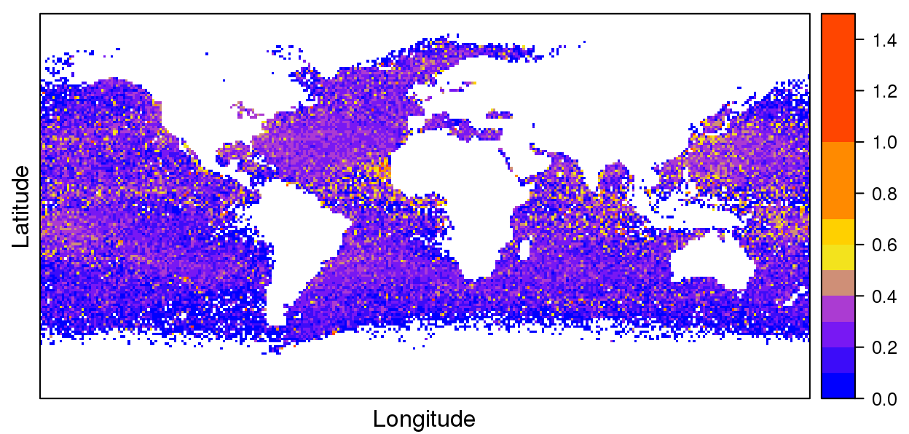
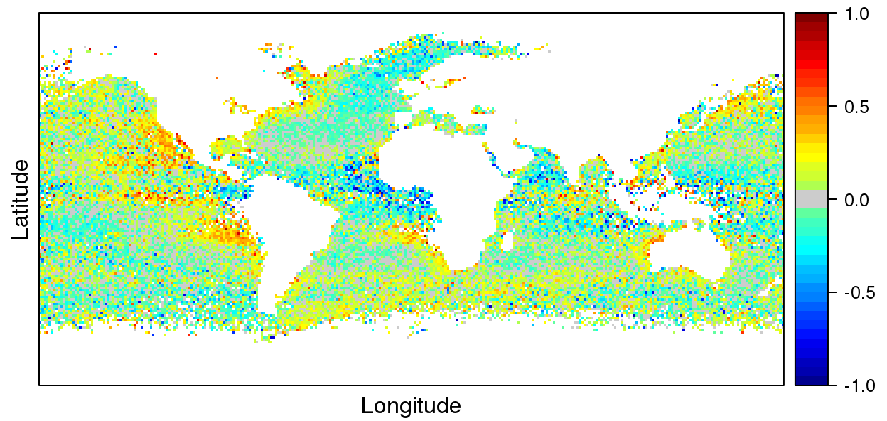
The global statistics of differences between the Terra and Aqua MODIS SST_{skin} retrievals and SSTskin derived from shipboard radiometers are given in Table 1 (above). These aggregate statistics are relatively coarse metrics for algorithm performance;regional and seasonal patterns of differences are a better indicator of algorithm performance. Figure 4 shows the distribution of the differences between Aqua MODIS SST_{skin} (derived using Equation 1 with monthly, latitude-dependent coefficients) and subsurface temperatures from buoys, adjusted by -0.17K for the mean skin effect. While the global statistics are good, there are clearly regional differences in the performance of the algorithms that require better understanding and improvement.
Figure 4. Distribution of differences between Aqua MODIS SST_{skin} and buoy subsurface temperatures adjusted by -0.17K as a mean skin effect. Medians of values in 1º resolution bins are shown (left) and robust standard deviation (right) in K, with the color scales given at right.

A major objective of the current VIIRS grant (NNX14AP79A) is to ensure continuity of the MODIS SST_{skin} retrievals into the VIIRS era. Figure 5 shows consistent SST_{skin} retrievals for a five year period for MODIS on Terra and Aqua and for VIIRS on S-NPP, with respect to subsurface temperatures from buoys. The data are taken from the highest quality SST_{skin} retrievals in the MUDBs for each sensor, and are represented as monthly median differences and robust standard deviations. Comparisons with NOAA-19 AVHRR Pathfinder SST_{skin} (Kilpatrick et al., 2001) are also shown. The consistency between the SSTskin fields from these sensors is very encouraging for the prospect of deriving CDRs, but improvements are necessary to achieve the required accuracy.

Algorithm improvements
In related research, funded by a NASA Earth and Space Science Graduate Fellowship, to quantify the consequences of sampling errors in spatial and temporally averaged infrared SST_{skin} fields, (Liu and Minnett, 2016; Liu et al., 2017) an unphysical property of the MODIS SST_{skin} sampling errors at high latitudes was identified. This was traced to differences in the persistence of clouds, as identified by the MODIS cloud screening algorithm (Kilpatrick et al., 2015), between day and night. The same problem was then identified in VIIRS SST_{skin} at high latitudes
A revised VIIRS cloud screening algorithm based on the machine learning approach of Alternating Decision Trees (Freund and Mason, 1999; Pfahringer et al., 2001) was developed. This new approach was separately applied to four classes of conditions: (i) nighttime, (ii) daytime with minor sun glint, (iii) daytime moderate glint and (iv) daytime severe glint. The new classification algorithm reduces the sampling error problem and also improves the coverage of the VIIRS data in daily global maps by about ~ 10-20% at night and up to 30% daytime depending on the location and season, significantly reducing false positives in the previous cloud-screening algorithms. Visual inspection of the images indicates that the gain in the daytime VIIRS coverage occurs primarily in high latitudes during summer and for both day and night in areas around cloud edges. A long-standing problem of false positives (pixels identified as cloud contaminated when they were not in the vicinity of surface temperature fronts is also much improved. We will further refine this approach for VIIRS cloud screening and then apply it to MODIS SST_{skin} retrievals.
Figure 5. Global monthly median and robust standard deviations of the differences between SST_{skin} from S-NPP VIIRS and MODIS on Terra and Aqua relative to buoy subsurface temperatures; statistics of NOAA-19 AVHRR Pathfinder are also shown. Dots represent the monthly median differences and the whiskers represent the robust standard deviations. Values are in K, and the offset of ~-0.17K is caused by the skin effect. From Minnett et al., 2017.

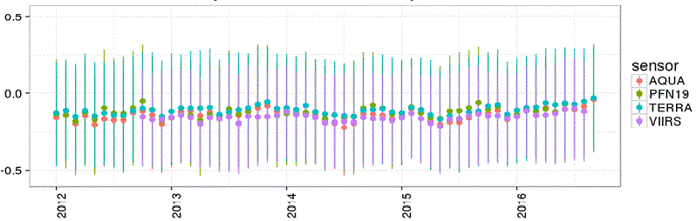
Two other long-standing problems with the NLSST-type algorithm occur in very dry atmospheres at high latitudes and near swath edges where the surface radiance has long path lengths through the atmosphere . We have made progress in improving long path retrievals by the addition of scan angle terms in the algorithm (Equation 1), but further improvements are needed. Improvement in the accuracy of high latitude SST_{skin} is particularly important as temperature changes in the Arctic are greater than elsewhere (Serreze and Barry, 2011; Pithan and Mauritsen, 2014) as has been expected for over a century (Arrhenius, 1896).
A potentially very important contribution to improved cloud screening at night is the highly sensitive “Day-Night Band’ (DNB) on the S-NPP VIIRS. The DNB has a broad, panchromatic response across visible and near-infrared wavelengths, with a large dynamic range with good low-light sensitivity (Lee et al., 2014). The low-light sensitivity offers an unprecedented capability to identify the high reflectance of clouds against the dark sea beneath even in the absence of lunar illumination (Miller et al., 2012). We have begun exploring the DNB for night-time cloud screening supported by grant NNX14AP79A, and propose to extend this research.

Meaning of accuracy
The terms “error” and “uncertainty” have distinct meanings. Error is the difference between a measured value and the true value (which is often not known) and uncertainty is the dispersion, or spread, of a group of measurements of the same quantity. Thus, uncertainty is a quantification of the doubt about the measurement result, and it requires two quantities, an estimate of the uncertainty and the confidence of that estimate (Bell, 2001; Working Group 1 of the Joint Committee for Guides in Metrology, 2008). The nature of errors and uncertainties are often described as either systematic or random. Systematic errors and uncertainties can be significantly reduced, and possibly eliminated, through an understanding of their sources and by averaging? multiple measurements. In contrast, those that are random cannot be eliminated, but can be reduced by multiple sampling of the same measurement, or of multiple measurements taken under the same conditions. Estimates of the uncertainty can best be determined by statistical methods applied to a set of measurements, and these are referred to as Type A uncertainties. Where a rigorous estimation is not feasible, the estimate based on non-statistical methods is referred to as Type B uncertainties. Having determined the uncertainty, the expression of the confidence of the estimate is achieved using a coverage factor, k, which multiplies the uncertainty to give the expanded uncertainty. Based on a Gaussian distribution, the confidence of the estimate using k = 1 is ~ 65%, for k = 2 it is ~ 95%, and for k = 3 it is 99.7%. We will adhere to these conventions, derived by the Metrology community (ibid), in our assessment of the accuracy of the MODIS and VIIRS SST_{skin} retrievals.

Assessment of accuracy
Temperature is one of the seven base variables of the International System of Units (SI), therefore temperature measurements are equivalent if taken by instruments that have a calibration traceable to an SI standard. Thus, data sets of measurements taken by different sensors can be combined in a meaningful manner (World Meteorological Organisation and Bureau Internationale de Poids et Mesures, 2010).
Typically, the accuracy of a satellite-derived SST is expressed as a mean error, or bias, and a scatter, or standard deviation. These metrics assume the distribution of the error is Gaussian, but this is rarely the case as the effects of undetected clouds, nearly always colder than the underlying sea surface, introduces a negative skewness to the distribution, and the estimates of both mean and standard deviation. Recently, the use of the median and robust standard deviation, which reduces the sensitivity to outliers in the distribution has become a more accepted method of representing the central tendency and dispersion of the differences (Embury et al., 2012; Kilpatrick et al., 2015).
The differences between satellite-derived SSTs and in situ temperature measurements, within acceptable spatial and temporal interval for coincidence (Minnett, 1991; Embury et al., 2012) are often interpreted as an estimate of the accuracy of the satellite SST retrievals. However, it is clear that there are multiple contributions to the differences between satellite and in situ temperatures. Some of these contributions include inaccuracies in the in situ measurements, the consequences of variability in the ocean temperature fields, imperfections in the cloud screening algorithms, and so on.
Many of the contributions to the uncertainties in the comparison between satellite and in situ temperatures are independent of each other and so can be summed in quadrature to determine the total uncertainty in the differences, which is itself evaluated by analysis of the MUDBs. Knowncontributions to the combined error and uncertainty comes from imperfections in either the cloud screening or the atmospheric correction algorithms, which, when combined with the errors and uncertainties in the satellite radiometric measurements, gives us the desired estimate of the accuracy for the MODIS and VIIRS SST_{skin} retrievals.
The analysis proposed here will be focused on the comparisons of MODIS and VIIRS L2 data with independent measurements. Nevertheless, a hitherto largely neglected issue is the consequence of the irregular, and in some cases spatially sparse distribution of the in situ measurements (Figures 1, 4, 5) on the estimate of accuracy. Figure 6 shows the distribution of highest quality matchups between the Aqua MODIS and buoy measurements, grouped in 5º cells. A subset of these matchups is used in algorithm development and refinement, and another subset is uses to assess accuracy. There have been no rigorous studies of the effects of the irregular disruptions of the in situ measurements, and an approach similar to that used to quantify the sampling errors introduced by clouds and interswath gaps on MODIS SST_{skin} accuracy (Liu and Minnett, 2016; Liu et al., 2017).
Figure 6. Distribution of clear sky, night time Aqua MODIS buoy matchups in 5º degree cells. Colors indicate the decile of the numbers of matchups in each bin. Ten means the number of matchups in that bin is in the top 10% of the distribution of numbers of matchups per bin.

Representation of accuracy
For more than a decade GHRSST has required its members to generate “Single Sensor Error Statistics” (SSESs), which are estimates of the errors and uncertainty in the SSTs retrieved from each satellite radiometer; these are intended to guide users, both scientific and operational, on the appropriate application of the data (e.g., for combining SSTs from multiple sources). In addition, a quality indicator for each SST retrieval is required. An approach developed by RSMAS investigators – called the “SST Uncertainty Hypercube” – involves the partition of all good-quality records in the MODIS matchup database into a multi-dimensional set of bins defined by the unique combination of various levels of seven dimensions: (1) season (4 levels), (2) latitude (6 zones), (3) SST (8 levels in 5K increments), (4) satellite zenith angle (4 levels), (5) difference in brightness temperatures of two MODIS channels, used as a proxy for water vapor (4 levels for 4µm, 3 levels for 11µm), (6) SST quality level (2 levels) and (7) day or night (2 levels). In this approach, SST_{skin} accuracy (defined simply as satellite SST minus in situ SST) is computed using matchups in each bin. Then, the average (an estimate of bias) and standard deviation (an estimate of uncertainty) are calculated for each bin and provided to OBPG as lookup tables. During production of SST_{skin} fields, each MODIS pixel is assigned to one of the hypercube bins, and the appropriate bin uncertainty statistics are associated with that pixel.
This approach is a significant improvement over reporting simply a global mean and standard deviation (e.g. Table 1) as the contributions to error and uncertainty clearly are not spatially uniform. The approach also meets the requirement that each retrieval have its accuracy appropriately specified (e.g. Merchant et al., 2017). Nevertheless, the hypercube approach but has shortcomings. One concern is the uneven numbers of matchups among the hypercube bins. An example of the uneven geographic distributionof ,matchups (recall that latitude zonal bands are one fo the dimensions of the hypercube) is illustrated in Figure 6. Through simulated sampling, we have shown that a stable estimate of the mean error with an uncertainty < 0.05K requires >100 matchups in each hypercube bin (Kilpatrick et al., 2015). Another disadvantage of the hypercube approach was the appearance of obvious discontinuities in uncertainty fields when geographically mapped. For these reasons, we proposeto reassess the the representation of accuracy of the MODIS and VIIRS SST_{skin} fields, so that the Uncertainty Hypercubes will provide a smoothly varying estimation of uncertainty as a function of the controlling variables (not necessarily the same as the current hypercube dimensions) [Cite for example the Petrenko et al. paper?].

Transition results to OBPG and the JPL PO.DAAC
We will continue to ensure a smooth transition of algorithms and accuracy estimates to the OBPG to support the processing and reprocessing, of MODIS and VIIRS measurements. We will continue to interact with the GHRSST GDAC at the JPL PO.DAAC in the generation of the MODIS and VIIRS SST_{skin} L2P fields for distribution to the wider community.

Climate Data Records of SST
The use of shipboard radiometers to established retrieval uncertainties provides the pathway for ensuring the MODIS and VIIRS SST_{skin} fields are suitable for climate research and other applications. (Minnett and Corlett, 2012; World Meteorological Organisation and Bureau Internationale de Poids et Mesures, 2010).

Analysis approach
A major effort will be directed to the continuing development of the MUDBs. Enhanced analyses of these data using approaches already in hand, will guide algorithm improvement. Included in this goal is the implementation of the ADTree cloud screening for MODIS data, and further refinement of the ADTree approach for VIIRS.
The development of rigorous assessment and representation of accuracy will also be a major goal. Estimates of the various contributions to the errors and uncertainties by various sources can be made from analyses of subsets of the MUDBs, and others can be taken from the literature; an example being a recently published error budget of the ISAR (Wimmer and Robinson, 2016). Information about MODIS and VIIRS measurement accuracy is available in papers published by the MODIS and VIIRS Characterization Support Teams at NASA and, for VIIRS by colleagues at NOAA.

Work Plan
All three years – work very hard. We know what needs to be done.

Impact of proposed work to the state of knowledge in the field
By continuing to facilitate the accurate SST retrievals from MODIS, the proposed research is aimed at improving our understanding of the role of the oceans in the climate system. In recent years it has become increasingly apparent that users of satellite-derived variables, especially those involved in studies of the climate system, require good estimates of the uncertainties in the satellite retrievals, and the dependences of these uncertainties on other environmental (or instrumental) factors, especially if there is a risk of correlated errors. The use of ship-board radiometers, with SI-traceable calibration, in the validation of the satellite retrievals of SST provides a pathway to the generation of SST CDRs (Minnett and Corlett, 2012).

Related research
This research extends a long history at RSMAS and elsewhere of the PI and Co-Is of studies in improving the retrieval accuracies of IR-derived SSTs. Our contributions include the AVHRR SST Pathfinder Program, the MODIS SST retrievals, and the VIIRS SSTs. These satellite retrieval activities, which include improving the statistical atmospheric correction algorithms and the validation of the retrievals using a variety of independent fields and measurements, are currently active (see the Current Support listed in Section 10 below) and supported by NASA and NOAA. The proposed research is facilitated by experience with and access to the data bases that have been generated with NASA support over a decade.
A series of international infrared radiometry workshops have been hosted by the PI at RSMAS involving experts from NIST. A fourth workshop was held under the auspices of the Infrared and Visible Optical Sensors Subgroup (IVOS) of the WGCV, the CEOS Working Group on Calibration and Validation, chaired by Dr Nigel Fox of the UK National Physical Laboratory.
As with the original M-AERI, the 2nd generation M-AERI was developed with NASA funding. The ISARs that also contribute to the MUDBs were developed with NOPP funding.

Relevance of proposed work to NASA programs
The proposed research is directly relevant to priority research activities discussed in the White Paper for the OceanObs’09 conference dealing with sea-surface temperature (Donlon et al., 2010) which urges research into improved satellite SST retrievals and better estimation of the associated uncertainties. The proposed research is also directed at improving the uncertainty budgets of satellite-derived SSTs as presented in the NASA Interim SST Science Team White Paper (ISSTST, 2010).

Data Management and stewardship.
Collaboration with NASA efforts: As evidence of knowledge sharing, the RSMAS group works closely with the Ocean Biology Processing Group (OGPB) at NASA Goddard Space Flight Center by supplying the atmospheric correction algorithms which are then used for the routine production and dissemination of SST_{skin} from MODIS and VIIRS through the OGPB web interface of their data server. The MODIS and VIIRS SST_{skin} files from the OBPG are also sent to the GHRSST GDAC (Global Data Assembly Center) at the JPL PO.DAAC, where the file contents are augmented with ancillary data and reformatted into netCDF in the standardized GHRSST L2P (Level 2 Pre-processed) for distribution to the user community. After 28 days, these files are sent to the GHRSST LTSRF (Long Term Stewardship and Reanalysis Facility) at NOAA's National Centers for Environmental Information (NCEI) for distribution to users and perpetual stewardship.
There are several metrics for assessing the utility of the MODIS data files, but three commonly used ones – numbers of files and data volumes downloaded, number of users – are shown in Table 2 for the last year. These statistics are for L2P files, and do not include files included MODIS SSTs merged with others, such MUR (Multi-scale Ultrahigh Resolution SST; Chin et al., 2013) and the IR-microwave SSTs generated by Remote Sensing Systems. Additionally, L2 data are distributed from the OBPG and GHRSST L2P and higher level fields from the LTSRF. The dissemination of VIIRS L2P files from the PO.DAAC is getting underway, so user statistics are not available.
Table 2. Data download statistics from the JPL PO.DAAC for 06/2016 to 07/2017
Data Set | Users | GB | Files
SST_{skin} – MODIS on Terra | 466 | 28,753.9 | 2,543,378
SST_{skin} – MODIS on Aqua | 903 | 43,486.2 | 3,424,583
Totals | 1369 | 72,240.1 | 5,967,961
Data provided by Dr. E. Armstrong, PO.DAAC.
User total includes those likely using both data sets.
Within the framework of the GHRSST, the MODIS MUDBs have been shared with several groups worldwide, and we expect VIIRS to be included soon.
Indeed, the MODIS and VIIRS MUDBs will soon be made available through the OBPG server and, through collaborations supported by the new USPI project, through European Copernicus data servers too.
The results of this proposed project will be reported at scientific meetings. Information exchange will be facilitated by the GHRSST, of which the PI is a member and former Chair of the Science Team, and through the NASA SST Science Team, and other NASA meetings.

References
Allen, M.R., Mutlow, C.T., Blumberg, G.M.C., Christy, J.R., McNider, R.T., & Llewellyn-Jones, D.T. (1994). Global change detection. Nature 370, 24-25.
Arrhenius, S. (1896). On the Influence of Carbonic Acid in the Air upon the Temperature of the Ground. The London, Edinburgh and Dublin Philosophical Magazine and Journal of Science 41, 237-276.
Barker-Snook, I., Theocharous, E., & Fox, N.P. (2016). 2016 comparison of IR brightness temperature measurements in support of satellite validation. Part 2: Laboratory comparison of radiation thermometers (117 pp.)
Bell, S. (2001). A Beginner’s Guide to Uncertainty of Measurement, Measurement Good Practice Guide (41 pp.) National Physical Laboratory. Teddington, Middlesex, United Kingdom.
Brown, O.B., Brown, J.W., & Evans, R.H. (1985). Calibration of Advanced Very High Resolution Radiometer infrared observations. Journal of Geophysical Research 90, 11667-11677.
Casey, K.S., & Cornillon, P. (1999). A Comparison of Satellite and In Situ-Based Sea Surface Temperature Climatologies. Journal of Climate 12, 1848-1863.,
Castro, S.L., Wick, G.A., & Buck, J.J.H. (2014). Comparison of diurnal warming estimates from unpumped Argo data and SEVIRI satellite observations. Remote Sensing of Environment 140, 789-799. http://dx.doi.org/10.1016/j.rse.2013.08.042
Chin, T., Vazquez, J., & Armstrong, E. (2013). Algorithm Theoretic Basis Document: Multi-scale, motion-compensated analysis of sea surface temperature Version 1.3 (13 pp.) ftp://mariana.jpl.nasa.gov/mur_sst/tmchin/docs/ATBD/atbd_1.1.pdf
Donlon, C., Robinson, I.S., Reynolds, M., Wimmer, W., Fisher, G., Edwards, R., & Nightingale, T.J. (2008). An Infrared Sea Surface Temperature Autonomous Radiometer (ISAR) for Deployment aboard Volunteer Observing Ships (VOS). Journal of Atmospheric and Oceanic Technology 25, 93-113. http://dx.doi.org/10.1175%2F2007JTECHO505.1
Donlon, C.J., K. S Casey, C. Gentemann, P. LeBorgne, I. S. Robinson, R. W Reynolds, C. Merchant, D. Llewellyn-Jones, P. J. Minnett, J. F. Piolle, P. Cornillon, N. Rayner, T. Brandon, J. Vazquez, E. Armstrong, H. Beggs, I. Barton, G. Wick, S. Castro, J. Hoeyer, D. May, O. Arino, D. J. Poulter, R. Evans, C. T. Mutlow, Bingham, A.W., & Harris., A. (2010). Successes and Challenges for the Modern Sea Surface Temperature Observing System. OceanObs’09: Sustained Ocean Observations and Information for Society Venice, Italy
Donlon, C.J., Minnett, P.J., Gentemann, C., Nightingale, T.J., Barton, I.J., Ward, B., & Murray, J. (2002). Toward improved validation of satellite sea surface skin temperature measurements for climate research. Journal of Climate 15, 353-369.
Donlon, C.J., Minnett, P.J., Jessup, A., Barton, I., Emery, W., Hook, S., Wimmer, W., Nightingale, T.J., & Zappa, C. (2014). Ship-Borne Thermal Infrared Radiometer Systems. In G. Zibordi, C.J. Donlon, & A.C. Parr (Eds.), Experimental Methods in the Physical Sciences, Vol 47, Optical Radiometry for Ocean Climate Measurements (pp. 305-404): Academic Press.
Embury, O., Merchant, C.J., & Corlett, G.K. (2012). A reprocessing for climate of sea surface temperature from the along-track scanning radiometers: Initial validation, accounting for skin and diurnal variability effects. Remote Sensing of Environment 116, 62-78. 10.1016/j.rse.2011.02.028
Fowler, J.B. (1995). A third generation water bath based blackbody source. Journal of Research of the National Institute of Standards and Technology 100, 591-599.
Freund, Y., & Mason, L. (1999). The alternating decision tree learning algorithm. Proceeding of the Sixteenth International Conference on Machine Learning. Bled, Slovenia. Edited by I. Bratko, & S. Dzeroski. (pp. 124-133). (http://perun.pmf.uns.ac.rs/radovanovic/dmsem/cd/install/Weka/doc/classifiers-papers/trees/ADTree/atrees.pdf).
Gentemann, C.L., Minnett, P.J., LeBorgne, P., & Merchant, C.J. (2008). Multi-satellite measurements of large diurnal warming events. Geophysical Research Letters 35, L22602. 10.1029/2008GL035730
Gentemann, C.L., Minnett, P.J., & Ward, B. (2009). Profiles of Ocean Surface Heating (POSH): a new model of upper ocean diurnal thermal variability. Journal of Geophysical Research 114, C07017. 10.1029/2008JC004825
Good, S.A., Corlett, G.K., Remedios, J.J., Noyes, E.J., & Llewellyn-Jones, D.T. (2007). The Global Trend in Sea Surface Temperature from 20 Years of Advanced Very High Resolution Radiometer Data. Journal of Climate 20, 1255-1264. doi: 10.1175/JCLI4049.1
Interim Sea Surface Temperature Science Team (2010). Sea Surface Temperature Error Budget: White Paper (66 pp.) (http://www.yumpu.com/en/document/view/53023153/sea-surface-temperature-error-budget-white-paper).
ISSTST (2010). Sea Surface Temperature Error Budget: White Paper. Written by the Interim Sea Surface Temperature Science Team. http://www.google.com/url?sa=t&rct=j&q=&esrc=s&source=web&cd=2&cad=rja&ved=0CDgQFjAB&url=http%3A%2F%2Frainbow.ldeo.columbia.edu%2F~alexeyk%2FPapers%2FSST_Error_Budget_White_Paper_Final.pdf&ei=U1qSUeWDGYK08ASguoBo&usg=AFQjCNHNw1q35FObBPaCpA57HfDE3H8LDg&sig2=CZgyjK1KZVoHx9J8pnlUiw&bvm=bv.46471029,d.eWU
Jessup, A.T., Fogelberg, R.A., & Minnett, P. (2002). Autonomous shipboard infrared radiometer system for in situ validation of satellite SST. SPIE 4814, Earth Observing Systems VII, 222 (September 25, 2002). Edited by (pp. 222-229). (http://dx.doi.org/10.1117/12.451782).
Kilpatrick, K.A., Podestá, G., Walsh, S., Williams, E., Halliwell, V., Szczodrak, M., Brown, O.B., Minnett, P.J., & Evans, R. (2015). A decade of sea surface temperature from MODIS. Remote Sensing of Environment 165, 27-41. http://dx.doi.org/10.1016/j.rse.2015.04.023
Kilpatrick, K.A., Podestá, G.P., & Evans, R.H. (2001). Overview of the NOAA/NASA Pathfinder algorithm for Sea Surface Temperature and associated Matchup Database. Journal of Geophysical Research 106, 9179-9198.
Lee, S., Chiang, K., Xiong, X., Sun, C., & Anderson, S. (2014). The S-NPP VIIRS Day-Night Band On-Orbit Calibration/Characterization and Current State of SDR Products. Remote Sensing 6, 12427.2072-4292, http://www.mdpi.com/2072-4292/6/12/12427
Liu, Y., Chin, T.M., & Minnett, P.J. (2017). Sampling errors in satellite-derived infrared sea-surface temperatures. Part II: Sensitivity and parameterization. Remote Sensing of Environment 198, 297-309. http://dx.doi.org/10.1016/j.rse.2017.06.011
Liu, Y., & Minnett, P.J. (2016). Sampling errors in satellite-derived infrared sea-surface temperatures. Part I: Global and regional MODIS fields. Remote Sensing of Environment 177, 48-64. http://dx.doi.org/10.1016/j.rse.2016.02.026
Merchant, C.J., Paul, F., Popp, T., Ablain, M., Bontemps, S., Defourny, P., Hollmann, R., Lavergne, T., Laeng, A., de Leeuw, G., Mittaz, J., Poulsen, C., Povey, A.C., Reuter, M., Sathyendranath, S., Sandven, S., Sofieva, V.F., & Wagner, W. (2017). Uncertainty information in climate data records from Earth observation. Earth Syst. Sci. Data 9, 511-527. 10.5194/essd-9-511-2017
Miller, S.D., Mills, S.P., Elvidge, C.D., Lindsey, D.T., Lee, T.F., & Hawkins, J.D. (2012). Suomi satellite brings to light a unique frontier of nighttime environmental sensing capabilities. Proceedings of the National Academy of Sciences 109, 15706-15711. 10.1073/pnas.1207034109
Minnett, P.J. (1990). The regional optimization of infrared measurements of sea-surface temperature from space. Journal of Geophysical Research 95, 13,497-413,510.,
Minnett, P.J. (1991). Consequences of sea surface temperature variability on the validation and applications of satellite measurements. Journal of Geophysical Research 96, 18,475-418,489.,
Minnett, P.J. (2003). Radiometric measurements of the sea-surface skin temperature - the competing roles of the diurnal thermocline and the cool skin. International Journal of Remote Sensing 24, 5033-5047.
Minnett, P.J. (2010). The Validation of Sea Surface Temperature Retrievals from Spaceborne Infrared Radiometers. In V. Barale, J.F.R. Gower, & L. Alberotanza (Eds.), Oceanography from Space, revisited. (pp. 273-295): Springer Science+Business Media B.V.
Minnett, P.J., & Corlett, G.K. (2012). A pathway to generating Climate Data Records of sea-surface temperature from satellite measurements. Deep Sea Research Part II: Topical Studies in Oceanography 77–80, 44-51. 10.1016/j.dsr2.2012.04.003
Minnett, P.J., Kilpatrick, K., Podestá, G., Szczodrak, M., Izaguirre, M.A., Williams, E., Walsh, S., Evans, R.H., & Reynolds, R.M. (2017). Suomi-NPP VIIRS Sea Surface Temperature retrievals; algorithm evolution and an assessment of uncertainties. Remote Sensing of Environment, In preparation.
Minnett, P.J., Knuteson, R.O., Best, F.A., Osborne, B.J., Hanafin, J.A., & Brown, O.B. (2001). The Marine-Atmospheric Emitted Radiance Interferometer (M-AERI), a high-accuracy, sea-going infrared spectroradiometer. Journal of Atmospheric and Oceanic Technology 18, 994-1013.
Minnett, P.J., & Smith, D.L. (2014). Postlaunch Calibration and Stability: Thermal Infrared Satellite Radiometers. In G. Zibordi, C.J. Donlon, & A.C. Parr (Eds.), Experimental Methods in the Physical Sciences, Vol 47, Optical Radiometry for Ocean Climate Measurements (pp. 201-243): Academic Press.
Minnett, P.J., Smith, M., & Ward, B. (2011). Measurements of the oceanic thermal skin effect. Deep Sea Research Part II: Topical Studies in Oceanography 58, 861-868. 10.1016/j.dsr2.2010.10.024
NRC (2000). Issues in the Integration of Research and Operational Satellite Systems for Climate Research: II. Implementation. Washington, DC: National Academy of Sciences. 82
O'Carroll, A.G., Eyre, J.R., & Saunders, R.W. (2008). Three-Way Error Analysis between AATSR, AMSR-E, and In Situ Sea Surface Temperature Observations. Journal of Atmospheric and Oceanic Technology 25, 1197-1207. http://dx.doi.org/10.1175%2F2007JTECHO542.1
Ohring, G., Wielicki, B., Spencer, R., Emery, B., & Datla, R. (2005). Satellite Instrument Calibration for Measuring Global Climate Change: Report of a Workshop. Bulletin of the American Meteorological Society 86, 1303-1313. http://dx.doi.org/10.1175%2FBAMS-86-9-1303
Pfahringer, B., Holmes, G., & Kirkby, R. (2001). Optimizing the Induction of Alternating Decision Trees. Fifth Pacific-Asia Conference on Advances in Knowledge Discovery and Data Mining. Edited by (pp. 477-487). (http://www.cs.waikato.ac.nz/ml/publications/2001/pakdd2001.pdf).
Pithan, F., & Mauritsen, T. (2014). Arctic amplification dominated by temperature feedbacks in contemporary climate models. Nature Geosci 7, 181-184. 10.1038/ngeo2071
Rice, J.P., Butler, J.J., Johnson, B.C., Minnett, P.J., Maillet, K.A., Nightingale, T.J., Hook, S.J., Abtahi, A., Donlon, C.J., & Barton, I.J. (2004). The Miami2001 Infrared Radiometer Calibration and Intercomparison: 1. Laboratory Characterization of Blackbody Targets. Journal of Atmospheric and Oceanic Technology 21, 258-267.
Serreze, M.C., & Barry, R.G. (2011). Processes and impacts of Arctic amplification: A research synthesis. Global and Planetary Change 77, 85-96. http://dx.doi.org/10.1016/j.gloplacha.2011.03.004
Theocharous, E., Barker-Snook, I., & Fox, N.P. (2016). 2016 comparison of IR brightness temperature measurements in support of satellite validation. Part 1: Blackbody Laboratory comparison. (104 pp.) National Physical Laboratory. Teddington, Middlesex, UK.
Theocharous, E., Fox, N.P., Sapritsky, V.I., Mekhontsev, S.N., & Morozova, S.P. (1998). Absolute measurements of black-body emitted radiance. Metrologia 35, 549 - 554.0026-1394, http://stacks.iop.org/0026-1394/35/i=4/a=58
Walton, C.C., Pichel, W.G., Sapper, J.F., & May, D.A. (1998). The development and operational application of nonlinear algorithms for the measurement of sea surface temperatures with the NOAA polar-orbiting environmental satellites. Journal of Geophysical Research 103, 27,999-928,012.
Wimmer, W., & Robinson, I.S. (2016). The ISAR Instrument Uncertainty Model. Journal of Atmospheric and Oceanic Technology 33, 2415-2433. 10.1175/jtech-d-16-0096.1
Working Group 1 of the Joint Committee for Guides in Metrology (2008). Evaluation of measurement data — Guide to the expression of uncertainty in measurement (134 pp.) http://www.bipm.org/en/publications/guides/gum.html, http://www.iso.org/sites/JCGM/GUM-introduction.htm
World Meteorological Organisation and Bureau Internationale de Poids et Mesures (2010). Measurement Challenges for Global Observation Systems for Climate Change Monitoring: Traceability, Stability and Uncertainty, World Meteorological Organization (WMO). Geneva, Switzerland. http://www.bipm.org/en/conference-centre/bipm-workshops/wmo-bipm_workshop/
Xiong, X., Kwo-Fu, C., Aisheng, W., Barnes, W.L., Guenther, B., & Salomonson, V.V. (2008). Multiyear On-Orbit Calibration and Performance of Terra MODIS Thermal Emissive Bands. IEEE Transactions on Geoscience and Remote Sensing 46, 1790-1803. doi: 10.1109/TGRS.2008.916217

Biographical Sketches

Peter J. Minnett, PhD
Professor of Ocean Sciences
Rosenstiel School of Marine & Atmospheric Science, University of Miami

Higher Education
Oxford University, UK, B.A. Physics, 1973
Southampton University, UK, M.Sc. Oceanography, 1975
Southampton University, UK, Ph.D. Physical Oceanography, 1978

Experience
European Space Research Institute (ESRIN) | Visiting Scientist | 2014-2015
University of Miami | Professor, Ocean Sciences | 2014-present
University of Miami | Chairman, Meteorology& Physical Oceanography | 2008-2014
University of Miami | Professor, Meteorology & Physical Oceanography | 1999-2014
University of Miami | Research Professor | 1995-1999
North Carolina State University | Adjunct Professor | 1994-1999
State University of New York at Stony Brook | Adjunct Associate Professor | 1994-1999
Brookhaven National Laboratory | Scientist | 1990-1995
NATO Saclant Undersea Research Centre | Principal Scientist | 1985-1990
Rutherford Appleton Laboratory, UK | Senior Scientific Officer | 1981-1985
Christian-Albrechts University, Kiel, Germany | Scientist | 1977-1981

Selected Recent Publications
Liu, Y., Chin, M., & Minnett, P.J. 2017. Sampling Errors in Satellite-Derived Infrared Sea-Surface Temperatures. Part II: Sensitivity and Parameterization. Remote Sensing of Environment. 198, 297-309. http://dx.doi.org/10.1016/j.rse.2017.06.011
Wong, E.W., & Minnett, P.J. 2016a. Retrieval of the Ocean Skin Temperature Profiles from Measurements of Infrared Hyperspectral Radiometers - Part I: Derivation of an Algorithm. IEEE Transactions on Geoscience and Remote Sensing, 54, 1879-1890.
Wong, E.W., & Minnett, P.J. 2016b. Retrieval of the Ocean Skin Temperature Profiles from Measurements of Infrared Hyperspectral Radiometers - Part II: Field Data Analysis. IEEE Transactions on Geoscience and Remote Sensing, 54, 1891-1904.
Liu, Y., & Minnett, P.J. 2016. Sampling errors in satellite-derived infrared sea-surface temperatures. Part I: Global and regional MODIS fields. Remote Sensing of Environment, 177, 48-64.
Carvalho, G.d.A., Minnett, P.J., de Miranda, F.P., Landau, L., & Moreira, F. 2016. The Use of a RADARSAT-derived Long-term Dataset to Investigate the Sea Surface Expressions of Human-related Oil spills and Naturally Occurring Oil Seeps in Campeche Bay, Gulf of Mexico. Canadian Journal of Remote Sensing, 42, 1-15.
Walesby, K., Vialard, J., Minnett, P.J., Callaghan, A.H., & Ward, B. 2015. Observations indicative of rain-induced double diffusion in the ocean surface boundary layer. Geophysical Research Letters. DOI 10.1002/2015GL063506.
Saunders, R., S. Crewell, R. Gelaro, P.J. Minnett, V-H. Peuch, J. Schmetz, Turner, D., & Velden, C. 2015. Observations for Global to Convective Scale Models. In G. Brunet, Jones, S., & Mills, B. (Ed.), Seamless prediction of the Earth system: from minutes to months (pp. 15-36). Geneva, Switzerland: World Meteorological Organization.
Liu, Y., and P.J. Minnett. 2015. Evidence Linking Satellite-derived Sea-Surface Temperature Signals to Changes in the Atlantic Meridional Overturning Circulation. Remote Sensing of Environment. 169, 150–162.
Kilpatrick, K. A., G. Podestá, S. Walsh, E. Williams, V. Halliwell, M. Szczodrak, O. B. Brown, P. J. Minnett and R. Evans, 2015. A decade of sea surface temperature from MODIS. Remote Sensing of Environment, 165, 27-41.
Gehlot, S., Minnett, P.J., & D. Stammer, 2015. Impact of Sahara dust on solar radiation at Cape Verde Islands derived from MODIS and surface measurements. Remote Sensing of Environment, 166, 154-162.
Minnett, P. J., and D. L. Smith, 2014. Postlaunch Calibration and Stability: Thermal Infrared Satellite Radiometers, In Optical Radiometry for Ocean Climate Measurements. Experimental Methods in the Physical Sciences, Vol 47. G. Zibordi, C. J. Donlon and A. C. Parr, Eds. Academic Press/Elsevier. (ISBN-13: 978-0-12-417011-7), pp 201-243.
Donlon, C. J., P. J. Minnett, A. Jessup, I. Barton, W. Emery, S. Hook, W. Wimmer, T. J. Nightingale and C. Zappa, 2014. ibid, pp 305-404.
Corlett, G. K., C. J. Merchant, P. J. Minnett, C. J. Donlon, 2014. Assessment of Long-Term Satellite Derived Sea Surface Temperature Records. ibid, pp 639-677.
Zhu, X., Minnett, P.J., Berkelmans, R., Hendee, J., & Manfrino, C. 2014. Diurnal warming in shallow coastal seas: Observations from the Caribbean and Great Barrier Reef regions. Continental Shelf Research, 82, 85-98.
Woods, S., P. J. Minnett, C. Gentemann, and D. Bogucki. 2014. Influence of the cool skin layer on global air-sea CO₂ flux estimates. Remote Sensing of Environment. 145: 15-24.
Szczodrak, M., P. J Minnett and R. H. Evans, 2014. The effects of anomalous atmospheres on the accuracy of infrared sea-surface temperature retrievals: dry air layer intrusions over the tropical ocean. Remote Sensing of Environment, 140, 450–465.
Minnett, P. J., and G. K. Corlett, 2012. A pathway to generating Climate Data Records of sea-surface temperature from satellite measurements, Deep Sea Research Part II: Topical Studies in Oceanography, 77–80, 44-51, ISSN 0967-0645, 10.1016/j.dsr2.2012.04.003.
Minnett, P. J., M. Smith, and B. Ward, 2011, Measurements of the oceanic thermal skin effect. Deep Sea Research Part II: Topical Studies in Oceanography, 58, 861-868.
Minnett, P.J., 2010. The Validation of Sea Surface Temperature Retrievals from Spaceborne Infrared Radiometers. In: Barale, V., Gower, J.F.R., Alberotanza, L. (Eds.), Oceanography from Space, revisited. Springer Science+Business Media B.V., pp. 273-295.
Castro, S. L., G. A. Wick, P. J. Minnett, A. T. Jessup, and W. J. Emery, 2010. The impact of measurement uncertainty and spatial variability on the accuracy of skin and subsurface regression-based sea surface temperature algorithms. Remote Sensing of Environment, 114, 2666-2678
Relevant Community Activities:
Member, ESA-EUMETSAT Sentinel-3 Validation Team, 2013-
Chair, Science Team, Group for High Resolution Sea Surface Temperature, 2011 - 2016
Member, METImage Science Advisory Group, EUMETSAT & DLR, 2011 –
Member, Universities Space Research Association, Earth Science Council, 2009-
Team Leader, CDRs for SST, International Space Science Institute, Bern, Switzerland, 2011- 2014.
Member, Science Study Group for the Hyperspectral Infrared Imager (HyspIRI), NASA, 2008-
Subject Matter Expert, NPOESS Mission, 2007 - 2010
Member, Post-EPR Mission Experts Team, EUMETSAT, 2006 – 2013
Member of the Scientific Committee, MERIS/(A)ATSR User Workshops. ESA. 2004, 2005, 2008
Science Team Member, Moderate Resolution Imaging Spectroradiometer (MODIS, NASA), 2002-
Science Team Member of the GHRSST Project, 2001 –
Science Advisory Group Member for the Advanced Along-Track Scanning Radiometer (AATSR). 2000 –
Relevant Awards:
NASA Group Achievement Award - MODIS Support Team. August 2001.
NASA Outstanding Teamwork Award – NASA Earth Observing System Aqua satellite, June 2003.
NASA Group Achievement Award, Aqua Mission Team. August 2003.

Guillermo Podestá PhD.

Malgorzata Szczodrak PhD.
Associate Scientist, Rosenstiel School of Marine & Atmospheric Science, University of Miami.
Higher education: 1998 PhD, Atmospheric Science; University of British Columbia, Canada
1991 Diploma, Meteorology; University of British Columbia, Canada
1984 B.Sc/M.Sc, Physics; Jagiellonian University, Poland
Experience:
2008 to present Associate Scientist, Meteorology and Physical Oceanography, Rosenstiel School of Marine and Atmospheric Science, University of Miami.
2001 to 2008 Assistant Scientist, Meteorology and Physical Oceanography, Rosenstiel School of Marine and Atmospheric Science, University of Miami.
1998 to 2001 Postdoctoral Associate, Meteorology and Physical Oceanography, Rosenstiel School of Marine and Atmospheric Science, University of Miami.
1997 to 1998 Health Canada, Environmental Radiation Hazards Division, Radiation Protection Bureau.
1991 to 1998 Research Assistant, Atmospheric Science Programme, Department of Geography, University of British Columbia.
1989 to 1991 Research Assistant, Tri-University Meson Facility (TRIUMF) University of Victoria, Canada.
Relevant Publications:
Kilpatrick, K. A., G. Podestá, S. Walsh, E. Williams, V. Halliwell, M. Szczodrak, O. B. Brown, P. J. Minnett and R. Evans, 2015. A decade of sea surface temperature from MODIS. Remote Sensing of Environment, 165, 27-41.
Szczodrak M., P. J. Minnett and R.H. Evans 2014: The effects of anomalous atmospheres on the accuracy of infrared sea-surface temperature retrievals: dry air layer intrusions over the tropical ocean. Remote Sensing of Environment, 140: 450-465.
Tjernström, M., C.E. Birch, I.M. Brooks, M.D. Shupe, P.O.G. Persson, J. Sedlar, T. Mauritsen, C. Leck, J. Paatero, M. Szczodrak, and C.R. Wheeler 2012: Meteorological conditions in the central Arctic summer during the Arctic Summer Cloud Ocean Study (ASCOS). Atmos. Chem. Phys., 12, 6863-6889, 2012
Szczodrak M., P. J. Minnett, N.R. Nalli, W.F. Feltz, 2007: Profiling the Lower Troposphere Over the Ocean With Infrared Hyperspectral Measurements of the Marine-Atmosphere Emitted Radiance Interferometer. Journal of Oceanic and Atmospheric Technology, 24, 390-402.
Nalli, N.R., Pablo Clemente-Colon, Peter Minnett, Malgorzata Szczodrak, Vernon Morris, Everette Joseph, Mitchell Goldberg, Chris Barnet, Walter Wolf, Andrew T. Jessup, Ruth Branch, Robert Knuteson, Wayne F. Feltz 2006: Ship-based measurements for infrared sensor validation during AEROSE 2004, Journal of Geophysical Research, 111, D09S04 doi:10.1029/2005JD006385.
Nalli, N.R., P. Clemente-Colon, V. Morris, E. Joseph, M. Szczodrak, P. Minnett, J. Shannahoff, M. Goldberg, C. Barnet, W. Wolf, R. Knuteson, and W. Feltz 2005: Profile observations of the Saharan Dust Layer during AEROSE 2004, Geophys. Res. Lett., 32, 10.1029/2004GL022028.
Vogelmann A.M., P.J. Flatau, M. Szczodrak, K.M. Markowicz, P.J. Minnett, 2003: Observations of Large Aerosol Greenhouse Effects at the Surface. Geoph. Res. Lett., 30(12), 10.1029/2002GL016829.
Szczodrak M., P.H. Austin, and P.B. Krummel, 2001: Variability of Optical Depth and Effective Radius in Stratocumulus Clouds. J. Atmos. Sci., 58, 2912 2926.
Pincus R., M. Szczodrak, J. Gu and P.H. Austin, 1995: Uncertainty in Cloud Optical Depth Estimates Made from Satellite Radiance Measurements. J. Climate, 8, 1453 1462.

Current and Pending Support

Current Support – Peter J. Minnett PhD
 | Salary coverage per year | Duration | Total award
NOPP (Co-I, C. L. Gentemann & P. Cornillon, P.I.s)  MISST for IOOS  Eric Lindstrom, eric.j.lindstrom@nasa.gov, 202-358-4540 | 0.25 mo | 11/15/12-11/14/17 | $ 276,350
NASA  Continued maintenance and minor refinement of algorithms for deriving SST from MODIS  Eric Lindstrom, eric.j.lindstrom@nasa.gov, 202-358-4540 | 0.25 mo | 06/10/14-06/9/18 | $ 544,321
NASA  The forward solution to sea-surface temperature retrieval from MODIS measurements  Eric Lindstrom, eric.j.lindstrom@nasa.gov, 202-358-4540 | 0.5 mo | 06/05/14-06/04/18 | $ 794,255
NOAA  Collaboration with NOAA on Pathfinder SST (Co-PI) Sheekela Baker-Yeboah, sheekela.baker-yeboah@noaa.gov, 301-713-4922 | 0.1 mo | 10/01/16-09/30/17 | $ 40,357
NASA  Sea-surface temperatures from Copernicus Sentinel-3s and EUMETSAT Polar System Second Generation (EPS-SG)  Eric Lindstrom, eric.j.lindstrom@nasa.gov, 202-358-4540 | 1 mo | 06/08/17-  06/07/22 | $ 769,127

Current Support – Guillermo Podestá PhD

Current Support – Malgorzata Szczodrak PhD
 | Salary coverage per year | Duration | Total award
NASA (Co-I; P. J. Minnett is PI)  The forward solution to sea-surface temperature retrieval from MODIS measurements  Eric Lindstrom, eric.j.lindstrom@nasa.gov, 202-358-4540 | 6 mo | 06/05/14-06/04/18 | $ 794,255
NASA (Co-I; P. J. Minnett is PI)  Continued maintenance and minor refinement of algorithms for deriving SST from MODIS  Eric Lindstrom, eric.j.lindstrom@nasa.gov, 202-358-4540 | 1 mo | 06/10/14-06/09/18 | $ 544,321

Pending Support – P. J. Minnett
 | Salary coverage per year | Duration | Total budget
NASA  Exploring the ability of thermo-fluorescent dyes to probe the near surface ocean structure.  Eric Lindstrom, eric.j.lindstrom@nasa.gov, 202-358-4540 | 0.5 mo | 01/01/18-12/31/19 | $ 346,357
NASA  Improving Satellite Retrieved Infrared Sea Surface Temperatures in Aerosol Contaminated Regions  Paula Bontempi, paula.bontempi@nasa.gov, 202-358-1508 | x mo | 12/01/17-11/30/0 | $ xxx,xxx
NASA (This proposal)  SSTs from MODIS and VIIRS – refinement of continuity algorithms  Paula Bontempi, paula.bontempi@nasa.gov, 202-358-1508 | x mo | 12/01/17-11/30/0 | $ xxx,xxx

Pending Support – Guillermo Podestá

Pending Support – Malgorzata Szczodrak
 | Salary coverage per year |  | Duration |  | Total budget
NASA  Improving Satellite Retrieved Infrared Sea Surface Temperatures in Aerosol Contaminated Regions  Paula Bontempi, paula.bontempi@nasa.gov, 202-358-1508 |  | x mo |  | 12/01/17-11/30/0 |  | $ xxx,xxx
NASA (This proposal)  SSTs from MODIS and VIIRS – refinement of continuity algorithms  Paula Bontempi, paula.bontempi@nasa.gov, 202-358-1508 |  | x mo |  | 12/01/17-11/30/0 |  | $ xxx,xxx

Budget Details
The requested budget is summarized in the table below, and explanations follow.
Table 20.1: Budget details.

Salaries
The personnel to be supported by this proposed grant and their work effort are given in Table 20.2.
Table 20.2. Personnel and Work Effort
Name | Job title | Effort | Comments
Dr Peter J Minnett | Professor | 0.5 mo/yr | PI
Dr Guillermo Podestá | Research Professor | 1 mo/yr | Co-PI
Dr Malgorzata Szczodrak | Associate Scientist | 1 mo/yr | Co-PI
Mr Miguel Angel Izaguirre | Senior Research Associate | 2 mo/yr | Technical support
Ms Katherine Kilpatrick | Senior Research Associate | 2 mo/yr | Data Analysis
Ms Elizabeth Williams | Senior Research Associate | 2 mo/yr | Data Processing; coordination with RCCL
Ms Susan Walsh | Database Manager | 2 mo/yr | Software development
Support is requested for 0.5 month per year of Dr. P. Minnett’s time. He will supervise all aspects of the project, including directing the research related to the physical properties of the thermal skin layer in the experimental set-up. Dr. Minnett will coordinate the reporting of the results of the proposed studies in the form of research articles and oral presentations at an international conference.
One month of Dr G Podesta’s salary is requested. He has specialized knowledge in algorithm development and the statistical analysis of large data sets. He has been involved in the modification of atmospheric correction algorithms and the estimation of coefficient sets for many versions of the AVHRR and MODIS retrieval schemes. He will continue in this role.
We request 3 months support for Dr M. Szczodrak who is an Associate Scientist in the PI’s group. She will to continue to participate in the M-AERI cruises, including the post-cruise analyses.
Mr Miguel Izaguirre, Senior Research Associate in the PI’s group, will maintain and calibrate the instruments before and after deployments, and do the initial quality assurance of the data. He monitors over a satellite internet link the instruments on the RCCL cruise ships on a daily basis. Six months of his salary is requested.
Ms Kay Kilpatrick, Senior Research Associate has a part-time appointment in Meteorology and Physical Oceanography. She has worked with the PI and CoI’s over many years and has a deep knowledge of the issues associated with assessing the performance of SST retrieval algorithms. Four months per year of salary support is requested.
Ms Elizabeth Williams, Senior Research Associate, undertakes the day-to-day updating of the MODIS and VIIRS Match-Up Data Bases and performs the quality assurance and basic analysis. She interfaces with the Ocean Biology Processing Group at NASA Goddard Space Flight Center on the extraction of MODIS data at the time and location of the validating measurements, and with Royal Caribbean Cruise Lines related to the logistics of maintaining our instruments on their ships. Four months per year of salary support is requested.
Ms Susan Walsh is a highly experienced scientific computer programmer who develops the software packages that are delivered to the OBPG at Goddard SFC. She also provides scientific programing support to the other team members. Four months per year of salary support is requested.
The maintenance of the ISARs is done though a sub-contract to Remote Measurements and Research (RMRCo) in Seattle for the appropriate time of Dr. Michael Reynolds or a technician. Local calibration facilities are provided by Dr. Andrew Jessup at the Applied Physics Laboratory, University of Washington, at no cost. Dr. Reynolds was involved in the initial development of the ISARs and it is to his credit that they have performed so well over long deployments at sea. RMRCo also provides data quality assessment and control, including producing diagnostic plots and statistics on a weekly basis and delivers data to RSMAS for inclusion in the MODIS and VIIRS MUDBs.

Materials and Supplies:
Instrument refurbishment
The costs for instrument refurbishment are for replacing components that are damaged at sea, usually as a result of prolonged exposure to the moist, salty, marine atmosphere. Cables and connectors are prone to such corrosion and require frequent attention.
Replacement of some components of the M-AERI Mk2, such as the scan mirror assembly (~$1200 each), rain sensor (susceptible to salt corrosion, at ~$500 each), Dewars (susceptible to damage by vibration and temperature cycling, at ~$2400 each), and humidity sensors and thermistors ($100 each).
In 2016 a Heitronics pyrometer in one of the ISARs was replaced at a cost of $5550, and we anticipate a similar failure in the other ISAR in the course of this project. Both ISARS have been deployed at sea for over 15 yrs.
Instrument deployments.
There are no costs anticipated for the instrument deployments. RCCL has provided hardware and technical support for the M-AERI installations, including minor modifications to the ships railings and decks, installation of cables, access to UPS power, and communications support at no cost.
The ISAR installation on the N/V Andromeda Leader is in place and it is not expected to need significant upgrading. On board technical support, in terms of routine monitoring of a computer on the bridge, and alerting our team to error messages or anomalous behavior, is provided by NYK Lines. Bridge officers have shown themselves to be capable of following email instructions to rectify some problems.
Communications
Telemetry of ISAR data using Iridium based on current charges is $3,500/yr. Internet access to the M-AERIs on the RCCL ships is provided free of charge by RCCL
Domestic travel
Following the guidance in the A.37, two Team Meetings or Workshops are budgeted each year on the west coast. The cost of a single trip is:
Airfare: Miami to Los Angeles or Seattle | $ 650.00
Local transport | $ 300.00
Hotel and per diem (1 person, 3 days) | $1000.00
Per diem on travel days | $ 50.00
 | $2000.00

Domestic travel includes one scientific meeting per year, such as the AGU Fall Meeting in San Francisco. The anticipated costs are outlined below based on recent costs:
Conference Registration Fee and Abstract submission Fee | $ 480.00
Airfare: Miami to New Orleans or San Francisco | $ 920.00
Local transport | $ 300.00
Hotel and per diem (1 person, 5 days) | $2000.00
Per diem on travel days | $ 50.00
 | $3750.00

Local transport (private car and occasional hire of a flat-bed truck) for visits to the three RCCL ships for M-AERI maintenance or instrument replacement while in port is expected to amount to $250/yr. Thus, total domestic travel is requested at $8,000/yr.
Publication costs
Costs for publishing the results in the peer-reviewed literature are requested in each year. Costs are estimated at $3500 based on recent experience; this is comparable to the charges for publishing Open Access papers.

Facilities and equipment
The proposed research is based on the use of existing facilities at the University of Miami. No capital equipment purchases are necessary. The computer and communications resources at RSMAS are provided to this project without charge.
The 2nd generation M-AERI’s and ISARs, needed for the measurements of skin SST, are available for this project. We anticipate having M-AERI Mk 2’s on three ships of the Royal Caribbean Cruise Lines by the start of the this project. We also expect to continue to deploy the ISARs on commercial vessels throughout this project. We will continue to deploy instruments on research vessels as opportunities arise, as we have done in the past.

Marine-Atmospheric Emitted Radiance Interferometer (M-AERI)
The M-AERI is a well-calibrated spectral radiometer. In the proposed research, a recently-developed 2nd generation M-AERI will be used to extend the at-sea radiometric measurements of skin SST. The M-AERI’s are Fourier-Transform Infrared Spectroradiometer that operates in the range of infrared wavelengths from ~3 to ~18µm and measures spectra with a resolution of ~0.5 cm⁻¹. It uses two infrared detectors to achieve this wide spectral range, and these are cooled to ~78ºK (close to the boiling point of liquid nitrogen) by a Stirling cycle cryo-cooler to reduce the noise equivalent temperature difference to levels well below 0.1K. The M-AERI’s include two internal black-body cavities for accurate real-time calibration. Measurements are integrated over a pre-selected time interval, usually a few tens of seconds, to obtain a satisfactory signal to noise ratio. The accuracy of the internal calibration process is checked before and after deployments using NIST-traceable calibration equipment in the PI’s laboratory. Further details are given in Minnett et al., 2001.

ISAR
The ISAR (Donlon et al., 2008) is an autonomous instrument developed for deployment periods of up to 3 months. It uses two precision calibration blackbody cavities to maintain the radiance calibration of a modified Heitronics KT15.85D pyrometer in the spectral range of 9.6 to11.5 μm. The blackbody apertures are completely sealed from direct water ingress using a rotating shutter triggered by an optical rain sensor that completely seals the ISAR from the external environment. The instrument is controlled by an internal computer, and data are logged internally, with a subset being transmitted to RSMAS by an Iridium satellite communications link.

MODIS Matchup Data bases
The MODIS Matchup Data Bases have been populated with global satellite and in situ observations from launch to present for the AQUA and TERRA sensors. In addition to the brightness temperatures for all IR channels and in situ SST provided by buoys and ship based radiometers (M-AERI and ISAR), extensive ancillary information is stored such as satellite measurement geometry, time, location, SST observed by microwave sensors (AMSR-E and WINDSAT), and the L4 global daily, ¼º spatial resolution “Reynolds” SST analysis.

http://www.eohandbook.com/eohb2008/climate_variables.html
http://www.star.nesdis.noaa.gov/sod/sst/iquam/
https://www.ghrsst.org/ghrsst-science/science-team-groups/stval-wg/sses-common-principles/
https://abstracts.congrex.com/scripts/jmevent/abstracts/FCXNL-09A02a-1708567-1-CWP-4B-04.pdf
e.g. http://oceancolor.gsfc.nasa.gov/cgi/browse.pl?sub=level3&per=CU&day=15884&set=10&ndx=0&mon= 15826&sen=am&rad=0&frc=0&dnm=D@M&prm=SST
http://ghrsst.jpl.nasa.gov/
http://www.nodc.noaa.gov/SatelliteData/ghrsst/
http://www.remss.com/measurements/sea-surface-temperature/oisst-description

