**Mobile Version changes and enhancements**

* 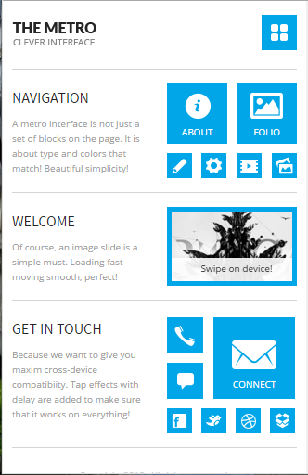 May be something like this.
* Login
* Attendance
* View Court with google map and other details like court faculties details
* People using these courts and any star player who used it.
* A chat system for people to chat with people in courts
* Court rating & reviews
* We have groups in our system can we go for network. Means like ‘find a tennis network near you ’ also plot on google map
* Event Scheduler with upcoming events notifications
* Skills level chart
* Find a partner to play
* See individual player profile with skills and statistics display like schedules
* Score reporting.
* Match details
* Prizes distribution details
* Ladder

**Dashboard and UI changes**

<http://heyflat.com/themes/heymetro/angular/#/page/settings>

http://themes.laborator.co/xenon/angular/#/app/dashboard-variant-1

http://www.ilcorsaronero.it/progettienvato/SiteParallax/ParallaxSite/site_tennis/preview/index.html

<http://demo.themestreet.net/wba/standard/index-video.html>

<http://make-lemonade.co/themes/sport/skin1/>

<http://demo.curlythemes.com/html/leisure/>

The purpose of giving you many templates is that we can have club to choose from these existing template .

**Event Scheduler**

<http://angular-ui.github.io/ui-calendar/>

http://code.daypilot.org/63034/angularjs-event-calendar-open-source