1. Remote Desktop onto 199.180.154.214 and go to D:\WebSitesV\SPA-New\FE

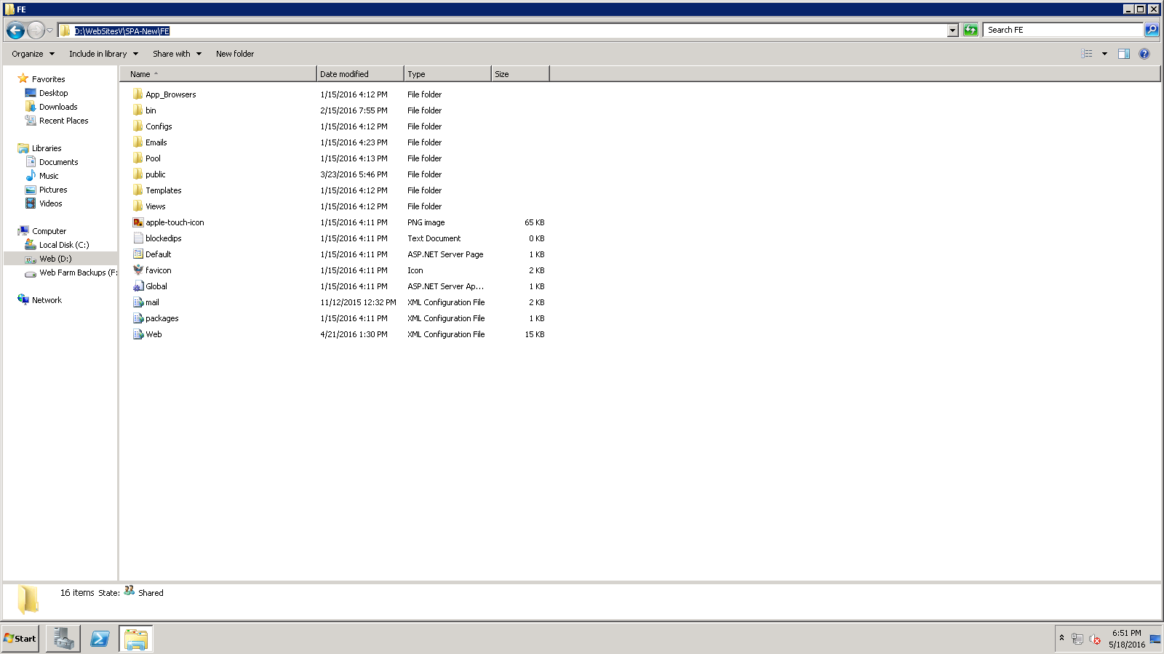

1. Double click the Web.config file to edit it as below. On the highlighted line, change SPA_New to SPA (remove the _NEW). Click the Save Button to save your changes.

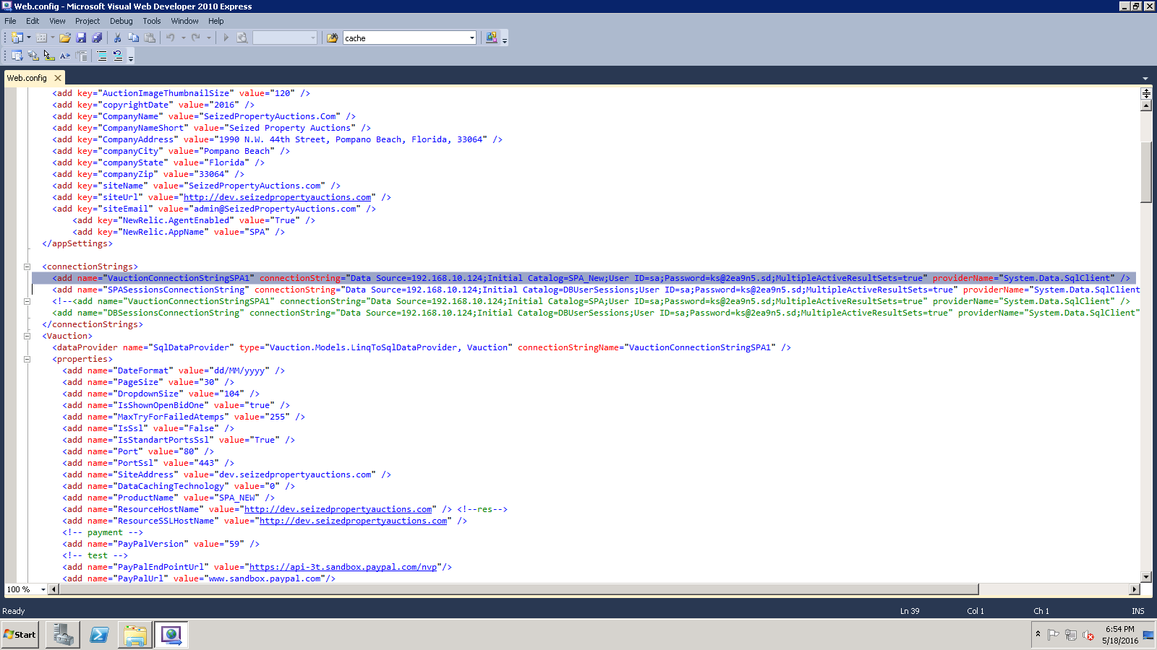

1. Navigate to D:\WebSitesV\SPA-New\BE to change the Back End.
2. Double Click the Web.config file to edit it as below. On the highlighted line, change SPA_New to SPA (remove the _NEW). Click the Save Button to save your changes.

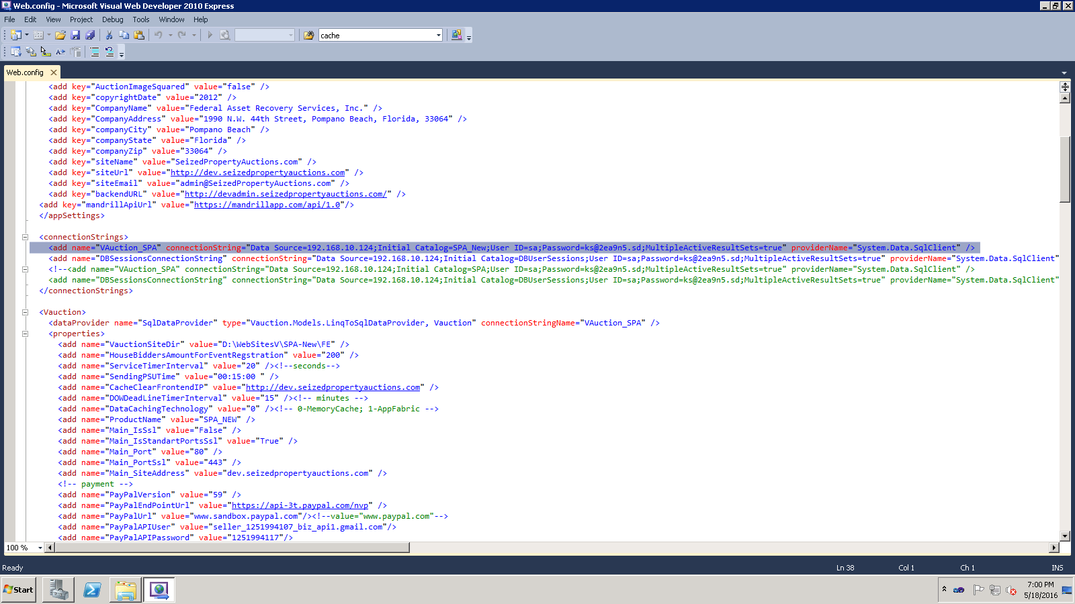

1. Close the Explorer window and from machine 198.180.154.214, remote onto 198.160.10.20 as below:

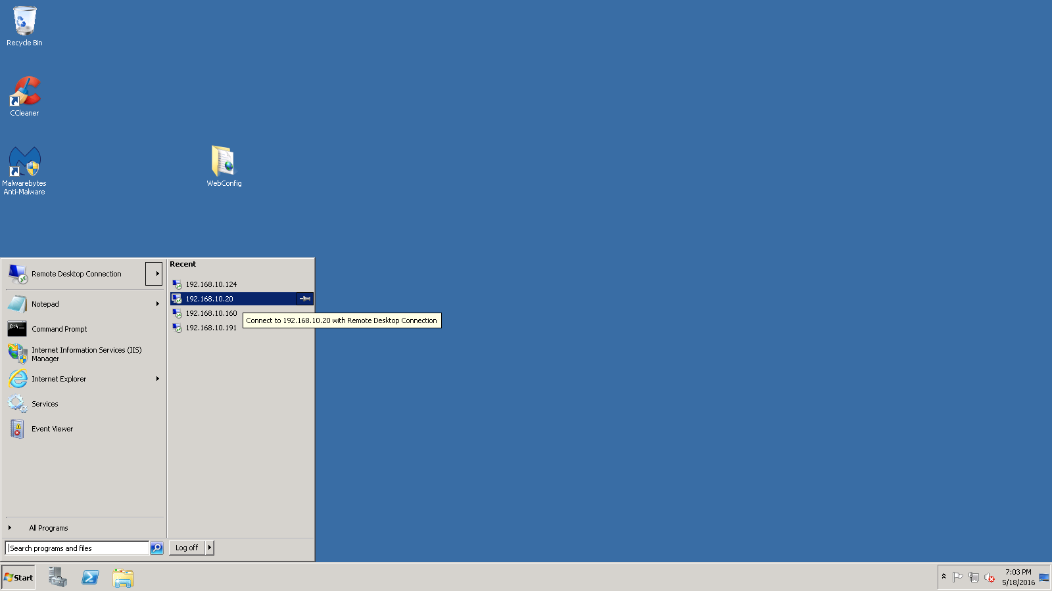

1. Password below is: A1~s2d3fCl&Fi and then click OK.

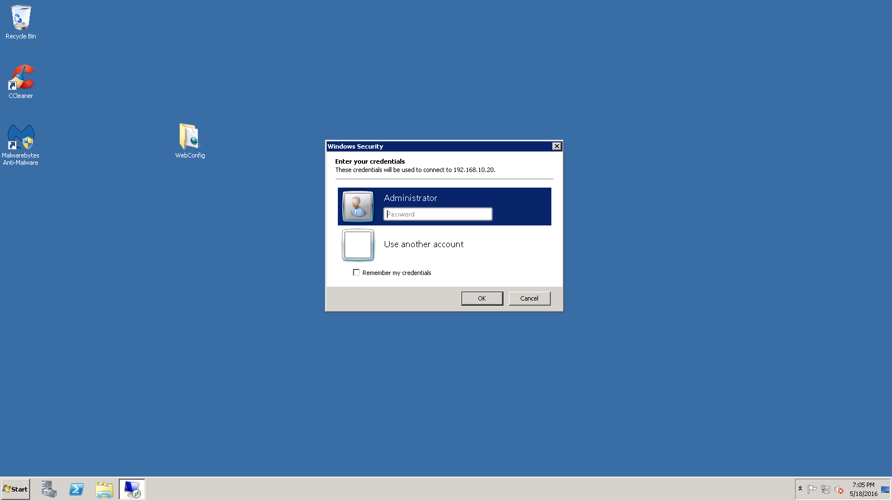

1. Click OK below:

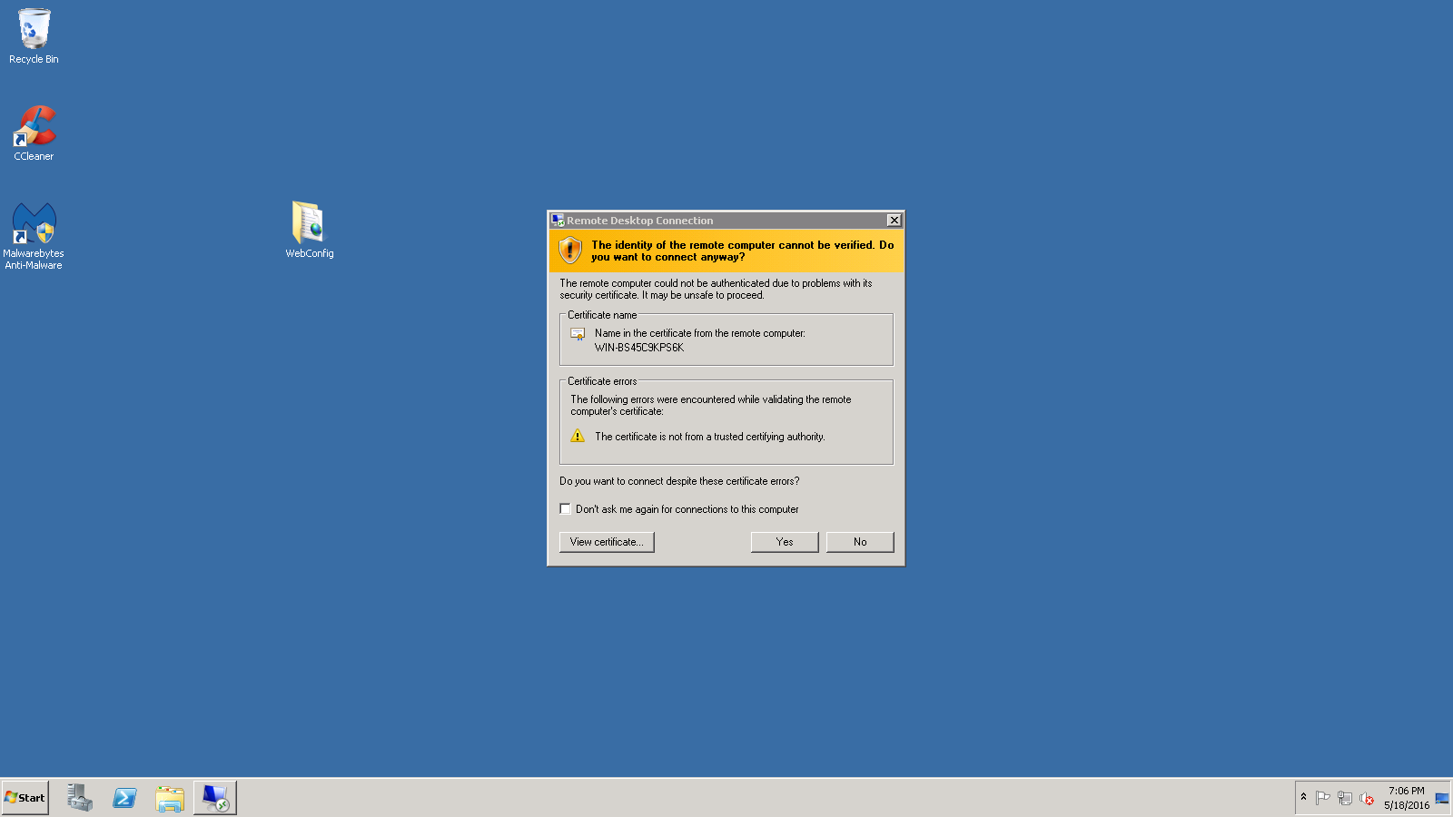

1. You are now on machine 199.160.10.20. You may need to close the Server Window when it comes up so that it looks like below.

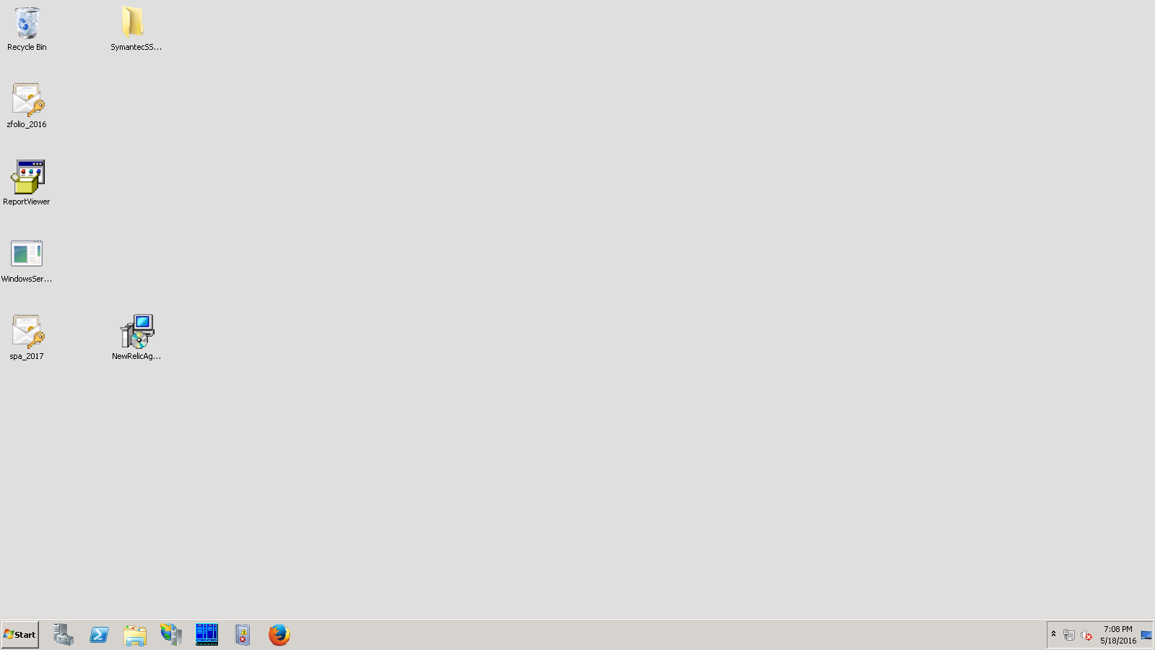

1. Click on Start Menu then Click on Services:

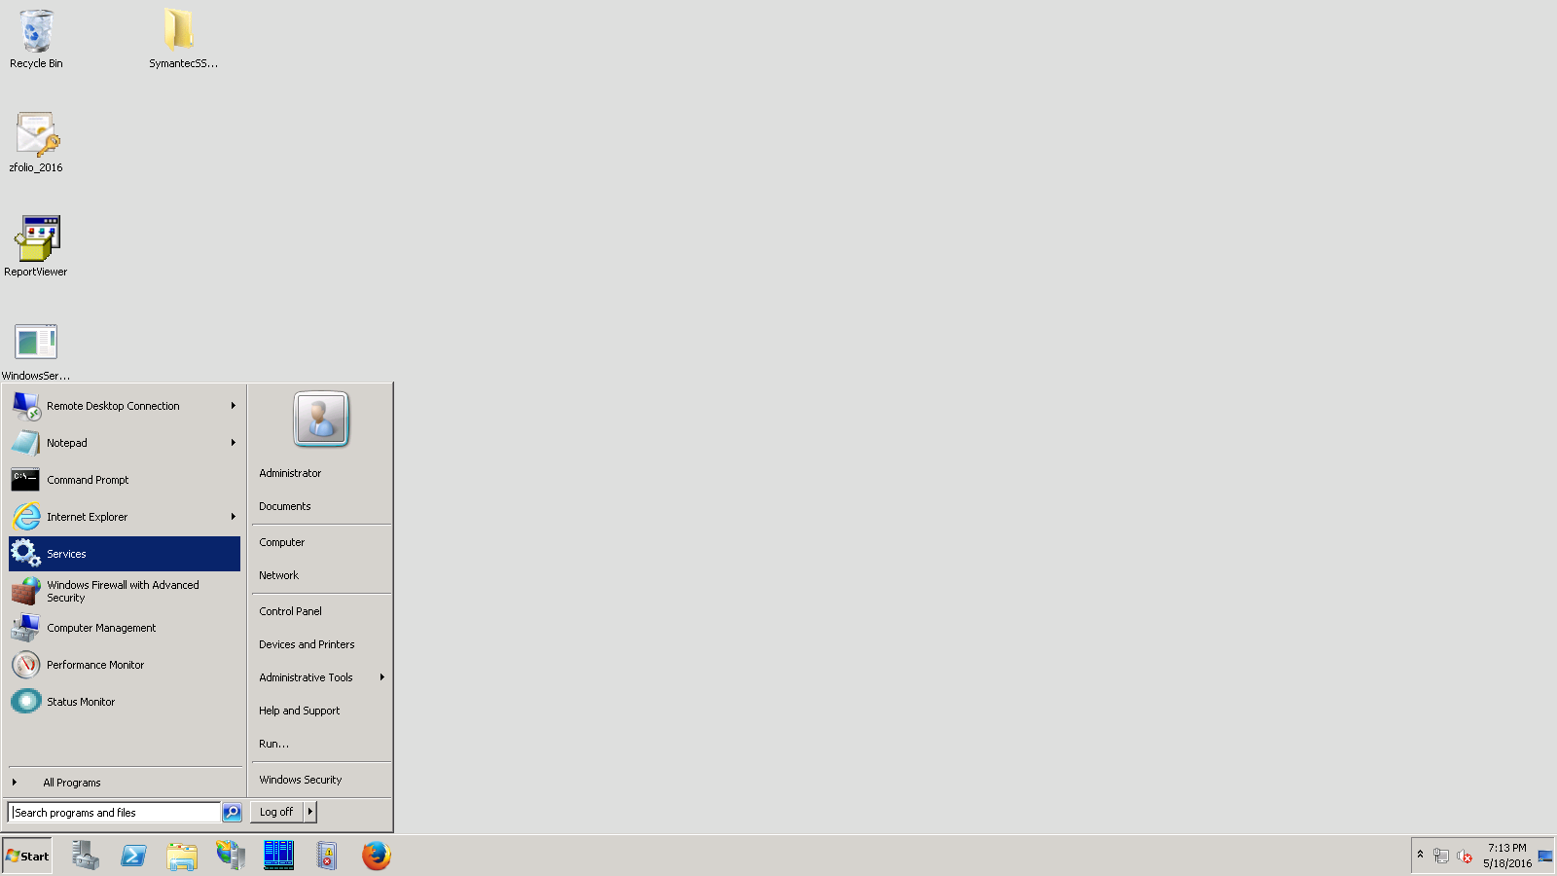

1. Scroll down and find SPA Service and click on it and stop the service:

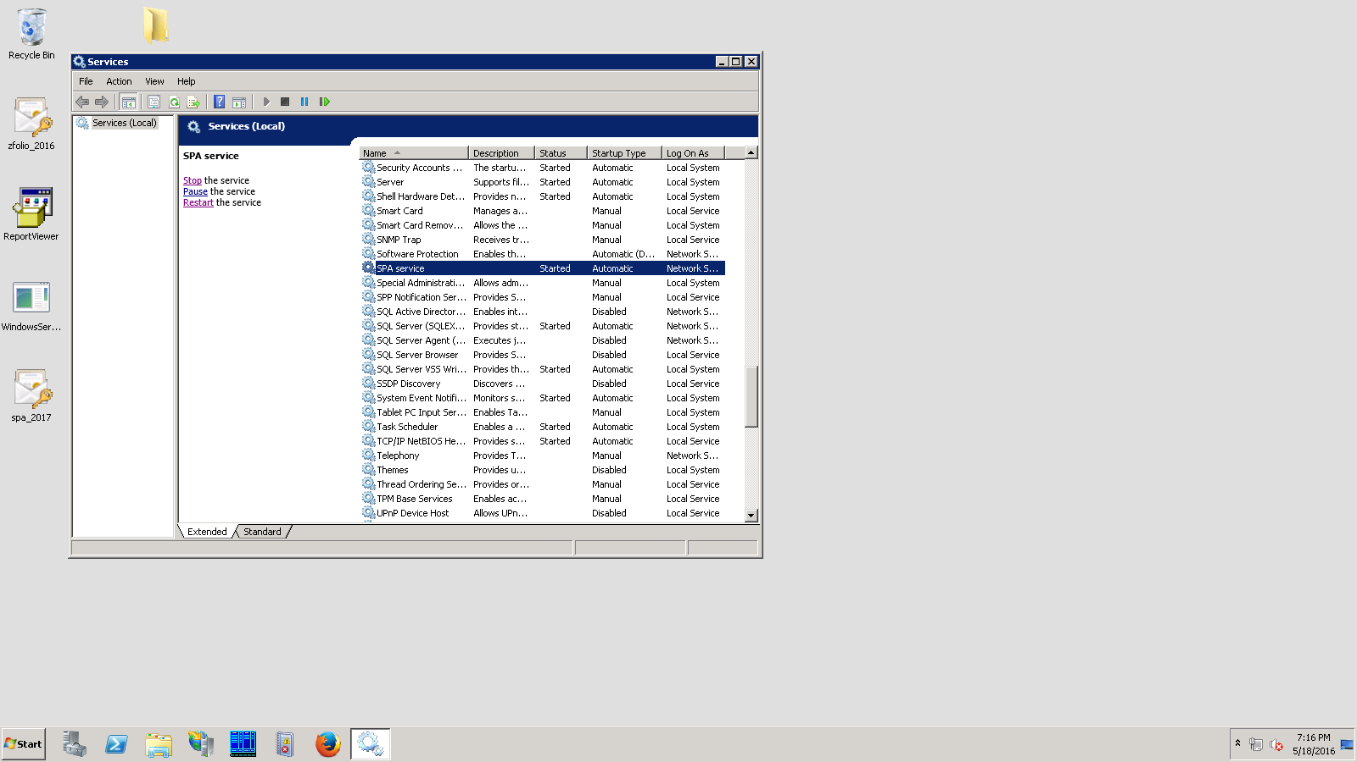

1. Go to Explorer and navigate to: C:\Program Files\Clicktech\SPA Service. Double click on SPA_WS.exe XML Configuration File to open it for editing.

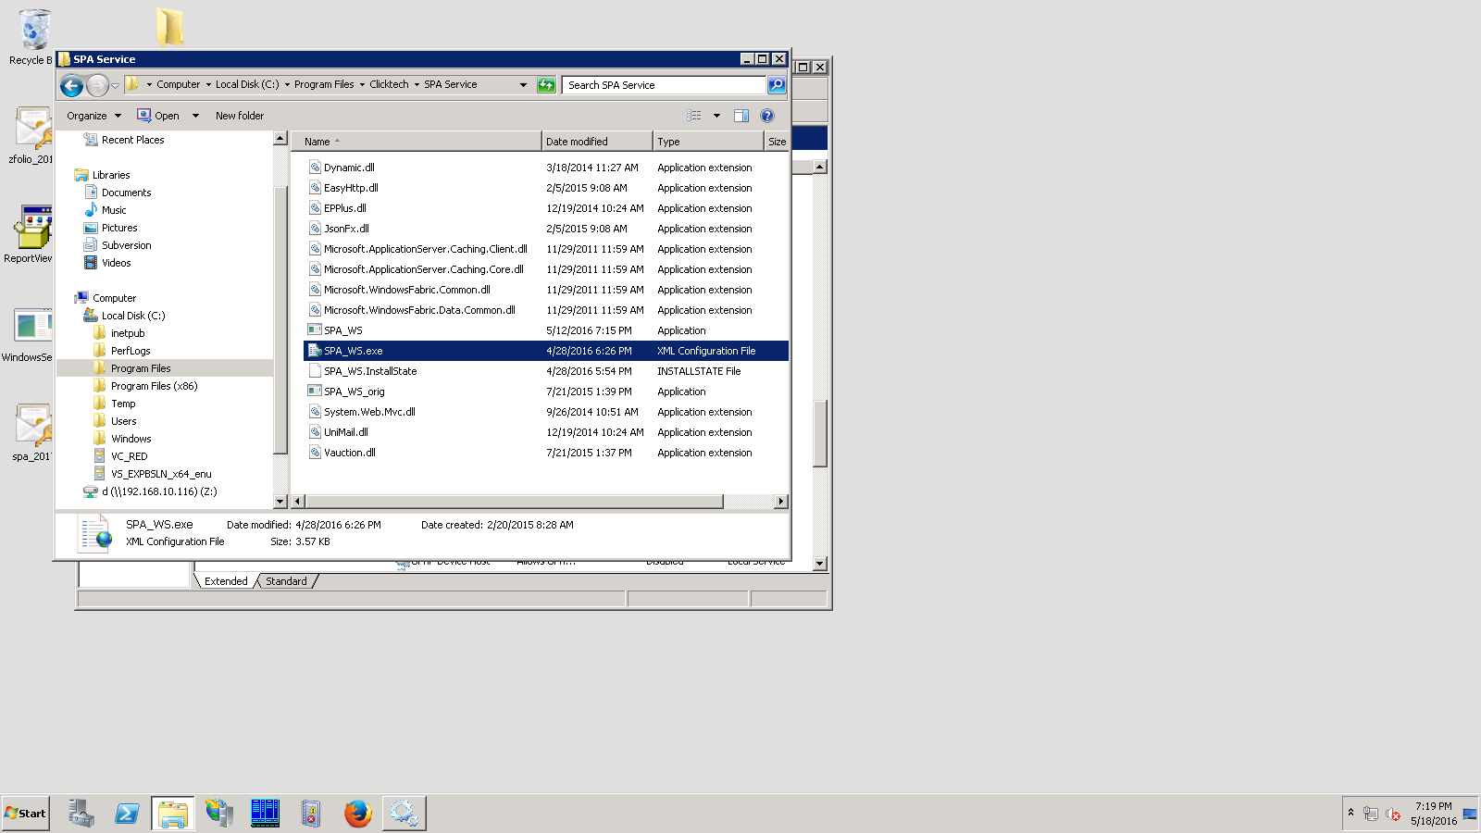

1. The Configuration file opens as below. In the highlighted line below, Change SPA_New to SPA (remove the _New). Click the Save Button to save your changes and then close the file.

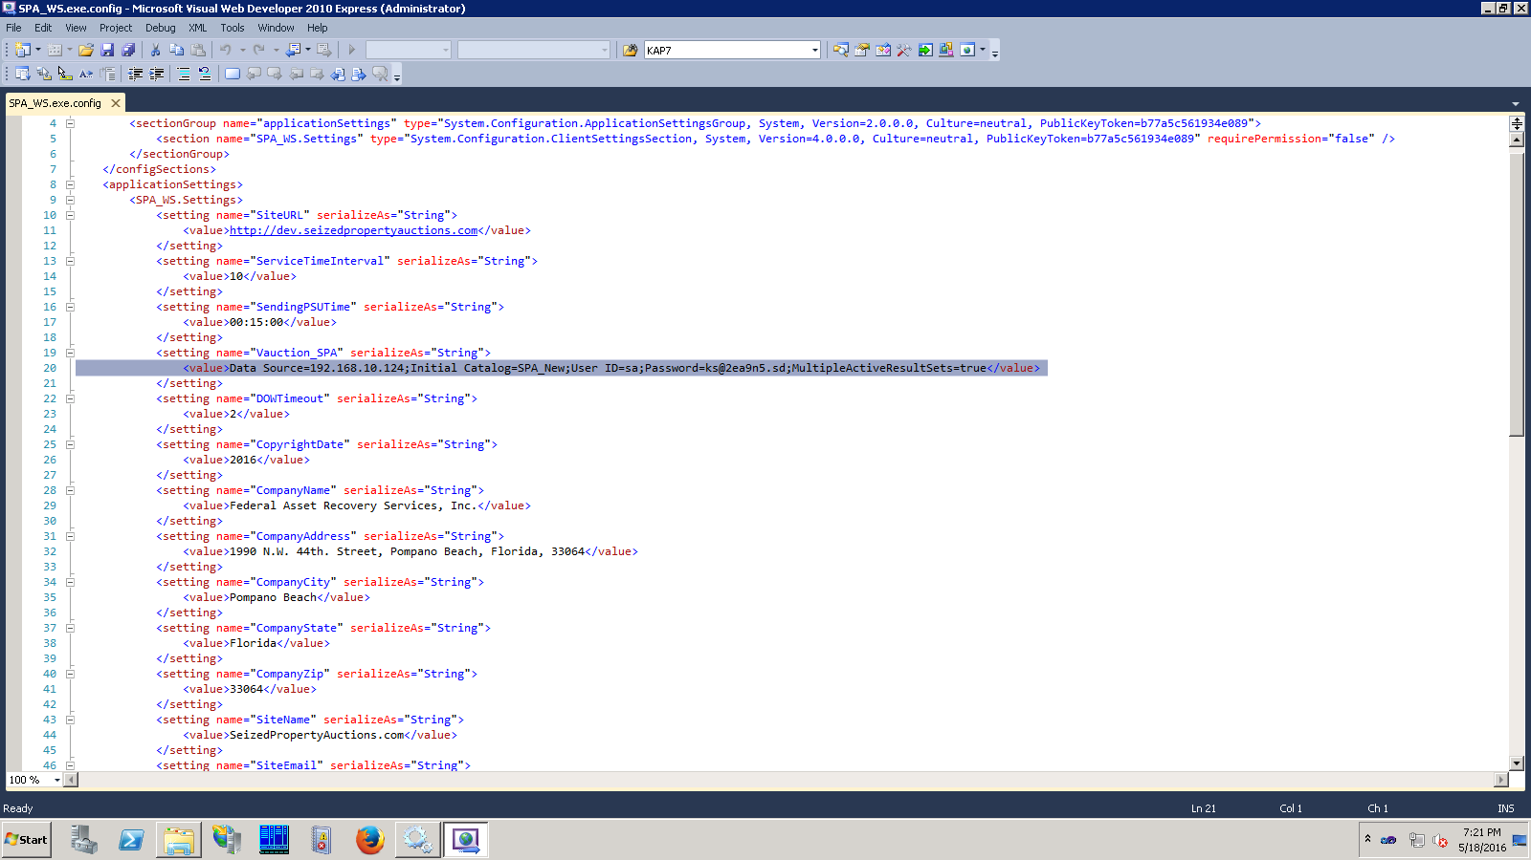

1. Log of the server machines.
2. You are now ready to set up auctions in the devadmin.seizedpropertyauctions.com site and then bid on them in the dev.seizedpropertyauctions.com. You will be using the production database and you will not be changing anything in the existing production site.