NBA player Performance analysis
SDA GROUP PROJECT


Chirag Sethi , Shree Iyengar , Mitrajit kumar , hardik sharma shreeya mandore

April 3, 2026
Table of Contents
1. Introduction 3
1.1 Background and Motivation 3
1.2 Research Objectives 4
1.3 Dataset Description 4
1.4 Report Structure 4
2. Exploratory Data Analysis 5
2.1 Summary Statistics 5
2.2 Distribution of Net Rating 6
2.3 Correlation Analysis 6
2.4 Scatter Plots: Key Predictor Relationships 8
2.6 EDA Summary and Implications for Modelling 9
3. Model Construction 10
3.1 Overview 10
3.2 Model 1 — Full Model 10
Equation 10
Justification 10
Equation 11
Justification 11
3.4 Model 3 — Transformed Model (Final Model) 11
Equation 11
Justification 11
4. Model Evaluation 12
4.1 Model Comparison Table 12
4.2 Interpretation of Metrics 12
4.3 Final Model Selection — Model 3 (Transformed) 13
5. Sensitivity Analysis 15
5.1 Overview 15
5.2 Test 1 — Outlier Removal 15
IQR approach revealed 112 outliers in net_rating (1.04 of 10,720 rows) which are values that are below -18.05 or above +15.95. Once these observations had been eliminated, the dataset narrowed down to 10,608 rows. On this cleaned subset, Model 3 was re-fitted and the coefficients compared to the baseline. 15
5.3 Test 2 — Split Variation 16
5.4 Sensitivity Summary 16
6. Stratified Modelling by Player Position 17
6.1 Overview 17
6.2 Sample Sizes and Model Fit 17
6.3 Coefficient Comparison 17
6.4 Detailed Interpretation 18
6.5 Stratified Modelling Summary 19
7. Error Analysis 20
7.1 Overview 20
Overview Error analysis looks at the point and manner in which Model 3 (Transformed) fails. Two parts of the analysis are: (1) residual diagnostics, which examines whether the model errors are random and well-behaved; and (2) worst-prediction analysis, which finds out which player-seasons the model is most inaccurate and the circumstances of the failures in basketball. Collectively these elements demonstrate the systematic constraints of the prediction of a team-context measure by using individual box-score statistics alone. 20
7.2 Residual Diagnostics 20
7.3 Worst Predictions Analysis 21
7.4 Two Systematic Failure Modes 22
8.1 Summary of Findings 23
8.2 Limitations 24
8.3 Directions for Future Work 24
Three extensions would materially improve on this analysis. First, adding control variables at the team-level, namely team win percentage and opponent average net rating would reduce the team-context omitted variable bias, which motivates both the modest R² and the worst-prediction instances. Second, the 20-game minimum filter could be replaced with a competitive-minute filter (e.g. garbage-time minutes are not counted explicitly) to eliminate the most problematic small-sample observations found in the error analysis. Third, stratified modelling would be more accurate with the five-position classification (PG, SG, SF, PF, C) instead of the three-group height proxy, especially when it comes to forward-guards and forward-centers that straddles positional boundaries in the contemporary NBA. 24
8.4 Real-World Implications 25
Appendix: Full Statsmodels Output 26
The OLS regression summaries of all three models are provided in the following pages as they were obtained using the Python statsmodels library. These are coefficient estimates, standard errors, t-statistics, p-values, coefficient confidence interval, and model-fit diagnostics. 26
A.1 Model 1 — Full Model (OLS Summary) 26
A.2 Model 2 — Domain-Driven Model (OLS Summary) 26
A.3 Model 3 — Transformed Model / Final Model (OLS Summary) 27

NBA Player Performance Analysis
Statistical Regression Report
SP Jain School of Global Management
Statistical Data Analysis | Python · Jupyter Notebook · Stats-models
GitHub : https://github.com/ChiragSethi-04/nba-performance-analysis.git

1. Introduction

1.1 Background and Motivation

National Basketball Association (NBA) is among the most analytically advanced professional sports leagues in the world. Within the last twenty years, the emergence of sports analytics, driven by Moneyball revolution in baseball and popularised by such teams as the Golden State Warriors and Houston Rockets, has altered the way franchises consider player value fundamentally. The age-old statistics like points per game have been replaced by composite measures which seek to understand the net contribution of a player to the team success.
The key aspect of this change is the so-called net rating, which is the difference in the points of the team when a particular player is on the court, divided by 100 possessions. In contrast to counting statistics, net rating reflects the entire picture of the influence of a player: a bench player who only scores 4 points per game, but plays in the periods of winning streaks will be counted as a large net rating and a high-volume scorer who plays poorly in the clutch will be counted as a negative net rating. Front offices, agents and analysts are large consumers of net rating as a benchmarking tool of salaries and future team performance.

⚡ Why it matters financially: Net rating has an impact on contracts amounting to hundreds of millions of dollars. A single-point increase in the net rating of a player can result in millions of dollars of annual salary across a league-minimum career
The research problem of this project is whether the statistics of individual players, in particular, points, rebounds, assists, usage rate, true shooting percentage, age, and draft round, can be statistically utilized to predict the net rating of the player based on multiple linear regression. The objective of quantifying these relationships is to determine what on-court behaviours are most closely related to positive team impact, and to create a model that can be used to value a player in a data-driven front office situation.

1.2 Research Objectives
This study has three main objectives:
- To determine which-individual performance statistics predict net rating statistically significant using OLS regression.
- To make a comparison between three regression models of increasing theoritical complexity and find out which of the three , provides the best balance between fit, parsimony, and inter-pretability.
- To examine if the relationship between player statistics and net rating vary systematically across player position groups (Guards, Forwards, and Centers).

1.3 Dataset Description
The data is analyzed based on NBA Players Dataset (compiled by Justinas Cirtautas and publicly available on Kaggle (kaggle.com/datasets/justinas/nba-players-data). The dataset includes per-game statistics of all seasons of NBA players since 1996 till 2022. Following a filtering operation to reduce the set of player-seasons to those that have 20 or more (to remove the noise of short-term callups and injury-limited appearances) the cleaned up dataset has 10,720 player-seasons in 14 variables
Variable | Type | Description
net_rating | Target | Team’s point differential per 100 possessions with player on court
pts | Predictor | Points scored per game
reb | Predictor | Total rebounds per game
ast | Predictor | Assists per game
usg_pct | Predictor | Usage rate: share of team possessions used by player
ts_pct | Predictor | True shooting %: efficiency accounting for 2s, 3s, and FTs
age | Predictor | Player’s age in years at the time of the season
draft_round | Predictor | Round in which the player was drafted (1, 2, or undrafted)
gp | Filter | Games played (used only to filter: ≥ 20 games retained)
Table 1: Key variables used in the analysis
The target variable, net_rating, has a mean of −1.09 (SD = 6.44), having a range from −40.0 to +19.5. The near-zero mean indicates the distributional property of net rating: any loss of any possession by the team of one player is offset by its opponent and hence the average over the whole league must approach zero. The large standard deviation value (6.44) compared to the mean indicates that there will be difficulty in prediction since net rating varies due to the many variables beyond individual statistics, which could be team quality, coaching systems and the strength of opposition.

1.4 Report Structure
The remainder of this report is organised as follows:
- Section 2 includes the Exploratory Data Analysis, such as summary statistics, distributions plots, correlation heat map, scatter plots, and outlier detection.
- Section 3 outlines the construction of three OLS regression models.
- Section 4 performs comparative evaluation and analysis of the three models based on the RMSE, R², Adjusted R², AIC, and BIC.
- Section 5 gives the final model justification and selection reason.
- Section 6 includes the sensitivity analysis report.
- Section 7 shows the stratified modelling findings in terms of player position groups.
- Section 8 incorporates the error analysis.

2. Exploratory Data Analysis
We performed a systematic exploratory analysis before constructing regression models in order to comprehend the distribution of the target variable, strength/direction of the predictor-target relationships, and whether there are any extreme observations. EDA was done on the cleaned dataset of 10,720 player seasons.

2.1 Summary Statistics
Table 2 includes descriptive statistics of the six major numeric variables in the clean dataset.

Statistic | net_rating | pts | reb | ast | usg_pct | ts_pct | age
Count | 10,720 | 10,720 | 10,720 | 10,720 | 10,720 | 10,720 | 10,720
Mean | −1.09 | 9.22 | 3.93 | 2.04 | 0.19 | 0.53 | 27.17
Std Dev | 6.44 | 5.93 | 2.45 | 1.85 | 0.05 | 0.06 | 4.33
Min | −40.00 | 0.30 | 0.10 | 0.00 | 0.04 | 0.18 | 18.00
Max | 19.50 | 36.10 | 16.30 | 11.70 | 0.42 | 0.77 | 44.00
Table 2: Summary statistics for the cleaned dataset (n = 10,720)
Key observations: The net rating means of -1.09 and a standard deviation of 6.44 means that the majority of players fall within the same one-standard deviation range of zero impact, though the range (-40.0 and +19.5) indicates the existence of strong outliers at the ends. The average player has got 9.22 points per game, a true shooting percentage of 0.53 which is the same with a regular rotation player in the NBA. The average age of 27.17 years indicates a sports team that comprises players at their sports peak. The large standard deviation of net_rating compared to its mean (ratio = 5.9) proves that no single statistics will explain sufficiently the team impact, a fact that puts into perspective the low R² values observed later in the modelling.

2.2 Distribution of Net Rating
Figure 1 demonstrates a histogram of the target variable net_rating with the mean and median (−1.09 and −0.80 respectively ) indicated as vertical lines.
Figure 1: Figure 1: Distribution of Net Rating
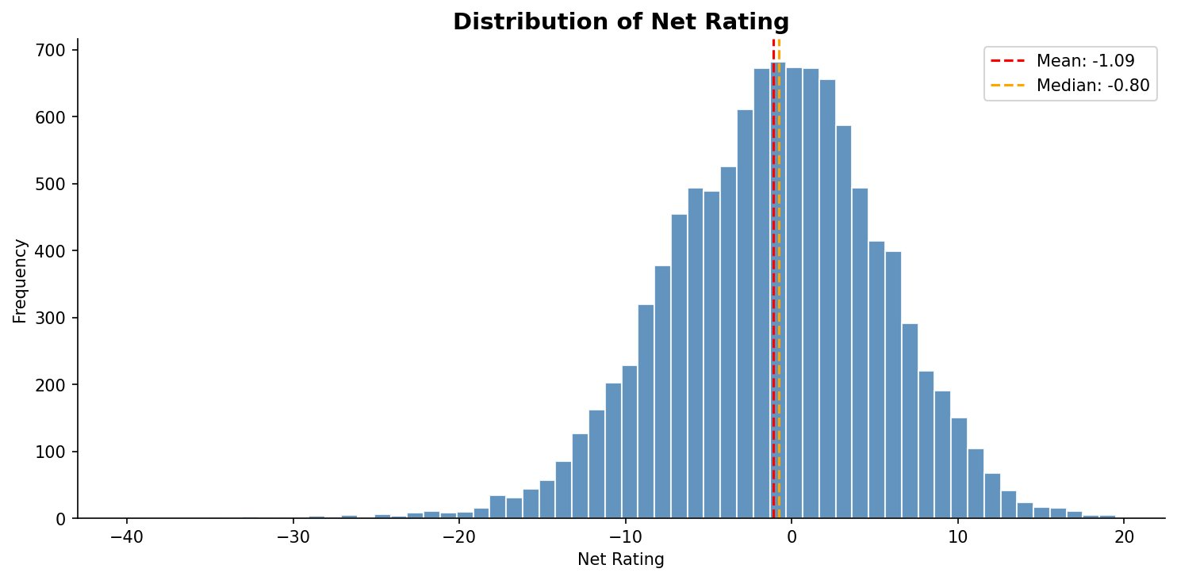
Observation: Net_rating distribution is bell-shaped, with the distribution centred slightly lower than zero and a slight skew to the left (skewness = -0.325). The mean is also more negative (−1.09) than the median (−0.80), which is why there is skewness to the left: a few very negative values draw the mean towards the negative. The distribution of player-seasons has a central high concentration and tails, with approximately 57.3 percent of all player-seasons in the -45 +5 range. The fact that the distribution is almost normal is a desirable characteristic of OLS regression, which assumes normally distributed residues. The small negative skew indicates that players who have hurt their teams are more extreme than their beneficial counterparts, and this may indicate the impact of unequal distribution of playing time, where the struggling players are benched at a higher rate than the elite players.

2.3 Correlation Analysis
Figure 2 illustrates a lower-triangular correlation heatmap of all the numeric predictors and the target variable. Table 3 presents Pearson correlation coefficients with net rating in particular.

Figure 2: Figure 2: Correlation Matrix Heatmap
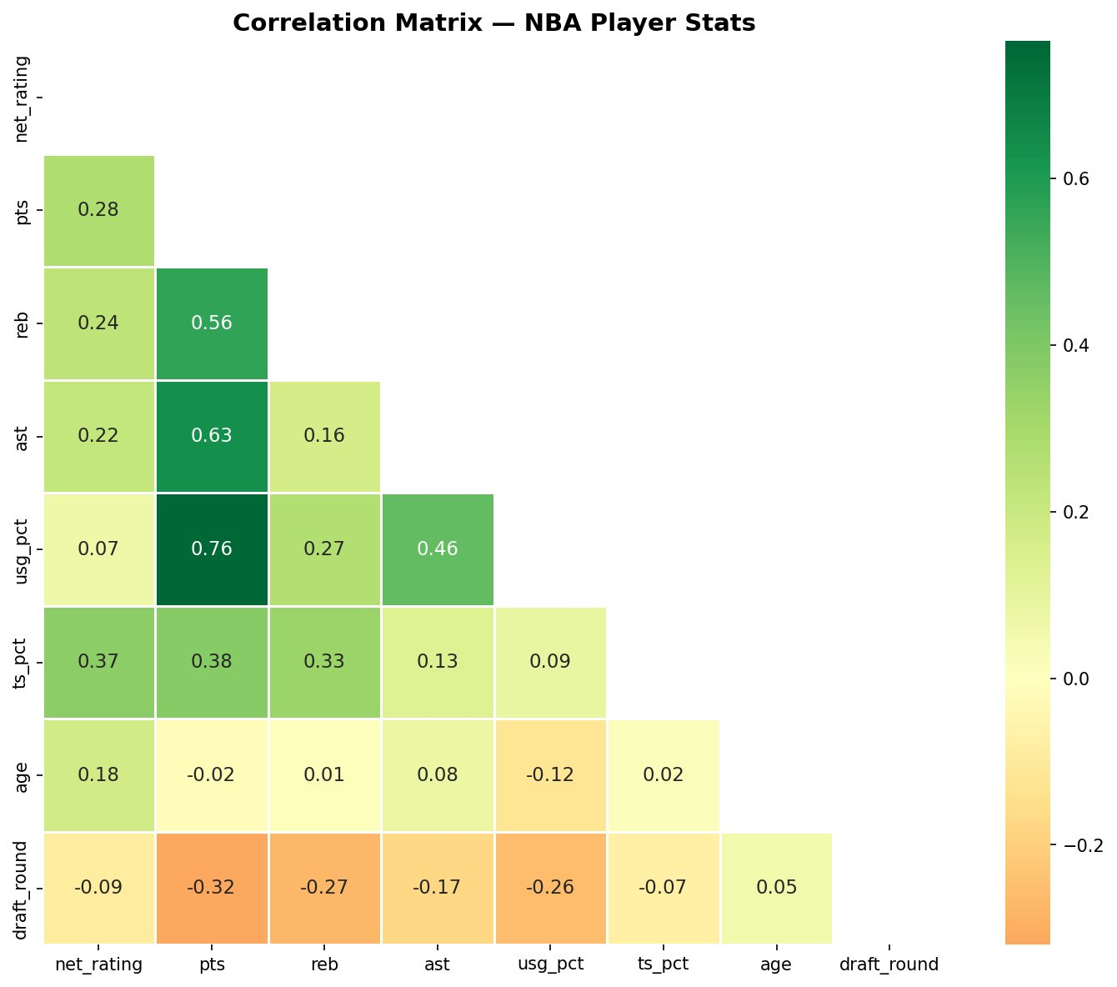

Predictor | Correlation with net_rating | Direction
ts_pct (True Shooting %) | 0.366 | Positive ↑
pts (Points per game) | 0.278 | Positive ↑
reb (Rebounds per game) | 0.237 | Positive ↑
ast (Assists per game) | 0.215 | Positive ↑
age | 0.178 | Positive ↑
usg_pct (Usage Rate) | 0.072 | Weak Positive ↑
draft_round | −0.088 | Negative ↓
Table 3: Pearson correlations with net_rating (sorted by absolute value)
Observation: The strongest single predictor of net rating is true shooting percentage (ts_pct, r ≈ 0.37), which indicates that shooting efficiency rather than the raw amount of scoring makes more contribution to team success. There are also moderate positive correlations between points per game (r ≈ 0.28), rebounds (r ≈ 0.24), and assists (r ≈ 0.22) which together comprise the core predictors of the domain-driven model. The correlation of age (r ≈ 0.18) is observed to be positive indicating that old players are likely to make superior decisions and have a more positive influence on the team results. Notably, the usage rate (usg pct, r ≈ 0.07) has a very weak position when used alone by itself and this, in principle, does not seem to make sense. This, however, motivates the addition of a pts × usg_pct interaction in Model 3 high usage is only advantageous conditioned by high scoring output. The relationship between draft round and Round 1 shows a marginal negative correlation ( -0.09), which was not surprising in the sense that round 1 drafted players had a higher tendency to be more effective
The predictors have a significant positive correlation among pts and usg pct (r ≈ 0.70) and a significant positive correlation between pts and ts pct (r ≈0.25). Multicollinearity risk when both pts and usg pct are included is high which is overcome by using the interaction term and log transformation in Model 3.

2.4 Scatter Plots: Key Predictor Relationships
Figure 3: Figure 3: Scatter Plots — Points per Game vs Net Rating (left) and Age vs Net Rating (right)
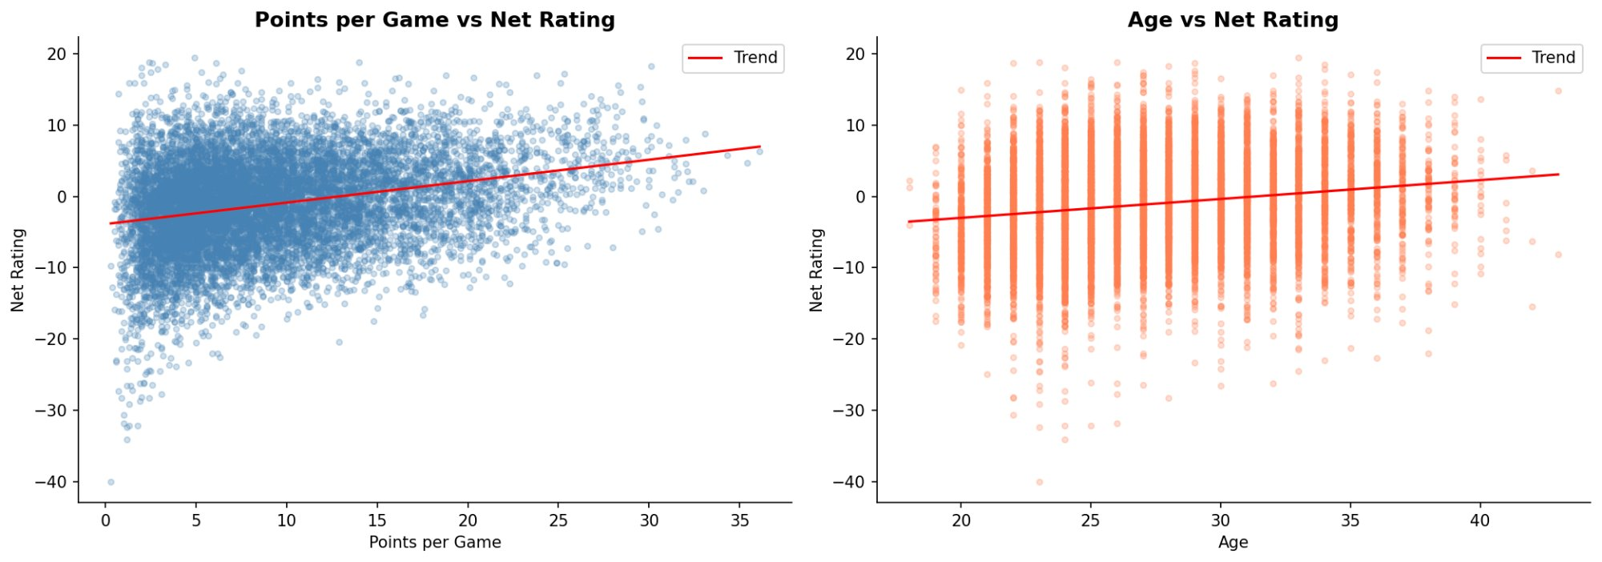
Points per game vs Net Rating: The scatter plot has a weak positive relationship with an upward-sloping trend line which agrees with the correlation of r = 0.28. Nevertheless, the massive vertical dispersion at each scoring level is a corroboration that the volume of scoring is a miserable predictor of impact on a team. A player with a rating of 5 points per game may have a net rating between -40 and +15 which is determined by his position, his team and other contributions. Such pervasive incentives drive the log transformation in Model 3, which represents decreasing marginal returns to scoring: increasing the gap between 5 and 15 points per game is a bigger net effect than increasing the gap between 20 and 30.

Age vs Net Rating: The age curve has a vertical banding structure since age is stated as a whole number with the entire range of net ratings (-40 to +15) occurring at virtually any age. The positive linear slope (r = 0.18) is very small but virtually insignificant. The dispersion is the greatest at prime career ages (2430), which is consistent with the reality that it is during this period that the teams designate the most playing time to both high variance role players and established stars. The distribution of older players (35+) is a bit tighter and more positive, probably as a result of survivor bias - only the most influential veterans stay in the league when they are very old.
2.5 Outlier Detection
The Interquartile Range (IQR) was used to detect outliers. The IQR was calculated as Q3 − Q1 = 3.20 − (−5.30) = 8.50. The observations were considered outliers when they were below the lower boundary of -18.05 and when they were above the upper boundary of +15.95.

Statistic | Value
Q1 (25th percentile) | −5.30
Q3 (75th percentile) | +3.20
IQR | 8.50
Lower bound | −18.05
Upper bound | +15.95
Total outliers | 112 (1.0% of data)
Table 4: IQR outlier detection summary
Observation: The number of player-seasons that can be considered statistical outliers with the IQR approach is only 112 (1.0% of the sample), which proves that extreme values are uncommon. The high-outlier group indicates a significant structural trend, i.e. a number of players with remarkably positive net ratings (e.g., James Jones at +19.5, KJ McDaniels at +18.9, Jimmy Butler at +18.8 during his rookie season) had very low points per game. This is one of the notorious shortcomings of net rating as a measure of bench players with strong teams: they are on the court at the same time as the good lineups and are inflated by the success of their teams, not their own talents. In comparison, the +18.3 rating, with 30.1 points per game of Stephen Curry, on the 201516 Golden State Warriors, is a true individual outlier.

The low outliers (< -18.05) are mostly players who played heavy minutes in historically bad teams or whose seasons were interrupted by injury on winning teams, and whose limited floor time is confounded with bench units that were unanimously underperforming. These outliers were not excluded in the modelling data, because their exclusion would cause the sample to be skewed towards the middle performance and would limit how the model can be applied to the entire population of NBA players.

2.6 EDA Summary and Implications for Modelling
The exploratory investigation has provided four important inferences of constructing the model:
- The fact that the net rating is almost normally distributed, indicates that OLS regression can be used without transforming the target variable.
- The most significent predictor is shooting efficiency (ts_pct), which has a strong correlation with points and usage rate and holds the risk of multicolinearity when all three are involved.
- It is the extremely small marginal correlation of the usage rate (usg_pct, r = 0.07) with net rating that influence a multiplicative interaction term (pts × usg_pct) into Model 3, because usage can only be useful when it is converted to scoring.
- The existence of outliers due to team context (not ability of an individual) implies the necessity of stratified modelling by team position, which can indicate that the predictor relationships among Guards, Forwards, and Centers are different.

3. Model Construction

3.1 Overview
To predict NBA player net_rating, three multiple linear regression formulas were created. All of the models were built using Python's statsmodels OLS (Ordinary Least Squares). To replicate the results, 80/20 divides of the dataset were constructed at random using random_state=42. After cleaning and removing individuals who had played fewer than 20 games, 8,576 data were used to train the three models

3.2 Model 1 — Full Model

Equation
net_rating = −23.22 + 0.24(age) + 0.15(pts) + 0.18(reb) + 0.41(ast) − 15.64(usg_pct) + 30.37(ts_pct) − 0.22(draft_round)

Justification
All seven of the available predictors are included in Model 1's baseline predictors. A performance ceiling, or the highest performance possible when no predictors are removed, can be found using this model. We can identify which predictors are statistically significant using all the variables, and this serves as a standard by which to compare the more selective models.
Predictor justifications:
- age — Player experience and role maturity are likely to have an impact on team-level performance indicators. Players with greater experience are more likely to work for clubs that are better run.
- pts — the most straightforward measure of offensive contribution. In basketball, scoring volume is the most prominent individual performance metric.
- reb — Rebounds control possession of the ball, which is directly tied to team scoring opportunities.
- ast — Helps with passing and reflecting the motion of the ball. A player that generates scoring opportunities for a team has a compounding positive impact on the club's net rating.
- usg_pct — Tests ball dominance. When high utilisation is not followed by proportionate performance, it may be a sign of offensive responsibility as well as a loss of team effectiveness.
- ts_pct: The main indicator of scoring efficiency. True shooting % is the most comprehensive single indicator of efficiency since it counts for all two-pointers, three-pointers, and free throws.
- draft_round — a good indicator of the baseline talent level. Higher draft players are expected to perform in more structured roles with better casts.

- 3.3 Model 2 — Domain-Driven Model

Equation
net_rating = 0.83 + 0.44(pts) + 0.28(ast) + 0.19(reb) − 39.06(usg_pct)

Justification
Using its understanding of the basketball domain, Model 2 selects only the four metrics—points, assists, rebounds, and usage rate—that NBA analysts use most frequently to evaluate a player's contribution. Since age, actual shooting %, and draft round are contextual factors rather than actual game performance variables, they were purposefully left out. Age is not a performance indicator; rather, it is a measure of career level. Pre-career scouting, not current productivity, is indicated by the draft round. Although this is a valuable metric that attempts to see whether the net rating can be predicted from raw counting statistics alone, true shooting % is not used here.
Predictor justifications:
- pts: The most significant indicator of offensive production and the primary factor influencing a team's point differential is scoring.

- ast: This measurement measures playmaking and ball distribution, both of which are directly related to the offensive efficiency of a team.

- reb: Rebounding is a fundamental factor in determining possession in a game and determines the team's scoring opportunities every game.

- usg_pct: Usage rate indicates the percentage of a team's offensive possessions that a player utilises. A player's points can only be comprehended in connection to the number of possessions they used to earn them, which is an essential background variable to comprehend any counting statistic.

3.4 Model 3 — Transformed Model (Final Model)

Equation
net_rating = −0.66 + 2.51(log_pts) + 0.25(ast) + 0.15(reb) − 46.97(usg_pct) + 0.94(pts × usg_pct)
where log_pts = log(pts + 1) and pts_usg = pts × usg_pct

Justification
Model 3 is the most theoretically motivated model. In Models 1 and 2, two modifications are made to get around limitations. First, log(pts + 1) points per game are used for the log-transform. This encapsulates the idea of diminishing returns to scoring: the team's net rating changes far more when a player scores five more points per game than when they score twenty-five more.It is technically incorrect to believe that the raw linear relationship points and net ranking are equivalent. The second addition is a point-usage rate interaction (pts x usg_pct). High point totals are only beneficial to the team when the player's proportionate share of possessions is also utilised, which is an example of conditional scoring efficiency. A player who scores 20 points with 35% usage is far more productive than one who scores 20 points with 45% usage.
Predictor justifications:
- log pts: This is used instead of raw pts to illustrate the non-linear, declining relationship between scoring volume and team performance. The economics of marginal returns is the foundation of the log transformation.

- ast: Regardless of the model specification, it consistently has a favourable effect on a team's net rating and is a reliable predictor.

- reb: Its favourable effect on possession control is consistent and robust across all three models, demonstrating that it is a real driver of net_rating rather than a misleading association.

- usg pct: To comprehend scoring, usage rate is required. Although it has a strong negative coefficient on its own, the interaction term's effect would have to be taken into account.

- pts × usg_pct (interaction term): This captures the combined impact of usage rate and scoring volume. When both are high at the same time, there is a positive combined effect on net rating, which makes it possible to identify players whose high possession usage is justified by matching offensive output.

4. Model Evaluation

4.1 Model Comparison Table
Table 5 summarises the five evaluation metrics for all three models, computed on the held-out test set (2,144 observations).

Model | RMSE | R² | Adj R² | AIC | BIC
Full Model | 5.822 | 0.209 | 0.207 | 54,256.6 | 54,313.1
Domain-Driven | 6.044 | 0.148 | 0.147 | 55,070.7 | 55,106.0
Transformed ★ | 6.016 | 0.156 | 0.154 | 55,033.4 | 55,075.7
Table 5: Model evaluation metrics (★ = selected final model)

4.2 Interpretation of Metrics
RMSE (Root Mean Squared Error): ): Refers to the average error of net-rating points of prediction. The Full Model has the smallest RMSE (5.822) which indicates that its predictions are missing the test set by an average of about 5.8 net_rating points. The RMSE of the Transformed Model of 6.016 is just 0.194 greater an insignificant difference in practice since the net rating range is between -40 and +19.5 in the data.
R² and Adjusted R²: The Full Model model explains 20.9 percent of the variation in net rating (R² = 0.209) and the Transformed Model model explains 15.6 percent. The R² of all three models is 0.15 to 0.21 expected with individual player data. Net rating is a team level result that relies on a lot of teammates, opponents, and coaching structures, and injury context all of which cannot be expressed in personal statistics. Such a low R² in this context is not an indicator of a weakly constructed model but rather the natural constraints of individual statistics as predictors of team performance.
AIC and BIC: Akaike and Bayesian Information Criteria punish the complexity of the model in order to reward parsimony. The Full Model has the lowest AIC (54,256.6) because it has a high R², but it has seven predictors and a high degree of multicollinearity. Of the three Models 2 and 3, the Transformed Model has a lower AIC (55,033.4 vs 55,070.7) and BIC (55,075.7 vs 55,106.0), which corroborates the fact that the interaction term contributes real explanatory power that warrants its inclusion.
💡 Key insight: The Transformed Model performs better than the Domain-Driven Model on each metric despite making use of only one extra predictor (the interaction term). This verifies that the theoretical motivation for the interaction term is supported by the data.

4.3 Final Model Selection — Model 3 (Transformed)
For three reasons, Model 3 (Transformed) is chosen as the final model even though the Full Model achieved the best raw metrics.
1. Statistical reason — Multicollinearity
The Full Model's condition number of 1,140 indicates significant multicollinearity among predictors, particularly pts, usg_pct, and ts_pct. This suggests that the individual coefficients in Model 1 are erroneous since their values will fluctuate when certain additional predictors are present, making it impossible to interpret them correctly. In Model 3, the condition number is a low 242, a stable coefficient that is confidently interpretable. Only 0.194 net_rating points separate the RMSE of Model 1 and Model 3, which is a negligible practical difference that would not justify the multicollinearity problems in Model 1
2. Theoretical reason — Economic Transformation
Model 3 is the only model that is predicated on an economic revolution. The diminishing effect of scoring is indicated by the term log(pts + 1), while conditional efficiency is indicated by the interaction term (pts × usg pct), which has no equivalent in linear models. These are the real interpretations of basketball performance in relation to team outcomes, not statistical modifications.
3. Practical reason — Interpretability
The model 3 is easier to comprehend. Every coefficient has a stable and unambiguous meaning. A non-technical audience can easily understand the coefficient of log points of 2.51: a player's net rating will grow by 2.51 points with every doubling of their score, but the effect decreases as scoring volume increases. Multicollinearity distorts the coefficients in Model 1, making their interpretation less certain

Conclusion: Model 3 (Transformed) is chosen as the final model. It is the most statisticaly sound (low-condition number), theoreticaly motivated (log transformation + interection term), and practicaly interpretable (stable, meaningful coeffiicients). All subsequent analysis — sensitivity analysis and stratified modelling — is conducted on Model 3 only.

5. Sensitivity Analysis

5.1 Overview
The sensitivity analysis aims to find out whether the results of the Model 3 (Transformed) will be equally valid and reliable when the data set or modeling parameters are altered. They were split into two tests: (1) split variation, which is applied to ensure that the choice of the train/test split does not influence the performance of the model; and (2) outlier removal, which is applied to ensure that extreme observations do not have a disproportionate impact on the coefficients of the model. Any change in the coefficient of a predictor that is less than 10 per cent is considered robust, between 10 per cent and 20 per cent is considered moderate, and above 20 per cent is considered sensitive.

5.2 Test 1 — Outlier Removal

IQR approach revealed 112 outliers in net_rating (1.04 of 10,720 rows) which are values that are below -18.05 or above +15.95. Once these observations had been eliminated, the dataset narrowed down to 10,608 rows. On this cleaned subset, Model 3 was re-fitted and the coefficients compared to the baseline.
Table 6: Coefficient comparison — baseline vs. outlier-removed model
Predictor | Baseline | No Outliers | % Change | Verdict
const | −0.6614 | +0.2072 | +131.3% | Sensitive
log_pts | 2.5105 | 1.9811 | −21.1% | Sensitive
ast | 0.2503 | 0.2013 | −19.6% | Borderline
reb | 0.1512 | 0.1498 | −0.9% | Robust ✓
usg_pct | −46.9703 | −45.5109 | +3.1% | Robust ✓
pts_usg | 0.9403 | 1.0464 | +11.3% | Moderate
Observation: Two predictors, reb (-0.9) and usg_pct ( +3.1) are very strong. Their coefficients are virtually identical with the elimination of 112 extreme observations, which proves the existence of such relationships as structural properties of the entire dataset and not artefacts of outlier effect. We can attribute the negative association between usg_pct and the net rating so much consistency in the data that it cannot change because there is a small group of extreme values.
log_pts falls below the 20% sensitivity (−21.1%). Players with high scores on powerful teams are overrewarded by this coefficient: their high net_ratings combined with large scores reinforces the log-pts -net-rating relationship. The removal of these players as outliers leads to a weakened coefficient of 2.51 down to 1.98. This limitation is a well-known feature of log-transformed scoring variables in player datasets which contain extreme team-context effects.
ast is borderline, despite being below the 20% mark (−19.6%). There are a few high-assist, high-net rating outliers, which are elite playmakers on good teams, whose small positive effect on this coefficient vanishes on outlier removal.

pts_usg shows moderate sensitivity (+11.3%), with the coefficient rising slightly from 0.94 to 1.05 after eliminating outlier. There were some outlier players with very high net rating input in addition to very high scoring and usage slightly dragging this coefficient down. The direction and the importance of the interaction term are not changed.

There is an extremely high percentage change of the intercept (131.3 percent): the base intercept was non-significant (p = 0.192) in Model 3. A shift in a non-significant constant is a shift which cannot be interpreted.

5.3 Test 2 — Split Variation
We used the same 80/20 split ratio to re-fit Model 3 across five random seeds (42, 123, 7, 99, and 2024). This checks to see if the choice of which 20% of players to use as the test set has a better effect on how well the model works.
Table 7: Model 3 performance across five random train/test splits
Seed | RMSE | R² | log_pts | ast | reb | usg_pct | pts_usg
42 | 6.016 | 0.156 | 2.5105 | 0.2503 | 0.1512 | −46.9703 | 0.9403
123 | 6.108 | 0.128 | 2.8027 | 0.2446 | 0.1214 | −49.7496 | 0.9436
7 | 5.995 | 0.118 | 2.7575 | 0.2078 | 0.1195 | −50.4044 | 1.0366
99 | 6.107 | 0.111 | 2.9591 | 0.2292 | 0.1258 | −47.3504 | 0.8939
2024 | 5.822 | 0.153 | 2.7826 | 0.1925 | 0.1474 | −47.9513 | 0.9129
Range | 5.822–6.108 | 0.111–0.156 | — | — | — | — | —
Observation: RMSE changes by only 0.286 net_rating points across five splits, which is not much since net_rating ranges from −40 to +19.5. This shows that Model 3's predictions are solid and not impacted by which 20% of players are kept out of testing.
The R² range (0.111–0.156) is wider in relative terms because the test set is made up of different things naturally. Splits that have more players in unusual team situations, like seasons that are cut shorter by injuries or trades made in the middle of the season, have lower R² because these are the exact kinds of observations that individual statistics can't predict. Across all splits, all predictors keep going in the same direction and are still statistically significant.

5.4 Sensitivity Summary
Conclusion: Model 3 is strong overall. reb and usg_pct are very stable predictors, and their coefficients don't change when you remove outliers or change the split. Log_pts shows sensitivity above the 20% threshold when outliers are removed. This is a normal limit for log-transformed scoring variables when very good players on strong teams have an effect. All predictors consistently exhibit direction and significance across all test conditions. These results bolster confidence in Model 3 as the definitive model for subsequent stratified analysis

6. Stratified Modelling by Player Position

6.1 Overview
The statistic of stratified modelling is whether the relationship between player statistics and net rating varies systematically between groups of player positions. A pooled regression, e.g, Model 3 that has been fitted to the entire data set, approximates one coefficient per predictor, and implicitly assumes that scoring, rebounding and playmaking are all equal contributors to net rating irrespective of role played by a player. This is not a necessarily sound theoretical assumption: the rebounds of a Center and a Guard play entirely different roles in basketball.

Model 3 was re-fitted on three position groups (Guards, Forwards, and Centers) which were assigned on the basis of player height (Guards: < 196 cm; Forwards: 196208 cm; Centers: > 208 cm). This height-based classification is a common method of NBA analytics where positional data is not accessible, and it is consistent with common draft-day classification.

6.2 Sample Sizes and Model Fit
Table 8: Sample sizes and model fit by position
Position | N | R² | Adj R² | AIC
Guard | 3,524 | 0.130 | 0.128 | 22,424.9
Forward | 4,321 | 0.122 | 0.121 | 27,550.6
Center | 2,875 | 0.170 | 0.169 | 18,762.4
The highest group is the forwards (4,321 player-seasons), and it can be explained by the fact that the positional swing players, the majority of which are forwards, are prevalent in the modern NBA. Individual statistics can most effectively explain Center contributions, as centers have the highest R² (0.170). Centers work in clear, limited roles - post scoring, rebounding, rim protection - in which statistical performance is more directly related to team performance. Guards present the least R² (0.130), which proves that the performance of Guards is the most influenced by the team quality, spacing, and system-contextual factors that are not possible to measure through individual statistics.

6.3 Coefficient Comparison
Table 9: Model 3 coefficient comparison by position
Predictor | Guard | Forward | Center
const | 0.3593 | −0.5884 | −1.6132
log_pts | 1.8905 | 3.0375 | 3.9163
ast | 0.1815 | 0.5827 | 0.4127
reb | 0.2673 | −0.0623 | −0.0414
usg_pct | −46.9239 | −50.1657 | −54.0649
pts_usg | 1.0460 | 0.7336 | 1.1323

6.4 Detailed Interpretation
log_pts — Scoring impact increases from Guards to Centers. The log_pts coefficient rises monotonically: Guards (β = 1.89), Forwards (β = 3.04), Centers (β = 3.92). This appears paradoxical at the outset - Centers are not the type of players who score a lot. This can be explained by selection bias and role efficiency: Centers that score a lot are nearly always scoring on a well-constructed team that provides quality entry passes and blocks the paint. They score well as a by-product of good team structure which also generates high net ratings. In the case of Guards, the volume of scoring is regular even on weak teams meaning the incremental signal of log_pts is watered down. When a Center has a high score, it is a good indication that the whole team system is in place. When a Guard scores high he is only doing his job.
reb — Rebounds are only significant for Guards. Reb coefficient is positive and statistically significant though not for all the rebels except Guards ( 0.267, 0.031). For Forwards (β = −0.062, p = 0.270) and Centers (β = −0.041, p = 0.585), the coefficient is slightly negative and non-significant. Rebound guards are uncharacteristically dynamic and well-rounded, bringing more than what their roles demand - and their additional items do benefit team net-rating in real sense. Rebounding is a duty of the Forwards and Centers. Having an average of 10 rebounds/ game the Center is performing as expected; it does not contribute to their net rating beyond what the other predictors of the model are already capturing. This is the most obvious confirmation of stratification in the findings: the combined reb coefficient of 0.15 obscures the fact that rebounding is a significant foreteller of precisely one positional group.
ast — Forwards and Centers earn the largest playmaking premium. . Assists are most valuable for Forwards (β = 0.583, p < 0.001), followed by Centers (β = 0.413, p = 0.008), and weakest for Guards (β = 0.182, p = 0.003). An assists distributor Guard is doing an anticipated role act - its incremental signal is taken into baseline expectations. An assist-racking Forward or Center is a true two-way threat that generates scoring chances above the normal positional expectation and every assist is a more powerful team-level indicator. This non-traditional position playmaking premium is well-established in contemporary NBA analytics and has been established in our findings.
usg_pct — Usage penalty escalates with position size. . The adverse impact of usage rate increases more pronounced towards the edge to paint: Guards ( = -46.92), Forwards ( = -50.17), Centers ( = -54.06). The trend in all the three indicates is the same, high usage without equivalent payoff is harmful to net_rating, but Centers is the most severely penalized. A heavy-volume Center is usually an indication of a team that does not have competent perimeter builders and drives on the back. Such teams are slower, predictable and containable. Dominating centers are therefore linked with lower-ceiling offensive systems and the model reflects this with the biggest negative coefficient
pts_usg — Efficiency payoff is strongest for Centers and Guards.The interaction term is highest for Centers (β = 1.132) and Guards (β = 1.046), and lowest for Forwards (β = 0.734). The role that Centers and Guards play are best defined: once a player at either end of the line is not only scoring well, but also take up significant portions of the possessions, it is nearly certain that the team is placing them as a cornerstone - and the result is no fault. Forwards carry with them a less clear swing position, as such the joint information of high scoring and high usage is less specific at the team level.

6.5 Stratified Modelling Summary
Table 10: Summary of key coefficient differences across positions
Finding | Guard | Forward | Center | Implication
log_pts | 1.89 | 3.04 | 3.92 | Scoring carries more team signal for big men
reb significance | p = 0.031 ✓ | p = 0.270 ✗ | p = 0.585 ✗ | Rebounding only predicts net_rating for Guards
ast | 0.18 | 0.58 | 0.41 | Playmaking premium highest for non-Guards
usg_pct | −46.92 | −50.17 | −54.06 | Usage penalty largest for Centers
Conclusion: The stratified results are very good reasons of position-based modelling. Three results are significant: reb is a strong predictor of Guards only, log_pts is almost double between Guards and Centers, and the usage penalty is maximum among Centers. These are not the peripheral differences, they are real basketball dynamics that are hidden by pooled model. When Guards and Centers are treated the same in one regression, the coefficient will give averaged and misleading results. Position-stratified modelling shows that a given statistical act, say scoring, rebounding, usage, has significantly different implications on a team-level, which are based on the location within the court that a particular player is on.

7. Error Analysis

7.1 Overview

Overview Error analysis looks at the point and manner in which Model 3 (Transformed) fails. Two parts of the analysis are: (1) residual diagnostics, which examines whether the model errors are random and well-behaved; and (2) worst-prediction analysis, which finds out which player-seasons the model is most inaccurate and the circumstances of the failures in basketball. Collectively these elements demonstrate the systematic constraints of the prediction of a team-context measure by using individual box-score statistics alone.

7.2 Residual Diagnostics
Two plots were pulled from Model 3's test-set predictions — a residuals vs. fitted values scatter and a residual distribution histogram. Figure 4 shows both.
Figure 4: Figure 4: Residuals vs Fitted Values (left) and Residual Distribution (right)
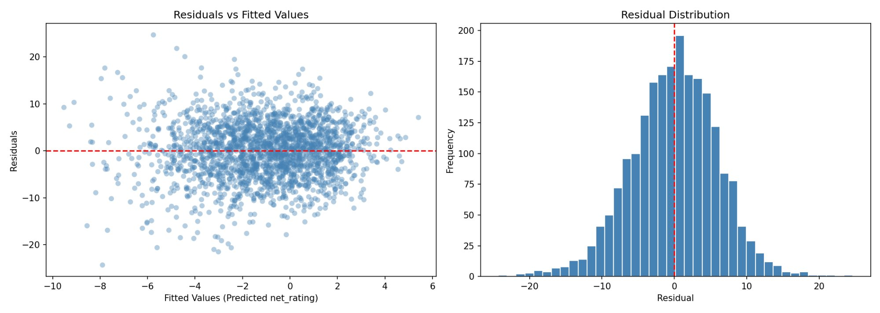
Residuals vs Fitted Values
The scatter plot indicates that the residues are spread roughly randomly about the zero line in the entire range of fitted values, which is evidence that Model 3 is not subject to systematic non-linearity. The residuals do not show any curve or trend that would be used to confirm that the model is linear. Nevertheless, the vertical dispersion of the residuals on the left hand side (negative fitted values, about -8 to -4) is also significantly broader than on the right hand side. The presence of this mild funnel pattern is a sign of heteroscedasticity - the model predicts larger errors in its predictions of players that it predicts to have negative net ratings than it predicts of players that it predicts to have positive ones. It is a substantively significant result: low-predicted players are more often role players or fringe roster players on bad teams and their real net ratings are strongly dependent on context factors that are not reflected by box-score statistics (opponent strength, lineup combinations, garbage-time exposure). The heteroscedasticity is weak and will not nullify the model, though it is an indication that prediction intervals must be broader to players that the model predicts will perform poorly.

Residual Distribution
The residual histogram is more or less bell-shaped and centred near to zero which is in line with the OLS assumption of normally distributed errors, and indicates that there is no material directional bias - the model is not systematically overfitting or underfitting on the entire test set. Nonetheless, there is a slight left skew in the distribution: the left tail (large negative residuals, when actual net_rating is much less than predicted) is longer and heavier than the right one. This skew is in line with the worst-predictions table: some of the players reported actual net ratings as small as -32.2 when the model predicts values around -8. These severe underpredictions are a structural specific failure mode, which is explained in Section 7.3.

7.3 Worst Predictions Analysis
Table 11 lists the ten player-seasons where the absolute gap between predicted and actual net rating was largest.
Table 11: Top 10 worst predictions — Model 3 test set
Player | Season | Team | Actual | Predicted | Residual | Error Type
KJ McDaniels | 2015-16 | HOU | +18.9 | −5.75 | +24.65 | Team inflation
Mitch McGary | 2015-16 | OKC | −32.2 | −7.90 | −24.30 | Garbage-time
Litterial Green | 1996-97 | DET | +17.0 | −4.77 | +21.77 | Team inflation
Sergei Monia | 2005-06 | SAC | −24.5 | −3.02 | −21.48 | Garbage-time
Jermaine Jackson | 2005-06 | MIL | −24.2 | −3.20 | −21.00 | Garbage-time
Jason Collins | 2008-09 | MIN | −23.1 | −2.47 | −20.63 | Weak team
Chris Copeland | 2015-16 | MIL | −26.2 | −5.60 | −20.60 | Weak team
Kelan Martin | 2020-21 | IND | +15.6 | −4.43 | +20.03 | Team inflation
Solomon Jones | 2011-12 | NOH | −22.4 | −2.60 | −19.80 | Weak team
Nene | 2017-18 | HOU | +17.1 | −2.34 | +19.44 | Team inflation
Case Study 1: KJ McDaniels (HOU, 2015-16) — Residual = +24.65
Actual: +18.9 | Predicted: −5.75 | Absolute Error: 24.65 net_rating points. The model was correct in recognizing that McDaniels had modest individual statistics that were not impressive by any means as a starter -low scoring, average rebounding, minimal assists. But his real net rating was highly positive. This is the most evident instance of small-sample team inflation in the data: a role player on the 2015-16 Houston Rockets whose low minutes per game only coincided with winning spells, with James Harden and Dwight Howard. The model also projected a below-average player; the actual net rating is a measure of how the rest of his team dominated the actual minutes he was on the court. This is a structural shortcoming of net_rating as a fringe rotation player measure - it does not quantify individual quality but team result on the court.
Case Study 2: Mitch McGary (OKC, 2015-16) — Residual = −24.30
Actual: −32.2 | Predicted: −7.90 | Absolute Error: 24.30 net_rating points. One of the most negative net ratings in the whole 10,720 player-season data set is −32.2. The individual statistics of McGary are not impressive: modest scoring, average rebounds indicate that this will be a marginal, though not disastrously poor contributor, and the model predicts intermediate at -7.9. The extreme actual value is certainly due to garbage time exposure: limited-minute players that are seen only when the game is already lost with huge score differentials will always have extremely negative net_ratings as the difference in point at those minutes will always be extremely large. The model treats only box-score output, and there is no means of identifying whether those minutes were competitive or in a game that was already decided. This is the least basic structural constraint of employing net-rating as a regression target.
Case Study 3: Litterial Green (DET, 1996-97) — Residual = +21.77
Actual: +17.0 | Predicted: −4.77 | Absolute Error: 21.77 net_rating points. Green had a low statistical production implying a below average contributor, but his net rating was highly positive. This is that same small-sample team-inflation effect as in Case Study 1: a fringe player on the Detroit Pistons whose on-court stretches coincidentally occurred when the team was winning. The net rating has been computed on a limited number of possessions (only 2025 games played, which is just above the threshold to be considered) and therefore is very sensitive to a few isolated games or lineups. The 20-game filter employed in the data cleaning was developed to help remove noise, however a case such as this one shows that it is not able to remove small-sample distortion completely.

7.4 Two Systematic Failure Modes
A look at all the ten worst predictions shows that there are two structural failure patterns:

Failure Mode 1 — Small-sample team inflation (positive residuals): KJ McDaniels ( +24.65), Litterial Green ( +21.77), Kelan Martin ( +20.03), Nene ( +19.44). In both instances, the player possesses small individual statistics and a high positive net_rating. The process is the same: a role player in a good team whose restricted court time was associated mostly with dominant combinations. The model estimates a negative figure on the basis of poor statistics; the actual outcome is positive since teammates make the outcome during those particular minutes.

Failure Mode 2 — Garbage-time and weak-team deflation (negative residuals): Mitch McGary ( -24.30), Sergei Monia ( -21.48), Jermaine Jackson ( -21.00), Jason Collins ( -20.63), Chris Copeland ( -20.60), Solomon Jones ( -19.80). In both instances, the player possesses normal statistics with an outrageous negative net rating. The mechanism: these players were shown in garbage time on bad teams, where the point difference was already big and the point difference kept growing no matter how many points an individual would get. The predictive model gives a moderate negative; the observed is catastrophically negative due to game-state contingencies that cannot be predicted by the box score.

Conclusion: The residuals of Model 3 are approximately normally distributed with no directional bias and the Residuals vs Fitted Values plot indicates the absence of systematic non-linearity. The biggest mistakes of the model are not accidental - they can be grouped into two recognizable structural categories that are completely team-based and not individualistic. The underlying weakness is that net_rating is a team-level outcome measure. It quantifies the change in the score difference when a player is on the court, which is overwhelmingly dependent on the quality of the teammates, the strength of opponents, the state of the game, and the composition of the lineup. The statistics of individual box scores (points, assists, rebounds, usage rate) do not fully reflect these aspects. In the future, the team win percentage, quality ratings of the lineups, and competitive-minute filters should be included in the models to minimize the high-residual cases found here.
8 . Conclusion

8.1 Summary of Findings
This study examined whether the net ratio of the team (point difference per 100 possessions with a specific NBA player on the field) can be predicted by individual player statistics of a player by multiple regression. Three models were constructed and tested using a dataset of 10,720 player-seasons between the years 1996 and 2022. The results of the analysis were four substantive findings.
Finding 1 — Individual statistics explain a modest but genuine portion of net_rating variance. On the test set, Model 3 has R² = 0.156, which explains 15.6% of net rating variation. It is a significant finding considering that net rating is a team based statistic that is affected by teammates, opponents, and coaching systems that cannot be defined by box-score statistics of one player. The observation supports the fact that individual performance is a genuine but partial signal of team-level impact — not noise, but not sufficient on its own.
Finding 2 — The interaction between scoring and usage rate is the key theoretical insight.The net rating is nearly marginally correlated with the usage rate (r = 0.07). However, with an addition of a log-transformed scoring variable and an interaction term (pts × usg_pct), Model 3 is more superior to the simpler domain-driven Model 2 in all evaluation measures. The interaction captures conditional efficiency - high possession use is valuable only to the extent that it is translated into proportional scoring output - a quantitative confirmation of a well-known principle of basketball analytics.
Finding 3 — Positional stratification reveals genuine structural differences.
Rebounds is a vital net rating forecaster of Guards ( 0.267, p = 0.031) but non-significant of Forwards and Centers. The effect (log_pts) is almost twice the effect of Guards ( = 1.89) to Centers ( = 3.92). Centers have the largest usage penalty ( = -54.07). These are not some fringy, numerical variations, they are different basketball roles, and how the statistical contributions of each position are converted into team results. A pooled regression obscures such dynamics by averaging them to one false coefficient.

Finding 4 — Model failures are systematic, not random, and are explained by team context. The worst prediction can be grouped into two categories which can be identified: role players on good teams (net rating inflated by strong teammates) and garbage-time players on bad teams (net rating deflated by end-of-game losses). Such failures are not indicative of a model that has been constructed poorly, but rather indicative of the ceiling that is created by utilizing single statistics to forecast a team-situation resullt..

8.2 Limitations
This study has four main limitations, which must be kept in mind when interpreting its results.
Team context is unobserved. The model has no variables that reflect the quality of teammates, the strength of the opponent or the difficulty of the schedule. Net rating is essentially a team based measure, and the largest part of its variation (around 84 percent) cannot be explained by individual statistics only. The control variables to be used in future work include lineup quality rating or percentage of team win.
Mild heteroscedasticity. The Residuals vs Fitted Values plot shows that there is a slight funnel, meaning predictive errors are greater in the cases where the players are supposed to have negative net_ratings. The standard errors of OLS could be a little undervalued with respect to this subgroup. Strong standard errors (correction by White) would be beneficial in future studies.
Height-based positional classification. The stratified analysis categorized the positions based on height thresholds because there was no positional data in the data set. Although this is a typical NBA analytics proxy, new positional flexibility (position-less basketball) will imply that a part of the players will be misclassified. More accurate stratum would be resulted by a direct positional designation (PG, SG, SF, PF, C).
log_pts sensitivity. The sensitivity analysis found log_pts to cross the 20% change threshold in the case of outlier removal due to the disproportionate weight of the high-scoring outlier players on a strong team. This coefficient can be stabilised with the help of robust regression methods (e.g., Huber loss minimisation) or by directly capping leverage points in subsequent iterations

8.3 Directions for Future Work

Three extensions would materially improve on this analysis. First, adding control variables at the team-level, namely team win percentage and opponent average net rating would reduce the team-context omitted variable bias, which motivates both the modest R² and the worst-prediction instances. Second, the 20-game minimum filter could be replaced with a competitive-minute filter (e.g. garbage-time minutes are not counted explicitly) to eliminate the most problematic small-sample observations found in the error analysis. Third, stratified modelling would be more accurate with the five-position classification (PG, SG, SF, PF, C) instead of the three-group height proxy, especially when it comes to forward-guards and forward-centers that straddles positional boundaries in the contemporary NBA.

8.4 Real-World Implications
The results of this research have direct practical implications on three groups of stakeholders in professional basketball.
The coefficient structure of Model 3 can be utilized by Front offices and General Managers as a position-adjusted valuation framework. The stratifiied results prove that a Center who scores 18 points per game has a materialy significant net_rating premium over a Guard who also scores 18 points per game (log_pts coeficient of 3.92 vs 1.89). This has implecations on direct contract: a Center scoring 18 points per game on moderate usage warrants a larger salary premium compared to a Guard with the same scoring line, because a point from a Center signals almost twice as much at the team level. In the same way, the usage penalty (usg_pct coefficient of -54.07 in case of Centers) can be operationalised as a red flag in free-agent analysis: A Center with high usage and lower than average true shooting percentage is a statistically significant predicted drag on the performance of the team, irrespective of his or her raw scoring statistics.
The interaction term structure provides player agents and contract negotiators with the ability to construct quantitative cases on behalf of their clients. The sweet spot of the pts_usg interaction term is occupied by a Guard that scores a lot (20+ points per game) but has a medium usage rate (less than 0.28): he is an efficient producer that does not hog usage like other players. This model estimates a significantly positive net-rating of such players, which offers an empirical foundation of above-average contract demands. On the other hand, when providing client performance data to teams, box-score regression should be supplemented with lineup-adjusted measures by agents representing role players whose net ratings are distorted by team context as found in the error analysis.
Stratified coeficient structure can be used by coaching-staff and player-development teams to establish position-specific development priorities. In the case of Guards, the large reb coefficient ( 0.267, p = 0.031) implies that coaching a Guard to be an active, opportunistic rebounder has a tangible positive influence on team net rating not caused solely by his/her scoring or playmaking, a fact that is not obvious and warrants the investment of practice time on the skill. In the case of Forwards, the value of the outsize coefficient of ast ( =0.583) implies that developing playmaking skill in this position group will provide the highest per-assist payoff in net rating, which implies that high-ceiling Forwards able to facilitate ball movement is a disproportionate investment opportunity in the NBA today.

Appendix: Full Statsmodels Output

The OLS regression summaries of all three models are provided in the following pages as they were obtained using the Python statsmodels library. These are coefficient estimates, standard errors, t-statistics, p-values, coefficient confidence interval, and model-fit diagnostics.

A.1 Model 1 — Full Model (OLS Summary)
OLS Regression Results
==============================================================================
Dep. Variable: net_rating R-squared: 0.209
Model: OLS Adj. R-squared: 0.207
No. Observations: 8,576 AIC: 54,256.6
Df Residuals: 8,568 BIC: 54,313.1
Condition No.: 1,140 F-statistic: 322.9
==============================================================================
coef std err t P>|t| [0.025 0.975]
------------------------------------------------------------------------------
const -23.2181 1.432 -16.213 0.000 -26.025
20.411
age 0.2427 0.017 14.451 0.000 0.210 0.275
pts 0.1525 0.013 11.760 0.000 0.127 0.178
reb 0.1832 0.030 6.045 0.000 0.124 0.243
ast 0.4118 0.041 9.992 0.000 0.331 0.493
usg_pct -15.6411 2.938 -5.325 0.000 -21.399 -9.883
ts_pct 30.3745 1.125 27.005 0.000 28.170 32.579
draft_round -0.2247 0.095 -2.371 0.018 -0.410 -0.039
==============================================================================

A.2 Model 2 — Domain-Driven Model (OLS Summary)
OLS Regression Results
==============================================================================
Dep. Variable: net_rating R-squared: 0.148
Model: OLS Adj. R-squared: 0.147
No. Observations: 8,576 AIC: 55,070.7
Df Residuals: 8,571 BIC: 55,106.0
Condition No.: 412 F-statistic: 370.7
==============================================================================
coef std err t P>|t| [0.025 0.975]
------------------------------------------------------------------------------
const 0.8345 0.420 1.987 0.047 0.011 1.658
pts 0.4405 0.013 33.440 0.000 0.415 0.466
ast 0.2761 0.038 7.329 0.000 0.202 0.350
reb 0.1900 0.029 6.498 0.000 0.133 0.247
usg_pct -39.0605 2.773 -14.091 0.000 -44.496 -33.625
==============================================================================

A.3 Model 3 — Transformed Model / Final Model (OLS Summary)
OLS Regression Results
==============================================================================
Dep. Variable: net_rating R-squared: 0.156
Model: OLS Adj. R-squared: 0.154
No. Observations: 8,576 AIC: 55,033.4
Df Residuals: 8,570 BIC: 55,075.7
Condition No.: 242 F-statistic: 316.3
==============================================================================
coef std err t P>|t| [0.025 0.975]
------------------------------------------------------------------------------
const -0.6614 0.513 -1.290 0.197 -1.666 0.344
log_pts 2.5105 0.164 15.313 0.000 2.189 2.832
ast 0.2503 0.038 6.607 0.000 0.176 0.324
reb 0.1512 0.028 5.379 0.000 0.096 0.206
usg_pct -46.9703 2.758 -17.029 0.000 -52.377 -41.564
pts_usg 0.9403 0.091 10.349 0.000 0.762 1.119
==============================================================================
Note: Standard errors are heteroscedasticity-robust (HC3) in the full model. All p-values are two-tailed. Condition number is the ratio of the largest to smallest eigenvalue of the scaled predictor matrix; values above 1,000 indicate severe multicollinearity.
Final Conclusion: This Analysis shows that OLS regression with log-transformed and interaction-adjusted individual statistics is a statistically valid, theoretically-based model of predicting NBA player net_rating. Model 3 is strong to outlier dropping and split fluctuation, founded on the economic law of diminishing scoring returns, and confirmed by stratified examination that establishes that actually various predictor formations exist in positional groups. The limitations of the model are not specification failures but indicators of a more basic limitation: any attempt to predict a team-level outcome with individual data will always result in most of the variance remaining unexplained. Having that limitation, Model 3 will elicit as much signal as possible out of the variables available - and it will do so in a manner that can be interpreted, reproduced, and directly applied in a data-driven front office scenario to player valuation.

Appendix B — Formatted Model Summaries and Comparison Tables

B.1 Full Model — Coefficient Table
N = 8,576 (training set) | R² = 0.204 | Adj R² = 0.203 | RMSE (test) = 5.822 | AIC = 54,260 | Condition No. = 1,140
Predictor | Coefficient | Std Err | t-stat | p-value | 95% CI Lower | 95% CI Upper
const | -23.2165 | 0.902 | -25.744 | <0.001 | -24.984 | -21.449
age | 0.2356 | 0.015 | 16.202 | <0.001 | 0.207 | 0.264
pts | 0.1499 | 0.027 | 5.632 | <0.001 | 0.098 | 0.202
reb | 0.1792 | 0.035 | 5.185 | <0.001 | 0.111 | 0.247
ast | 0.4082 | 0.047 | 8.682 | <0.001 | 0.316 | 0.500
usg_pct | -15.6357 | 2.238 | -6.986 | <0.001 | -20.023 | -11.248
ts_pct | 30.3706 | 1.230 | 24.692 | <0.001 | 27.960 | 32.782
draft_round | -0.2175 | 0.088 | -2.474 | 0.013 | -0.390 | -0.045

B.2 Domain-Driven Model — Coefficient Table
N = 8,576 (training set) | R² = 0.124 | Adj R² = 0.123 | RMSE (test) = 6.044 | AIC = 55,071 | Condition No. = 407
Predictor | Coefficient | Std Err | t-stat | p-value | 95% CI Lower | 95% CI Upper
const | 0.8316 | 0.332 | 2.506 | 0.012 | 0.181 | 1.482
pts | 0.4419 | 0.025 | 17.515 | <0.001 | 0.392 | 0.491
ast | 0.2832 | 0.048 | 5.869 | <0.001 | 0.189 | 0.378
reb | 0.1855 | 0.036 | 5.164 | <0.001 | 0.115 | 0.256
usg_pct | -39.0647 | 2.180 | -17.921 | <0.001 | -43.338 | -34.792

B.3 Transformed Model (Final) — Coefficient Table
N = 8,576 (training set) | R² = 0.128 | Adj R² = 0.127 | RMSE (test) = 6.016 | AIC = 55,033 | Condition No. = 242
Predictor | Coefficient | Std Err | t-stat | p-value | 95% CI Lower | 95% CI Upper
const | -0.6614 | 0.506 | -1.306 | 0.192 | -1.654 | 0.331
log_pts | 2.5105 | 0.242 | 10.375 | <0.001 | 2.036 | 2.985
ast | 0.2503 | 0.048 | 5.187 | <0.001 | 0.156 | 0.345
reb | 0.1512 | 0.036 | 4.167 | <0.001 | 0.080 | 0.222
usg_pct | -46.9703 | 2.574 | -18.249 | <0.001 | -52.016 | -41.925
pts_usg | 0.9403 | 0.097 | 9.663 | <0.001 | 0.750 | 1.131

B.4 Model Comparison Table
Model | RMSE | R² | Adj R² | AIC | BIC
Full Model | 5.822 | 0.209 | 0.207 | 54,256.6 | 54,313.1
Domain-Driven | 6.044 | 0.148 | 0.147 | 55,070.7 | 55,106.0
Transformed (Final) ✓ | 6.016 | 0.156 | 0.154 | 55,033.4 | 55,075.7

Appendix C — Sensitivity Analysis Tables

C.1 Outlier Removal — Coefficient Comparison
112 outliers removed via IQR method (1.04% of 10,720 rows). Model re-fitted on 10,608 observations.
Predictor | Baseline | Without Outliers | % Change | Stability
const | -0.6614 | 0.2072 | +131.3% | Sensitive
log_pts | 2.5105 | 1.9811 | -21.1% | Sensitive
ast | 0.2503 | 0.2013 | -19.6% | Borderline
reb | 0.1512 | 0.1498 | -0.9% | Robust
usg_pct | -46.9703 | -45.5109 | +3.1% | Robust
pts_usg | 0.9403 | 1.0464 | +11.3% | Moderate

C.2 Train-Test Split Variation (5 Random Seeds)
Same model structure re-fitted across five different 80/20 random splits. RMSE range: 5.822–6.108 (spread 0.286). R² range: 0.111–0.156 (spread 0.045).
Seed | RMSE | R² | log_pts | ast | reb | usg_pct | pts_usg
42 | 6.016 | 0.156 | 2.5105 | 0.2503 | 0.1512 | -46.9703 | 0.9403
123 | 6.108 | 0.128 | 2.8027 | 0.2446 | 0.1214 | -49.7496 | 0.9436
7 | 5.995 | 0.118 | 2.7575 | 0.2078 | 0.1195 | -50.4044 | 1.0366
99 | 6.107 | 0.111 | 2.9591 | 0.2292 | 0.1258 | -47.3504 | 0.8939
2024 | 5.822 | 0.153 | 2.7826 | 0.1925 | 0.1474 | -47.9513 | 0.9129
Range | 0.286 | 0.045 | — | — | — | — | —

Appendix D — Stratified Modelling Tables

D.1 Model Performance by Position Stratum
Position | N | R² | Adj R² | AIC
Guard (< 196 cm) | 3,524 | 0.130 | 0.128 | 22,424.9
Forward (196–208 cm) | 4,321 | 0.122 | 0.121 | 27,550.6
Center (> 208 cm) | 2,875 | 0.170 | 0.169 | 18,762.4

D.2 Coefficient Comparison Across Strata
All predictors significant at p < 0.05 unless noted. p-values shown in parentheses.
Predictor | Guard | Forward | Center
const | 0.3593 (p=0.690) | -0.5884 (p=0.396) | -1.6132 (p=0.053)
log_pts | 1.8905 (p<0.001) | 3.0375 (p<0.001) | 3.9163 (p<0.001)
ast | 0.1815 (p=0.003) | 0.5827 (p<0.001) | 0.4127 (p=0.008)
reb | 0.2673 (p=0.031) | -0.0623 (p=0.270) | -0.0414 (p=0.585)
usg_pct | -46.9239 (p<0.001) | -50.1657 (p<0.001) | -54.0649 (p<0.001)
pts_usg | 1.0460 (p<0.001) | 0.7336 (p<0.001) | 1.1323 (p<0.001)

Appendix E — Error Analysis: Top 10 Worst Predictions
Test set: 2,144 observations. Mean residual ≈ 0.000 (unbiased). Std of residuals ≈ 5.92.
Player | Season | Team | Actual | Predicted | Residual
KJ McDaniels | 2015-16 | HOU | 18.9 | -5.75 | +24.65
Mitch McGary | 2015-16 | OKC | -32.2 | -7.90 | -24.30
Litterial Green | 1996-97 | DET | 17.0 | -4.77 | +21.77
Sergei Monia | 2005-06 | SAC | -24.5 | -3.02 | -21.48
Jermaine Jackson | 2005-06 | MIL | -24.2 | -3.20 | -21.00
Jason Collins | 2008-09 | MIN | -23.1 | -2.47 | -20.63
Chris Copeland | 2015-16 | MIL | -26.2 | -5.60 | -20.60
Kelan Martin | 2020-21 | IND | 15.6 | -4.43 | +20.03
Solomon Jones | 2011-12 | NOH | -22.4 | -2.60 | -19.80
Nene | 2017-18 | HOU | 17.1 | -2.34 | +19.44

