NMAM INSTITUTE OF TECHNOLOGY, NITTE
Department of Information Science and Engineering

OPERATING SYSTEMS
PROGRAMMING ASSIGNMENT REPORT

Name:Chirag Sharma
USN:NNM24IS060
Course: Operating System
Github Repository:https://github.com/ChiragSharma1606/os-task-2

SUBMITTED TO
Dr Jason Elroy Martis
Associate Professor
Dept Information Science and Engineering,Nitte

1.Problem Statement and Objectives

1.1 Problem Statement
Operating systems depend on synchronization to control processes and threads that work with the same resources. Once several threads run at the same time, two difficulties usually appear: race conditions, and unsafe access to the shared data [1], [2]. In this assignment, the two classical problems, the Dining Philosophers Problem and the Readers–Writers Problem, have been implemented in Java using both semaphores and monitors [7], [8].
The work also demonstrates how synchronization keeps threads running safely, and how the execution of each thread can be followed through the HTML output produced by the programs.

1.2 Objectives
The main objectives set for this assignment are:

- Understand the ideas behind process and thread synchronization.
- Implement the Dining Philosophers Problem once with semaphores and once with monitors.
- Solve the Readers–Writers Problem using semaphores and again using monitors.
- Keep shared resources safe from simultaneous access by competing threads.
- Log the events that take place while each program runs.
- Produce HTML files that present the execution of every synchronization program

2.Readers-Writers Problem Using Semaphore

2.1 Introduction
The Readers–Writers Problem deals with several threads that operate on the same shared data. Readers only look at the data, whereas writers modify it. Any number of readers may work at the same time, but a writer must have the shared data entirely to itself [1].
A semaphore is the synchronization tool used here to regulate access to the shared resource and to coordinate readers with the writer [1], [8].

2.2 Implementation
The Readers–Writers problem has been solved in Java with semaphore objects [8]. A semaphore is used to grant or refuse access to the shared resource at any given moment.
The implementation also records the important events while the program is running, so it is easy to see when a particular reader starts and finishes reading, and when a writer is inside the shared data.

2.3 Working
- A reader first asks for permission to access the shared data.
- As long as no writer is modifying the data, the readers may read simultaneously.
- A writer has to obtain the semaphore permit before it starts writing.
- While one writer holds the permit, every other conflicting access is blocked.
- Once the operation is complete, the thread releases the semaphore so the waiting threads can continue.
In this way the semaphore coordinates the threads and keeps access to the shared data safe.

3.Readers-Writers Problem Using Monitor

3.1 Introduction
A monitor is a higher-level construct that bundles the shared data together with the operations acting on it, so that access to the resource is controlled from a single place [1].
In this section the same problem is solved with Java's monitor-based synchronization instead of semaphores [5], [6].

3.2 Implementation
Java's built-in synchronization facilities coordinate the readers and writers in this program [2], [5]. The shared variables are reached only through synchronized methods, and every event is written to the log as it occurs.
Because all of the synchronization logic sits inside one monitor, the code stays easy to follow, and it is straightforward to see how access to the shared resource is being controlled.

3.3 Working

- A reader or a writer asks the monitor for access to the shared resource.
- The monitor looks at its internal state to decide whether the request may be granted.
- While no writer is active, the readers are allowed to read concurrently.
- A writer receives exclusive use of the shared resource while it makes its changes.
- When the operation is finished, the monitor admits the next waiting thread so that it can proceed.

The whole arrangement shows how monitors can coordinate threads without any explicit semaphore handling

4. Dining Philosophers Problem Using Semaphore

4.1 Introduction

The Dining Philosophers Problem is one of the best-known synchronization problems in operating systems [1]. Five philosophers sit around a table, alternating between thinking and eating. To eat, a philosopher needs two forks, and each fork is shared with one neighbour on either side.
If every philosopher reaches for both forks at the same moment, each one holds a single fork while waiting for the other, and nobody can move ahead. This situation is called deadlock [1].

4.2 Implementation

This program solves the Dining Philosophers problem in Java by giving every fork its own semaphore [8]. The semaphores control how the philosophers interact with the forks, so two philosophers can never pick up the same fork at once.
Every action of every philosopher, thinking, waiting for the forks and eating, is written to the log.

4.3 Working

- Each philosopher begins in the thinking state.
- When a philosopher decides to eat, the program attempts to pick up the two forks lying beside that philosopher.
- A semaphore guards each fork, so only one philosopher can be holding it.
- The philosopher eats only after both forks have been acquired.
- After the meal is over, the philosopher sets both forks down again.
- The released forks can now be taken up by the neighbouring philosophers, and the cycle continues.

This is how semaphores are used to synchronize access to shared resources. Whether deadlock occurs depends on the order in which the forks are acquired.

5. Dining Philosophers Problem Using Monitor
5.1 Introduction
The same problem can also be solved with a monitor [1]. Instead of giving each fork a semaphore of its own, the monitor holds the state of the whole table and decides which philosopher is allowed to eat.
It lays down the rules for taking the forks and decides when a philosopher has satisfied them.

5.2 Implementation
In this Java program a monitor-based technique controls both the philosophers and the forks [5], [10]. Before a philosopher is allowed to eat, the program tests whether the necessary conditions hold, which includes checking the state of the two neighbours.
Every change of state is written to the log, so a whole run can be traced philosopher by philosopher.

5.3 Working

- A philosopher starts in the thinking state.
- When the philosopher becomes hungry, the monitor checks whether the conditions for eating are satisfied.
- If they are, the philosopher moves straight into the eating state.
- If they are not, the philosopher has to wait until eating is permitted.
- When the meal is finished, the philosopher releases everything by updating the shared state, and the two neighbours can be allowed to eat in turn.

The implementation shows that a monitor on its own can handle a shared resource, without any separate semaphore objects.

6.HTML Output Generation

6.1 Introduction
So that a run can be examined afterwards, the Java programs write their output in HTML form instead of printing it to the console. The execution events are collected while the program runs and are then turned into an HTML file.
The result is a readable record of everything the program did while it was running.

  - Working

The program works in the following sequence:

- The Java program executes the synchronization code.
- Each important event is appended to the log as it happens.
- At the end of the run, the collected log is converted into HTML.
- The program writes that HTML text into a file of its own.
- The file can be opened in any web browser, where the events can be read in order.

One HTML file is produced for each of the four synchronization implementations.

7.Execution Results
All four Java programs were compiled and run separately, and the HTML files they produced were used to study the events of each execution.

7.1 Readers–Writers Using Semaphore

The timeline below shows readers and writers taking turns under semaphore control: readers R1 and R2 overlap safely, writer W1 is given exclusive access once both have finished, and reader R3 then has to wait for W1 to release the semaphore.

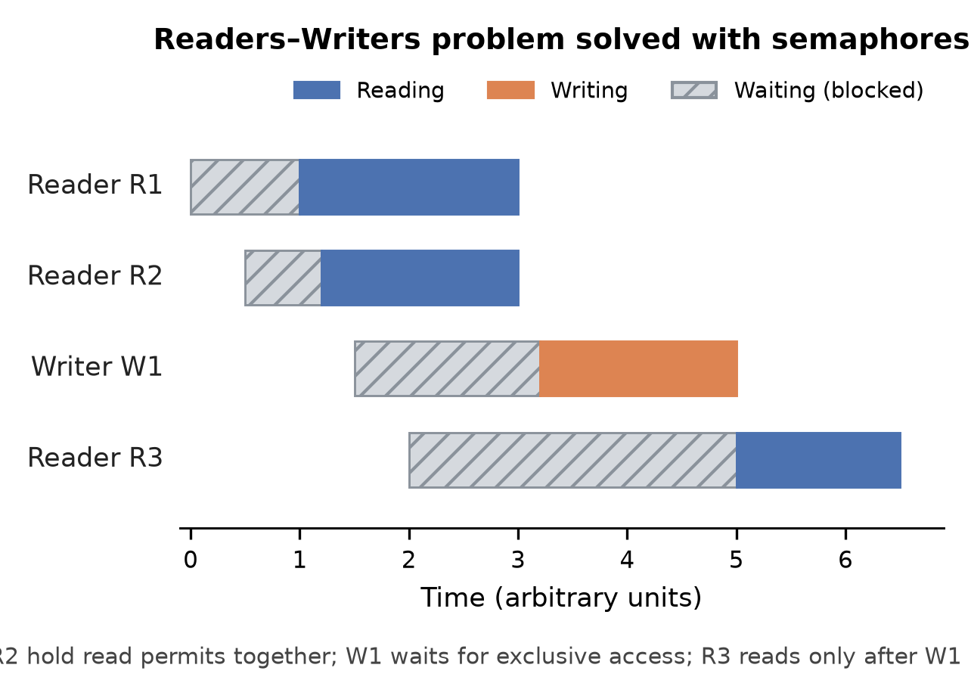
7.2 Readers–Writers Using Monitor

With monitor synchronization the coordination is done through synchronized methods. As the timeline shows, writer W1 enters the monitor as soon as reader R1 leaves, and the readers R2 and R3 that arrive meanwhile queue behind the writer instead of reading during its turn.
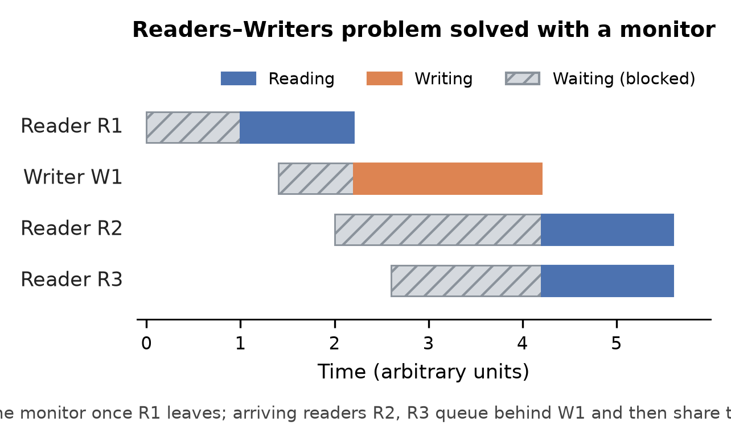

7.3 Dining Philosophers Using Semaphore
The figure illustrates the semaphore implementation of the dining philosophers problem: every fork is guarded by its own semaphore, and in the instant shown philosophers P1 and P3 are eating together while their neighbours are blocked.
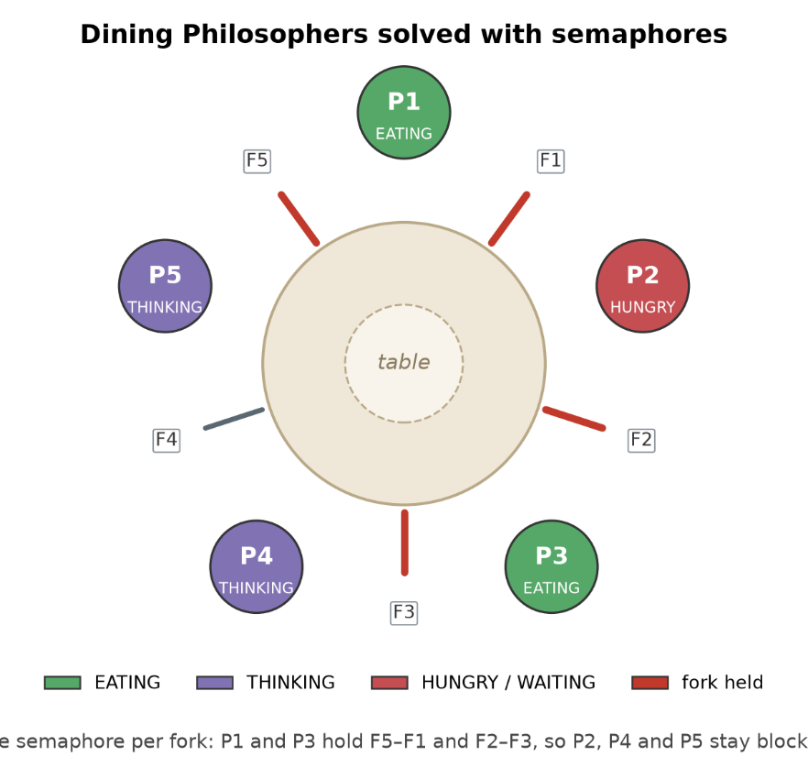
7.4 Dining Philosophers Using Monitor
This figure shows the monitor mechanism regulating the philosophers’ states and the allocation of the forks; the state of every philosopher is kept in one shared array inside the monitor
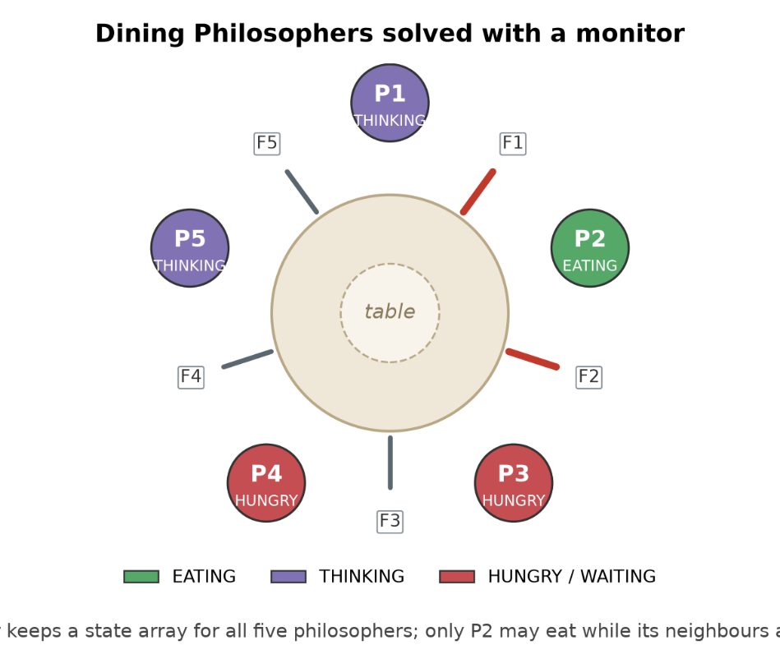

8. Operating System Concepts Used

8.1 Process and Thread Synchronization
Threads that work with a common resource have to be synchronized, otherwise their operations may overlap in unwanted ways [2], [4], [9]. Synchronization organizes the order of their work and prevents such conflicts.

8.2 Race Condition
A race condition occurs when the output of a program depends on the particular order in which the threads happen to run and to access and modify shared variables [1], [2].

8.3 Semaphore
Semaphore is a synchronization object which is probably used to control access of threads to shared resources [1], [8]. It is shown that the thread acquires the permit before entering the critical section and releases it after leaving it according to some rules.

8.4 Monitor
A monitor provides a natural instrument for several threads to share access to a resource, according to (most of) the literature [1]. In Java, it is probable that each synchronized method and synchronized block will use a monitor, locking the object's monitor (intrinsic lock) [3], [5], [6].

8.5 Mutual Exclusion
Mutual exclusion is the rule that guarantees only one thread holds a protected resource at any given moment [1].

8.6 Deadlock
A deadlock is stated to happen when threads keep waiting for resources that are being held by other threads causing them to wait forever [1]. The Dining Philosophers Problem is an example of an abnormal case where acquiring of resources in the wrong order leads to a deadlock [1].

9. Comparison of Semaphore and Monitor

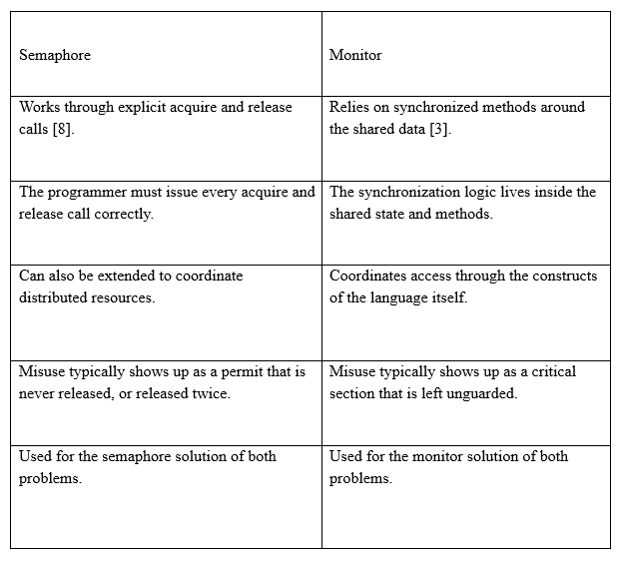

Both strategies are considered to be equally appropriate for the thread synchronization, according to the study in [1]. It seems that the program style and the needs of shared resource handling determine the choice between them.

10. Conclusion

In this task, a solution for the Dining Philosophers and Readers-Writers problems were made in Java using semaphores and monitors. This task demonstrates that a good grip on the understanding of synchronization is achieved, handling the threads and coordinating the access to shared resources.
The results also show that a good grip on mutual exclusion is also gained, and that for an improper handling of the shared resources, a deadlock can occur.
The fact that HTML output is generated gives a more accurate visualization of the log for the execution events.

11. AI Usage Summary

AI tools were also used to assist in the completion of this assignment. ChatGPT (OpenAI) was used to understand a range of concepts around synchronization in an OS, including how they work when applied to problems such as the Dining Philosophers Problem and Readers-Writers Problem (information on semaphores and monitors). This process was also used to understand Java code, and to identify fixes to code errors.
In addition, use was made of Claude (by Anthropic) to support in selecting relevant references and citations for the report. Please be aware that any references and citations identified with the use of this tool will be validated before they are included.
In summary, the report has made use of AI tools as helpers in the student's learning and preparation. The programs implemented, the results of execution and the explanations in the final report are meant to be the student's work.

12. References

- Silberschatz, A., Galvin, P. B., and Gagne, G. Operating System Concepts, 10th Ed., Wiley, 2018. Available at: https://codex.cs.yale.edu/avi/os-book/OS10/
- Oracle. Java Tutorials: Synchronization. Available at https://docs.oracle.com/javase/tutorial/essential/concurrency/sync.html
- Oracle. Java Tutorials: Synchronized Methods. Retrieved from https://docs.oracle.com/javase/tutorial/essential/concurrency/syncmeth.html
- Oracle. Java Tutorials: Thread Objects. Retrieved from https://docs.oracle.com/javase/tutorial/essential/concurrency/threads.html
- Oracle. Java Tutorials: Intrinsic Locks and Synchronization. Retrieved from https://docs.oracle.com/javase/tutorial/essential/concurrency/locksync.html
- Oracle. Java Language Specification, Chapter 17: Threads and Locks. Retrieved from https://docs.oracle.com/javase/specs/jls/se11/html/jls-17.html
- Oracle. Java SE Documentation: Concurrency. Retrieved from https://docs.oracle.com/en/java/javase/25/core/concurrency.html
- Oracle. Java Platform, Standard Edition API Specification: Semaphore. Retrieved from https://docs.oracle.com/en/java/javase/25/docs/api/java.base/java/util/concurrent/Semaphore.html
- Oracle. Java Platform, Standard Edition API Specification: Thread. Retrieved from https://docs.oracle.com/en/java/javase/25/docs/api/java.base/java/lang/Thread.html
- Oracle. Java Platform, Standard Edition API Specification: Object. Retrieved from https://docs.oracle.com/en/java/javase/25/docs/api/java.base/java/lang/Object.html

