Pseudocode MCQ

Q1) What will be the output of the following pseudocode for p = 3 and q = 4?
int fun1(int p, int q)
if(q EQUALS 0)
return 0
if(q mod 2 EQUALS 0)
return fun1(p + p, q/2) .
return fun1(p + p, q/2) + p
End function fun1()
A. None of the options
B. 7
C. 12
D. 8
Q2) What will be the output of the following pseudocode?
Integer x, y, Z, a
Set x=2,y=1,z=5
a = (x AND y) OR (z + 1)
Print a
A. 5
B. 3
C. 2
D. 1

Q3) What will be the output of the following pseudocode for a = 2, b = 3?
doSomething(Integer a, Integer b)
if(b EQUALS 1)
return 0
else
return a+ doSomething(a, b-1)
End function doSomething()
A. 3
B. 4
C. 2
D. 1
Q4) What will be the output of the following pseudocode?
Integer a, n, sum, q, r
Set a=123, n=0, sum=0
Set q=a
while (q mod 10 NOT EQUALS 0)
n=n+1
q=q/10
End while
Print n
while (a greater than 0)
r=a mod 10
sum =sum + r
a =a/power(10, n- 1)
End while
Print sum
A. 3 2
B. 6 4
C. 6 5
D. 3 4
Q5) What will be the output for the following pseudocode?
Integer a=5,b=8,c
if(a>8 OR b < 7)
c=a+b
elseif(a + b > 9)
c=a-b
else
a=a+5
c=c-2
end if
a=a+b
Print a and c
b=b-5
A. None of the mentioned
B. 5 -3
C. 5 1
D. 13 -3
Q6) What will happen when following pseudocode is executed?
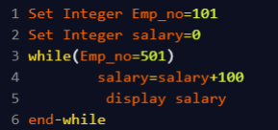
A. Code executes successfully and value of salary is displayed once.
B. Code executes successfully and nothing is displayed.
C. Code executes successfully and value of salary is displayed infinite number of times.
D. Compile time error.

Q7) What will happen when following program is executed?
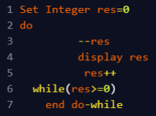
A. Code will run infinite number of times.
B. The program will not enter the loop.
C. Code will execute and value of res will be displayed twice.
D. Code will execute and value of res will be displayed once.
Q8) How many times will ‘#’ be displayed?
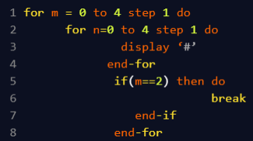
A. 15
B. 1
C. 2
D. 8

Q9) What will be the output of the following pseudocode?
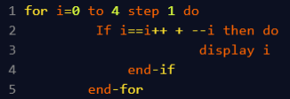
A. 0
B. 3
C. 1
D. 2
Q10) What will be the output of the following pseudocode?
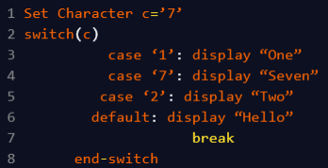
A. SevenTwoHello
B. OneHello
C. SevenTwo
D. Seven

Q11) What will be the output of the following pseudocode?
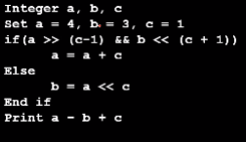
A. 3
B. 5
C. 8
D. None of these
Q12) What will be the output of the following pseudocode?
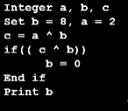
A. 3
B. 0
C. 10
D. 2

Q13) What will be the output of the following pseudocode?
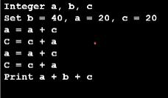
A. 40
B. 100
C. 300
D. None of these

Q.14) What will be the output of the following pseudocode?
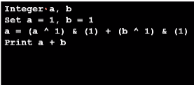
A.1
B. 2
C. 0
D. None of these

