**Nouveau Scrum Project Management Scenario**

**Group 25: Chirag Soni, Deepika Tripathi, Harsh Jain, Srinath Karimpuzha**

***Nouveau Scrum*** will allow efficient project management for software developers and managers following agile programming processes; with additional benefits of chatroom services and the ability to utilize the project’s git repository without the need to install git on the user’s machine. The first scenario describes account management of users involved in multiple teams which includes authentication of the user to enter the product. Also, it describes about creation of a new project along with developer or managerial level privileges to edit project where he/she can create sandbox, product backlog, stories and tasks.

The key feature of this scenario include Registration of a new user to the product and eventually logging into product, creating a user’s profile, updating it for every project the user is involved in and creating or managing user stories, tasks and product backlog.  
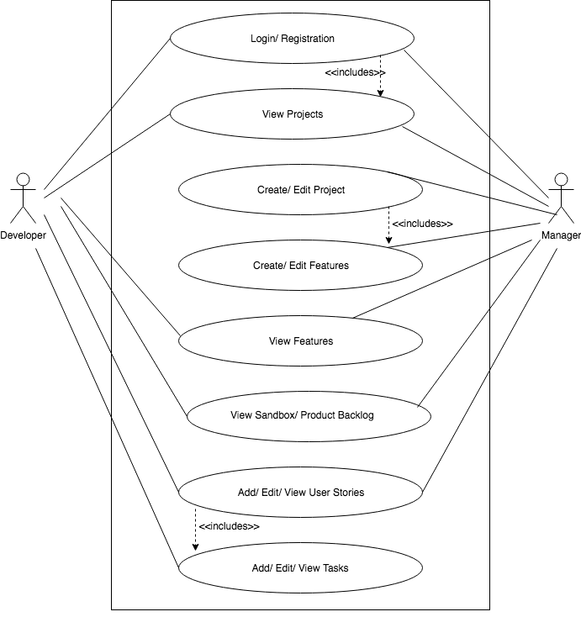

**Figure 1: Project Management**

**Scenario: Project Management:**

* *Registration/ Login* - Before being able to access the product for the first time, the user is required to register an account. The registration will require the user to enter into textboxes the username and password they wish to have. If there is an existing account and attempting to access the product, the user is prompted to enter his/her username and password which he/she created in the registration into the textboxes provided. This will allow the user to access his/her account.
* *Create / Edit Project:*New projects can be created by manager only. When creating a project, the manager is able to give the project a name, add other developers based on their profiles to associate them to the project. After entering that information and confirming, the project will appear in the projects toolbar on the side of the page. All project information may be viewed and/or edited later.
* *View Project*: When the user (manager or developer) clicks on a project on the side of the homepage, they are able to view the project. The user is able to view whatever is associated with the project, like the sandbox, project backlog, and stories/tasks.
* *Create / Edit Project Features*: If the user is a manager he/she will be able to manage the features of the project including functional and non-functional requirements.
* *View Features*: The features of the project are the main components of the project which are required to be in the finished version. Either the manager or developer can view features while the project progresses further.
* *View Sandbox/ Product Backlog*: After the project is created, the user will be able to view the sandbox and product backlog.
* *Add/ Edit / View User Stories:*If the user is a developer or a manager (as set in the profile page), he/she is able to create the user stories. Each user story will have a time estimate to complete it and an option to assign it to him/her to if the user is a manager, he/she will be able to assign a story to some other team member.
* *Add/ Edit / View tasks:* Only if the user is a developer, he/she shall be able to create subtasks under a particular story.