**Nouveau Scrum Release and Sprint Management Scenario**

**Group 25: Chirag Soni, Deepika Tripathi, Harsh Jain, Srinath Karimpuzha**

Release 2 of ***Nouveau Scrum*** will allow efficient release and sprint management with respect to user stories and tasks for its users. This scenario focus on creating:

* Standard agile components of a project like sandbox, product backlog, release plan, sprint plan and, timeline.
* The links between these different agile components and the ones developed in the first scenario like task, user stories.

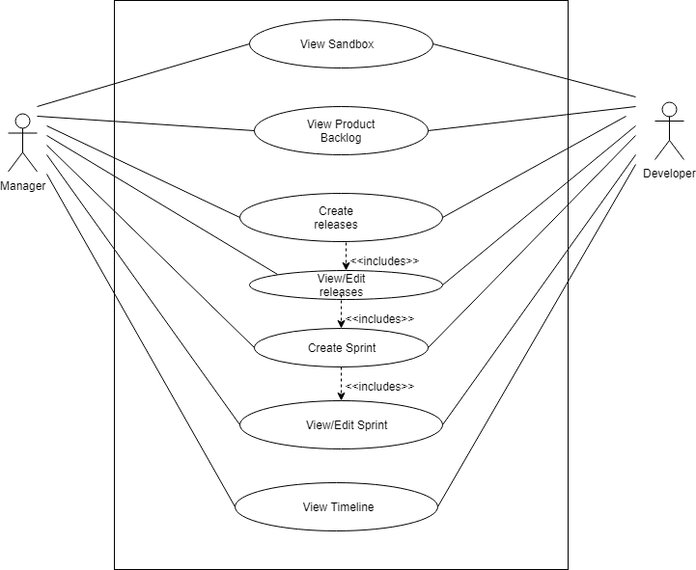

**Figure 1: Release and Sprint Management Scenario**

**Scenario: Release and Sprint Management:**

* *View Sandbox*: After the project is created, the user will be able to view the sandbox. Sandbox includes the stories that are over qualified to be achieved in a certain span of time in a particular release plan. The scope of these stories can be wide enough and can be further broken down into many sub-stories and accepted in any sprint plan.
* *View Product Backlog:* User can view the stories in product backlog. Stories in the product backlog are the ones which cannot be accomplished in the current sprint plan and can be moved so as to be completed in the later sprint plans of any release plan.
* *Create Releases*: The user will be able to create and set releases for a product in development. Start and end dates can be defined while creating different releases.
* *View/ Edit Releases*: Release once created will have an option to update the release date plan and the sprints linked to each release plan.
* *Create Sprint*: This feature of the project helps user to set a new sprint plan.
* *View/Edit Sprint*: After the sprint is created for a particular release, the user will be able to change the timeline of that sprint as and when required. The flow of traversing through different sprint plans leads user to the stories and its sub tasks.
* *View Timeline:* The overview of the components like release plan and sprint plan is viewed under the timeline.
* Apart from the above functionalities this scenario focuses on the linkage functionalities between:

1. User story and tasks under each story.
2. User story and its location (like its respective sprint and its parent release plan).
3. Releases and its respective sprints.