Date : 08-09-2021

Session : NodeJs Npm and nodemon

Given Task : NodeJs npm and its commands

My Task : I have refer npm, nodemon and its commands. And implemate table and form using adminlte.

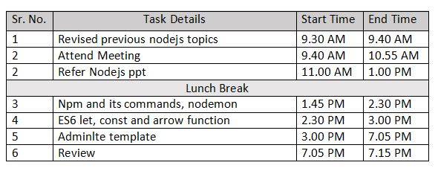

**Output**

