Date : 10-08-2021

Session : Introduction to CSS

Given Task : Basic CSS Properties

My Task : I have build registration form and pizza ordering form using Html and CSS properties.

**Output-1**

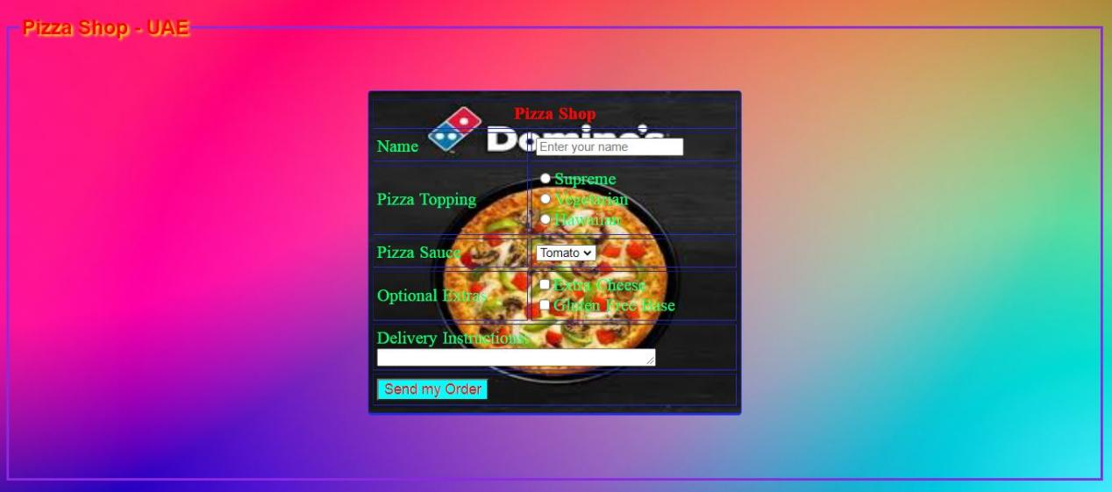

**Output-2**

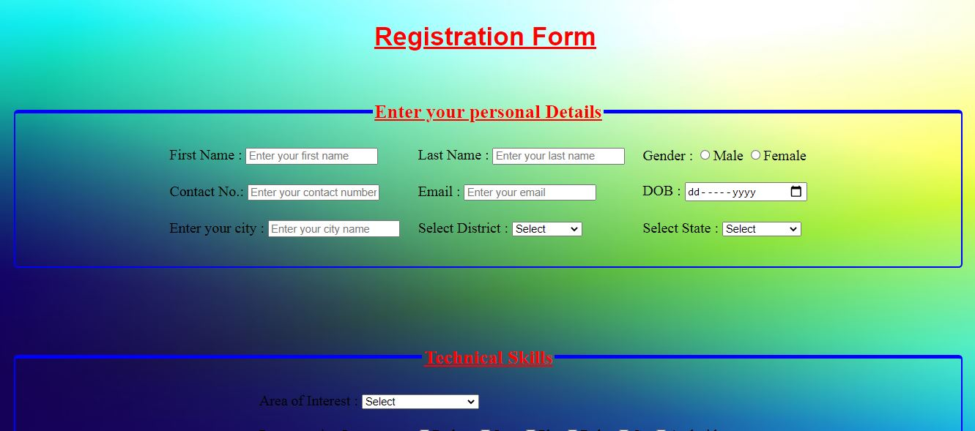

**Output-3**

