Date : 11-08-2021

Session : CSS and CSS3 Properties

Given Task : Custom Web Pages

My Task : I have build home page, about page and conatct page using Html and CSS properties.

**Output-1**

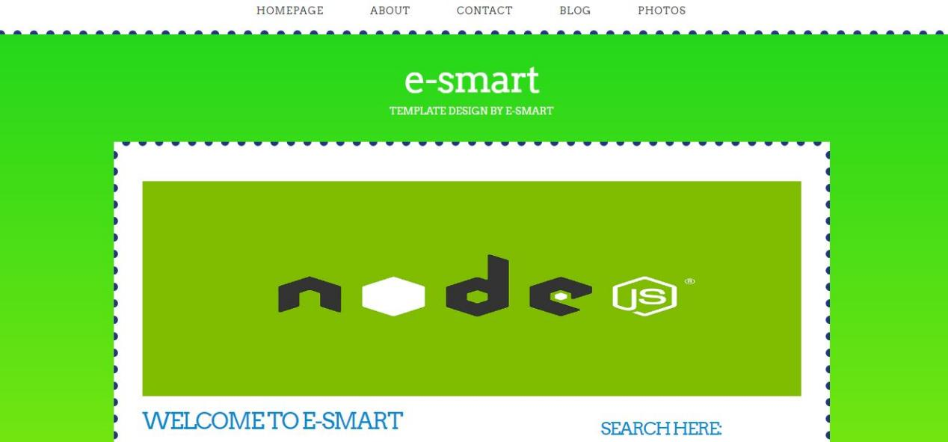

**Output-2**

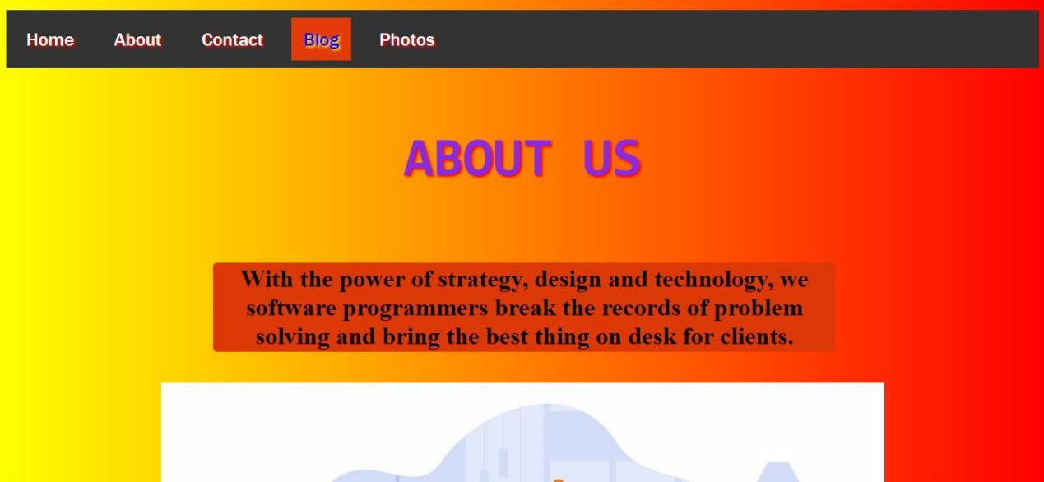

**Output-3**

