Date : 13-09-2021

Session : Node JS core modules

Given Task : Node JS core modules - file system, os, etc.

My Task : I have done Nodemailer with attachments task and done some examples of nodejs core modules.

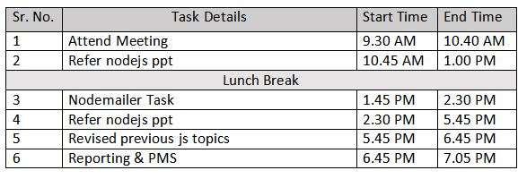

**Output**

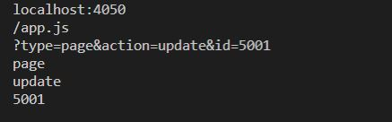

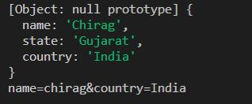

**13C**

**13E**

**13F**