Date : 14-09-2021

Session : Introduction of Express JS

Given Task : Introduction of Express JS

My Task : I have read express installation, simple hello world practical, routing, etc.

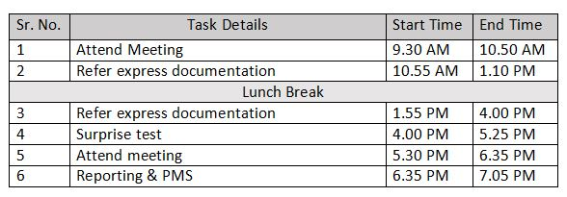

**Output**

**14A**

**14B**

**14C**

**14D**