Date : 19-08-2021

Session : JavaScript Event Listener

Given Task : Event Listener and Event Handlers

My Task : I have done task with event listeners and build form with event listeners.

**Output**

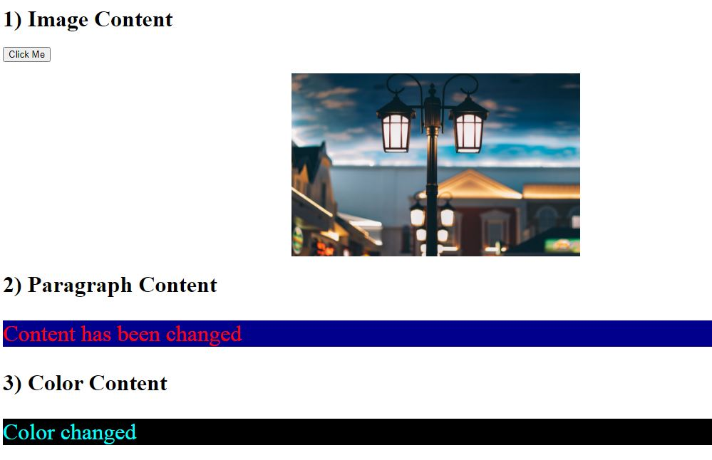

**19C**

