Date : 22-09-2021

Session : Session and Cookie

Given Task : Session and Cookie and Session counter app

My Task : I have done implementation of session and cookie and counter app.

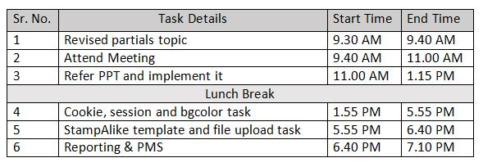

**Output**

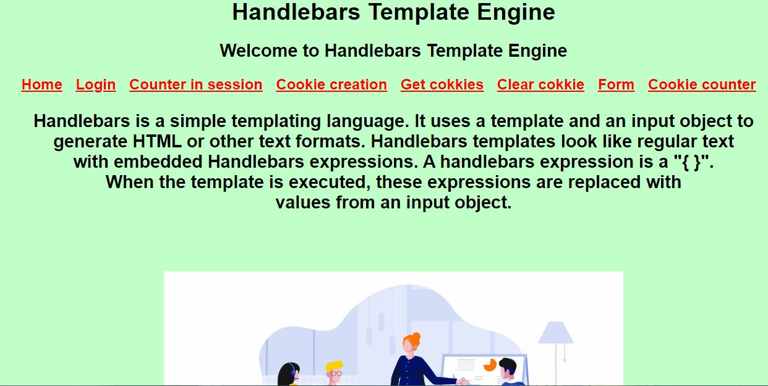

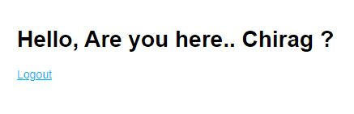

**22C**

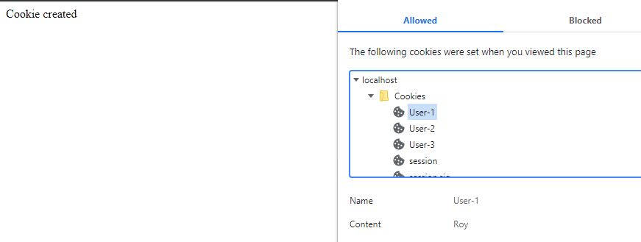

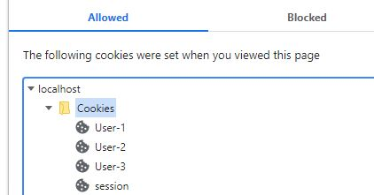

**22F**

**22G**

