Date : 24-09-2021

Session : CRUD operation with mongooes

Given Task : CRUD operation with mongooes

My Task : I have done implementation of CRUD operation with mongooes.

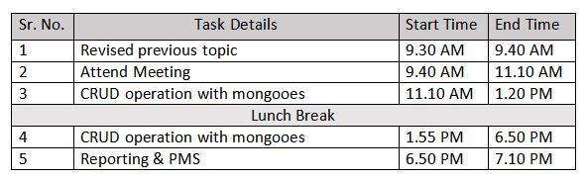

**Output:**

