Date : 31-08-2021

Session : Simple Jquery Plugins

Given Task : Simple Jquery Plugins

My Task : I have cover the jquery plugins like Jquery sweet Alerts, Jquery Toast, charts.

**Output**

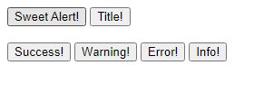

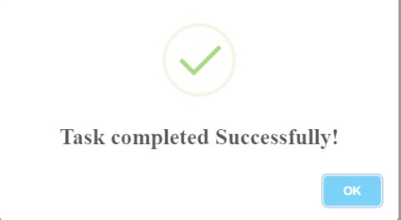

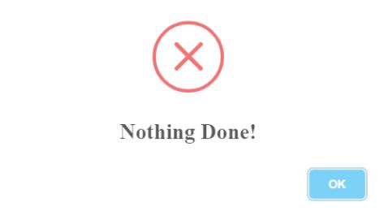

**31D**

