Date : 09-08-2021

Session : Html Forms and Tables

Given Task : Basic Tables and Forms

My Task : I have build various tables like Students Data, Sales Data, Time Table, etc and forms like Registration form.

Output :

**Output-1**

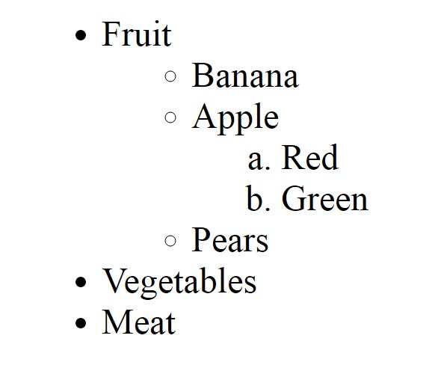

**Output-2**

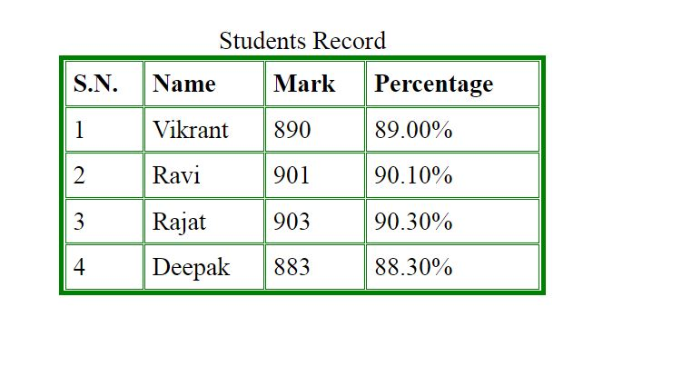

**Output-3**

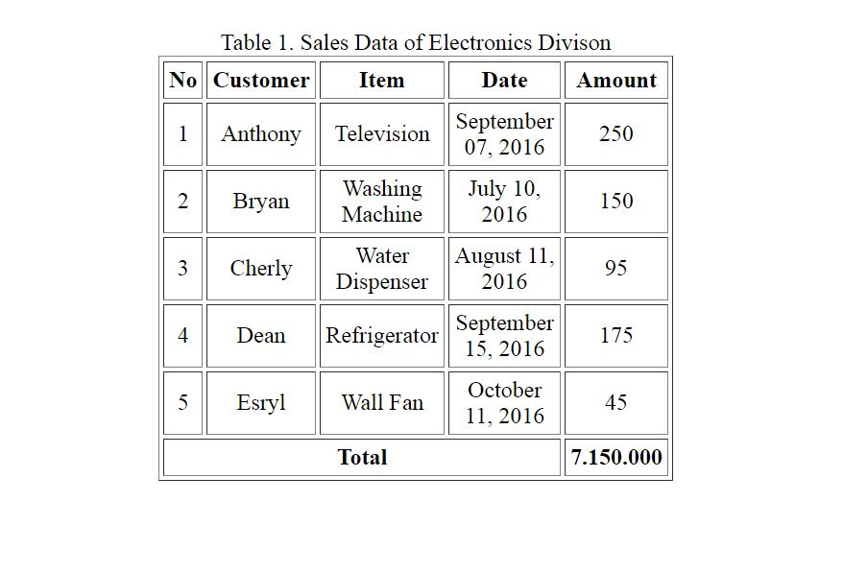

**Output-4**

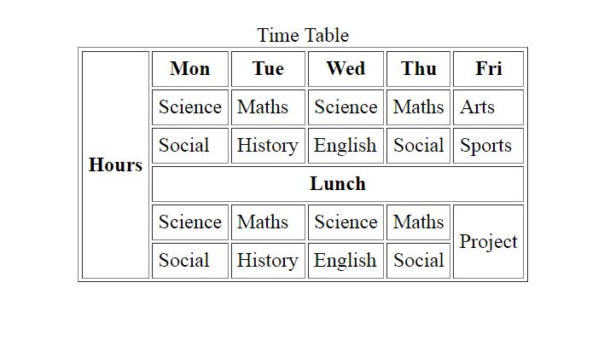

**Output-5**

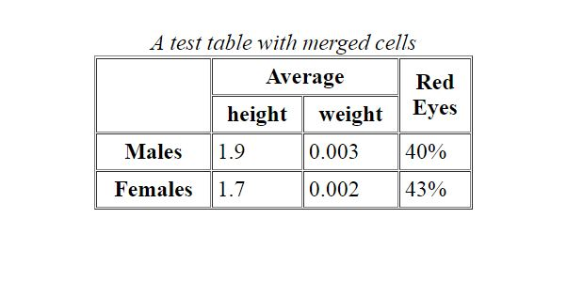

**Output-6**

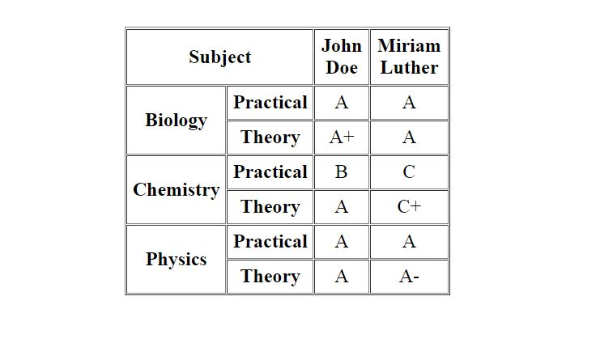

**Output-7**

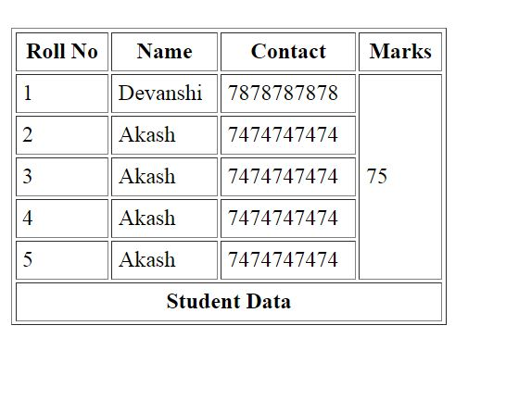

**Output-8**

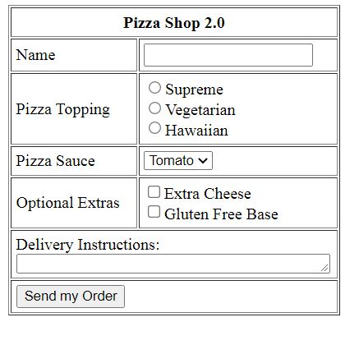

**Output-9**

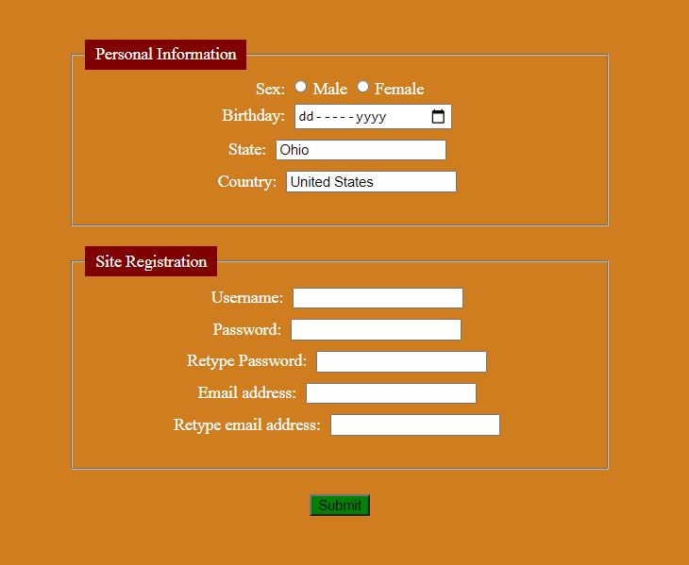

**Output-10**

