Date : 12-08-2021

Session : CSS and CSS3 Properties

Given Task : Build Web Pages

My Task : I have modified and build home page, about page, photos page , contact form and sign up form using Html and CSS properties.

**Output**

**Home Page:**

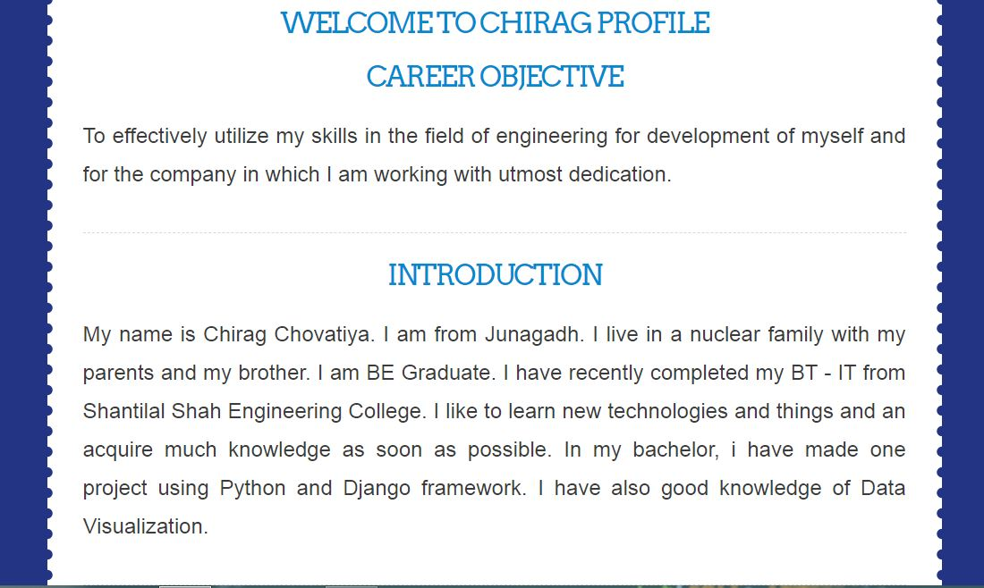

**About Page:**

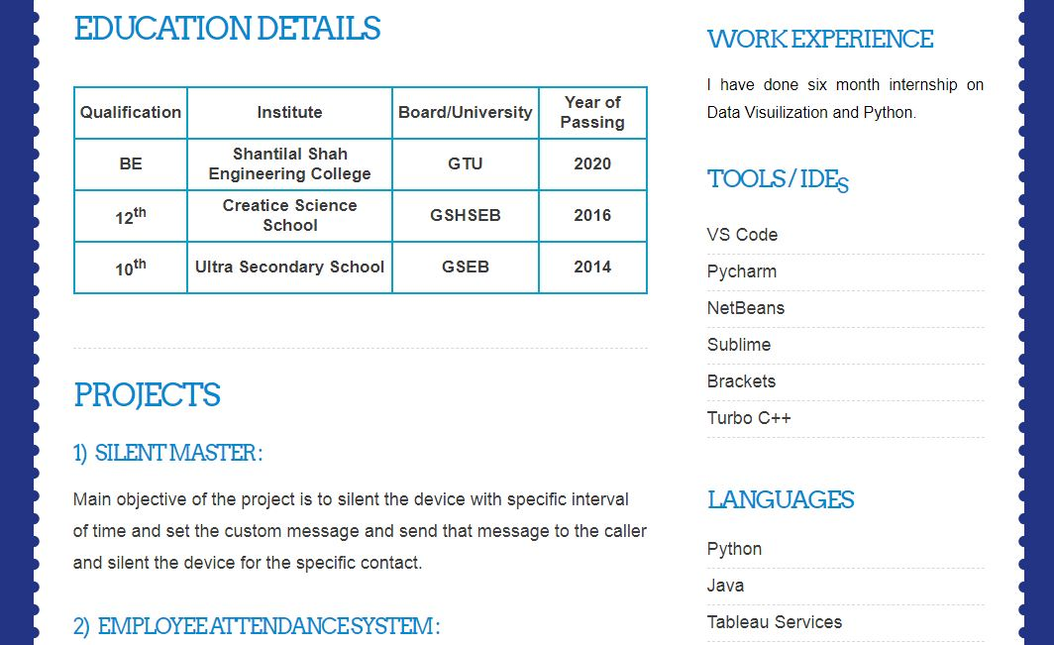

**Photos Page:**

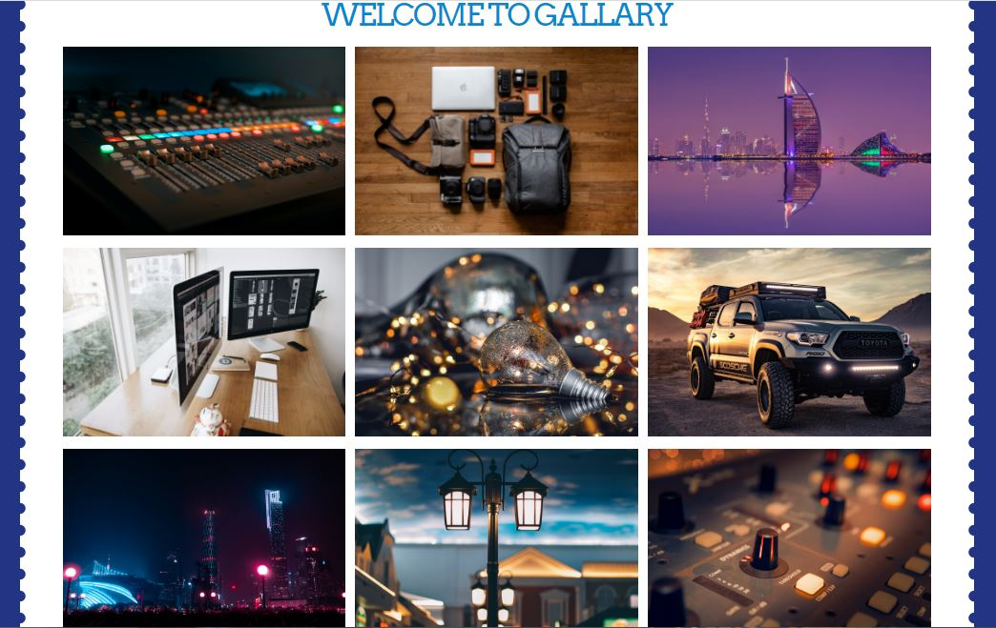

**Contact Page:**

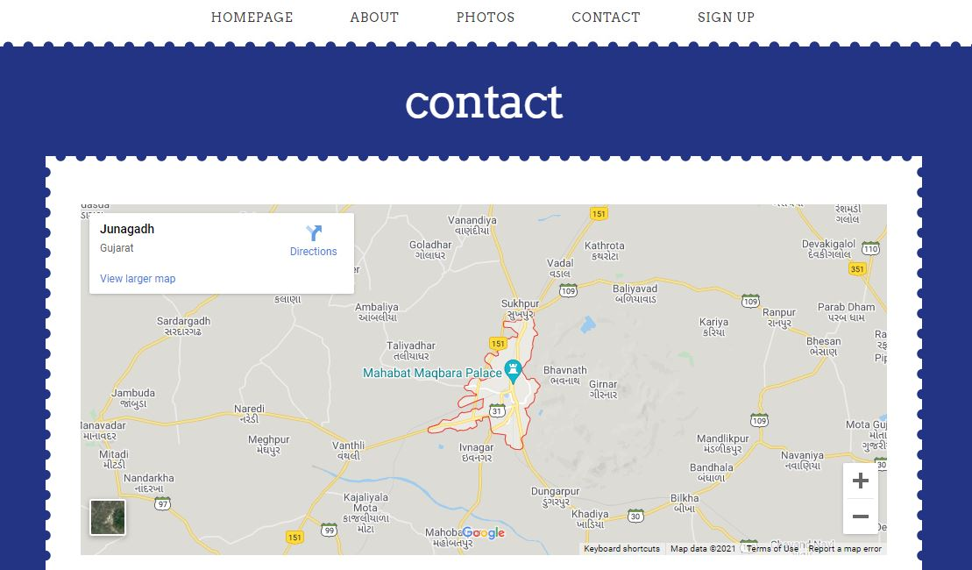

**Sign Up Form:**

