Date : 09-09-2021

Session : NodeJs Nodemailer and ES6 basics

Given Task : Nodemailer and adminlte template

My Task : I have successfully installed and run nodemailer. And work with adminlte template.

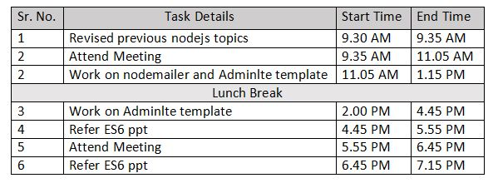

**Output**

