Date : 10-09-2021

Session : Advanced CSS Gradients and Text-Shadow

Given Task : CSS Gradients and Text-Shadow

My Task : I have done some examples of gradients and text-shadow.

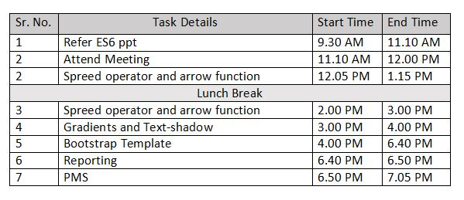

**Output**



