Date : 15-09-2021

Session : Node JS documentation

Given Task : Node JS documentation

My Task : I have implement css flex-box and installed express-generator successfully.

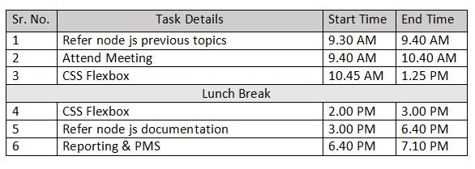

**Output**



