Date : 20-09-2021

Session : Express req.params and req.query

Given Task : Nodemailer with handlebars

My Task : I have done the implementation of the Nodemailer with handlebars.

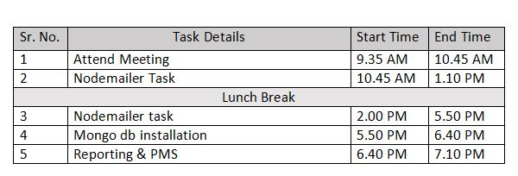

**Output**

