YUVA INTERN — NSDC
Virtual Data Analysis Intern — E-Governance & Digital Services
Week 1 Task
Strategic Planning for E-Governance Data Analysis
Duration: 31-Jul-2026 to 11-Sep-2026 (6 Weeks)
Prepared by: Chirag Chhabra | Rajasthan

1. Executive Summary
The objective of this report is to develop a comprehensive strategic plan for analyzing digital service performance and efficiency within the e-governance domain, using publicly available datasets. Under the Digital India mission, two flagship digital service delivery platforms — DigiLocker (document access) and Common Service Centres/CSC (last-mile service delivery infrastructure) — form the central focus of this analysis, as together they represent the complete landscape of 'digital service adoption versus delivery infrastructure'.
This strategic plan identifies key performance indicators, outlines the methodology for data collection and cleaning, proposes a visualization and statistical framework, and provides a 6-week timeline that will structure all deliverables across the internship.

2. Research & Scoping

2.1 Data Sources Identified
Two official, publicly available Open Government Data (OGD) sources have been chosen, both of which capture different dimensions of digital governance at state/UT-level granularity:
- DigiLocker Registered Users (State/UT-wise) — Rajya Sabha Session 265, Unstarred Question 543 (Official Government Data). This dataset gives the count of registered users of the DigiLocker platform in every state/UT, which is a direct measure of digital document adoption.
- Common Service Centres (CSC) — State-wise Active CSCs, June 2026 (CSC e-Governance Services India Ltd., official CSC portal). This dataset provides functional CSCs (rural + urban split), total Gram Panchayats (GPs), and GP-level registered/functional CSC coverage ratios.
Both datasets cover 36 states/UTs, making a complete national-level analysis possible without any regional gap.

2.2 Scope of Analysis — Key Performance Indicators
The scope of analysis is defined across three core KPI categories:
- Digital Adoption Rate — State-wise DigiLocker registered users (in absolute terms and per-capita context, where population data can be added in future weeks).
- Service Delivery Infrastructure — Functional CSC density (rural vs urban split), indicating how robust last-mile service access is.
- Access Equity — Gram Panchayat (GP) coverage ratio, i.e. the percentage of GPs with at least one functional CSC available — a direct indicator of the rural-urban digital divide.

3. Methodology Formulation

3.1 Data Collection Techniques
- Both datasets were downloaded directly from government portals (data.gov.in / Parliament Q&A records, official CSC portal) — no scraping or unofficial sources were used, ensuring data authenticity.
- State/UT names were standardized (case normalization, naming convention alignment such as 'NCT of Delhi' vs 'Delhi') so both datasets could be merged on a common key.

3.2 Preliminary Cleaning & Justification
- Missing values check: No missing/null entries were found in either dataset (complete 36-state coverage).
- Duplicate check: Each state/UT appears exactly once — no duplicates.
- Naming standardization: 4 states/UTs required manual name reconciliation (e.g., 'Dadra & NH, D&D' → 'Dadra and Nagar Haveli and Daman and Diu') for an accurate merge.
- Merged dataset: The final combined dataset has 36 rows and 8 columns — DigiLocker users, Functional CSC (total/rural/urban), No. of GPs, and GP coverage ratios.

4. Strategic Framework Development
The framework diagram below visually represents the 6-week pipeline of this internship — each week's output forms the foundation for the next week's analysis:
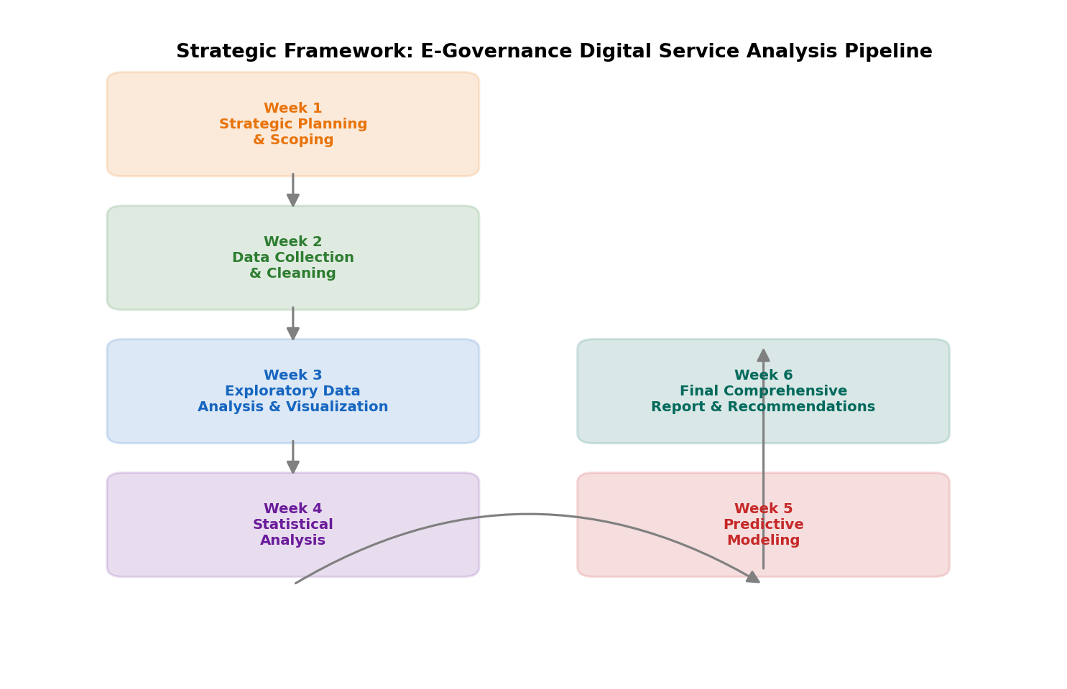
Figure 1: Strategic Framework — E-Governance Digital Service Analysis Pipeline (Week 1–6)

4.1 Proposed Visualization Techniques (for Week 3)
- Bar charts — State-wise ranking (top/bottom performers) for DigiLocker adoption and CSC density.
- Stacked bar charts — Rural vs Urban CSC split, to make infrastructure distribution clear.
- Scatter plots with trend line — To identify correlation between adoption and infrastructure.
- Choropleth-style ranking tables — To highlight equity gaps through GP coverage ratio.

4.2 Proposed Statistical Techniques (for Week 4)
- Pearson correlation analysis — To test the relationship between DigiLocker adoption and CSC infrastructure.
- Linear regression — A model to predict adoption from infrastructure metrics.
- Hypothesis testing — To check whether the adoption difference between high vs low GP-coverage states is statistically significant.

4.3 Preliminary Insight (Early Indicator)
Initial exploratory analysis found a strong positive correlation (r ≈ 0.83) between DigiLocker registered users and functional CSC count — meaning states with more robust CSC infrastructure also show higher digital adoption. This insight provides a strong foundation for Week 4 (Statistical Analysis) and Week 5 (Predictive Modeling).
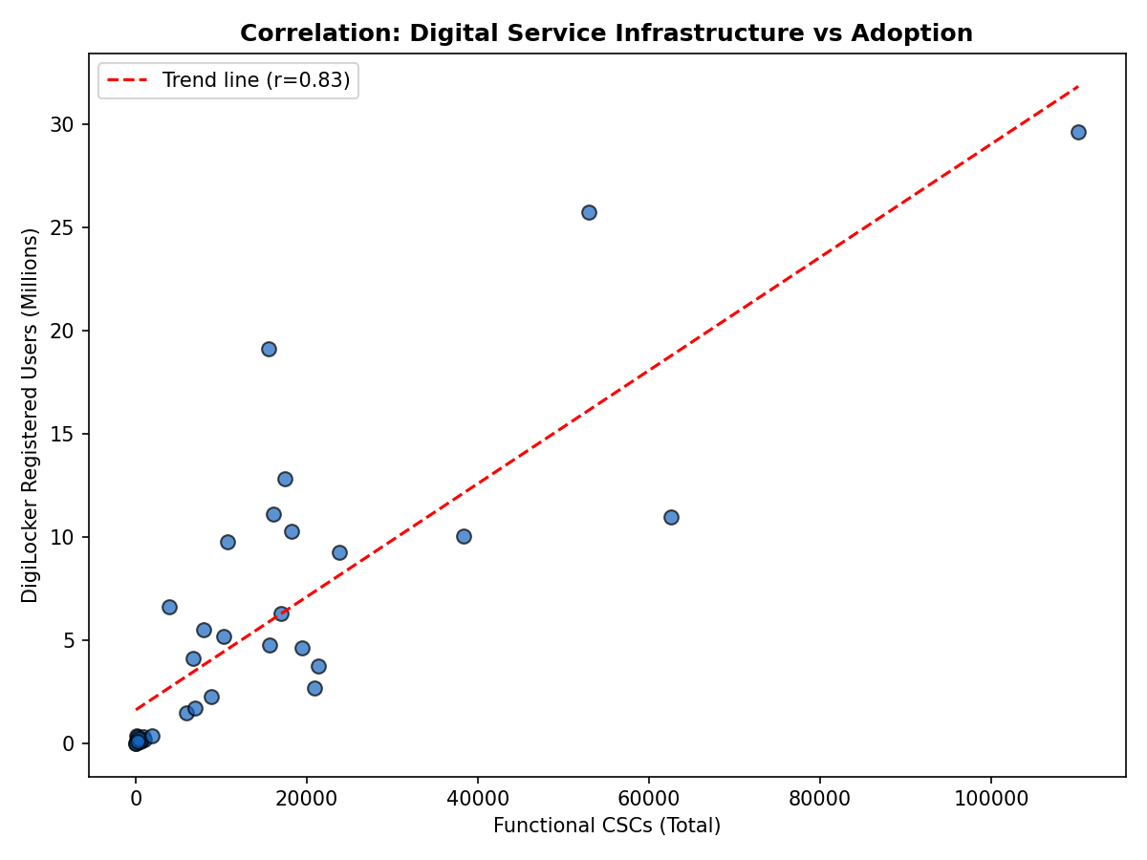
Figure 2: Correlation between Functional CSC count and DigiLocker Registered Users (r ≈ 0.83)

5. Timeline and Resource Identification

5.1 Estimated Timeline
Week | Focus Area | Key Output
1 | Strategic Planning & Scoping | Strategic plan DOC (this report)
2 | Data Collection & Cleaning | Cleaned merged dataset + replication guide
3 | Exploratory Data Analysis | 4+ visualizations + insight narrative
4 | Statistical Analysis | Correlation, regression, hypothesis tests
5 | Predictive Modeling | Demand forecasting model + evaluation
6 | Final Comprehensive Report | Consolidated findings + recommendations

5.2 Tools and Software
- Python (pandas, numpy) — Data cleaning, merging, and statistical computation.
- Matplotlib — Visualization and chart generation.
- Microsoft Excel — Cross-verification and pivot-based summary checks.
- Scikit-learn — Predictive modeling (Week 5).
- Microsoft Word — Final report documentation and formatting.

6. References / Data Sources
- DigiLocker Registered Users (State/UT-wise) — https://data.gov.in/ (Open Government Data (OGD) Platform India — based on Rajya Sabha Session 265, Unstarred Question No. 543)
- Common Service Centres — State-wise Active CSCs (June 2026) — https://csc.gov.in/ (Official portal, CSC e-Governance Services India Ltd., MeitY, Government of India)

7. Conclusion
This strategic plan combines the DigiLocker and CSC datasets into a unified analytical framework, covering both the adoption and infrastructure dimensions of e-governance digital services. The identified KPIs, proposed methodology, and 6-week timeline provide a clear roadmap for all subsequent tasks (data cleaning, EDA, statistical analysis, predictive modeling, and final reporting), using only publicly available data with no dependency on any internal/proprietary source.

