YUVA INTERN — NSDC
Virtual Data Analysis Intern — E-Governance & Digital Services
Week 3 Task
Exploratory Data Analysis and Visualization
Duration: 31-Jul-2026 to 11-Sep-2026 (6 Weeks)
Prepared by: Chirag Chhabra | Rajasthan

1. Data Selection
The dataset selected for this exploratory data analysis is the merged DigiLocker + Common Service Centres (CSC) dataset built in Week 2, covering 36 states/UTs of India. It combines DigiLocker registered users (Open Government Data Platform India, based on Rajya Sabha Session 265, Unstarred Question No. 543) with state-wise active CSC data for June 2026 (official CSC e-Governance Services India Ltd. portal).

1.1 Rationale for Selection
- The dataset directly addresses the internship's e-governance and digital services theme, combining a demand-side metric (DigiLocker adoption) with a supply-side metric (CSC infrastructure).
- Both sources are official, publicly available government data — no internal or proprietary data was used.
- State/UT-level granularity allows meaningful cross-regional comparison and correlation analysis.

1.2 Assumptions Made
- DigiLocker registered users is treated as a proxy for overall digital service adoption in a state, though actual usage/activity levels may differ from registration counts.
- Functional CSC count is treated as a proxy for physical service delivery infrastructure strength, independent of the quality or range of services offered at each centre.
- Chandigarh and NCT of Delhi report zero Gram Panchayats (fully urban administrative structure), so the GP-coverage-ratio metric is undefined for these two UTs and is excluded only from that specific ratio-based calculation.

2. Initial Analysis

2.1 Descriptive Statistics
Metric | DigiLocker Users | Functional CSC (Total)
Mean | 55,70,870 | 14,355
Median | 32,43,267 | 7,419
Minimum | 5,403 | 16
Maximum | 2,96,38,686 | 1,10,183
Std. Deviation | 72,14,079 | 21,989

Both variables show high variance and a right-skewed distribution (mean well above median), driven by a small number of large, high-population states such as Uttar Pradesh and Maharashtra. This skew is an important consideration for the visualization and statistical approaches used later.

2.2 Initial Hypotheses
- H1: States with a higher number of functional CSCs will also show higher DigiLocker adoption, since CSCs often assist citizens in registering for digital services.
- H2: Larger/more populous states will dominate the top ranks of both metrics, simply due to population scale rather than superior digital governance.
- H3: States with near-complete Gram Panchayat CSC coverage will show a measurably different adoption pattern than states with partial coverage.

3. Visualization

3.1 Visualization 1 — Top 10 States by DigiLocker Registered Users
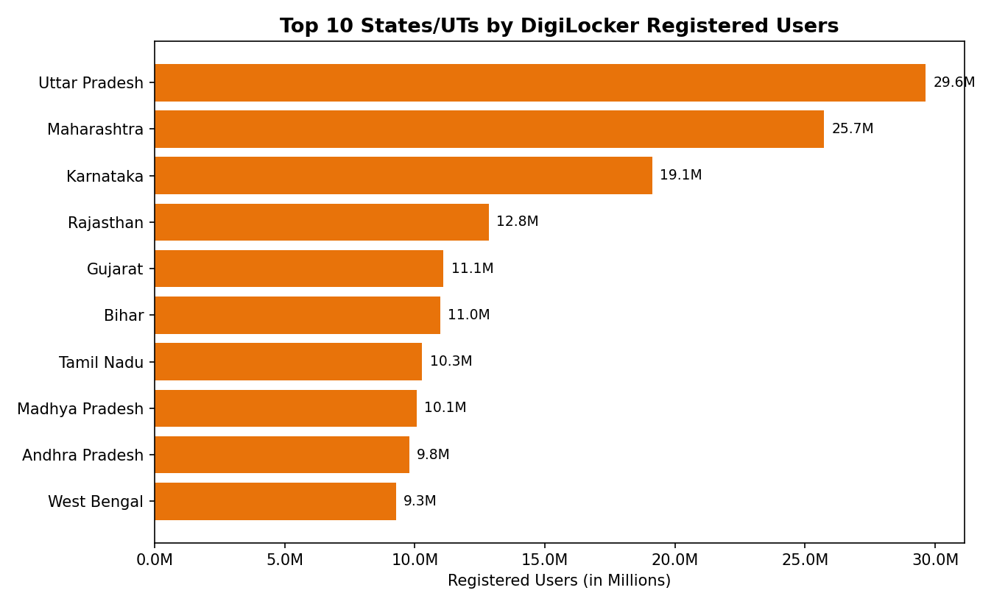
Figure 1: Top 10 States/UTs ranked by DigiLocker registered users (in millions).
This horizontal bar chart highlights that Uttar Pradesh (~29.6M) and Maharashtra (~25.7M) lead by a wide margin, consistent with their large populations. Karnataka and Rajasthan follow, showing that DigiLocker adoption, while high in absolute terms in large states, is not exclusively tied to any one region of the country.

3.2 Visualization 2 — Functional CSCs: Rural vs Urban Split (Top 10 States)
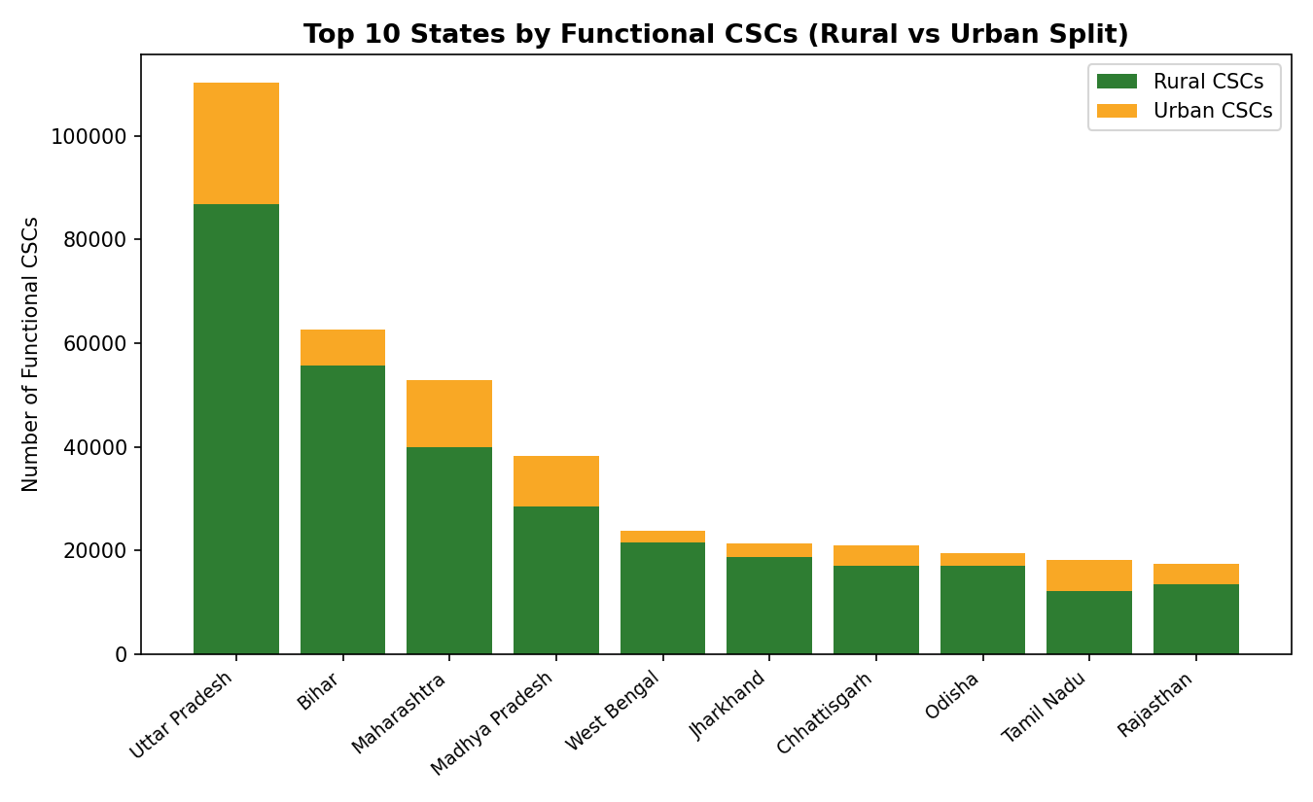
Figure 2: Stacked bar chart of rural vs urban functional CSCs for the top 10 states by total CSC count.
Uttar Pradesh has a dramatically larger CSC footprint than any other state, and rural CSCs dominate the split almost everywhere, confirming that CSC infrastructure has been built primarily to serve rural, last-mile access rather than urban populations who may have more digital access alternatives.

3.3 Visualization 3 — Correlation: Infrastructure vs Adoption
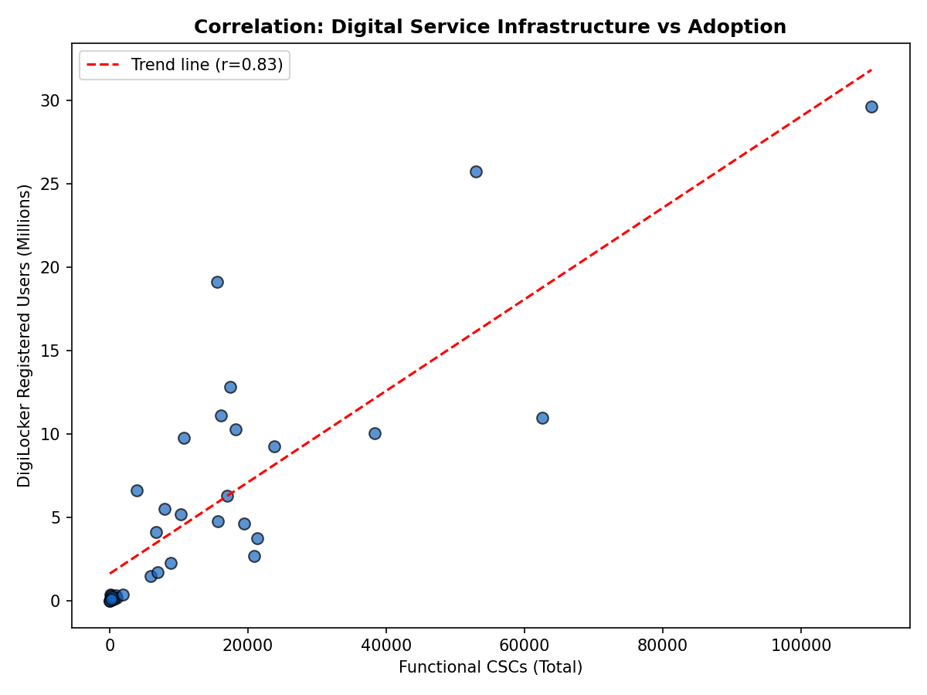
Figure 3: Scatter plot of functional CSCs against DigiLocker registered users, with fitted trend line (r ≈ 0.83).
A clear upward trend is visible: as functional CSC count increases, DigiLocker registered users also tend to increase. A small number of states (e.g., those with mid-range CSC counts but comparatively lower adoption) sit below the trend line, representing potential anomalies worth investigating further in Week 4.

3.4 Visualization 4 — Gram Panchayat CSC Coverage Rate (Top 10 States)
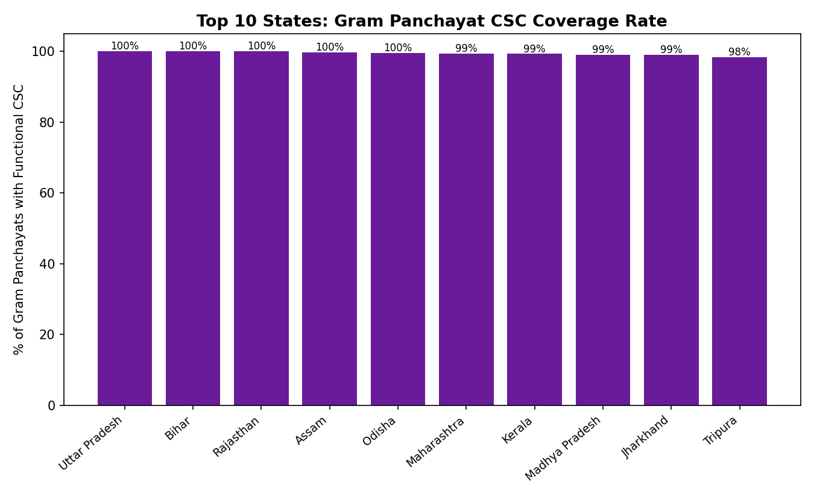
Figure 4: Percentage of Gram Panchayats with at least one functional CSC, top 10 states.
Bihar, Rajasthan, and Uttar Pradesh have achieved 100% Gram Panchayat CSC coverage, indicating near-complete last-mile infrastructure rollout in these states. This visualization highlights equity of access rather than raw scale, complementing the adoption-focused charts above.

4. Insight Discussion
- Adoption and infrastructure are positively related (r ≈ 0.83), broadly supporting H1 — states with stronger CSC infrastructure tend to show higher DigiLocker adoption, suggesting CSCs may play a facilitating role in digital onboarding.
- Scale effects are significant, supporting H2 — the largest states dominate both metrics in absolute terms, so future analysis should also consider per-capita or per-GP normalized metrics for a fairer cross-state comparison.
- High GP-coverage states (Bihar, Rajasthan, Uttar Pradesh) show consistently strong DigiLocker numbers, offering partial support for H3, though the relationship is not perfectly linear — some high-coverage states show comparatively modest adoption, indicating other factors (literacy, internet penetration, smartphone access) likely also influence adoption and should be considered in the Week 4 statistical analysis.
Overall, the exploratory analysis suggests that digital service adoption in e-governance is shaped jointly by physical infrastructure availability and state-level scale effects, with infrastructure density showing a meaningful — though not perfectly deterministic — relationship with adoption. These findings directly inform the correlation and regression analysis to be carried out in Week 4.

5. References / Data Sources
- DigiLocker Registered Users (State/UT-wise) — https://data.gov.in/ (Open Government Data (OGD) Platform India — based on Rajya Sabha Session 265, Unstarred Question No. 543)
- Common Service Centres — State-wise Active CSCs (June 2026) — https://csc.gov.in/ (Official portal, CSC e-Governance Services India Ltd., MeitY, Government of India)

