YUVA INTERN — NSDC
Virtual Data Analysis Intern — E-Governance & Digital Services
Week 4 Task
Statistical Analysis of E-Governance Performance Metrics
Duration: 31-Jul-2026 to 11-Sep-2026 (6 Weeks)
Prepared by: Chirag Chhabra | Rajasthan

1. Metric Identification
Building on the Week 1–3 work, three performance indicators relevant to digitalized public services are identified for statistical analysis, using the merged DigiLocker + CSC dataset covering 36 states/UTs:
- Service Efficiency / Adoption — DigiLocker Registered Users (state/UT-wise), representing how widely a flagship digital service has been adopted by citizens.
- Infrastructure Availability — Functional CSC Total, representing the physical last-mile access points available for citizens to avail digital services.
- Access Equity — Gram Panchayat (GP) Functional CSC Coverage Ratio (%), representing how equitably that infrastructure is distributed across rural administrative units within a state.

2. Data Simulation
No data simulation was required for this analysis. All three metrics above are drawn directly from the real, publicly available datasets collected and cleaned in Week 2 (DigiLocker OGD dataset and CSC official portal dataset). This preserves the authenticity of the findings, since no assumptions or synthetic values had to be introduced.
One data limitation is noted for transparency: Chandigarh and NCT of Delhi report zero Gram Panchayats, since both are fully urban administrative units. The GP coverage ratio is therefore undefined for these two UTs, and they are excluded only from calculations involving that specific ratio (n = 34 for ratio-based tests), while remaining included in all other analyses (n = 36).

3. Statistical Techniques

3.1 Technique 1 — Pearson Correlation Analysis
Pearson correlation was chosen to test the strength and direction of the linear relationship between infrastructure availability and adoption, since both variables are continuous and the scatter plot from Week 3 suggested a linear pattern.
Variable Pair | Result
Functional CSC Total vs DigiLocker Users (n=36) | r = 0.835, p < 0.001
GP Coverage Ratio (%) vs DigiLocker Users (n=34) | r = 0.418, p = 0.014

Step-by-step reasoning: For each variable pair, the covariance was standardized by the product of their standard deviations to obtain r. A two-tailed significance test was then applied to determine whether the observed correlation could plausibly arise from a population with true correlation zero. Both p-values are well below the conventional 0.05 threshold, indicating the relationships are statistically significant and not due to chance.

3.2 Technique 2 — Simple Linear Regression
Linear regression was applied to quantify how much DigiLocker adoption changes, on average, for each additional functional CSC, and to assess how much of the variation in adoption can be explained by infrastructure alone.
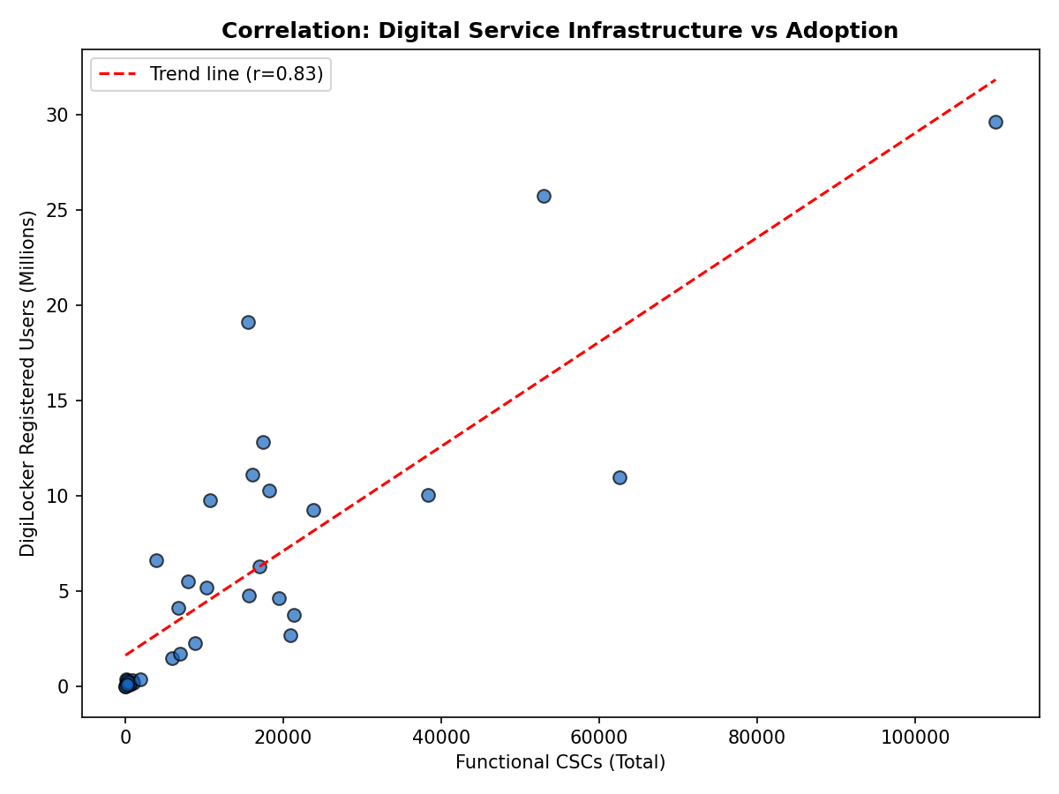
Figure 1: Fitted regression line — DigiLocker Users vs Functional CSC Total (also used in Week 3).
- Fitted equation: DigiLocker_Users ≈ 273.93 × Functional_CSC_Total + 16,38,484
- R² = 0.697 — approximately 70% of the variation in DigiLocker registered users across states is statistically explained by the number of functional CSCs.
- p < 0.001 — the slope is highly statistically significant, meaning the relationship is very unlikely to be a random artifact of this particular sample of 36 states.
Step-by-step reasoning: The regression line was fitted by minimizing the sum of squared vertical distances between observed DigiLocker user counts and the line's predicted values (ordinary least squares). The R² value was then computed as the square of the correlation coefficient, representing the proportion of variance in the dependent variable explained by the independent variable.

3.3 Technique 3 — Hypothesis Testing (Two-Sample t-test)
An independent-samples (Welch) t-test was used to test whether states with high Gram Panchayat CSC coverage show significantly different DigiLocker adoption than states with low coverage.
- Grouping: States were split at the median GP coverage ratio (91.28%) into a 'High Coverage' group (n = 17) and a 'Low Coverage' group (n = 17).
- High Coverage group — mean DigiLocker users ≈ 92,98,042
- Low Coverage group — mean DigiLocker users ≈ 20,88,066
- Welch's t-test: t = 3.24, p = 0.004
Step-by-step reasoning: Because the two groups have unequal variances (common with skewed, population-driven data), Welch's t-test was used instead of the standard Student's t-test, as it does not assume equal variances between groups. Since p = 0.004 is well below 0.05, the null hypothesis (that mean adoption is the same across high- and low-coverage states) is rejected.

4. Result Interpretation
- The strong, significant correlation (r = 0.835) between CSC infrastructure and DigiLocker adoption confirms the Week 3 exploratory observation with formal statistical backing, suggesting that policy investment in CSC infrastructure is associated with meaningfully higher digital service adoption.
- The regression result (R² = 0.697) indicates infrastructure availability is a strong, though not sole, predictor of adoption — the remaining ~30% of variation is likely driven by other factors such as literacy, internet penetration, and smartphone access, which fall outside the scope of the current dataset.
- The significant t-test result (p = 0.004) shows that Gram Panchayat-level equity of CSC coverage is meaningfully associated with adoption outcomes, not just the raw count of CSCs — supporting policies that prioritize equitable rural distribution of CSCs rather than concentration in a few large hubs.
- The weaker correlation for GP coverage ratio alone (r = 0.418) versus raw CSC count (r = 0.835) suggests that scale of infrastructure matters more strongly for adoption than equity of distribution alone — both should be tracked as complementary, not interchangeable, policy metrics.
For e-governance policy makers, these results suggest a two-pronged strategy: (1) continue expanding the absolute number of functional CSCs in states that still lag, since this shows the strongest statistical association with adoption, and (2) simultaneously monitor Gram Panchayat-level equity, since a purely urban-concentrated CSC rollout would leave adoption gains unevenly distributed, as reflected in the moderate but still significant equity correlation.

5. References / Data Sources
- DigiLocker Registered Users (State/UT-wise) — https://data.gov.in/ (Open Government Data (OGD) Platform India — based on Rajya Sabha Session 265, Unstarred Question No. 543)
- Common Service Centres — State-wise Active CSCs (June 2026) — https://csc.gov.in/ (Official portal, CSC e-Governance Services India Ltd., MeitY, Government of India)

