YUVA INTERN — NSDC
Virtual Data Analysis Intern — E-Governance & Digital Services
Week 5 Task
Predictive Modeling for Digital Service Demand Forecasting
Duration: 31-Jul-2026 to 11-Sep-2026 (6 Weeks)
Prepared by: Chirag Chhabra | Rajasthan

1. Problem Definition
This task forecasts state-level demand for digital public services, using DigiLocker registered users as the measurable proxy for demand. The forecasting problem is defined as: given a state's Common Service Centre (CSC) infrastructure profile, predict its expected level of DigiLocker adoption, and use this relationship to project how adoption would change if CSC infrastructure is expanded — directly supporting resource allocation decisions for digital service rollout.

1.1 Relevant Variables
- Target variable (demand): DigiLocker Registered Users (state/UT-wise).
- Predictor 1: Functional CSC Total — overall physical infrastructure scale.
- Predictor 2: Gram Panchayat (GP) Functional CSC Coverage Ratio (%) — equity/penetration of infrastructure.

1.2 Expected Trends
Based on the Week 3–4 findings, demand is expected to rise with total CSC count (r = 0.835) and, more moderately, with GP coverage equity (r = 0.418). The model in this report tests whether combining these two predictors together, rather than relying on infrastructure scale alone, improves on the single-variable regression used in Week 4, and whether this combined model generalizes to states it was not trained on.

2. Model Development

2.1 Modeling Approach
A multiple linear regression model was selected, since Week 3–4 analysis established an approximately linear relationship between infrastructure and adoption, and linear regression offers a transparent, interpretable model — important for a policy-facing forecasting tool, where stakeholders need to understand exactly how each factor drives the prediction. Only two predictors were retained — Functional CSC Total and GP Coverage Ratio — rather than also including the rural/urban CSC split, since rural and urban counts are components of the total and including all three together introduces multicollinearity that makes individual coefficients unstable and harder to interpret for policy use.

2.2 Training and Validation Process
- The 36-state merged dataset was split into a training set (27 states, 75%) and a held-out test set (9 states, 25%), using a fixed random seed for reproducibility.
- The model was fit on the training set only, learning a coefficient for each of the two predictors plus an intercept.
- Predictions were then generated for the test set — states the model had not seen during training — to evaluate real-world generalization rather than in-sample fit.
- A naive baseline model (always predicting the training-set mean) was also evaluated on the same test set, to give a reference point for how much better the regression model performs than a no-skill forecast.

2.3 Fitted Model
DigiLocker_Users ≈ 259.5 × CSC_Total + 23,361.5 × GP_Coverage_Ratio − 62,766
Both coefficients are positive, confirming that higher infrastructure scale and higher equitable coverage each independently push predicted adoption upward. The much larger coefficient on GP Coverage Ratio (relative to its 0–100 scale) versus CSC Total (relative to its thousands-scale) indicates that, per unit of standardized change, equity of distribution has a comparably strong influence on predicted adoption as raw infrastructure scale, even though its simple correlation with adoption (r = 0.418) was weaker than CSC Total's (r = 0.835).

3. Model Evaluation

3.1 Evaluation Metrics
Metric | Regression Model (Test Set) | Naive Baseline (Test Set)
MAE (Mean Absolute Error) | 20,91,419 | 33,99,139
RMSE (Root Mean Square Error) | 22,56,022 | 38,87,468
R² (Test set) | 0.599 | —
R² (Training set) | 0.705 | —

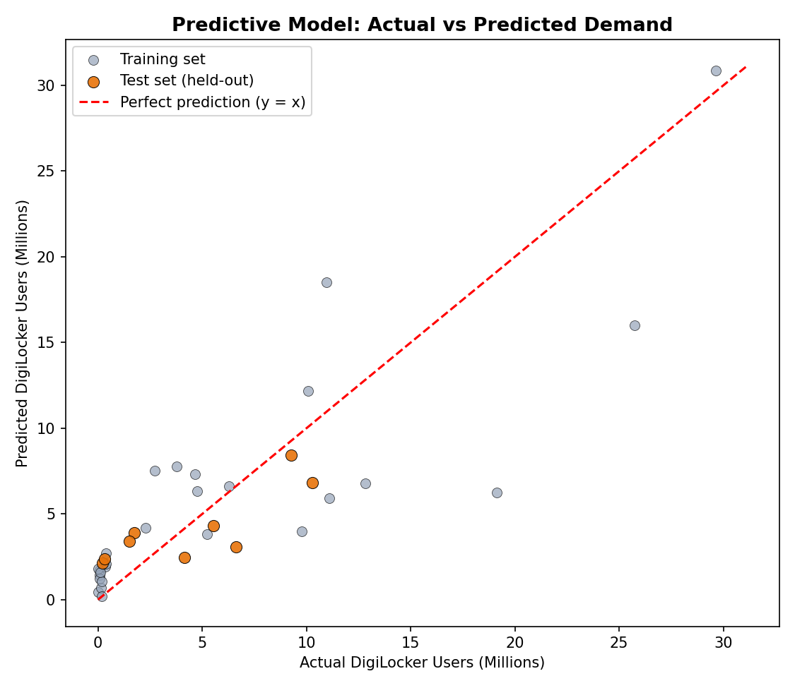
Figure 1: Actual vs predicted DigiLocker users for training and held-out test states, with the y = x reference line representing a perfect forecast.

3.2 Critical Analysis
- The regression model's test-set MAE (~20.9 lakh) is meaningfully lower than the naive baseline's MAE (~34 lakh), confirming the model provides genuine predictive value beyond simply guessing the average.
- The gap between training R² (0.705) and test R² (0.599) is modest, suggesting the simplified two-predictor model generalizes reasonably well and is not overly reliant on sample-specific noise, unlike a richer model with more overlapping predictors.
- The model under-predicts adoption for a few large-adoption states such as Tamil Nadu and NCT of Delhi, and over-predicts for several smaller states such as Jammu and Kashmir, Manipur, and Himachal Pradesh, suggesting unobserved state-specific factors — literacy rate, smartphone penetration, or state government digital campaigns — are not fully captured by CSC infrastructure and GP coverage alone.
- Given the small sample size (36 states/UTs), results should be treated as directional rather than precise; a production forecasting system would benefit from additional predictors (population, internet penetration, literacy rate) and, ideally, multi-year time-series data rather than a single snapshot.

4. Practical Implications
For policy makers and digital service managers, this model can be used as a planning tool: given a proposed CSC expansion plan for a state, the model can generate an approximate expected increase in DigiLocker adoption, helping justify infrastructure investment with a quantified, data-driven demand projection.

4.1 Example Scenario
Using Gujarat as an example (current: 16,097 functional CSCs, ~77.8% GP coverage), the model predicts current DigiLocker demand of approximately 59.3 lakh users. Simulating a 20% increase in functional CSC count, the model projects demand rising to approximately 67.7 lakh users — an estimated increase of about 8.4 lakh users (+14.1%), giving planners a concrete, quantified expectation for a proposed infrastructure investment.
- Resource allocation: States with high projected demand growth per additional CSC can be prioritized for infrastructure investment to maximize adoption impact per rupee spent.
- Monitoring: Actual adoption can be tracked against the model's forecast over time; large, persistent deviations would signal that non-infrastructure factors (e.g., awareness campaigns, connectivity) need attention in that state.
- Caveat for decision-makers: Given the moderate test R² (0.599) and limited sample size, this model should inform — not replace — policy judgement, and should be revisited as more states and time periods become available.

5. References / Data Sources
- DigiLocker Registered Users (State/UT-wise) — https://data.gov.in/ (Open Government Data (OGD) Platform India — based on Rajya Sabha Session 265, Unstarred Question No. 543)
- Common Service Centres — State-wise Active CSCs (June 2026) — https://csc.gov.in/ (Official portal, CSC e-Governance Services India Ltd., MeitY, Government of India)

