SUPERMARKET SALES
PERFORMANCE ANALYTICS REPORT
Data-Driven Insights on Branch, Product, and Customer Performance

Prepared for: IBM SkillsBuild — Data Analytics with AI Internship
Prepared by: Chirag
Maharaja Ganga Singh University (MGSU), Bikaner
September 2026

Table of Contents
1. Executive Summary 3
2. Methodology 3
3. Dataset Overview 4
4. Analysis & Visualizations 4
5. Summary Tables 9
6. Business Insights 10
7. Hypotheses 10
8. Recommendations 10
9. Interactive Dashboard 11
10. Conclusion 11

1. Executive Summary
This report presents a comprehensive analysis of 1,000 point-of-sale transactions across three supermarket branches (Alex, Cairo, and Giza), covering the period January to March 2019. The objective is to convert raw transaction data into actionable business intelligence — identifying which branches, product lines, and customer segments drive revenue, and where the business should focus its next set of decisions.
The dataset was verified to be clean: zero missing values and zero duplicate records across all 17 original fields, confirming the data is analysis-ready without additional imputation.

Key Performance Indicators
$322,967  Total Revenue | 1,000  Total Orders | $322.97  Avg. Order Value | 6.97 / 10  Avg. Customer Rating

2. Methodology
The analysis followed a structured Business Intelligence workflow, moving from raw data to executive-ready recommendations:
- Data Collection — Loaded the raw transactional dataset (1,000 rows × 17 columns) and validated data types.
- Data Cleaning — Checked for missing values, duplicate records, and inconsistent date/time formats. Result: 0 missing values, 0 duplicates.
- Feature Engineering — Derived Hour, Weekday, and Month fields from timestamps to enable time-based analysis.
- Aggregation — Grouped and aggregated data by Branch, Product Line, Customer Type, Gender, and Payment Method using totals, counts, and averages.
- Visualization — Built 8 visualizations covering revenue, profitability, time patterns, and correlations.
- Insight Generation — Converted statistical patterns into business insights, testable hypotheses, and prioritized recommendations.
Tools used: Python (pandas, NumPy) for data processing; Matplotlib and Seaborn for visualization; Streamlit for the interactive dashboard.

3. Dataset Overview
The dataset captures point-of-sale transactions with the following structure:
Field | Description | Type
Invoice ID | Unique transaction identifier | Text
Branch / City | Store location (Alex, Cairo, Giza) | Categorical
Customer type | Member or Normal | Categorical
Gender | Customer gender | Categorical
Product line | Product category (6 categories) | Categorical
Unit price / Quantity | Price per unit and units sold | Numeric
Sales / gross income | Total transaction value and gross income earned | Numeric
Date / Time | Transaction timestamp | Date/Time
Payment | Cash, Credit card, or Ewallet | Categorical
Rating | Customer satisfaction score (0–10) | Numeric

4. Analysis & Visualizations

4.1 Revenue by Branch
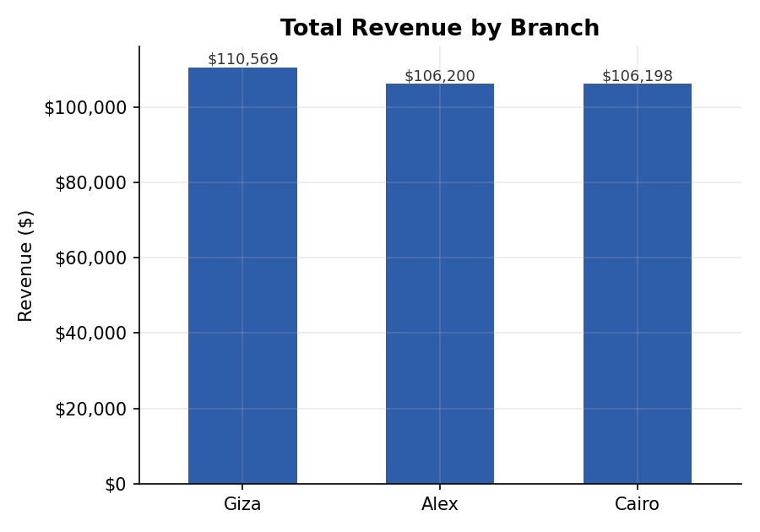
Figure 1: Total revenue generated by each branch.
Giza leads with $110,569 in total revenue, roughly 4% ahead of Alex ($106,200) and Cairo ($106,198), which are nearly tied. The gap is narrow — no single branch dominates, suggesting revenue is fairly evenly distributed across locations rather than concentrated in one market.

4.2 Revenue vs. Gross Income by Product Line
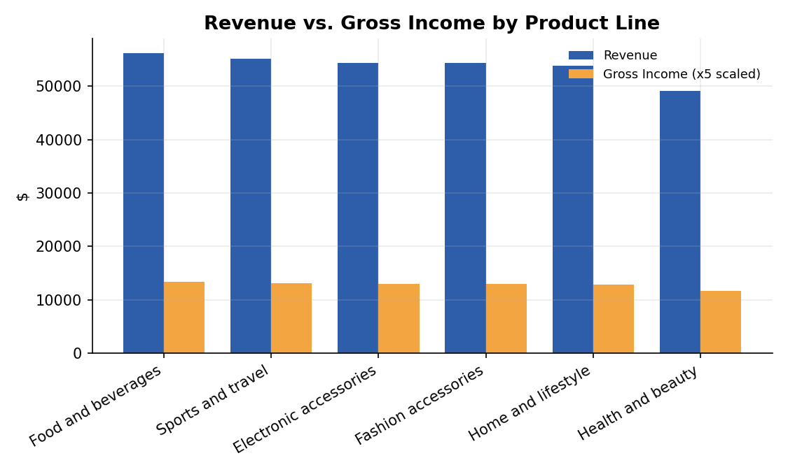
Figure 2: Revenue and gross income contribution across the six product categories.
Food and beverages is the top revenue generator ($56,145), followed closely by Sports and travel ($55,123). Health and beauty trails the group at $49,194 — roughly 12% below the leader — making it the clearest candidate for a targeted growth push.

4.3 Weekly Revenue Pattern
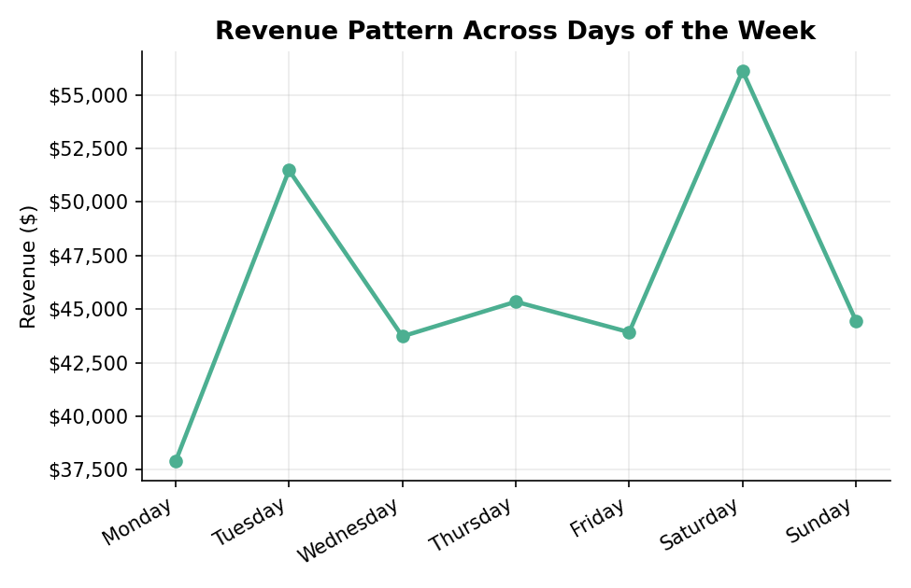
Figure 3: Revenue aggregated by day of the week.
Saturday is the strongest trading day, with revenue rising steadily from mid-week. This weekly rhythm has direct implications for staffing and inventory planning.

4.4 Hourly Revenue Pattern
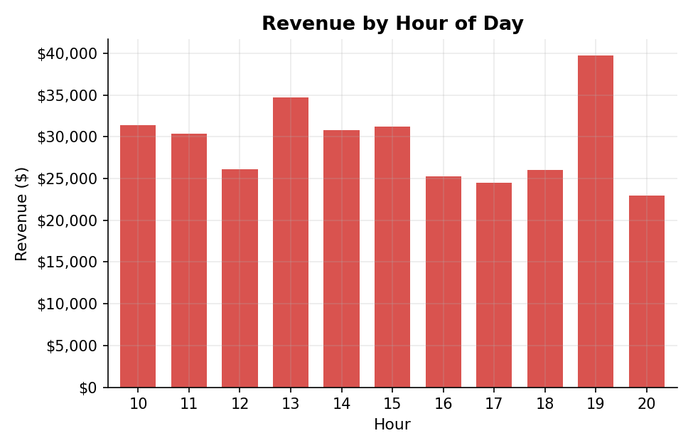
Figure 4: Revenue distribution across hours of the day.
Sales peak at 7 PM (19:00), consistent with after-work shopping behavior. Revenue is comparatively low in the early morning and late evening hours — useful for scheduling staff shifts around genuine demand rather than fixed hours.

4.5 Customer Type Contribution
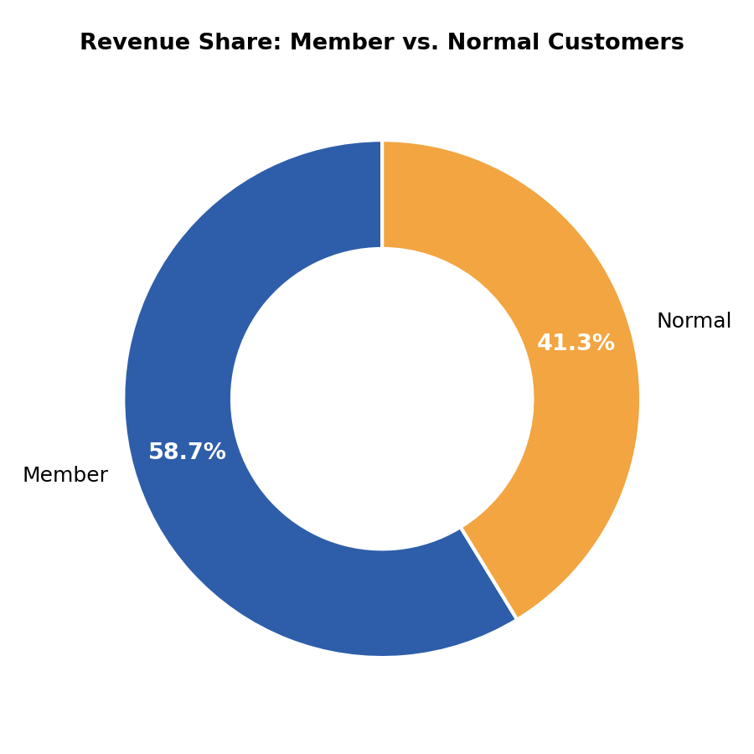
Figure 5: Share of total revenue from Member vs. Normal customers.
Member customers contribute 58.7% of total revenue and have a higher average order value ($335.74) than Normal customers ($306.37), a difference of roughly $29 per transaction.

4.6 Payment Method Preference
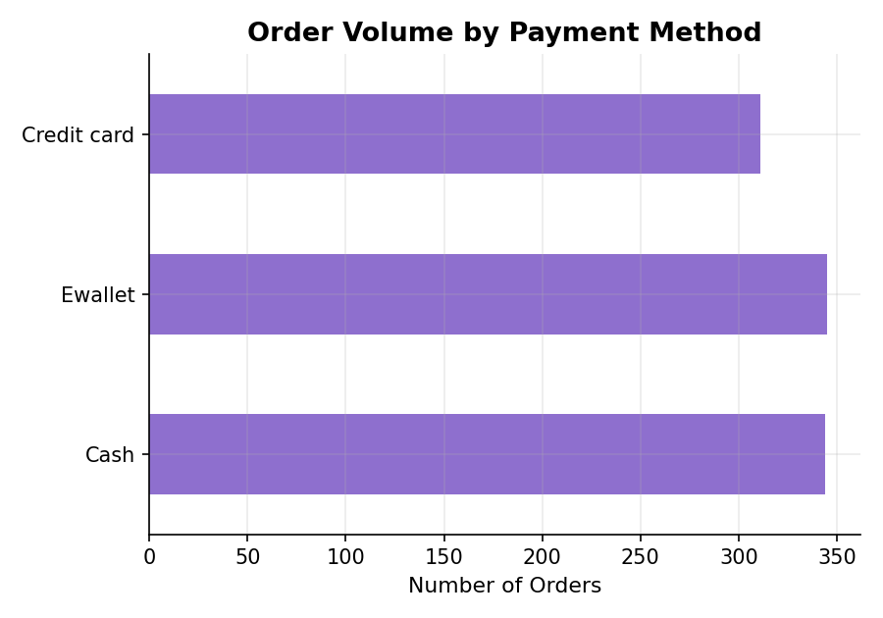
Figure 6: Order volume by payment method.
Cash (344 orders) and E-wallet (345 orders) are used almost equally, with Credit card slightly behind at 311 orders. No single payment channel dominates, so all three must remain fully supported at checkout.

4.7 Rating Distribution by Branch
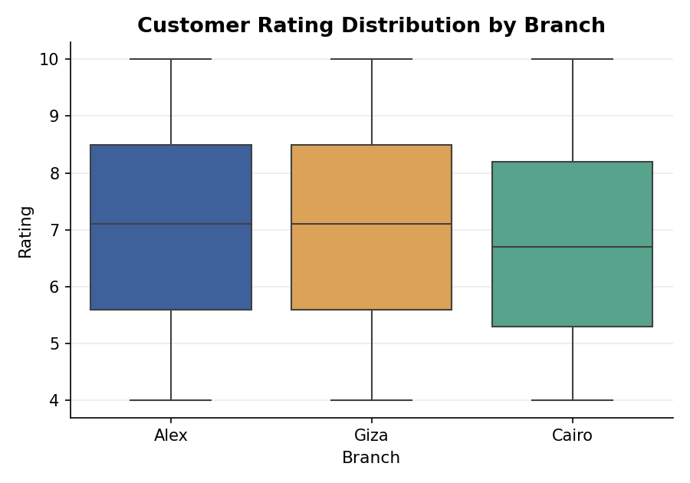
Figure 7: Spread of customer satisfaction ratings by branch.
Giza has the highest average rating at 7.07 and the tightest spread, indicating more consistent customer experience. Cairo's average rating (6.82) is the lowest of the three branches.

4.8 Correlation Between Key Metrics
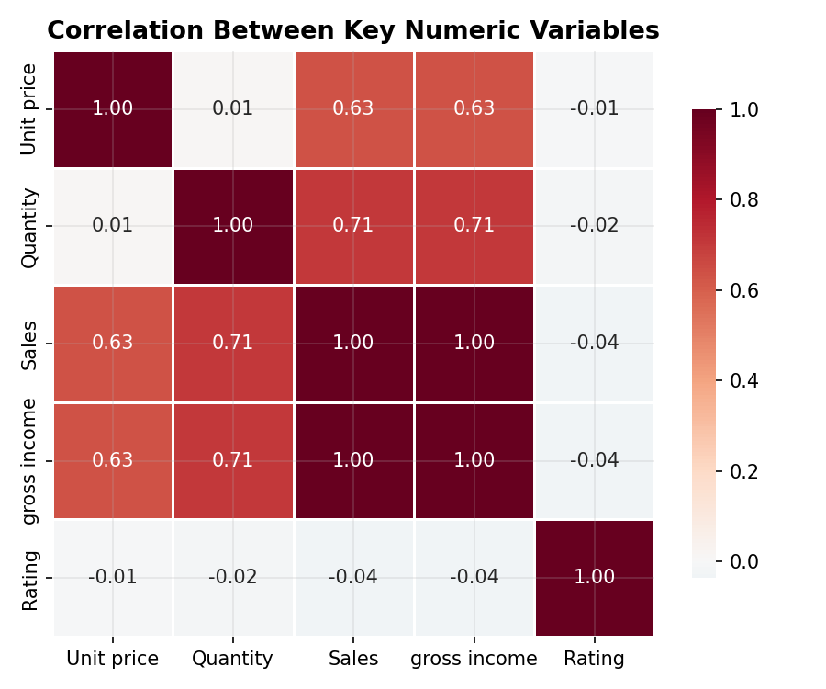
Figure 8: Correlation matrix of numeric variables.
Quantity and Sales show a strong positive correlation (r = 0.71), suggesting basket size tracks revenue more closely than unit price does. This is a correlation, not proof of causation — it indicates association, not that larger baskets directly cause higher sales. Rating shows negligible correlation with Sales (r ≈ 0.04) — satisfaction and spend appear largely independent in this dataset.

5. Summary Tables

5.1 Branch Performance
Branch | Revenue | Orders | Avg. Sale | Avg. Rating
Giza | $110,568.71 | 328 | $337.10 | 7.07
Alex | $106,200.37 | 340 | $312.35 | 7.03
Cairo | $106,197.67 | 332 | $319.87 | 6.82

5.2 Product Line Performance
Product Line | Revenue | Orders | Gross Income | Avg. Rating
Food and beverages | $56,144.84 | 174 | $2,673.56 | 7.11
Sports and travel | $55,122.83 | 166 | $2,624.90 | 6.92
Electronic accessories | $54,337.53 | 170 | $2,587.50 | 6.92
Fashion accessories | $54,305.90 | 178 | $2,586.00 | 7.03
Home and lifestyle | $53,861.91 | 160 | $2,564.85 | 6.84
Health and beauty | $49,193.74 | 152 | $2,342.56 | 7.00

5.3 Customer Type Performance
Customer Type | Revenue | Orders | Avg. Sale | Avg. Rating
Member | $189,694.76 | 565 | $335.74 | 6.92
Normal | $133,271.98 | 435 | $306.37 | 7.04

6. Business Insights
- Branch Performance: Giza generates the highest revenue ($110,569) and the highest average rating (7.07). The dataset does not capture staffing, layout, or service-process details, so the specific cause is not yet known — but the gap makes Giza's practices worth investigating as a starting point for improving Cairo, the lowest-rated branch.
- Category Leadership: Food and beverages leads all categories in both revenue and gross income, while Health and beauty lags roughly 12% behind the top performer — a clear gap worth investigating.
- Loyalty Program Impact: Member customers drive 58.7% of total revenue and spend $29 more per order on average than Normal customers, confirming the loyalty program's commercial value.
- Time-Based Demand: Revenue climbs through the week and peaks on Saturday, while daily sales peak at 7 PM — both signal windows where staffing and stock should be concentrated.
- Revenue Driver: Quantity purchased correlates strongly with revenue (r = 0.71), while customer rating shows almost no relationship with spend (r ≈ 0.04). Correlation alone does not establish causation — satisfaction should be tracked as a separate goal from revenue, not assumed to follow it.

7. Hypotheses
The following hypotheses are proposed for validation through future controlled testing (e.g., A/B campaigns) before being treated as confirmed drivers of the patterns observed above.
- H1 — Category Promotion: If a 4-week promotional campaign (bundle offers, in-store sampling) is run for Health and beauty, its revenue share will rise by at least 10% relative to other categories within the following quarter.
- H2 — Service Training: If Cairo branch staff receive targeted customer-service training, its average rating will move measurably closer to Giza's 7.07 benchmark within three months.
- H3 — Peak-Hour Staffing: If staffing is increased during the 6–9 PM window and on Saturdays, average order fulfillment speed will improve without a proportional rise in labor cost per dollar of revenue.

8. Recommendations
- Investigate and Test Giza's Practices at Cairo — The dataset does not record staffing, layout, or service-process details, so investigate Giza's actual practices on the ground, then pilot the most promising ones at Cairo for one quarter, tracking rating and revenue before and after.
- Invest in the Underperforming Category — Allocate a defined marketing budget to Health and beauty for the next quarter (cross-promotions, better shelf placement) and track whether the revenue gap to the top category narrows.
- Expand the Loyalty Program — Introduce a second loyalty tier with added benefits for high-spending Members, since they already outspend Normal customers by $29 per order on average.
- Optimize Staffing to Demand — Align staff schedules with the observed demand peaks — Saturdays and the 6–9 PM window — rather than uniform shift patterns, to reduce wait times during the busiest hours.
- Track Satisfaction Independently — Since rating and revenue are not correlated, track and report satisfaction as its own KPI on the dashboard rather than as a proxy for sales performance.

9. Interactive Dashboard
A companion Streamlit dashboard was built to make these findings explorable without needing to read code. It is structured as a single page around the same five-level hierarchy used throughout this report — KPIs, Trends, Drivers, Risk, and Action — so a viewer can move from “what is happening” to “what should we do” without switching screens.
- Level 1 — KPIs: Total revenue, orders, average order value, gross income, and average rating, with sidebar filters for Branch and Customer Type.
- Level 2 — Trends: Revenue by day of week and by hour of day.
- Level 3 — Drivers: Revenue and order volume broken down by branch and by product line.
- Level 4 — Risk: Lowest-rated branch and weakest product line flagged automatically, with the rating-vs-sales correlation shown for context.
- Level 5 — Action: The five recommendations from Section 8, reproduced inline.
Run locally with: streamlit run app.py

10. Conclusion
This analysis moved the raw transaction log through a full Business Intelligence pipeline — cleaning, aggregation, visualization, and interpretation — to arrive at five recommendations a store manager could act on this quarter. The clearest opportunities are closing the rating gap between Cairo and Giza, growing the underperforming Health and beauty category, and scheduling staff around the observed Saturday and evening demand peaks. None of these conclusions rest on a single chart in isolation; each is cross-checked against at least two independent views of the data (e.g., the branch revenue chart and the rating boxplot both point to Cairo as the branch needing attention). Correlations reported throughout — such as quantity's relationship with sales — describe association, not proof of cause, consistent with the principle that a model or a single chart's output is not itself a business decision — it requires business judgment applied on top.

