AI Advisor Platform
High-Level Architecture Document
A web application for discovering AI use cases and recommending implementation strategy, best practices, and cost optimization
Prepared by: Application Architecture
Version 1.0 · June 2026

Table of Contents

1. Purpose and Scope
This document describes the high-level architecture of the AI Advisor Platform, a web-based application that helps users understand where artificial intelligence can add value and then recommends an implementation strategy, applicable best practices, and cost-optimization techniques.
The platform is intended for product owners, engineering leads, and internal teams who are evaluating or planning AI adoption. Given a description of the user's context and goals, it identifies candidate use cases, sequences them into a pragmatic roadmap, attaches relevant patterns and guardrails, and estimates the associated cost envelope.
The scope of this document is the logical architecture, its major components, cross-cutting concerns, and two representative use cases. Detailed low-level design, API contracts, and infrastructure-as-code are out of scope and are addressed in subsequent design documents.

2. Architecture Overview
The platform follows a layered architecture. A web client captures user context and renders recommendations. An API gateway handles security and routing. A set of domain services encapsulates the business logic of discovery, recommendation, knowledge, and cost. These services rely on an AI/LLM orchestration layer that grounds its reasoning in curated data, and on a data layer that stores the knowledge base, embeddings, and operational data. Platform concerns such as identity, observability, and security cut across every layer.
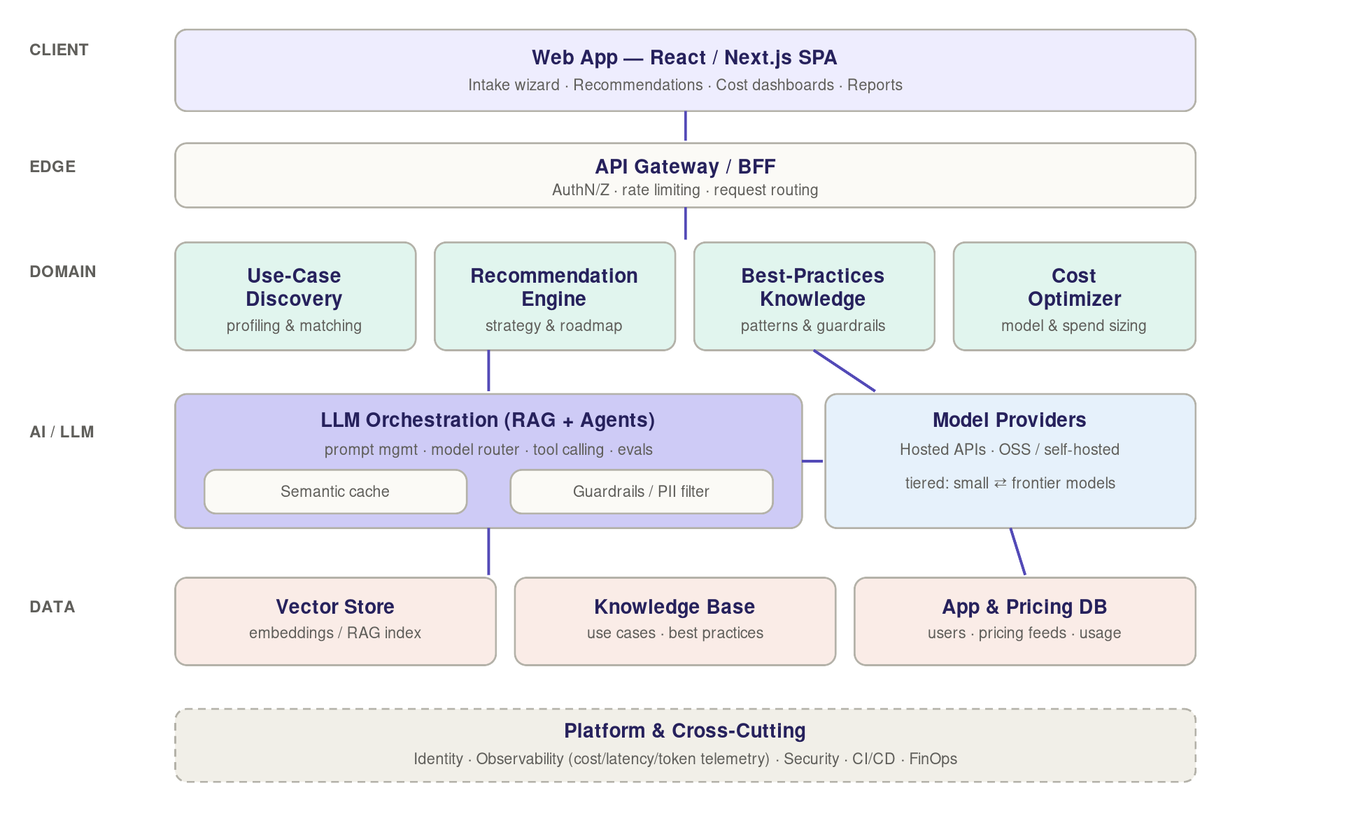
Figure 1. Layered reference architecture for the AI Advisor Platform.
The central design principle is grounded reasoning: recommendations are produced by a large language model that retrieves and cites curated content (retrieval-augmented generation) rather than relying on the model's parametric memory. This keeps recommendations accurate, current, and auditable, and allows the knowledge base to be updated without retraining.

3. Component Responsibilities
The table below summarizes the responsibility of each major component shown in Figure 1.

Layer | Component | Responsibility
Client | Web App (React/Next.js) | Intake wizard, recommendation views, cost dashboards, exportable reports.
Edge | API Gateway / BFF | Authentication, authorization, rate limiting, and routing to domain services.
Domain | Use-Case Discovery | Profiles the user and matches their context to a catalog of AI use cases.
Domain | Recommendation Engine | Turns matched use cases into a sequenced implementation strategy and roadmap.
Domain | Best-Practices Knowledge | Attaches architecture patterns, guardrails, and risk/compliance guidance.
Domain | Cost Optimizer | Sizes the recommended approach against live model and infrastructure pricing.
AI/LLM | LLM Orchestration | Prompt management, model routing, tool calling, RAG, and evaluation.
AI/LLM | Model Providers | Tiered access to hosted APIs and self-hosted open-source models.
Data | Vector Store | Stores embeddings and serves semantic retrieval for RAG.
Data | Knowledge Base | Curated, versioned use cases, patterns, and best practices.
Data | App & Pricing DB | User profiles, recommendations, pricing feeds, and usage telemetry.

4. Cross-Cutting Concerns
Identity and access. Single sign-on, role-based access control, and tenant isolation are enforced at the gateway and propagated as scoped tokens to downstream services.
Observability and telemetry. Token counts, latency, and cost per request are captured as first-class metrics, alongside standard logs and traces. This data feeds both the cost dashboards and the FinOps function.
Security and privacy. A guardrail and PII-redaction filter sits in front of the model layer. Sensitive inputs are masked, prompts and outputs are logged for audit, and provider data-retention settings are configured to disable training on customer data.
Quality and evaluation. Prompts are versioned artifacts with an automated evaluation suite (golden datasets and regression tests) so recommendation quality is measurable before each release.
Delivery. CI/CD pipelines build, test, evaluate, and deploy services; infrastructure is provisioned declaratively.

5. Best Practices Embedded in the Design
- Ground every recommendation in retrieved, citable content (RAG) rather than unverified model output, so recommendations remain defensible and current.
- Keep the AI layer stateless and pluggable behind an internal interface so providers and models can be swapped without touching domain services.
- Route requests to the cheapest model that meets the quality bar; reserve frontier models for genuine synthesis and nuanced reasoning.
- Treat prompts as code: version them, review them, and gate releases on an evaluation suite.
- Apply guardrails and human-in-the-loop review for high-stakes recommendations.
- Instrument cost, latency, and tokens from day one, because you cannot optimize what you do not measure.

6. Cost Optimization Techniques
Cost is driven primarily by model selection and token volume. The platform applies the following levers, listed roughly in order of impact:
- Tiered model routing: small, inexpensive models handle classification and extraction; frontier models handle only synthesis.
- Semantic and prompt caching: similar or repeated requests are served from cache rather than recomputed.
- Context minimization: RAG retrieves only the top-k relevant chunks instead of passing whole documents into the prompt.
- Batching and asynchronous processing for non-interactive workloads.
- Per-tenant token budgets with alerting to prevent runaway spend.
- A FinOps view that attributes spend to features and users, and a build-versus-buy evaluation of self-hosting open-source models for predictable high volume.

7. Use Case 1 — Identifying AI Usage During Application Development

7.1 Scenario
A development team is building or extending an application and wants to know where AI could be applied: which features would benefit, which AI capability fits each feature, how to implement it, and what it would cost to run. The user describes the application (its domain, tech stack, data, and target users) through the intake wizard.

7.2 Flow Through the Architecture
- The developer enters the application context in the Web App; the request passes through the API Gateway.
- Use-Case Discovery profiles the application and retrieves candidate AI use cases (for example: natural-language search, code assistance, document summarization, anomaly detection, intelligent form-filling) from the Knowledge Base via the Vector Store.
- The Recommendation Engine ranks candidates by feasibility and value, then sequences them into a roadmap (quick wins first, deeper integrations later), using the LLM Orchestration layer to reason over the retrieved patterns.
- Best-Practices Knowledge attaches implementation guidance for each candidate — integration pattern, required data, guardrails, and evaluation approach.
- The Cost Optimizer estimates the per-feature run cost across model tiers and presents the trade-offs.
- The Web App renders a prioritized roadmap with implementation notes and a cost estimate, exportable as a report.

7.3 Components and Data Involved
Component | Role in this use case
Use-Case Discovery | Maps application features to candidate AI capabilities.
Recommendation Engine | Prioritizes and sequences candidates into a development roadmap.
Best-Practices Knowledge | Supplies integration patterns and guardrails per capability.
Cost Optimizer | Estimates run cost and recommends model tier per feature.
Knowledge Base / Vector Store | Source of capability patterns and reference implementations.

7.4 Recommended AI Approach
Recommendations are generated with RAG grounded in a curated catalog of development-oriented AI patterns. For lightweight classification of features to capabilities, a small model is sufficient; the roadmap narrative and trade-off explanations use a higher-capability model. Outputs include concrete next steps (suggested libraries, APIs, and a proof-of-concept scope) so the team can act immediately.

8. Use Case 2 — Building an AI-Enabled Internal Knowledge Base

8.1 Scenario
An organization wants employees to ask natural-language questions and get accurate, sourced answers drawn from internal content — policies, wikis, runbooks, HR documents, and product specifications. The platform recommends and helps shape the architecture for this internal knowledge assistant.

8.2 Flow Through the Architecture
- The user describes the internal content sources, sensitivity levels, and the employee audience in the Web App.
- Use-Case Discovery recognizes this as an internal-knowledge-assistant pattern and retrieves the relevant reference architecture from the Knowledge Base.
- The Recommendation Engine produces an implementation strategy: ingestion and chunking, embedding and indexing in a vector store, retrieval-augmented generation, and an answer interface with citations.
- Best-Practices Knowledge attaches guardrails specific to internal data — access control aligned to document permissions, PII handling, citation of sources, and a feedback loop for answer quality.
- The Cost Optimizer estimates embedding, storage, and query costs at the expected employee query volume and recommends caching and model-tier strategy.
- The Web App presents the target architecture, a phased rollout plan, and a cost projection.

8.3 Components and Data Involved
Component | Role in this use case
Use-Case Discovery | Identifies the internal knowledge-assistant pattern from user context.
Recommendation Engine | Defines the ingest → embed → retrieve → generate pipeline and rollout plan.
Best-Practices Knowledge | Supplies permission-aware retrieval, PII, and citation guardrails.
Cost Optimizer | Projects embedding, storage, and query costs; recommends caching.
Vector Store / Knowledge Base | Reference pattern; mirrors the very architecture the user will build.

8.4 Recommended AI Approach
The recommended target is a permission-aware RAG system: internal documents are chunked, embedded, and indexed with their access-control metadata; at query time the assistant retrieves only chunks the requesting employee is authorized to see, then generates an answer with inline citations to the source documents. Answers that lack sufficient supporting context are declined rather than fabricated. A small reranking model improves retrieval precision, and a higher-capability model composes the final answer, keeping per-query cost low while preserving quality.
Note that this use case is reflexive: the AI-enabled knowledge base the user is being guided to build mirrors the RAG and vector-store pattern that the Advisor Platform itself uses internally.

9. Recommended Technology Stack
The following stack is a pragmatic default and can be substituted based on the organization's existing investments:
Concern | Recommended technology
Frontend | React / Next.js
Backend services | Python (FastAPI) or Node.js
AI orchestration | LangGraph / LlamaIndex for RAG and agent workflows
Vector store | pgvector, Pinecone, or Weaviate
Application database | PostgreSQL
Model providers | Hosted LLM APIs with a tiered router; optional self-hosted OSS models
Compute | Kubernetes or serverless functions
Observability | OpenTelemetry with cost/token instrumentation

10. Summary
The AI Advisor Platform is a layered, RAG-grounded web application that turns a description of a user's context into a prioritized, costed, and best-practice-aligned AI implementation plan. Its pluggable AI layer, tiered model routing, and first-class cost telemetry make recommendations accurate, adaptable, and economical. The two use cases — identifying AI opportunities during application development and building an internal knowledge base — demonstrate how the same components compose to serve distinct needs.

