Vendor Performance Analysis Project Report

An End-to-End Data Analytics Project using SQL, Python, and Power BI

Prepared by: Chirag Jain

**1. Project Objective**

The goal of this project is to analyze vendor performance in order to improve profitability, efficiency, and decision-making in retail and wholesale operations.

**2. Business Problem**

Effective inventory and sales management are critical for optimizing profitability in the retail and wholesale industry. Companies need to ensure that they are not incurring losses due to inefficient pricing, poor inventory turnover, or vendor dependency.

The goal of this analysis is to: -

* Identify underperforming brands that require promotional or pricing adjustments. -
* Determine top vendors contributing to sales and gross profit.
* Analyze the impact of bulk purchasing on unit costs.
* Assess inventory turnover to reduce holding costs and improve efficiency.
* Investigate the profitability variance between high-performing and low-performing vendors.

**3. Approach & Methodology**

**Step 1: Data Preparation (SQL) -**

- Explored and merged data from multiple database tables.

During observing datasets from database, we observe some informations like

***From the observation we gather some points on tables are:***

* The purchase table contains actual purchase data, including the date of purchase, products(brands) purchased by vendors, the amount paid in $, and the quantity purchased.
* The purchase price column is derived from the purchase_table, which provides product-wise actual and purchase prices. The combination of vendor and brands unique in this table.
* The vendor_invoice table aggregates data from purchase table, summarizing quantity and dollar amounts, along with additional column for frieght. This table maintains uniqueness based on vendor and PO number.
* The sales table captures actual sales transactions, detailing the brands purchased by vendors, the quantity sold,the selling price and the revenue earned.

***We obsereved data is distributed in different tables, for anlysis we need to create a summary table containing:***

* purchases transactions made by vendors
* sales transaction data
* freight cost for each vendor
* actual product prices from vendors

And then I created aggregated table by using sql and joins are used heavily.

- Created a single aggregated table for analysis.

- Cleaned the data to ensure accuracy and consistency.

**Step 2: Analysis (Python – Google Colab)** -

- Performed Exploratory Data Analysis (EDA).

- Conducted data cleaning and handled missing values. - Answered key research questions about sales, profit margins, and vendor efficiency.

***During Analysis we gather some informations about statistics of our dataset -***

**Negative & Zero Values**

* Gross profit: Minimum value 382956.54 indicating losses. Some product or transactions may be selling at a loss due to high costs or selling at discounts lower than the purchase price.
* Profit Margin: Has a minimum of -100, which suggest cases where revenue is zero or even lower than costs.
* Total Sales Quantity & Sales DOllars: Minimum values are 0, meaning some products were purchased but never sold. These could be slow-moving or absolute stock

**Outliers indicated by High Standard Deviations:**

* Purchase & Actual Price : The maximum values are significantly higher than the mean, indicating potential premium products.
* Frieght Cost: Huge variation, from 0.09 to 257,032.07, suggests logistic inefficiencies or built shipments.
* Stock Turnover: Ranges from 0 to 274.5, implying some products sell extremely fast while others remain in stock indefinitely, Values more than indicates that Sold quantity for that higher than purchased quantity due to either sales are being fulfilled from the older stock.

***Correlations of features :***

***Strongest positives***

* ***TotalSalesDollars, TotalSalesPrice, and TotalSalesQuantity form a tight block of high positive correlations, indicating these measures move together strongly in this dataset.***
* ***GrossProfit correlates strongly with TotalSalesDollars/Price/Quantity, suggesting higher sales are closely tied to higher gross profit.***
* ***TotalExciseTax tracks closely with TotalSales metrics, implying taxes scale with sales volume/value.***
* ***Purchase vs sales links TotalPurchaseQuantity and TotalPurchaseDollars show moderate-to-strong positive correlations with TotalSalesQuantity and TotalSalesDollars, consistent with inventory flowing through to sales.***
* ***Purchaseprice has mild-to-moderate positive correlation with TotalSalesPrice/Dollars, suggesting some pass-through from procurement cost to selling price/revenue.***
* ***Pricing/volume effects ActualPrice shows a moderate positive relationship with TotalSalesPrice and TotalSalesDollars, but only weak ties to Quantity, hinting that revenue aligns more with price than with units sold in this sample.***
* ***Volume has generally weak correlations across metrics, indicating volume units here are not a dominant driver of sales or margins compared to price and totals.***

***Weak or negligible links***

* ***VendorNumber and Brand display near-zero correlations with most financial measures, implying vendor/brand identifiers alone don’t explain variation in sales or profit in this view.***
* ***StockTurnover, ProfitMargin, and SalestoPurchaseRatio appear computed from sales and purchase metrics and therefore show near-perfect correlation among themselves but only modest additional insight beyond the core sales block.***

***After we analysis on different bussiness assumptions and questions :***

**1 .Identify Brands that needs Promotional or pricing adjustments which exhibit lower sales performance but higher profit margins.**

**Brands with low sales but high profit margins:**

**Brand TotalSalesDollars ProfitMargin**

**210 18000 35.91 1205.818182**

**2. Which vendors & Brands demonstrate the highest sales performance ?**

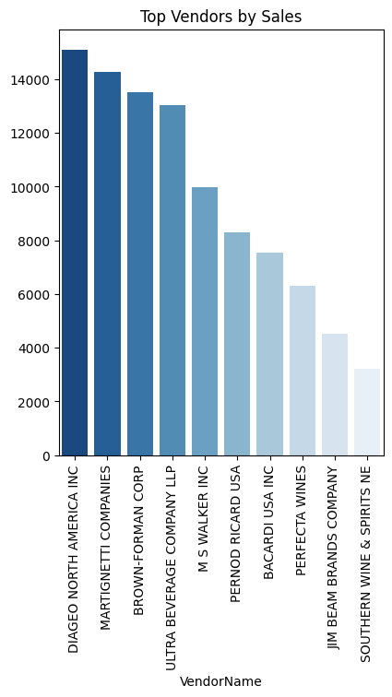

**3. Which vendors contribute the most total purchase dollars?**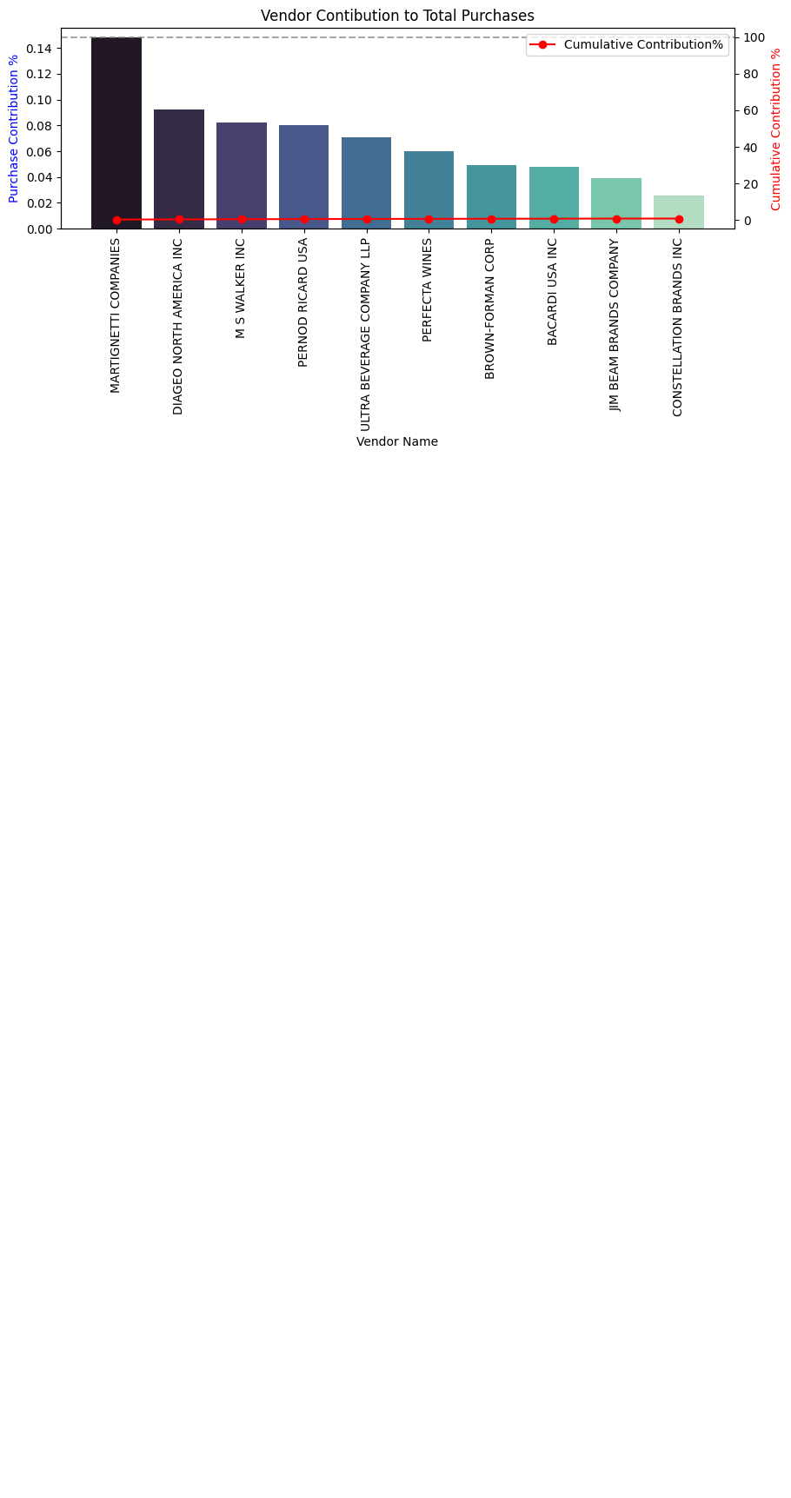

**4. Does purchasing in bulk reduce the unit price, and what is the optimal purchase volume for cost savings?**

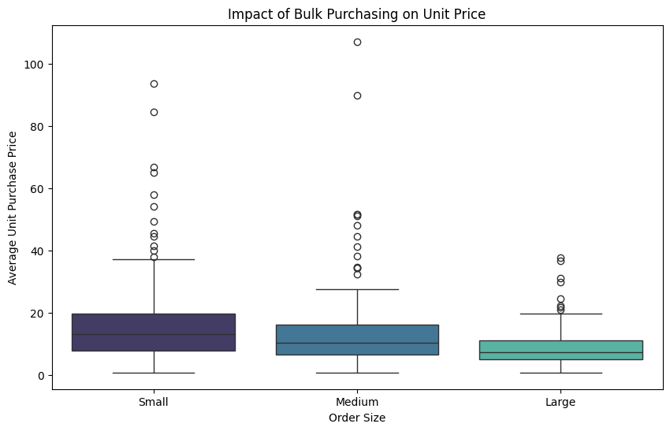

* **Vendors buying bulk get the lowest unit price , meaning higher margins if they can manage inventory efficiently.**
* **The price differrence b/w Small and large orders is substantial**
* **This suggests that bulk pricing strategies successfully encourage vendors to purchase in larger volumes, leading to higher overall sales despite lower per unit revenue.**

**5. Which vendors have low inventory turnover, indicating excess stock and sow-moving products?**

| **CONSTELLATION BRANDS INC** | **0.573889** |  |
| --- | --- | --- |
| **5** | **Dunn Wine Brokers** | **0.666667** |
| **7** | **HEAVEN HILL DISTILLERIES** | **0.666667** |
| **13** | **PALM BAY INTERNATIONAL INC** | **0.666667** |
| **21** | **WALPOLE MTN VIEW WINERY** | **0.692308** |

**6. how much capital is locked in unsold inventory per vendor, and which vendors contribute the most to it.**

| **VendorName** | **unsolvedInventoryValue** | **UnsoldInventoryValue** |  |
| --- | --- | --- | --- |
| **30** | **PALM BAY INTERNATIONAL INC** | **106.44** | **106.44000000000001** |
| **8** | **CRUSH WINES** | **103.19** | **103.19** |
| **45** | **Serralles Usa LLC** | **66.63** | **66.63** |
| **53** | **WALPOLE MTN VIEW WINERY** | **45.72** | **45.72** |
| **29** | **OLE SMOKY DISTILLERY LLC** | **27.12** | **27.12** |
| **47** | **TRINCHERO FAMILY ESTATES** | **16.10** | **16.1** |
| **13** | **Dunn Wine Brokers** | **12.98** | **12.98** |
| **16** | **FORTUNE WINE BROKERS LLC** | **0.00** | **0.0** |
| **6** | **CHARLES JACQUIN ET CIE INC** | **0.00** | **0.0** |
| **21** | **LAIRD & CO** | **0.00** | **0.0** |

# Confidence Interval & Hypothesis Testing -

**What is the 95% confidence intervals for profit margins of top-performing and low-performing vendors**

* **Top-performing vendors have a much higher average profit margin than low-performing vendors.**
* **Their profit margins are also more variable, as indicated by the wider confidence interval.**
* **Low-performing vendors have lower and more consistent profit margins, as shown by the tighter confidence interval.**

**Top vendors:**

* **Learn from the best to help others.**
* **Support them to keep profits steady.**
* **Reward and guide them for more growth.**

**Low vendors:**

* **Help them improve with training and advice.**
* **Show them how top vendors succeed.**
* **Set small, realistic goals to grow.**

**Is there a significant difference in profit margins B/w top performing and low performing vendors ?**

**Hypothesis:**

**H0: There is no significant diff. in the mean profit margins and top-performing and low performing vendors**

**H1: The mean profit margins of top - performing and low-performing vendors are significantly different**

**Step 3: Visualization & Dashboard (Power BI) -**

Built a Power BI dashboard to make insights interactive and easy to understand.

- Key visuals included Total Sales, Purchases, Gross Profit, Profit Margin, Top Vendors by Sales, Low Performing Vendors, and Vendor-specific insights.

**Step 4: Reporting -**

Summarized findings in a business-focused report for stakeholders.

**4. Key Insights**

- Total Sales: $138.87K

- Total Purchase: $59.83K

- Gross Profit: $79.03K - Profit Margin: 135.42%

- Unsold Capital: $4.97K

- Top Vendors by Sales: Diageo North America, Martignetti, Brown-Forman, Ultra Beverage Company.

- Low Performing Vendors: Kobrand Corporation, Jim Beam Brands Company, Crush Wines, Serralles USA.

- Stock Turnover: Some vendors show weak turnover, leading to inventory holding costs.

5. **Business Impact**

- Helps management spot high-performing vendors for stronger partnerships.

- Identifies underperformers for renegotiation or replacement.

- Supports inventory optimization, reducing unsold capital and costs.

6. **Conclusion**

This end-to-end project (SQL + Python + Power BI) provides a clear, data-driven view of vendor performance. It empowers decision-makers to improve vendor selection, enhance profitability, and strengthen supply chain efficiency.