**Exam:-2 Javascript**

Write a program to draw a pattern given below from 0-9 (odd). (max 2 loop allowed)

E.g. if n==3 {Take it as a challenge and solve for 0-99, Solution will be rewarded} (edited)

var n = 3

var str = ''

for (i = 0; i <= 3 * n + 1; i++) {

for (j = -n; j <= n; j++) {

if (i == 0 && j == 0) {

str += "0"

// for third triangle tree

} else if(i >3*n){

str+= "="

}

else if (i > 2 * n && j == 0) {

str += "="

}//end

else if (i + j == 0) {

str += "/"

}

//frist tringle

else if ( i - Math.abs(j) == 0) {

str += "\\"

}//end

// third triangle pip

else if (Math.abs(i) > 2 * n && Math.abs(j) == 1) {

str += "|"

}//end

//second tri

else if (i >= n + 1 && i - j == 3) {

str += "\\"

} else if (i >= n + 1 && Math.abs(i) - Math.abs(j) == 3) {

str += "/"

} else if(i <=n && Math.abs(j)<i || i<=n*2 && Math.abs(j)*2<i){

str+="-"

}

//end

else {

str += " "

}

}

str += "\n"

}

console.log(str);

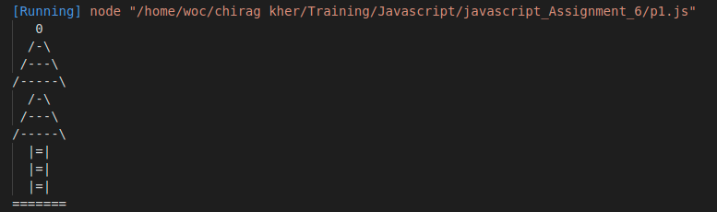

Write a program to draw a pattern given below from 0-9. (max 2 loops allowed)

{Take it as a challenge and solve for 0-99, Solution will be rewarded}

let n = 5;

let str = "";

for (i = -(n + 1); i <= (n + 1); i++) {

for (j = -(n + 1); j <= (n + 1); j++) {

if (Math.abs(j) == (n + 1) || (i == 0 && j == 0)) {

str += "O"

}

else if (Math.abs(i) == (n + 1))

{

str += "0"

} else if ((Math.sign(i) == Math.sign(j) && Math.abs(i) - Math.abs(j) >= 0)) {

str += Math.abs(j)

}

else if (Math.sign(i) != Math.sign(j) && Math.abs(j) - Math.abs(i) >= 0 && i!=0) {

str += n - Math.abs(j) + 1

}

else {

str += " "

}

}

str += "\n"

}

console.log(str);

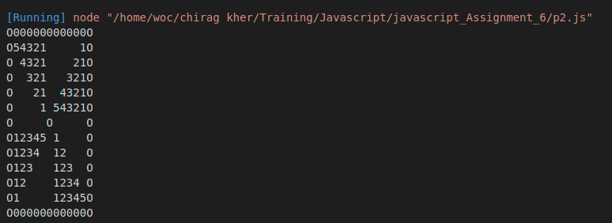

p2 (Advance) n=5

| = = = = = = = = = = = |

| \ 4 3 2 1 0 b c d e / |

| b \ 3 2 1 0 b c d / 1 |

| b c \ 2 1 0 b c / 2 1 |

| b c d \ 1 0 b / 3 2 1 |

| b c d e \ 0 / 4 3 2 1 |

| O O O O O X O O O O O |

| 1 2 3 4 / 0 \ e d c b |

| 1 2 3 / b 0 1 \ d c b |

| 1 2 / c b 0 1 2 \ c b |

| 1 / d c b 0 1 2 3 \ b |

| / e d c b 0 1 2 3 4 \ |

| = = = = = = = = = = = |

var n = 5;

var str = "";

for (i = -(n + 1); i <= n + 1; i++) {

for (j = -(n + 1); j <= n + 1; j++) {

if((Math.abs(j)==n+1)){

str += "| "

}

else if(Math.abs(i)==n+1){

str += "= "

}

else if(i==0 && j==0){

str+="x "

}

else if(i==0){

str += "0 "

}

else if(j==0){

str += "0 "

}

else if(i-j==0){

str+="\\ "

}

else if(i+j==0){

str+="/ "

}

else if ((Math.sign(i) == Math.sign(j)) && Math.abs(i) - Math.abs(j) >= 0) {

str += Math.abs(j) +" "

}

else if ((Math.sign(i) != Math.sign(j)) && Math.abs(j) - Math.abs(i) >= 0 && i!=0) {

str += n-Math.abs(j)+1 +" "

}

else if (Math.abs(i) - Math.abs(j) < 0) {

str += String.fromCharCode(97+n-Math.abs(j)+1)+" ";

}

else if (Math.abs(i) - Math.abs(j) > 0) {

// str += n-Math.abs(j)+1

str += String.fromCharCode(97+Math.abs(j)) + " ";

}

else {

str += " "

}

}

str += "\n";

}

console.log(str);

