**1. Abstract:**

In this paper we are proposing a new ensemble method for anemia detection using machine learning and a combination of data sources. By analysing both medical information that are symptoms, history, vitals and smartphone images of the eye conjunctiva, the approach aims to surpass traditional blood tests. The analysis involves extracting informative visual cues from the images using Convolutional Neural Networks (CNNs). Importantly, data from different sources is weighted based on significance for anemia detection before being combined. This method, along with other machine learning algorithms, is expected to improve detection accuracy and enable earlier diagnosis. Additionally, the accessibility of this non-invasive approach has the potential to empower individuals and transform preventative healthcare. However, further research is needed to validate this approach and ensure its effectiveness in real- world settings.

**2. Introduction:**

Anemia, a condition characterized by a deficiency in red blood cells or haemoglobin, casts a long shadow on global health. The World Health Organization estimates that a staggering 42% of children under six and 40% of pregnant women battle this condition, often due to iron deficiency [1]. Beyond its impact on physical and emotional well-being, untreated anemia can lead to irreversible organ damage and even death. Early detection is crucial to prevent these devastating consequences. While blood tests are the current standard for diagnosing anemia, their limitations are significant. The invasive nature of blood draws can be a deterrent, especially for children. Additionally, resource requirements can limit accessibility, particularly in regions with limited healthcare infrastructure. This paper proposes a groundbreaking solution that has the potential to revolutionize anemia detection: a machine learning model that leverages the power of smartphone technology and non-invasive data collection.

This innovative approach integrates traditional data, such as symptoms, patient history, and vitals, with a novel source of information – smartphone-captured images of the conjunctiva, the inner lining of the eyelids. Deep learning algorithms within the model will analyse these conjunctival images, extracting hidden visual cues that reveal subtle signatures of anemia. Unlike relying solely on individual sources of data, this approach fuses traditional and novel data, creating a multi-faceted risk assessment that boosts the model's accuracy and robustness. However, generalizability is key. Rigorous testing across diverse populations, including children, pregnant women, and individuals with varying skin tones, is essential to ensure the model's effectiveness for everyone. This focus on inclusivity is crucial to ensure equitable access to this potentially life-changing technology. The Devastating Consequences of Untreated Anemia When the body's oxygen delivery network falls short, the repercussions can be widespread. Individuals with anemia often experience Fatigue and Weakness, Shortness of Breath, Pale Skin, Headaches and Dizziness, Heart Complications. Early detection of anemia empowers healthcare professionals to intervene before these complications arise. By identifying individuals at risk, this technology has the potential to Our vision is a future where a non- invasive, AI-powered model seamlessly integrates diverse data sources to predict anemia risk with accuracy and generalizability. This model leverages several key components Conjunctival Images, Patient Data, Advanced Algorithms. This approach offers several advantages over traditional methods Non-invasive, Accessible, Empowering. The Landscape of Machine Learning and Anemia Detection, a growing body of research explores the potential of machine learning for anemia detection. Several studies have investigated the use of smartphone-based technologies like Fingernail Analysis, Conjunctival Pallor. When it comes to identifying individuals, factors like skin tone and lighting play a crucial role. Variations in pigmentation and lighting conditions can affect how accurate techniques rely on visual cues from skin, nails, or eyes. There is a lack of enough studies focusing on specific populations, such as children, pregnant women, and individuals with darker skin tones. More research is needed to create and confirm non-invasive methods that are uniquely suited for these groups. This will guarantee that these methods work effectively and accurately for these particular populations. Creating better algorithms for reliability: In order to develop precise machine learning models for detecting anemia, we require vast and varied datasets that have been meticulously validated to guarantee impartial and broadly applicable outcomes. When we want to introduce new non-invasive techniques into healthcare systems, we need to address regulatory and privacy concerns and also offer training to healthcare staff for successful integration.

**Related Work:**

The paper [1] suggests a plan for a system that recommends skincare products using face pictures. People upload photos. The system examines the pics to find face parts and study skin things like color, texture, and acne. It uses tech like color change and texture filters, and deep learning for acne and skin type. Then it gives tips based on the skin features. Still, it has flaws like errors, bias, and privacy risk. To work well, it needs to be brighter and fairer, and keep info safe. The study uses two main techniques: CNNs for pics and old pic tech for face pics.

The paper [2] talks about an app that uses AI to find iron levels by nail pics. Users take photos of their nails and the app checks them with an AI model. The model finds things like color and texture, and links them to a database of nails with iron levels. Then it guesses the user's iron level. But it has flaws. Pic good or bad can change the answer, and things like light and polish can mess up the study. It also needs more tests with diff skin colours and needs to be fair. And there's a risk with saving nail pics. But it's a good way to test for anemia without too much fuss. Later, it should be more right, fair, and safe to rule.

The paper [3] looks at using advanced learning systems to find signs of anemia in eye images. People take pictures of their eyes with their phones, concentrating on the eye's white part. These images are then studied by a trained computer program named VGG16. This program picks out characteristics from the images, like colours and patterns, and compares them to a collection of labelled eye images linked to different blood levels. According to this comparison, the program gives a score showing the likelihood of anemia for the user. But there are still limits. The quality of the image, lighting, and eye issues can affect accuracy. The system's performance with different skin tones needs more study, and possible biases need attention. Also, worries about user privacy when storing face images need strong security. Despite these hurdles, this research gives a new, easy way to check for anemia. In the future, work should aim to boost accuracy, lessen bias, and keep user privacy safe to make way for using this tech.

The paper [4] also talks about the problems of the usual anemia check. It also explains the benefits of using computer programs for anemia discovery. The article checks different computer programs and how good they are. Key points are that using computer programs for anemia spotting is not invasive, cheap, and saves time. These programs can also be very correct. The factors are image size, getting data ready, and the correctness of the computer program. The ways are getting blood out, the eye's white part, nail colour, feeling the palm, and devices for smartphones. There are issues like not agreeing between different people, the eye’s white part colour not being sensitive enough, not enough anemia info, and issues with current info.

The paper [5] explores machine learning to predict anemia in kids. It tests different methods and finds Random Forest works best, with 98.4% accuracy. It also looks at ways to improve accuracy, like picking important features and using combined learning. But these didn't beat Random Forest. The study checked things like Parameters, Accuracy, Precision, Recall, F1- score, AUC, CPU time, and Wall time. It used methods like Random Forest, Decision Tree, Naïve Bayes, Support Vector Machine, Logistic Regression, Artificial Neural Network, Feature selection, and Ensemble learning. Downsides include data just from one hospital, so it might not apply broadly, and only a small set of features used. Also, Ensemble learning didn't top Random Forest's accuracy.

**3. Methodologies:**

The methodology that we have used in the project is a collection of multiple symptoms related to anemia and predict probability of anemia individually on each of them and then combine them into a final result with different importance to each element. This will make sure that we have taken all the different symptoms into consideration according to their importance.

Information needed for this ensemble technique is

* ***Medical Information*:** Patient data including symptoms (fatigue, shortness of breath), family history, and vitals.
* ***Visual Data*:** Smartphone-captured images of the conjunctiva (eye's inner lining) - potentially including the palm in future iterations.

***Data Pre-processing*:** Both medical information and visual data undergo pre-processing to ensure consistency.

This might involve:

* ***Visual Data***: Convolutional Neural Networks (CNNs) analyse the conjunctival images, focusing on extracting features like subtle color variations that might indicate anemia. A similar CNN might analyse palm images in the future.
* ***Medical Data***: Statistical or machine learning techniques like feature selection or dimensionality reduction extract relevant patterns from the medical data. This might involve identifying correlations between specific symptoms and anemia.
* ***Weighted Feature Fusion***: Weights are assigned to each data source (medical information, eye image, palm image) based on their relative importance in anemia detection. These weights can be determined by medical expertise or the model itself through feature importance analysis. The extracted features from each source are then multiplied by their corresponding weights before being combined. This ensures information deemed more crucial by the model contributes more to the overall analysis.
* ***Machine Learning Model***: DNNs (Deep Neural Networks) are a type of ML algorithm with multiple layers that progressively extract higher- level features from the data. In our case, DNNs can analyse conjunctival images to identify subtle patterns indicative of anemia. CNNs are a specific type of DNN particularly adept at processing image data. Their ability to automatically learn features from raw images extracting relevant information

***The other machine learning classifiers implemented are:***

* ***Convolutional Neural Network (CNN)***: A Convolutional Neural Network (CNN) is a specialized deep learning model used for analysing visual data like images. It includes layers of neurons that perform operations like convolution, pooling, and activation. CNNs are great for tasks such as image classification, object detection, and facial recognition because they can learn hierarchical features from pixel values. They have transformed computer vision and are used across different industries like healthcare, autonomous vehicles, and security systems.
* ***Random Forest***: Random Forest is a method in machine learning that creates multiple decision trees and then combines their predictions to make a final decision. It is widely used because it can improve accuracy and generalization in many different types of tasks. Random Forest is known for being robust, versatile, and resistant to overfitting, which is why it is a popular choice for both classification and regression tasks.

**3.1 Proposed Architecture:**

In this machine learning model devised for anemia detection, multiple data sources are tactically merged using a weighted fusion methodology. Initially, medical data such as symptoms and vital signs undergo pre-processing. Additionally, smartphone-captured images of the conjunctiva (inner eye lining) and optionally the palm undergo pre-processing, potentially involving resizing and color normalization. Subsequently, a Convolutional Neural Network (CNN) extracts features from the eye image, concentrating on subtle color or texture variations indicative of anemia. If included, a similar CNN might analyse the palm image for pertinent features. Concurrently, statistical techniques derive meaningful patterns from the medical data. The pivotal distinction lies in the assignment of weights to each data source (medical information, eye image, palm image) based on their relevance in anemia detection. These weights could be determined by medical expertise or the model itself. The extracted features are then scaled by their respective weights before amalgamation, ensuring that information deemed more critical by the model contributes more significantly to the analysis. Ultimately, a machine learning model such as a Support Vector Machine (SVM) assesses this weighted, merged data to forecast the patient's risk of anemia. This architecture capitalizes on the strengths of diverse data sources while prioritizing the most pertinent information, potentially yielding a more precise and adaptable anemia detection system.

***Here's a breakdown of the model's components***:

1. *Medical Information*: This includes traditional data sources like symptoms (fatigue, shortness of breath), family history, and vitals.
2. *Eye Image*: A smartphone-captured image of the conjunctiva, the inner lining of the eyelid.
3. *Palm Image***:** An optional input containing a smartphone-captured image of the palm.
4. *Data Pre-processing*: Each data source undergoes pre-processing to ensure consistency and quality.

This may involve:

*Image Pre-processing*: Resizing images, scaling pixel values, and normalization for both eye and palm images (if applicable).

*Medical Information Pre-processing*: Encoding categorical data and scaling numerical data.

*Eye Image***:** A Convolutional Neural Network (CNN) extracts features from the pre-processed eye image. The CNN focuses on identifying subtle variations in color or texture that might indicate anemia.

*Palm Image***:** A separate CNN (or potentially the same architecture) extracts relevant features from the palm image, likely focusing on variations in palm color.

*Medical Information:* Statistical or machine learning techniques like feature selection or dimensionality reduction are employed to extract relevant features from the medical data. This might involve identifying patterns in a patient's medical history or correlations between specific symptoms and anemia.

*Weighted Feature Fusion*: Here's where the architecture deviates from the previous explanation. Instead of simple data fusion, a weighted approach is implemented:

*Weights*: Weights are assigned to each data source (medical information, eye image, and palm image) based on their relative importance in anemia detection. These weights are determined through techniques like domain knowledge from healthcare professionals or feature importance analysis within the model itself.

1. *Weighted Feature Combination*: The extracted features from each source are then multiplied by their corresponding weights before being combined. This ensures that information sources deemed more significant by the model contribute more to the overall analysis.
2. *Machine Learning Model*: The combined, weighted features are fed into a machine learning model, such as a Support Vector Machine (SVM) or Random Forest algorithm. This model has been trained on a large dataset of labelled examples (data where the presence or absence of anemia is known). The model learns to identify patterns in the weighted, fused data that are indicative of anemia.

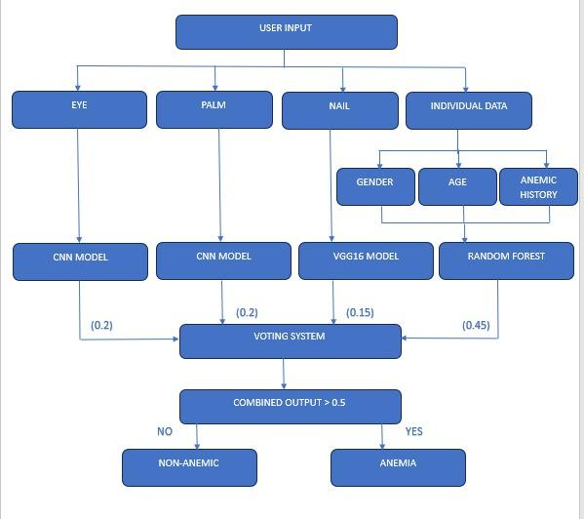

Fig 3.1 architecture of the project

**3.2 Datasets :**

The datasets were collected from the undermentioned hospitals located in Ghana; Komfo Anokye Teaching Hospital at Kumasi,Bolgatanga Regional Hospital at Bolgatanga, Kintampo Municipal Hospital at Kintampo, Ahmadiyya Muslim Hospital at Techiman, Sunyani Municipal Hospital at Sunyani, Manhyia District Hospital at Kumasi, Ejusu Government Hospital at Ejusu, SDA Hospital at Sunyani, Nkawie-Toase Government Hospital at Nkawie- Toase and Holy Family Hospital at Berekum. The dataset for this study focuses on young children aged five and below. Laboratory technicians take a blood sample from suspected anemic patients to measure the Hb values of the patients, and images of the fingernails are taken afterwards, and a remark is given based on the Hb value of the patient either anemic or non-anemic.

Dataset for fingernails:

[https://data.mendeley.com/datasets/2xx4j3kjg2/1 /files/e3d97e08-0c09-45bc-bde6-68c30e98319b](https://data.mendeley.com/datasets/2xx4j3kjg2/1/files/e3d97e08-0c09-45bc-bde6-68c30e98319b)

Dataset for palm:

[https://data.mendeley.com/datasets/ccr8cm22vz/ 1/files/92d613b4-0fe4-427e-972c-dc5fa2a3d5de](https://data.mendeley.com/datasets/ccr8cm22vz/1/files/92d613b4-0fe4-427e-972c-dc5fa2a3d5de)

Dataset for eye:

[https://onlinelibrary.wiley.com/doi/full/10.1002/ eng2.12667](https://onlinelibrary.wiley.com/doi/full/10.1002/eng2.12667)

**3.3 Eye Model Training:**

**3.3.1 Data Preparation:**

The initial step involves preparing the dataset for model training. This includes defining the paths to directories containing anemic and nonanemic images. Using the os.listdir() function, images and their corresponding labels are loaded into lists. These image paths and labels are then combined into a pandas DataFrame for convenient handling. Subsequently, the DataFrame is split into training and testing sets using the train_test_split() function from scikit- learn.

**3.3.2 Feature Extraction:**

Feature extraction is a critical preprocessing step where relevant information is extracted from the raw image data. In this project, the extract_features() function is defined to perform this task. Within this function, images are resized to a standard size of 224x224 pixels using the resize() function from the Python Imaging Library (PIL). Additionally, pixel values are normalized by dividing by 255.0 to ensure uniformity across the dataset. The extracted features are reshaped into the required format for input into the CNN model.

**3.3.3 Model Architecture:**

The core of the anemia detection system lies in the design of the CNN architecture. Utilizing the Sequential API of Keras, a CNN model is constructed layer by layer. The architecture typically comprises convolutional layers for feature extraction, followed by max-pooling layers to reduce spatial dimensions. Additional convolutional layers with increasing filter sizes capture higher-level features. Fully connected layers with Rectified Linear Unit (ReLU) activation function are incorporated for classification, with dropout regularization to prevent overfitting. The output layer consists of a single neuron with sigmoid activation for binary classification.

**3.3.4 Model Compilation and Training:**

Once the model architecture is defined, it is compiled and trained using the specified optimizer, loss function, and training parameters. In this project, the Adam optimizer and binary cross-entropy loss function are chosen. Training is performed using the fit() method, specifying parameters such as batch size, number of epochs, and validation split. During training, the model learns to minimize the loss function by adjusting its weights and biases to make accurate predictions. Training and validation accuracy and loss metrics are monitored and stored for later analysis.

**4.3.5 Model Evaluation:**

After training, the model is evaluated using the testing dataset to assess its performance on unseen data. The trained model is saved for future use, and its accuracy and loss curves are plotted using matplotlib to visualize the training process. Test images are pre-processed similarly to the training images, and their labels are predicted using the trained model. Model accuracy is then calculated by comparing the predicted labels with the ground truth labels from the testing dataset. This evaluation step provides insights into the model's generalization capability and its effectiveness in detecting anemia from blood sample images.

**3.4 Palm model Training:**

**3.4.1 Feature Extraction:**

The extract_features() function is defined to extract both color and texture features from pre-processed palm images. Initially, the images are converted to the HSV color space to capture color information effectively. For each channel in the HSV image, statistical features such as mean, standard deviation, and percentiles are computed and added to the feature list. Additionally, texture features are extracted using the Local Binary Pattern (LBP) method applied to the grayscale version of the image.

**3.4.2 Data Preparation:**

The script loads palm images from directories containing anemic and healthy samples. For each image, features are extracted using the defined function, and corresponding labels (1 for anemic, 0 for healthy) are assigned. The extracted features and labels are stored in separate lists, forming the feature matrix (X) and target vector (y) for model training.

**3.4.3 Model Training:**

The feature matrix (X) and target vector (y) are split into training and testing sets using the train_test_split() function from scikit-learn. A RandomForestClassifier model with 100 decision trees is initialized and trained on the training set using the fit() method. The trained model is then ready for evaluation and deployment.

**3.4.4 Model Evaluation:**

The trained model's performance is evaluated using various evaluation metrics, including accuracy, precision, recall, and F1 score. Predictions are made on the test set using the predict() method, and the computed metrics are printed to assess the model's effectiveness in distinguishing between anemic and healthy palm images.

**3.5 Fingernail model Training:**

**4.5.1 Data Loading and Pre-processing:**

The script begins by defining a function load_data() to load and pre-process the images from the specified folder path. Images are resized to 224x224 pixels using the target_size parameter of image.load_img(). For each image, its corresponding label (1 for Anemic and 0 for Non- Anemic) is assigned, and both images and labels are stored in numpy arrays X and y, respectively.

**3.5.2 Feature Extraction:**

The pre-trained VGG16 model is loaded with weights from the ImageNet dataset, excluding the fully connected layers (include_top=False). Feature extraction is performed by passing the input images through the base VGG16 model and flattening the output. The resulting features are stored in the features variable using the predict() method.

**3.5.3 Model Creation:**

The extracted features are split into training and testing sets using train_test_split(). A new model is created with a custom top layer for classification. The input tensor shape matches the dimensions of the extracted features, and two dense layers are added for classification. The final output layer uses a sigmoid activation function for binary classification.

**3.5.4 Model Training:**

The model is compiled with the Adam optimizer and binary cross-entropy loss function. A learning rate of 0.0001 is specified for the Adam optimizer. Training is performed using the fit() method, specifying the training data, batch size, number of epochs, and validation data. Training history is stored in the history variable for later visualization.

**3.5.6 Model Evaluation:**

The trained model's performance is evaluated using the testing data, and both test loss and test accuracy are computed using the evaluate() method. Test accuracy is also converted to percentage for better readability.

**4. Results:**

The final output of the model is a prediction of the patient's anemia risk. This could be:

*Binary Classification*: Anemic or not anemic.

*Probability Score*: Likelihood of having anemia (ranging from 0 to 1).

The expected results include:

*Improved Accuracy and Generalizability*: Data fusion with weighted features leverages strengths of various sources and prioritizes the most relevant information, potentially leading to more accurate anemia detection compared to relying on single data sources.

*Early Detection*: By providing a non-invasive and potentially accessible approach, early detection of anemia becomes possible, enabling timely interventions and improved health outcomes.

*Democratization of Healthcare*: Empowering individuals and communities with the ability to assess their anemia risk using smartphones puts preventative healthcare within reach.

The accuracy of the final model is 86.33%. This is calculated using the average of the other models.



Fig 4.1 Accuracy of Eye Model

We have observed an accuracy of 71.11 for the eye training model.

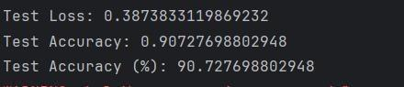

Fig 4.2 Accuracy of Finger Nails

We have observed an accuracy of 90.7% for the finger training model.

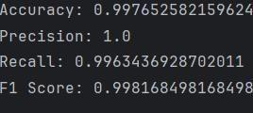

Fig 4.3 Accuracy of Palm

We have observed an accuracy of 99.6% for the palm training model.

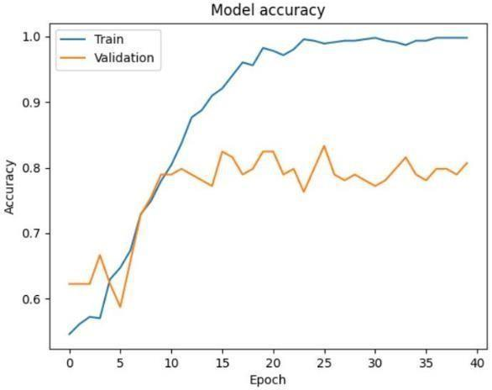

Fig 4.4 Processing of eye image

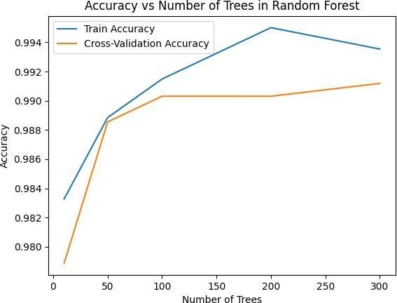

Fig 4.5 Processing of palm image

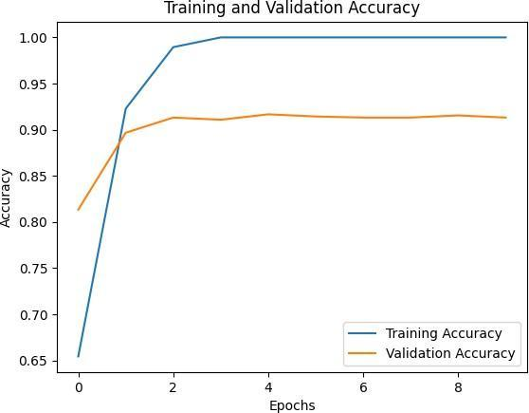

Fig 4.6 Processing of nail image

**4.1. UI/UX of the website**

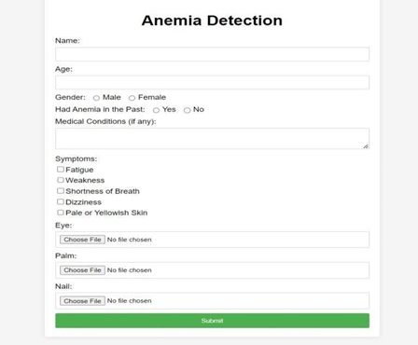

Fig 4.5 Details of the user

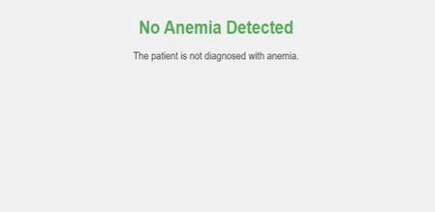

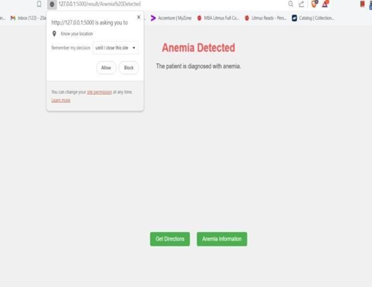

Fig 4.6 Results of the user

**4.2 Inputs used**

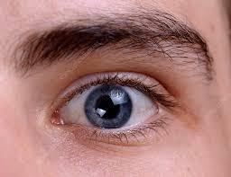

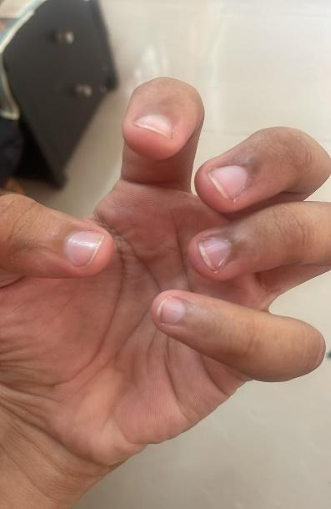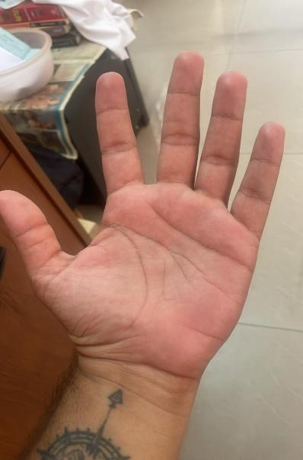

Fig 4.7 non-anemic Images

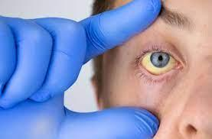

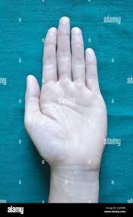

Fig 4.8 Anemic Images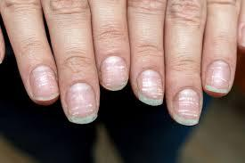

**5 Conclusion:**

The global burden of anemia necessitates innovative solutions, and the potential of converging technologies and data sources to revolutionize its diagnosis and management. Evidence shows the pervasiveness of anemia, particularly among vulnerable populations like children and pregnant women, emphasizing the urgent need for accessible and accurate detection methods. While traditional blood tests have been fundamental, their limitations in accessibility and resource demands call for alternative approaches. Machine learning (ML) emerges as a promising solution, offering a non- invasive, AI-powered pathway to early detection. Our survey highlights various ML techniques, notably Convolutional Neural Networks (CNNs) and Deep Neural Networks (DNNs), showcasing their ability to analyse conjunctival images and extract subtle visual cues indicative of anemia. These findings not only demonstrate the accuracy and generalizability of prediction but also signify the potential for democratizing healthcare. Practical Implications include the potential for ML-driven approaches to improve accessibility and accuracy of anemia diagnosis, particularly in underserved populations. Leveraging smartphones and readily available data, this non-invasive approach holds promise in reaching regions with limited healthcare infrastructure, empowering individuals and communities with early detection capabilities. Future research should focus on optimizing ML algorithms for diverse demographic groups, integrating ML-based diagnostic tools into existing healthcare systems, and assessing the long-term impact of ML-driven early detection on anemia management and public health outcomes. By addressing these areas, we can further advance proactive health management and build resilience against anemia.

**6 References:**

1. Yang N, Li X, Wu X, Lin F, Wu X, Zhu W, et al. (2022) A deep learning approach for facial image-based skincare product recommendation system. Front. Public Health 10:964385. doi: 10.3389/fpubh.2022.964385
2. Tilburg University, Digital Sciences for Society Program. (n.d.). NAIL: Nail based Artificial Intelligence image Learning for measuring iron status. Project website.
3. G. Dimauro, A. Guarini, D. Caivano, F. Girardi, C. Pasciolla and A. Iacobazzi, "Detecting Clinical Signs of Anaemia From Digital Images of the Palpebral Conjunctiva," in IEEE Access, vol. 7, pp. 113488-113498, 2019, Doi : 10.1109/ACCESS.2019.2932274.
4. Appiahene P, Asare JW, Donkoh ET, Dimauro G, Maglietta R. Detection of iron deficiency anemia by medical images: a comparative study of machine learning algorithms. BioData Min. 2023 Jan 24;16(1):2.   
   Doi: 10.1186/s13040-023-00319-z. PMID: 36694237; PMCID: PMC9875467.
5. Dhakal, P., Khanal, S., & Bista, R. (2023). Prediction of anemia using machine learning algorithms. International Journal of Computer Science and Information Technology, 15.
6. Dimauro, G.; Caivano, D.; Di Pilato, P.; Dipalma, A.; Camporeale, M.G. A Systematic Mapping Study on Research in Anemia Assessment with Non-Invasive Devices. Appl. Sci. 2020, 10, 4804.<https://doi.org/10.3390/app10144804>
7. An R, Huang Y, Man Y, Valentine RW, Kucukal E, Goreke U, Sekyonda Z, Piccone C, Owusu-Ansah A, Ahuja S, Little JA, Gurkan UA. Emerging point- of-care technologies for anemia detection. Lab Chip. 2021 May 18;21(10):1843-1865. doi: 10.1039/d0lc01235a. PMID: 33881041; PMCID: PMC8875318.
8. Shekhar, M., Berk, D. T., Mohammed, M., Mustafa, K., & Freeman, C. (2023). Anemia detection through non-invasive analysis of lip mucosa images. Frontiers in Big Data,6. https://doi.org/10.3389/fdata.2023.124