Our final project will consist of a user controlling a character within a game. This game will be very similar to Pokémon.

When the program runs for the first time, on the client side, an interface will be created to visualize the user’s current location on a giant grid.

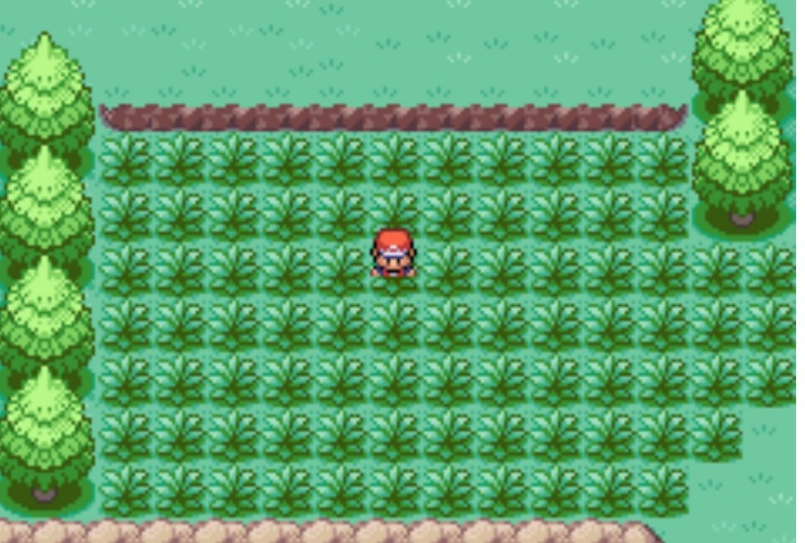

Also, when the program runs for the first time, on the server side, a signal will be sent over the network to a database. This large database holds the details and location data of *creatures* that will exist on the grid. The database is asked to send over this information to the client so that they may be initialized on the client side.

The locations of creatures won’t be visualized to the user. The user will only see their location and their surrounding area. Our game flows like this. The user moves a set distance away from their current location. This movement will be visualized. Their new location and path they traveled will be sent over the network to check with the database whether the user passed through or is currently standing on the location of a creature.

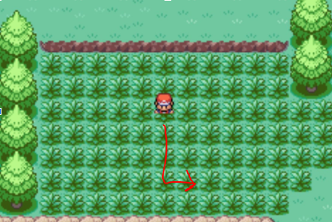

If the user passed through or is standing on a creature, then the database will send the client the details of the creature that they passed through; this creates an encounter.

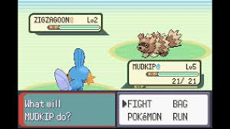

An encounter consists of catching, battling, or running from a creature. The creature will either stay or be removed from the database depending on the user’s choices.

When the user ends an encounter or if a creature wasn’t encountered, then the user will again be able to move. This process will loop until the user decides to end the game.