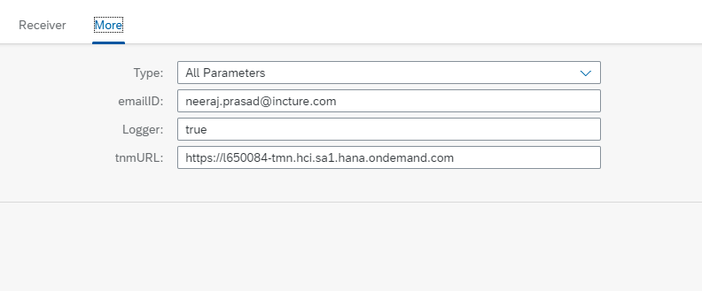  
  
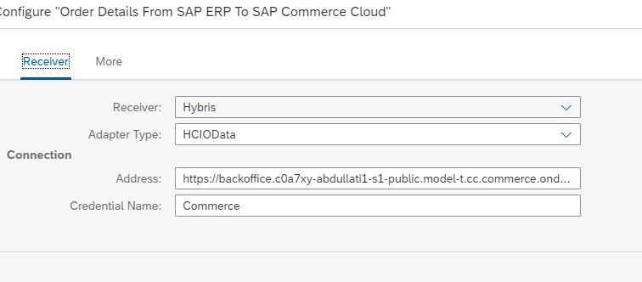  
  
https://backoffice.c0a7xy-abdullati1-s1-public.model-t.cc.commerce.ondemand.com/odata2webservices/ALJCarInboundOrderUpdate