**ABSTRACT**

**THE ROBOTICS CLUB – SNIST**

**INDUCTION’25**

**TEAM No –07**

**TITLE OF THE PROJECT:** **Chimney Sentinel**

**THE PROBLEM :**

High-rise chimneys are susceptible to hazardous buildup, structural damage, and deterioration, leading to increased risk of catastrophic fires, accidents, and system failures. Inadequate cleaning and maintenance also result in reduced system efficiency, increased energy consumption, costly repairs, and significant environmental pollution. Furthermore, neglected chimneys can compromise air quality, posing health risks to occupants, nearby communities, and wildlife, while also contributing to broader environmental degradation.

**THE TEAM’S APPROACH TO SOLVE THE PROBLEM:**

We're a team driven by the shared goal of making high-rise chimney maintenance safer and more efficient. Understanding the risks and difficulties involved, we're developing a smart, reliable solution that blends mechanical design, robotics, and automation. Our idea is to create a device that can handle complex chimney structures with little need for human involvement, keeping workers out of harm's way. Each of us brings unique skills to the table, and we're working closely together-from brainstorming and building to testing and improving our prototype. Our focus is on safety, affordability, and real-world usability, so our solution can truly make a difference where it's needed most.

**BLOCK DIAGRAM:**

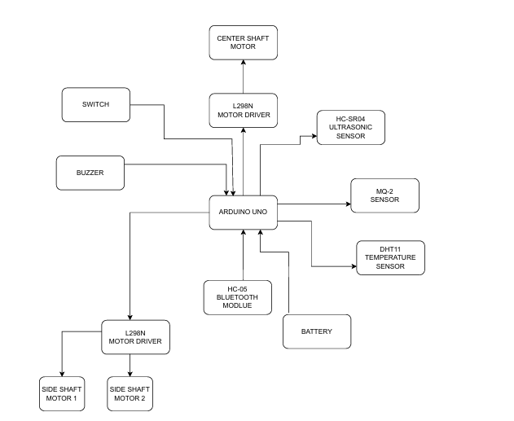

**WHAT MAKES OUR CHIMNEY CLEANING ROBOT INNOVATIVE:**

Our solution revolutionizes high-rise chimney maintenance by integrating mechanical design, robotics, and automation, ensuring unparalleled safety, efficiency, and reliability. With its potential to mitigate risks, boost productivity, and deliver sustainable outcomes, it is poised to become an indispensable asset in the industry, setting a new standard for excellence.

**TEAM DETAILS:**

Mentors: 1. Chiranjeevi

2. Harsha Veena

|  |  |  |
| --- | --- | --- |
| S.No | Name | Club ID |
| 1. | Pranathi Chityala | 24-ECE-48 |
| 2. | D.Sushmitha | 24-CSE-08 |
| 3. | Swathi Reddy Pailla | 24-CSE-10 |
| 4. | Gottam Ranjith | 24-ECE-20 |
| 5. | Gouri vyas | 24-ECE-78 |
| 6. | Jeevan R | 24-ECE-51 |
| 7. | P. Sri Latha | 24-ECE-55 |
| 8. | Madhireddy Rohit Reddy | 24-CSE-24 |
| 9. | Dorashetty Karthikeya | 24-ECE-19 |
| 10. | Gugulothu Sathwik | 24-ECE-33 |
| 11. | T.Hruthik | 24-ECE-65 |
| 12. | Macharla Tanishka | 24-ECE-97 |
| 13. | G.Srihitha | 24-CSE-33 |
| 14. | T.Shivani | 24-ECE-110 |
| 15. | Vaishnavi | 24-ECE-109 |