**THE ROBOTICS CLUB-SNIST**

**TEAM-10 INDUCTION’24**

**SMART BRIDGE**

**ABSTRACT**

**THE PROBLEM:**

Bridge is a key infrastructure which connects two different areas making trasportation accessible. During flooding events, bridges can be challenging to maintain.Traditional lifting mechanisms may not operate efficiently, leading to traffic disruptions or even collapse leading to a safety hazard.

**TEAM'S APPROACH TO SOLVE THE PROBLEM:­­**

To prevent this, we have developed an automatic height-adjusting bridge that can help maintain the safety of the bridge by rising it to a safe height even during heavy rain or floods. This bridge is equipped with an Arduino, moisture sensor /water level sensor and servo motor. Moisture sensor detects the water level and gives input to arduino and sends signals to the servo motors to adjust the bridge's height. This process continues until the water level reaches to a safe level. Similarly, when the water level decreases, brige's height is lowered. This helps ensure that bridge is at a safe height preventing any accidents or damage during heavy rain or floods.

**BLOCK DIAGRAM:**

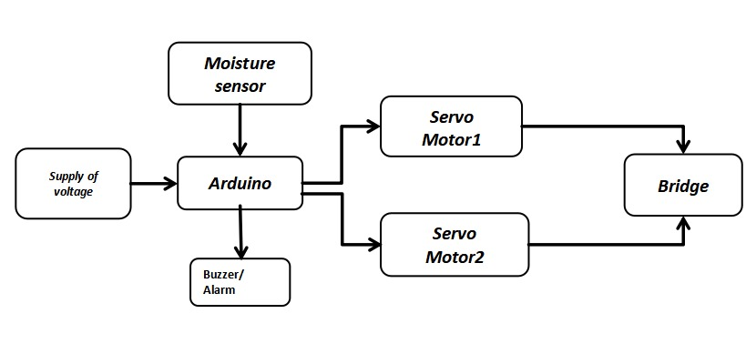

**TEAM MEMBERS**

**Mentor 1:** Srinath

**Mentor 2:** Geethika

|  |  |
| --- | --- |
| 1. B.Akshay Kumar 2. Varikala Anil 3. Eshwar 4. Pasupunoori Shanmukhi 5. Induja 6. B.Asmith Parthiv 7. Chiranjeevi Chathresh Vasagiri 8. Ananthu Nikhil 9. Sonthe Vasanth 10. Anugu Thanusree 11. Amogh Deshpande 12. Shiva Abhishek 13. Bhasker | 23-CSE-16  23-CSE-13  23-ECE-1  23-ECE-70  23-CSE-22  23-CSE-23  23-ECE-64  23-ECE-65  23-ECE-66  23-ECE-67  23-CSE-21  23-AIML-24  23-ECE-74 |