**1.ReactJS-HOL**

App.js

import './App.css';

function App() {

  return (

    <div className="App">

      <header className="App-header">

        <h1>Welcome to the first session of React</h1>

      </header>

    </div>

  );

}

export default App;

App.css

.App {

  text-align: center;

  background-color: #f5f7fa;

  min-height: 100vh;

  padding: 20px;

  font-family: 'Segoe UI', Tahoma, Geneva, Verdana, sans-serif;

}

.App-logo {

  height: 30vmin;

  pointer-events: none;

  border-radius: 50%;

  margin-bottom: 20px;

  box-shadow: 0 4px 12px rgba(0, 0, 0, 0.2);

}

@media (prefers-reduced-motion: no-preference) {

  .App-logo {

    animation: App-logo-spin infinite 20s linear;

  }

}

.App-header {

  background-color: #1e1e2f;

  padding: 40px;

  border-radius: 12px;

  color: #ffffff;

  box-shadow: 0 10px 30px rgba(0, 0, 0, 0.3);

}

.App-header h1 {

  font-size: 2.5rem;

  margin-bottom: 10px;

}

.App-link {

  color: #ffd700;

  font-weight: bold;

  text-decoration: none;

  margin-top: 20px;

  font-size: 1.2rem;

  display: inline-block;

  transition: color 0.3s ease;

}

.App-link:hover {

  color: #ff69b4;

}

@keyframes App-logo-spin {

  from {

    transform: rotate(0deg);

  }

  to {

    transform: rotate(360deg);

  }

}

OUTPUT

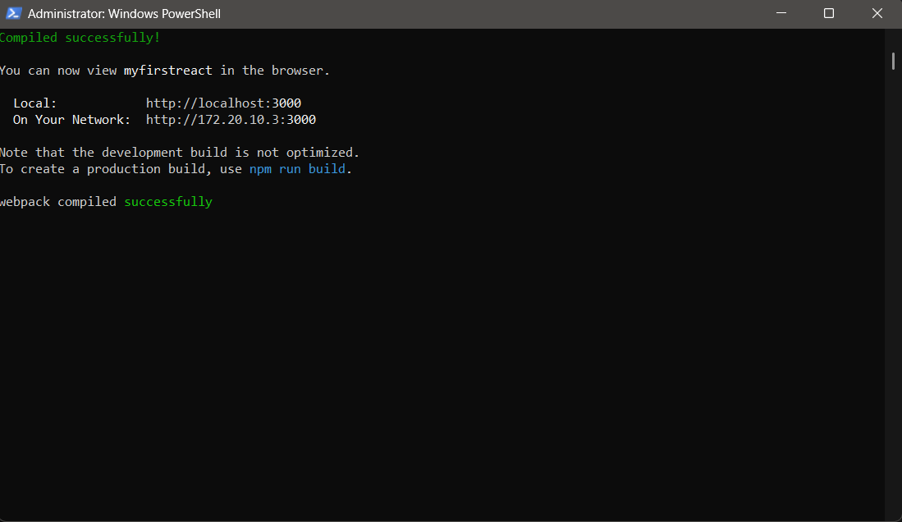

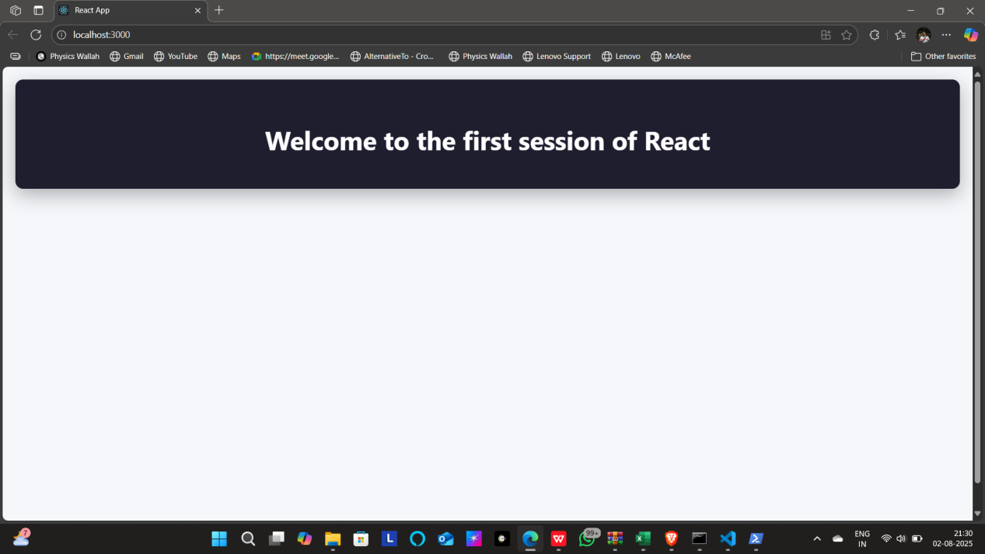

**2.ReactJS-HOL**

App.js

import React from 'react';

import Home from './components/Home';

import About from './components/About';

import Contact from './components/Contact';

function App() {

  return (

    <div>

      <h1>Welcome to Student App</h1>

      <Home />

      <About />

      <Contact />

    </div>

  );

}

export default App;

Home.js

import React from 'react';

function Home() {

  return <h2>Welcome to the Home Page</h2>;

}

export default Home;

About.js

import React from 'react';

function About() {

  return <h2>This is the About Page</h2>;

}

export default About;

Contact.js

import React from 'react';

function Contact() {

  return <h2>Contact us at: student@example.com</h2>;

}

export default Contact;

OUTPUT

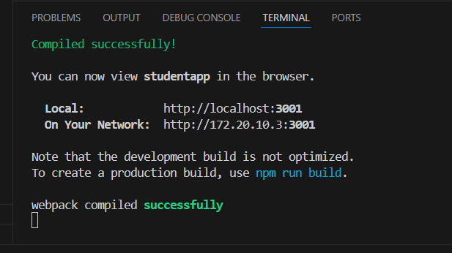

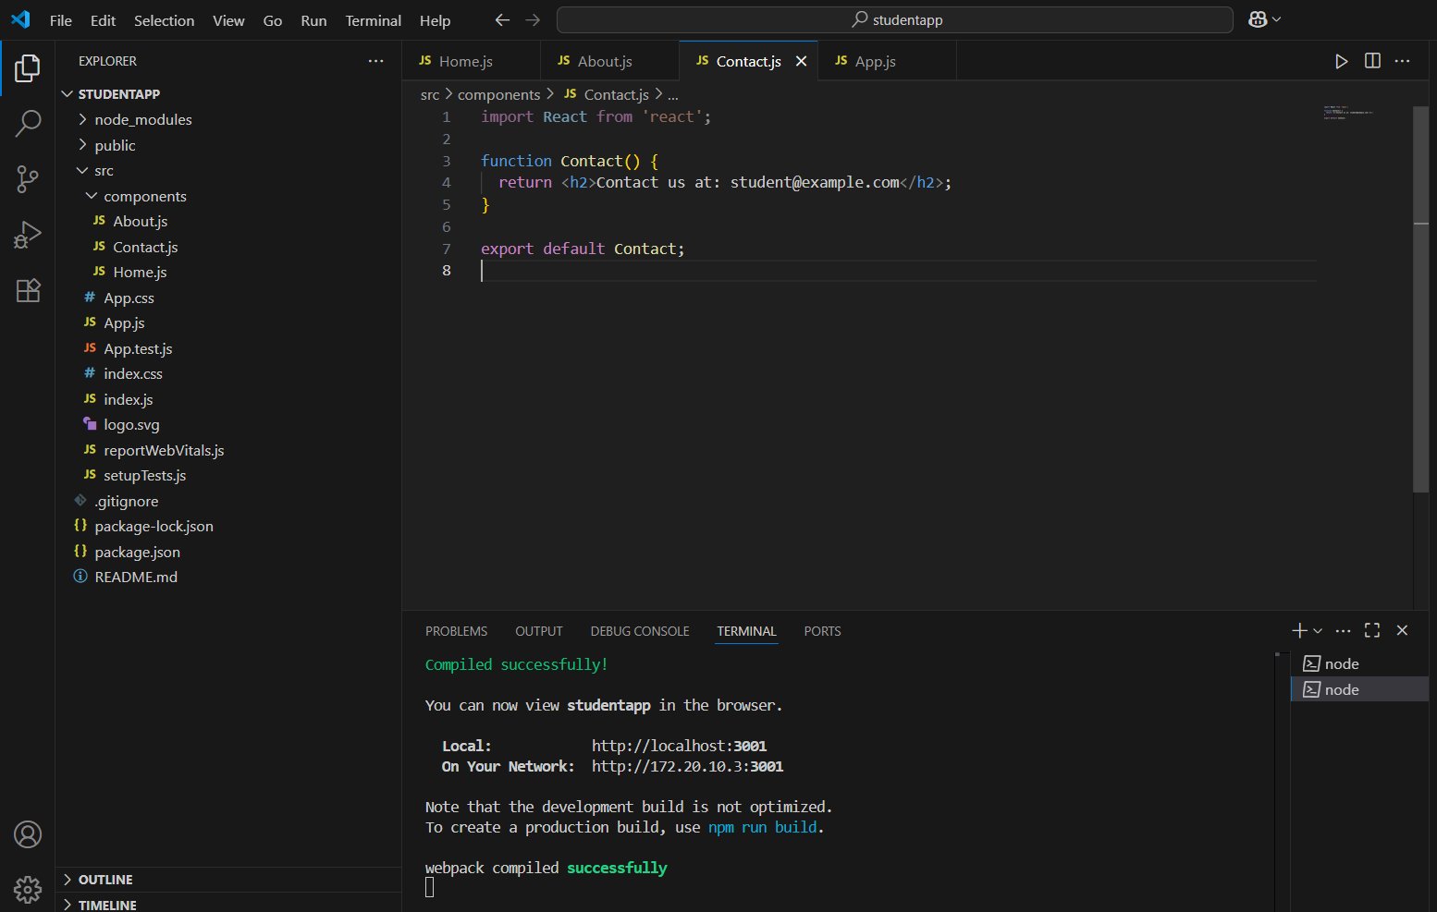

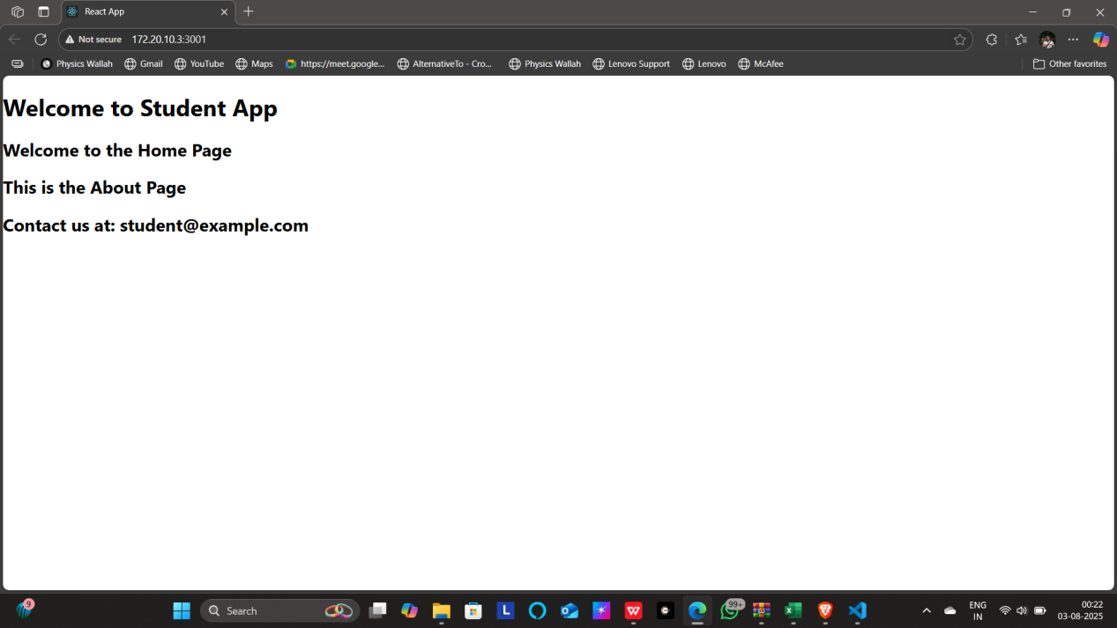

**3.ReactJS-HOL**

**CalculateScore.js**

import React, { useState } from 'react';

function CalculateScore() {

  const [name, setName] = useState('');

  const [school, setSchool] = useState('');

  const [total, setTotal] = useState('');

  const [goal, setGoal] = useState('');

  const [average, setAverage] = useState(null);

  const handleSubmit = (e) => {

    e.preventDefault();

    const avg = (parseFloat(total) / parseFloat(goal)).toFixed(2);

    setAverage(avg);

  };

  return (

    <div>

      <h2>Score Calculator</h2>

      <form onSubmit={handleSubmit}>

        <input type="text" placeholder="Name" value={name} onChange={(e) => setName(e.target.value)} required />

        <br />

        <input type="text" placeholder="School" value={school} onChange={(e) => setSchool(e.target.value)} required />

        <br />

        <input type="number" placeholder="Total Marks" value={total} onChange={(e) => setTotal(e.target.value)} required />

        <br />

        <input type="number" placeholder="Goal" value={goal} onChange={(e) => setGoal(e.target.value)} required />

        <br />

        <button type="submit">Calculate</button>

      </form>

      {average !== null && (

        <div>

          <h3>Results:</h3>

          <p>Name: {name}</p>

          <p>School: {school}</p>

          <p>Average Score: {average}</p>

        </div>

      )}

    </div>

  );

}

export default CalculateScore;

**Mystyle.css**

.score-card {

  border: 2px solid #333;

  padding: 20px;

  margin: 20px auto;

  max-width: 400px;

  background-color: #f9f9f9;

  font-family: 'Segoe UI', sans-serif;

  border-radius: 8px;

  box-shadow: 2px 2px 12px rgba(0, 0, 0, 0.1);

}

**App.js**

import React from 'react';

import './App.css';

import CalculateScore from './components/CalculateScore';

function App() {

  return (

    <div className="App">

      <h1>Welcome to the Score Calculator App</h1>

      <CalculateScore />

    </div>

  );

}

export default App;

**OUTPUTS**

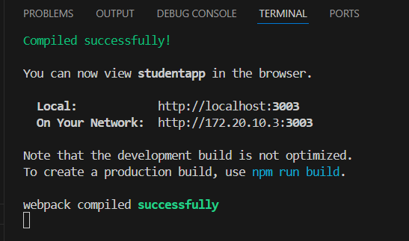

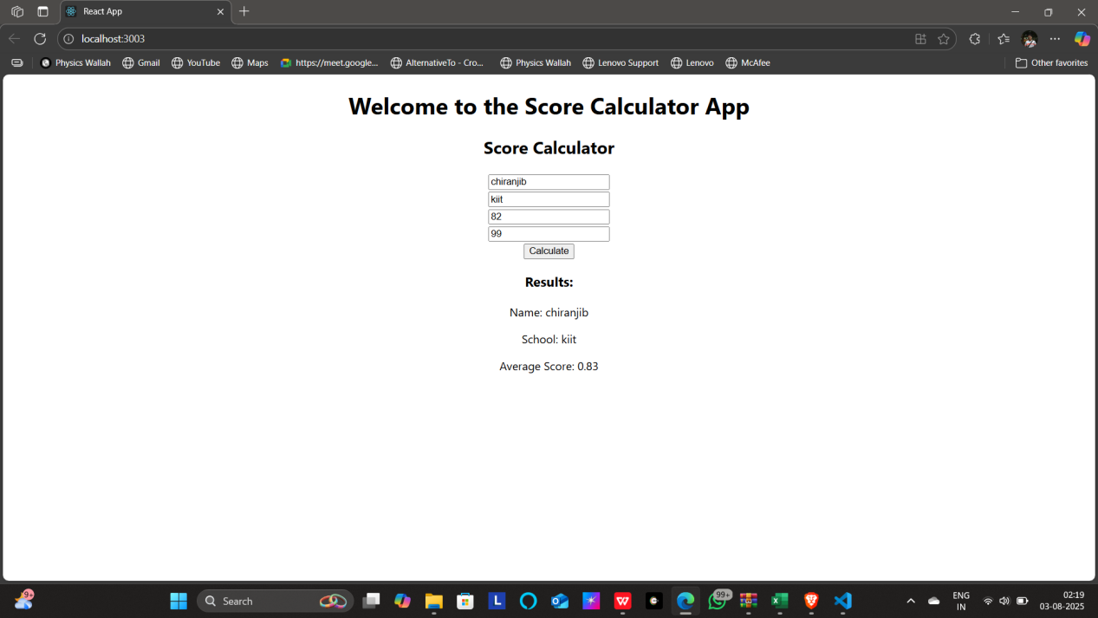

**4.ReactJS-HOL**

BlogComponent.js

import React, { Component } from 'react';

class BlogComponent extends Component {

  constructor(props) {

    super(props);

    this.state = {

      blogs: [],

      loading: true,

    };

  }

  componentDidMount() {

    setTimeout(() => {

      const blogs = [

        { title: 'React Lifecycle', author: 'John' },

        { title: 'Hooks vs Classes', author: 'Jane' }

      ];

      this.setState({ blogs, loading: false });

    }, 2000);

  }

  render() {

    if (this.state.loading) {

      return <p>Loading blog posts...</p>;

    }

    return (

      <div>

        <h2>Blog Posts</h2>

        <ul>

          {this.state.blogs.map((blog, index) => (

            <li key={index}>{blog.title} by {blog.author}</li>

          ))}

        </ul>

      </div>

    );

  }

}

export default BlogComponent;

ErrorComponent.js

import React, { Component } from 'react';

class ErrorComponent extends Component {

  constructor(props) {

    super(props);

    this.state = { hasError: false };

  }

  componentDidCatch(error, info) {

    this.setState({ hasError: true });

  }

  render() {

    if (this.state.hasError) {

      return <h2>Something went wrong while loading the blog.</h2>;

    }

    return this.props.children;

  }

}

export default ErrorComponent;

App.js

import React from 'react';

import './App.css';

function BlogComponent() {

  const blogTitle = "React Lab Task 4";

  const author = "Chiranjib Parida";

  const currentDate = new Date().toDateString();

  return (

    <div className="App">

      <h1>{blogTitle}</h1>

      <p>Author: {author}</p>

      <p>Date: {currentDate}</p>

      <p>This is a sample blog post demonstrating React component rendering.</p>

    </div>

  );

}

function App() {

  return (

    <div className="App">

      <BlogComponent />

    </div>

  );

}

export default App;

OUTPUTS

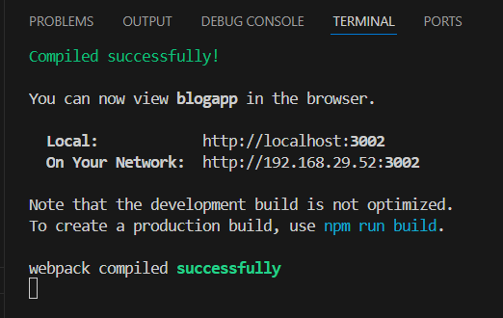

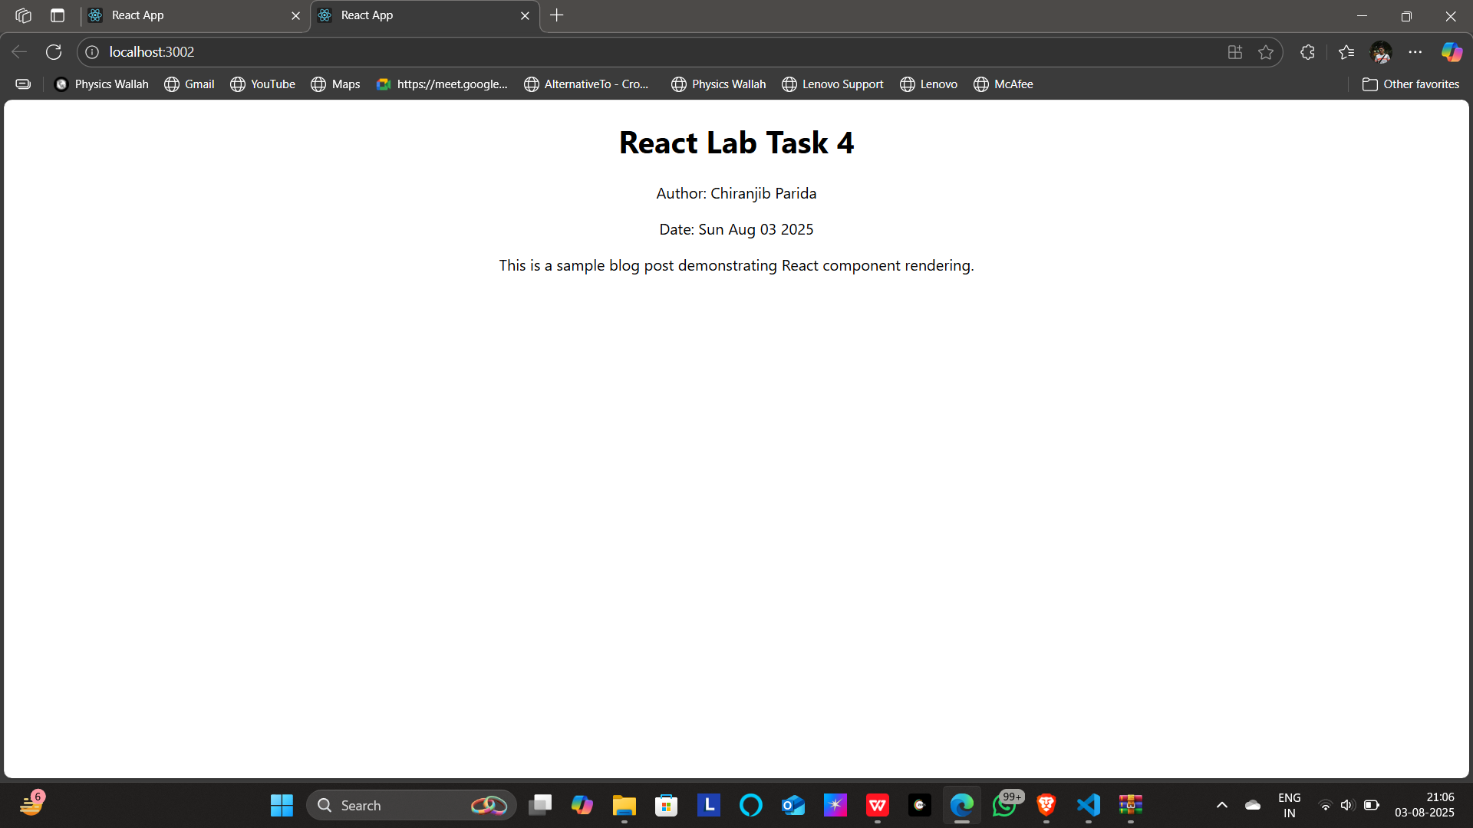

**5.ReactJS-HOL**

(Cohort Tracker Web Application using React.js)

App.js

import logo from './logo.svg';

import './App.css';

import { CohortsData} from './Cohort'

import CohortDetails from './CohortDetails';

function App() {

  return (

  <div>

    <h1>Cohorts Details</h1>

    {CohortsData.map(cohort => <CohortDetails cohort={cohort}/>)}

  </div>

  );

}

export default App;

Cohort.js

class Cohort {

    constructor(cohortCode,

        startDate,

        technology,

        trainerName,

        coachName,

        currentStatus) {

        this.cohortCode = cohortCode;

        this.coachName = coachName;

        this.trainerName = trainerName;

        this.technology = technology;

        this.startDate = startDate;

        this.currentStatus = currentStatus;

    }

}

const CohortsData =[

    new Cohort('INTADMDF10','22-Feb-2022', '.NET FSD', 'Jojo Jose','Aathma', 'Scheduled'),

    new Cohort('ADM21JF014','10-Sep-2021', 'Java FSD', 'Elisa Smith','Apoorv', 'Ongoing'),

    new Cohort('CDBJF21025','24-Dec-2021', 'Java FSD', 'John Doe','Aathma', 'Ongoing'),

    new Cohort('INTADMJF12','22-Feb-2022', 'Java FSD', 'To Be Assigned','Ibrahim', 'Scheduled'),

    new Cohort('CDE22JF011','24-Dec-2021', 'Java FSD', 'Emma Swan','Apoorv', 'Ongoing'),

    new Cohort('INTADMDF09','22-Feb-2022', 'Dataware Housing', 'Babjee Rao','Aathma', 'Scheduled'),

    new Cohort('ADM22DF001','10-Sep-2021', '.NET FSD', 'Marie Curie','Ibrahim', 'Ongoing'),

];

export {Cohort, CohortsData};

CohortDetails.js

function CohortDetails(props) {

    return (

        <div>

            <h3>

                {props.cohort.cohortCode} -

                <span>{props.cohort.technology}</span>

            </h3>

            <dl>

                <dt>Started On</dt>

                <dd>{props.cohort.startDate}</dd>

                <dt>Current Status</dt>

                <dd>{props.cohort.currentStatus}</dd>

                <dt>Coach</dt>

                <dd>{props.cohort.coachName}</dd>

                <dt>Trainer</dt>

                <dd>{props.cohort.trainerName}</dd>

            </dl>

        </div>

    );

}

export default CohortDetails;

OUTPUTS

