**9.REACTJS-HOL**

Create a React Application named “cricketapp” with the following components:

**1.List of Players**

App.js

import React from 'react';

import PlayersList from './components/PlayersList';

import IndianPlayers from './components/IndianPlayers';

function App() {

  const flag = true;

  return (

    <div>

      <h1>Cricket App using ES6</h1>

      {flag ? <PlayersList /> : <IndianPlayers />}

    </div>

  );

}

export default App;

PlayersList.js

import React from 'react';

const PlayersList = () => {

  const players = [

    { name: "Virat Kohli", score: 85 },

    { name: "Rohit Sharma", score: 40 },

    { name: "KL Rahul", score: 72 },

    { name: "Jasprit Bumrah", score: 55 },

    { name: "Hardik Pandya", score: 90 },

    { name: "Shikhar Dhawan", score: 60 },

    { name: "MS Dhoni", score: 95 },

    { name: "Ravindra Jadeja", score: 45 },

    { name: "R Ashwin", score: 75 },

    { name: "Suresh Raina", score: 67 },

    { name: "Yuvraj Singh", score: 30 }

  ];

  const filteredPlayers = players.filter(player => player.score < 70);

  return (

    <div>

      <h2>All Indian Players</h2>

      <ul>

        {players.map((player, index) => (

          <li key={index}>{player.name} - {player.score}</li>

        ))}

      </ul>

      <h3>Filtered Players (Score &lt; 70)</h3>

      <ul>

        {filteredPlayers.map((player, index) => (

          <li key={index}>{player.name} - {player.score}</li>

        ))}

      </ul>

    </div>

  );

};

export default PlayersList;

IndianPlayers.js

import React from 'react';

const IndianPlayers = () => {

  const oddTeam = ["Virat Kohli", "KL Rahul", "Hardik Pandya", "MS Dhoni", "R Ashwin"];

  const evenTeam = ["Rohit Sharma", "Jasprit Bumrah", "Shikhar Dhawan", "Ravindra Jadeja", "Suresh Raina", "Yuvraj Singh"];

  const [captain, viceCaptain, ...others] = oddTeam;

  const t20 = ["Rishabh Pant", "Surya Kumar Yadav", "Shubman Gill"];

  const ranji = ["Cheteshwar Pujara", "Ajinkya Rahane", "Hanuma Vihari"];

  const merged = [...t20, ...ranji];

  return (

    <div>

      <h2>Odd Team Players (Destructured)</h2>

      <p>Captain: {captain}</p>

      <p>Vice Captain: {viceCaptain}</p>

      <p>Others: {others.join(", ")}</p>

      <h2>Even Team Players</h2>

      <ul>

        {evenTeam.map((player, index) => (

          <li key={index}>{player}</li>

        ))}

      </ul>

      <h2>Merged Players (T20 + Ranji)</h2>

      <ul>

        {merged.map((player, index) => (

          <li key={index}>{player}</li>

        ))}

      </ul>

    </div>

  );

};

export default IndianPlayers;

**OUTPUTS**

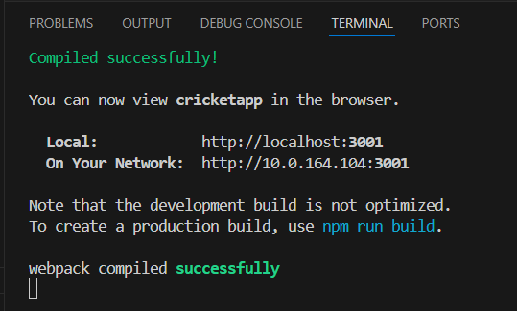

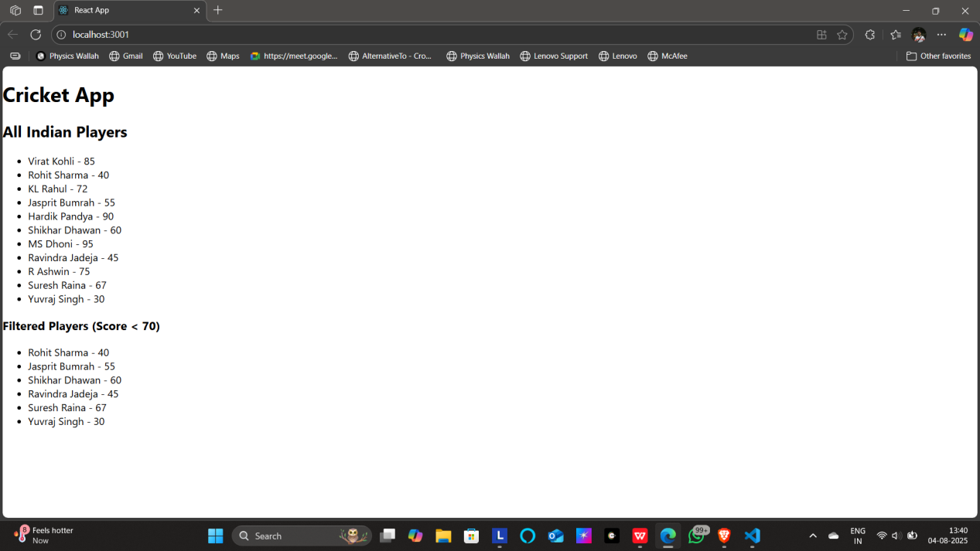

**2.Indian Players**

* 1. Display the Odd Team Player and Even Team players using the Destructuring features of ES6
  2. Declare two arrays T20players and RanjiTrophy players and merge the two arrays and display them using the Merge feature of ES6

App.js

import React from 'react';

import IndianPlayers from './components/IndianPlayers';

function App() {

  return (

    <div className="App">

      <h1>Indian Cricket Players</h1>

      <IndianPlayers />

    </div>

  );

}

export default App;

IndianPlayers.js

import React from 'react';

const IndianPlayers = () => {

  const T20Players = ['Virat Kohli', 'Rohit Sharma', 'Jasprit Bumrah', 'Suryakumar Yadav'];

  const RanjiPlayers = ['Cheteshwar Pujara', 'Ajinkya Rahane', 'Shubman Gill', 'Ishant Sharma'];

  // Merging two arrays using spread

  const mergedPlayers = [...T20Players, ...RanjiPlayers];

  // Filtering Odd Team and Even Team based on index

  const oddTeam = mergedPlayers.filter((_, index) => index % 2 === 0);  // 0,2,4...

  const evenTeam = mergedPlayers.filter((_, index) => index % 2 !== 0); // 1,3,5...

  // Destructuring example

  const [firstPlayer, secondPlayer, ...rest] = mergedPlayers;

  return (

    <div>

      <h2>All Indian Players (Merged from T20 & Ranji)</h2>

      <ul>

        {mergedPlayers.map((player, index) => (

          <li key={index}>{player}</li>

        ))}

      </ul>

      <h3>Odd Team Players</h3>

      <ul>

        {oddTeam.map((player, index) => (

          <li key={index}>{player}</li>

        ))}

      </ul>

      <h3>Even Team Players</h3>

      <ul>

        {evenTeam.map((player, index) => (

          <li key={index}>{player}</li>

        ))}

      </ul>

      <h3>Destructuring Example</h3>

      <p>First Player: {firstPlayer}</p>

      <p>Second Player: {secondPlayer}</p>

    </div>

  );

};

export default IndianPlayers;

OUTPUTS

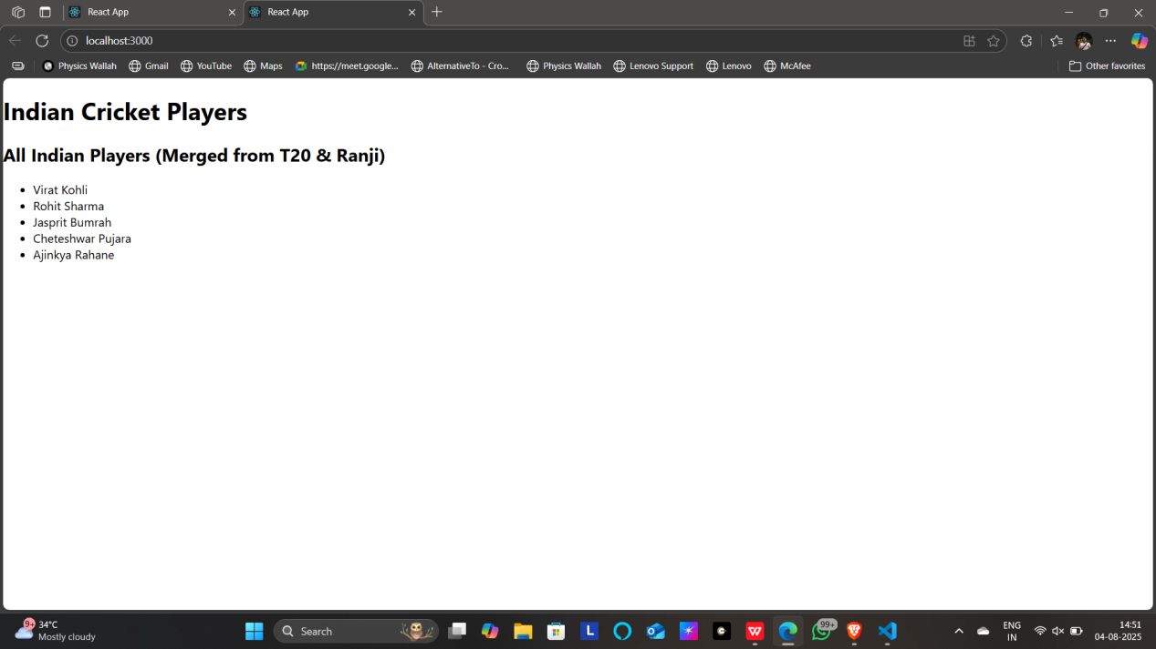

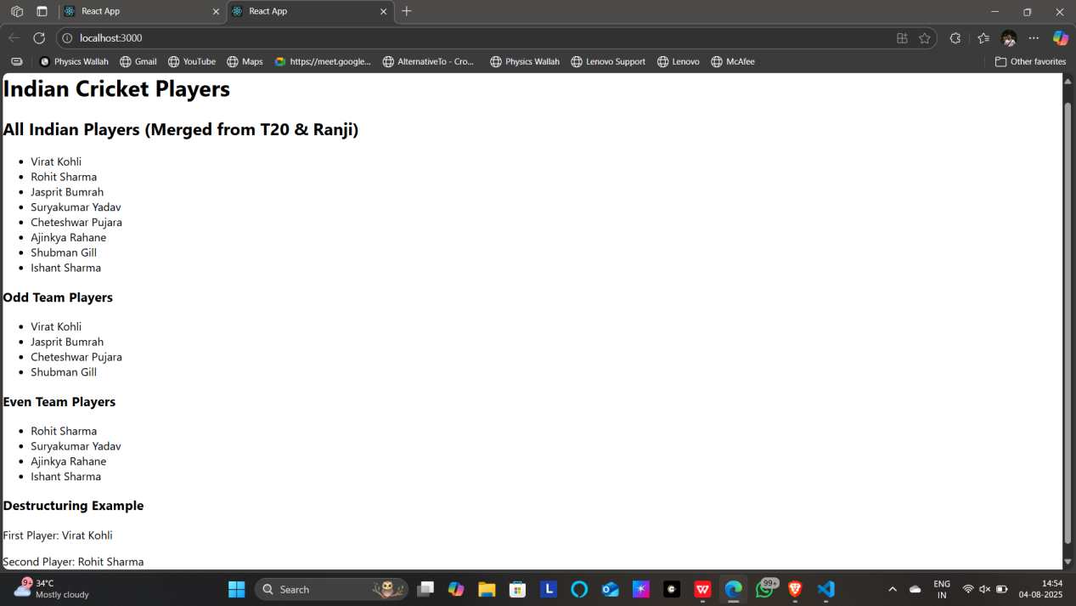

**10.REACTJS-HOL**

Create a React Application named “officespacerentalapp” which uses React JSX to create elements, attributes and renders DOM to display the page.

App.js

// src/App.js

import React from 'react';

import OfficeSpaceList from './OfficeSpaceList';

function App() {

  return (

    <div className="App">

      <h1>Office Space Rental Portal</h1>

      <OfficeSpaceList />

    </div>

  );

}

export default App;

OfficeSpacelist.js

// src/OfficeSpaceList.js

import React from 'react';

const OfficeSpaceList = () => {

  const offices = [

    {

      name: "Tech Park",

      rent: 75000,

      address: "MG Road, Bangalore",

      image: "techpark.webp"

    },

    {

      name: "Startup Hub",

      rent: 55000,

      address: "Salt Lake, Kolkata",

      image: "startup-hub.webp"

    },

    {

      name: "Coworking Space",

      rent: 60000,

      address: "Cyber City, Gurgaon",

      image: "coworking-space.webp"

    }

  ];

  return (

    <div>

      <h2>Available Office Spaces</h2>

      {offices.map((office, index) => (

        <div key={index} style={{ border: '1px solid gray', margin: '10px', padding: '10px' }}>

          <h3>{office.name}</h3>

          <img

            src={`/${office.image}`}  // ✅ direct path from public folder

            alt={office.name}

            style={{ width: '300px', height: '150px' }}

          />

          <p><strong>Address:</strong> {office.address}</p>

          <p><strong>Rent:</strong> ₹{office.rent}</p>

        </div>

      ))}

    </div>

  );

};

export default OfficeSpaceList;

OUTPUTS

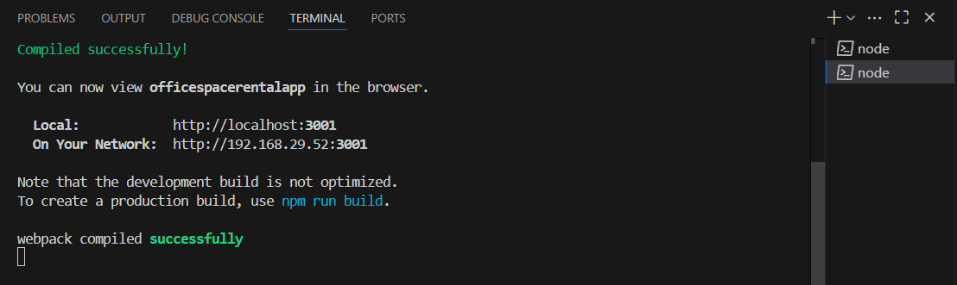

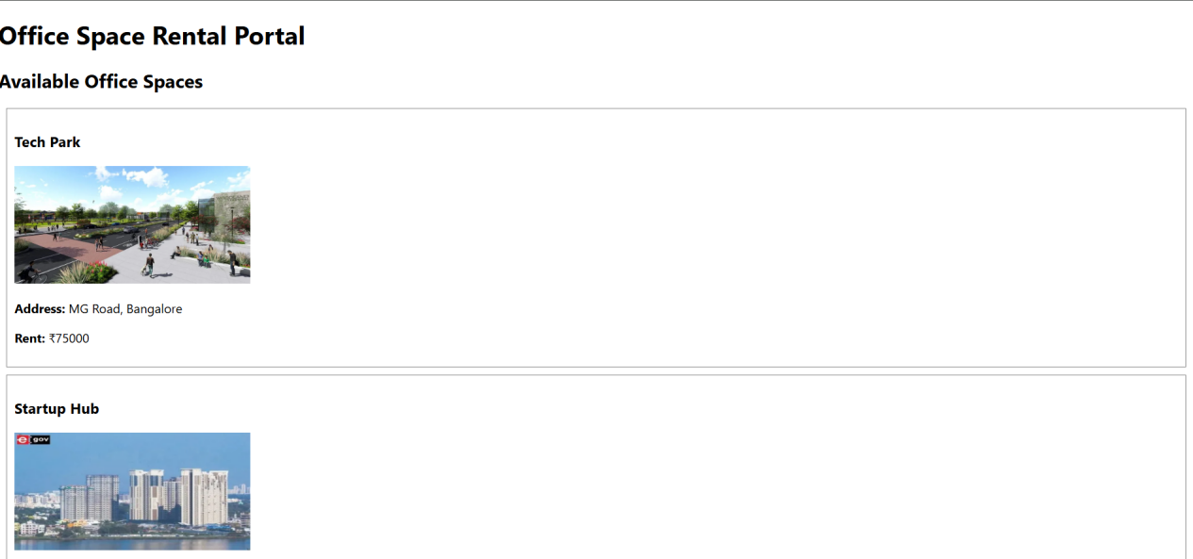

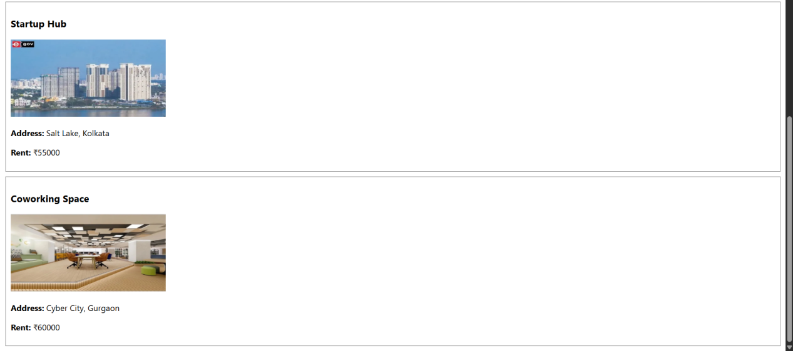

11.REACTJS-HOL

Create a React Application “eventexamplesapp” to handle various events of the form elements in HTML.

1. Create “Increment” button to increase the value of the counter and “Decrement” button to decrease the value of the counter. The “Increase” button should invoke multiple methods.
   1. To increment the value
   2. Say Hello followed by a static message.
2. Create a button “Say Welcome” which invokes the function which takes “welcome” as an argument.
3. Create a button which invokes synthetic event “OnPress” which display “I was clicked”
4. Create a “CurrencyConvertor” component which will convert the Indian Rupees to Euro when the Convert button is clicked.

Handle the Click event of the button to invoke the handleSubmit event and handle the

The conversion of euro to rupees.

App.js

import React, { Component } from 'react';

import './App.css';

import CurrencyConverter from './CurrencyConverter';

class App extends Component {

  constructor(props) {

    super(props);

    this.state = {

      count: 0

    };

  }

  increment = () => {

    this.setState({ count: this.state.count + 1 });

    this.sayHello();

  };

  decrement = () => {

    this.setState({ count: this.state.count - 1 });

  };

  sayHello = () => {

    alert("Hello! Have a great day.");

  };

  sayWelcome = (message) => {

    alert(message);

  };

  handleClick = (e) => {

    e.preventDefault();

    alert("I was clicked");

  };

  render() {

    return (

      <div className="App">

        <h2>Counter: {this.state.count}</h2>

        <button onClick={this.increment}>Increment</button>

        <button onClick={this.decrement}>Decrement</button>

        <br /><br />

        <button onClick={() => this.sayWelcome("Welcome!")}>Say Welcome</button>

        <br /><br />

        <button onClick={this.handleClick}>Synthetic Event (OnPress)</button>

        <br /><br />

        <CurrencyConverter />

      </div>

    );

  }

}

export default App;

CurrencyConverter.js

import React, { Component } from 'react';

class CurrencyConverter extends Component {

  constructor(props) {

    super(props);

    this.state = {

      rupees: '',

      euro: ''

    };

  }

  handleChange = (e) => {

    this.setState({ rupees: e.target.value });

  };

  handleSubmit = (e) => {

    e.preventDefault();

    const euroRate = 0.011;

    const euro = (this.state.rupees * euroRate).toFixed(2);

    this.setState({ euro });

  };

  render() {

    return (

      <div>

        <h2>Currency Converter (INR to Euro)</h2>

        <form onSubmit={this.handleSubmit}>

          <input

            type="number"

            placeholder="Enter INR"

            value={this.state.rupees}

            onChange={this.handleChange}

          />

          <button type="submit">Convert</button>

        </form>

        <h3>Converted Euro: €{this.state.euro}</h3>

      </div>

    );

  }

}

export default CurrencyConverter;

OUTPUTS

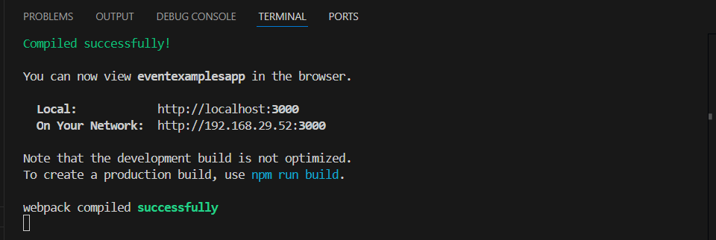

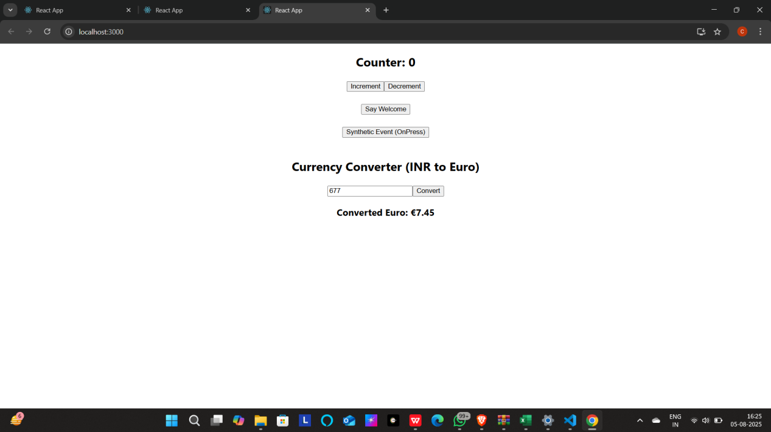



**12.REACTJS-HOL**

Create a React Application named “ticketbookingapp” where the guest user can browse the page where the flight details are displayed whereas the logged in user only can book tickets.

The Login and Logout buttons should accordingly display different pages. Once the user is logged in the User page should be displayed. When the user clicks on Logout, the Guest page should be displayed.

App.js

import React, { Component } from 'react';

import './App.css';

import GuestPage from './GuestPage';

import UserPage from './UserPage';

class App extends Component {

  constructor(props) {

    super(props);

    this.state = {

      isLoggedIn: false

    };

  }

  handleLogin = () => {

    this.setState({ isLoggedIn: true });

  };

  handleLogout = () => {

    this.setState({ isLoggedIn: false });

  };

  render() {

    let page;

    if (this.state.isLoggedIn) {

      page = <UserPage onLogout={this.handleLogout} />;

    } else {

      page = <GuestPage onLogin={this.handleLogin} />;

    }

    return (

      <div className="App">

        <h1>✈️ Ticket Booking App</h1>

        {page}

      </div>

    );

  }

}

export default App;

GuestPage.js

import React from 'react';

function GuestPage({ onLogin }) {

  return (

    <div>

      <h2>Welcome, Guest!</h2>

      <p>You can browse available flight details below.</p>

      <ul>

        <li>Flight AI203 - Delhi to Mumbai - 10:00 AM</li>

        <li>Flight AI505 - Bangalore to Kolkata - 2:00 PM</li>

        <li>Flight AI789 - Hyderabad to Chennai - 6:00 PM</li>

      </ul>

      <button onClick={onLogin}>Login to Book</button>

    </div>

  );

}

export default GuestPage;

UserPage.js

import React from 'react';

function UserPage({ onLogout }) {

  return (

    <div>

      <h2>Welcome, User!</h2>

      <p>You are now logged in. Book your flight below:</p>

      <form>

        <label>Flight No: </label>

        <input type="text" placeholder="Enter flight number" />

        <br /><br />

        <label>Passenger Name: </label>

        <input type="text" placeholder="Enter your name" />

        <br /><br />

        <button type="submit">Book Ticket</button>

      </form>

      <br />

      <button onClick={onLogout}>Logout</button>

    </div>

  );

}

export default UserPage;

OUTPUTS

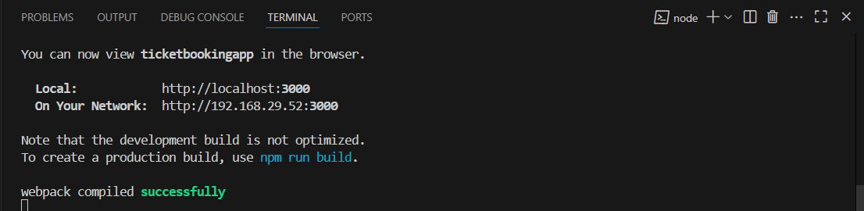

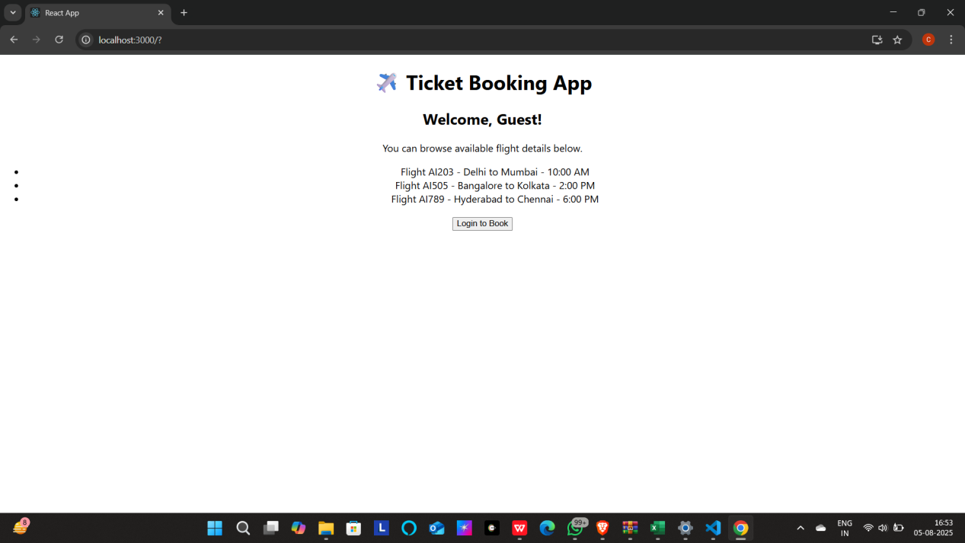

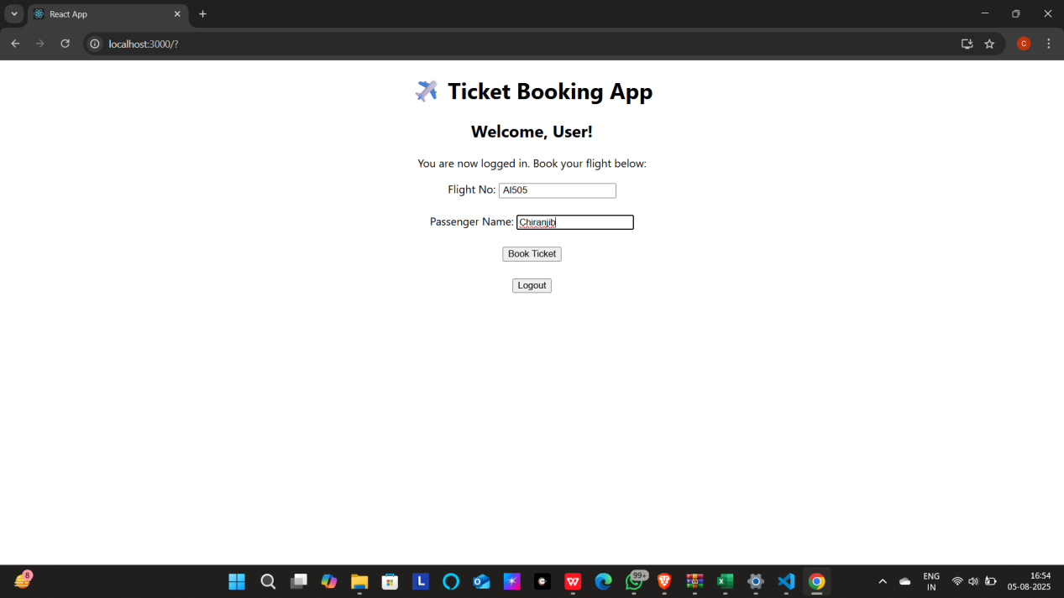

**13.ReactJS-HOL**

Create a React App named “bloggerapp” in with 3 components.

1. Book Details
2. Blog Details
3. Course Details

Implement this with as many ways possible of Conditional Rendering.

App.js

import React, { useState } from 'react';

import './App.css';

import BookDetails from './BookDetails';

import BlogDetails from './BlogDetails';

import CourseDetails from './CourseDetails';

function App() {

  const [section, setSection] = useState('none');

  let displayComponent;

  if (section === 'book') {

    displayComponent = <BookDetails />;

  } else if (section === 'blog') {

    displayComponent = <BlogDetails />;

  } else if (section === 'course') {

    displayComponent = <CourseDetails />;

  } else {

    displayComponent = <p>Please choose a section to view.</p>;

  }

  return (

    <div className="App">

      <h1>📚 Blogger App</h1>

      <button onClick={() => setSection('book')}>Show Book Details</button>

      <button onClick={() => setSection('blog')}>Show Blog Details</button>

      <button onClick={() => setSection('course')}>Show Course Details</button>

      <hr />

      {displayComponent}

    </div>

  );

}

export default App;

BookDetails.js

import React from 'react';

const books = [

  { id: 1, title: 'Atomic Habits', author: 'James Clear' },

  { id: 2, title: 'The Alchemist', author: 'Paulo Coelho' },

  { id: 3, title: 'Deep Work', author: 'Cal Newport' }

];

function BookDetails() {

  return (

    <div>

      <h2>Book List</h2>

      <ul>

        {books.map(book => (

          <li key={book.id}>

            <strong>{book.title}</strong> by {book.author}

          </li>

        ))}

      </ul>

    </div>

  );

}

export default BookDetails;

BlogDetails.js

import React from 'react';

function BlogDetails() {

  const isPublished = true;

  return (

    <div>

      <h2>Blog Section</h2>

      {isPublished ? (

        <p>Our blog is live! Visit: <a href="https://example.com">example.com</a></p>

      ) : (

        <p>Blog is under construction.</p>

      )}

    </div>

  );

}

export default BlogDetails;

CourseDetails.js

import React from 'react';

function CourseDetails() {

  const courses = ['ReactJS', 'NodeJS', 'MongoDB', 'ExpressJS'];

  return (

    <div>

      <h2>Course Details</h2>

      {courses.length > 0 && (

        <ul>

          {courses.map((course, index) => (

            <li key={index}>{course}</li>

          ))}

        </ul>

      )}

    </div>

  );

}

export default CourseDetails;

OUTPUTS

