**GIT**

1.GIT-HOL

To create a new repository, signup with GitLab and register your credentials

Login to GitLab and create a “GitDemo” project.

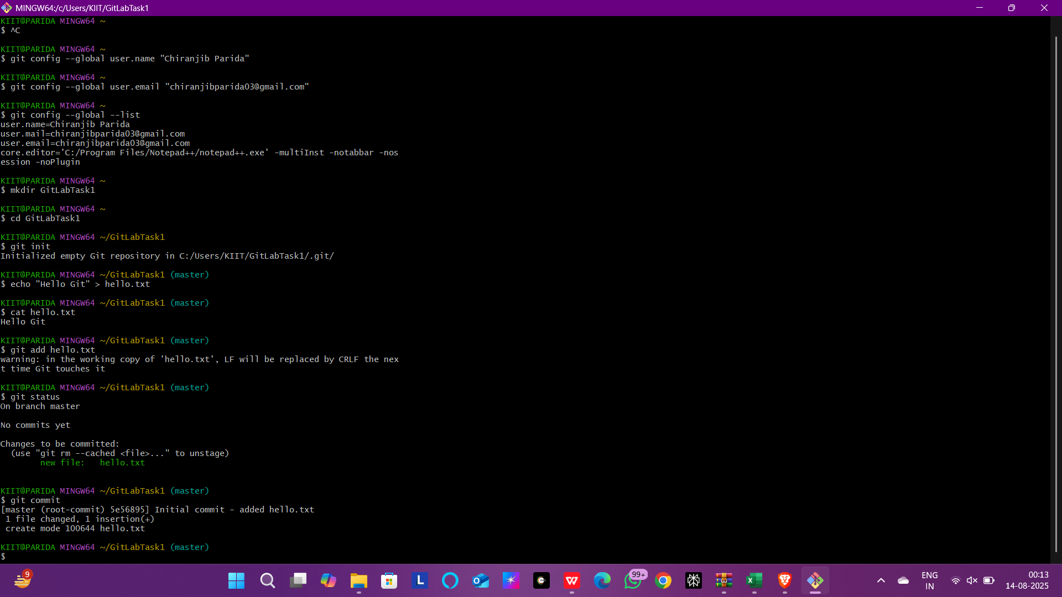

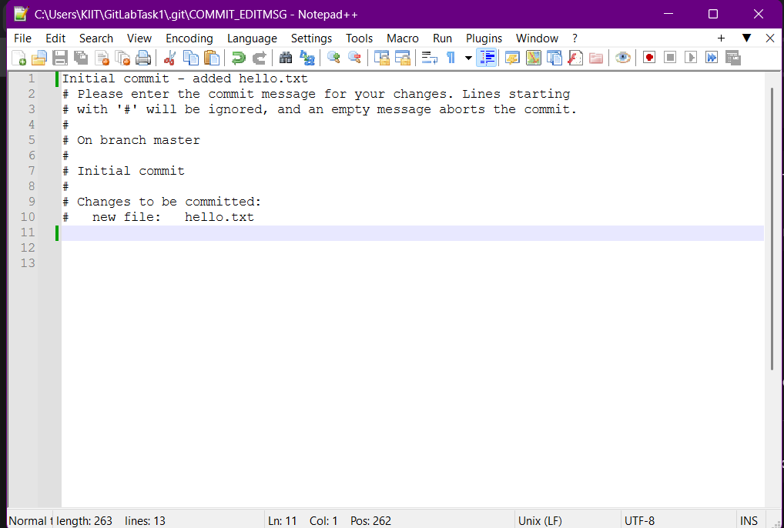

2.GIT-HOL

Create a **“.log”** file and a **log folder** in the working directory of Git. Update the **.gitignore** file in such a way that on committing, these files (.log extensions and log folders) are ignored.

Verify if the git status reflects the same about working directory, local repository and git repository.

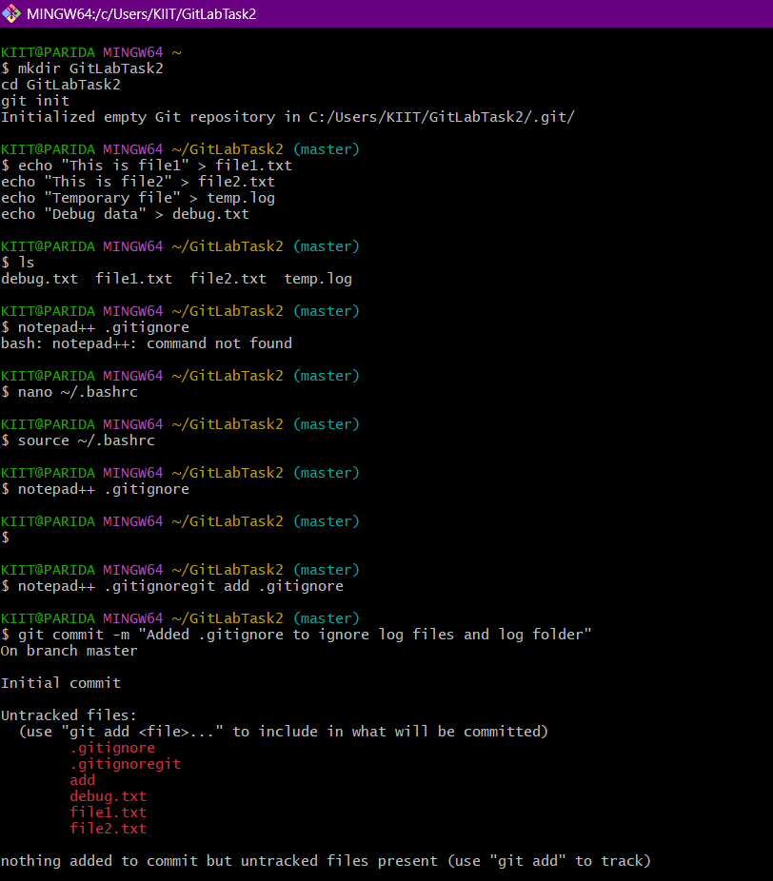

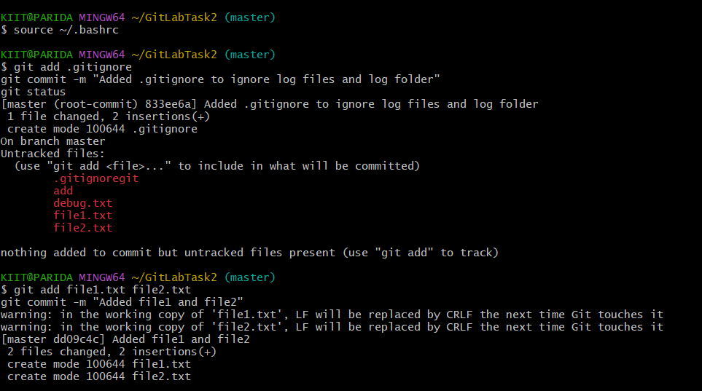

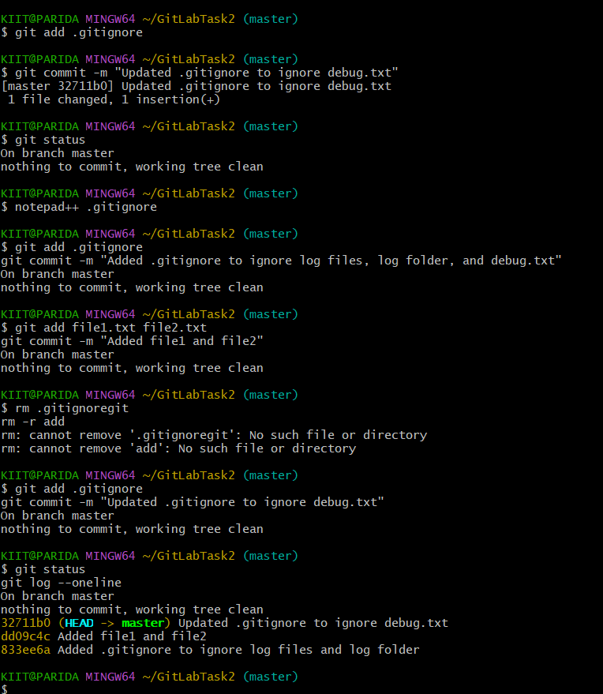

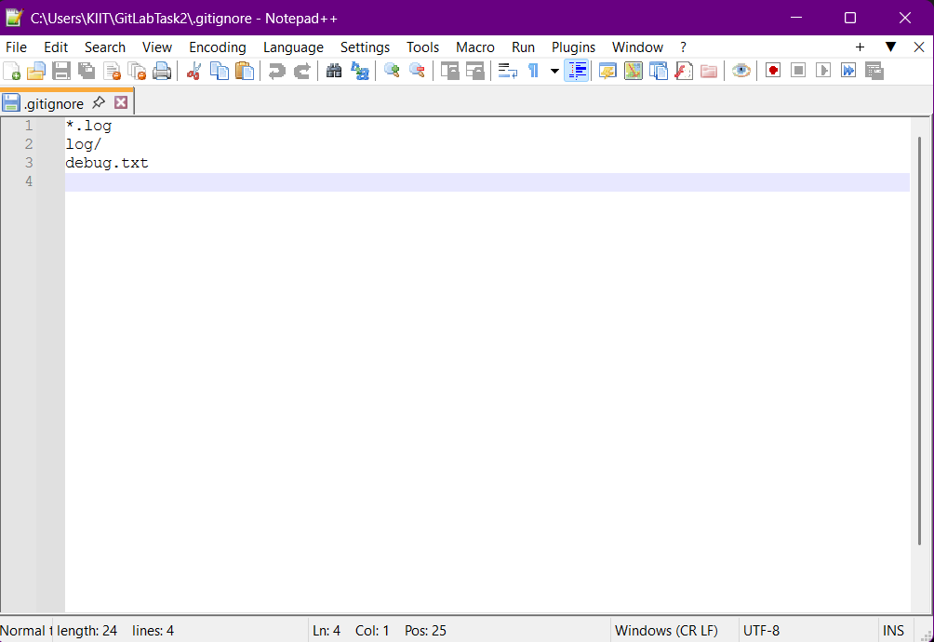

3.GIT-HUB

**Branching:**

1. Create a new branch **“GitNewBranch”.**
2. List all the local and remote branches available in the current trunk. Observe the “*” mark which denote the current pointing branch.
3. Switch to the newly created branch. Add some files to it with some contents.
4. Commit the changes to the branch.
5. Check the status with **“git status”** command.

**Merging:**

1. Switch to the master
2. List out all the differences between trunk and branch. These provide the differences in command line interface.
3. List out all the visual differences between master and branch using **P4Merge tool**.
4. Merge the source branch to the trunk.
5. Observe the logging after merging using **“git log –oneline –graph –decorate”**
6. Delete the branch after merging with the trunk and observe the git status.

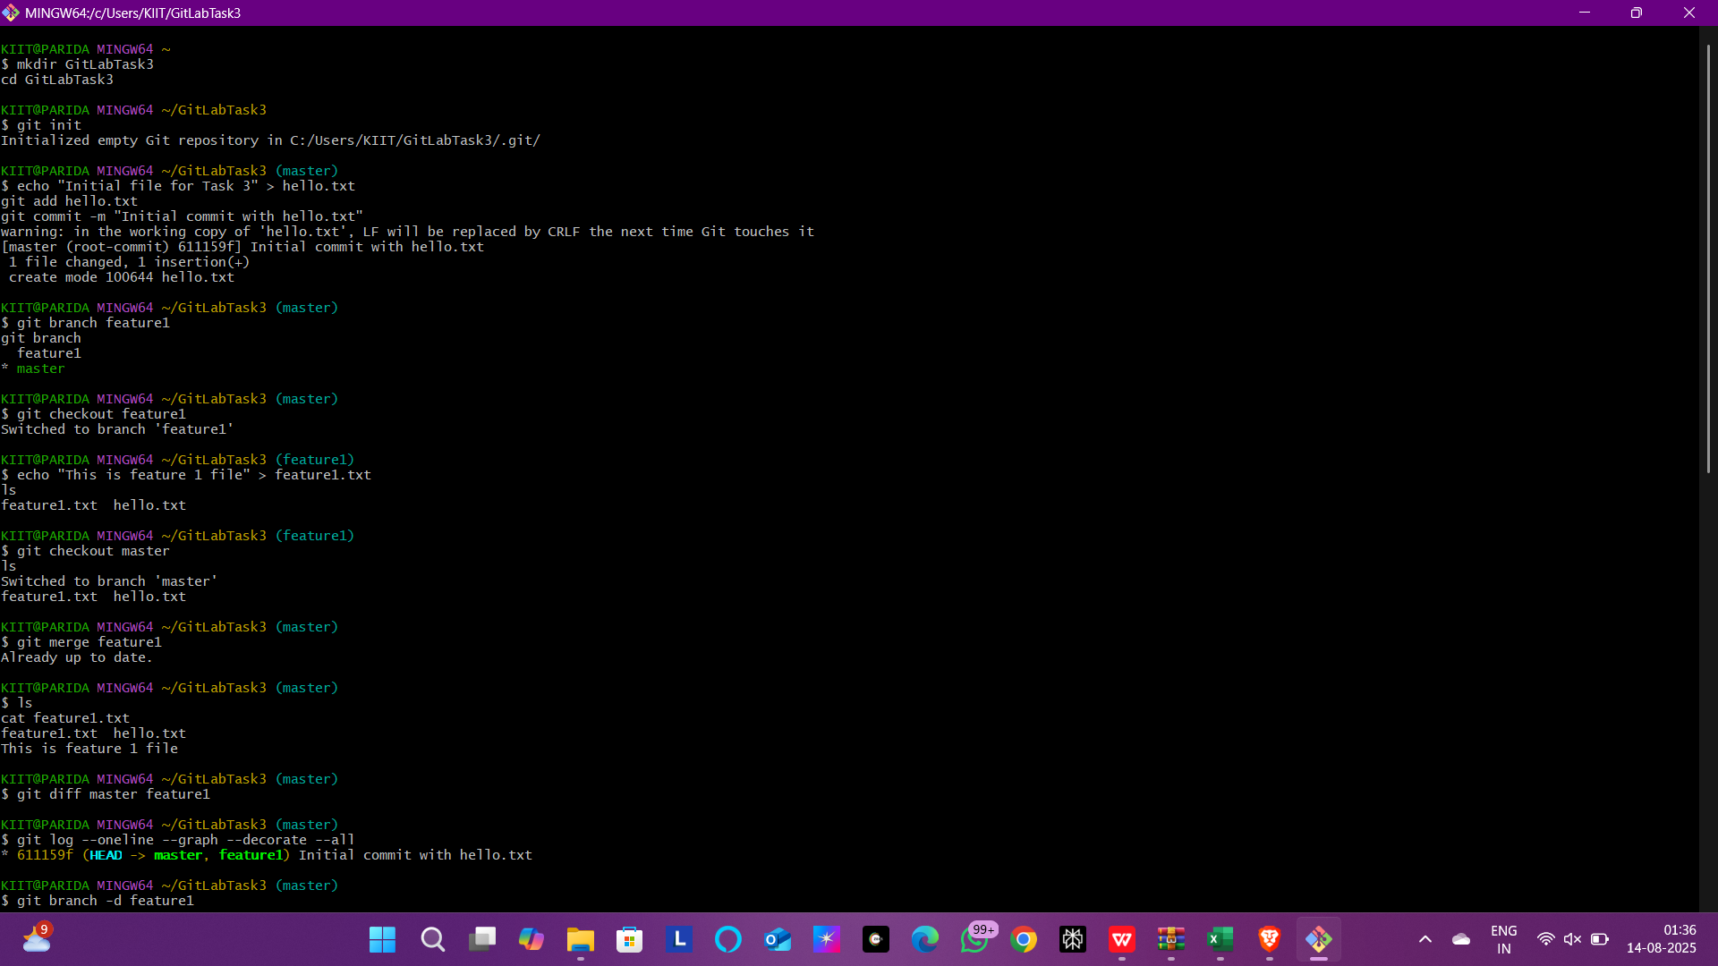

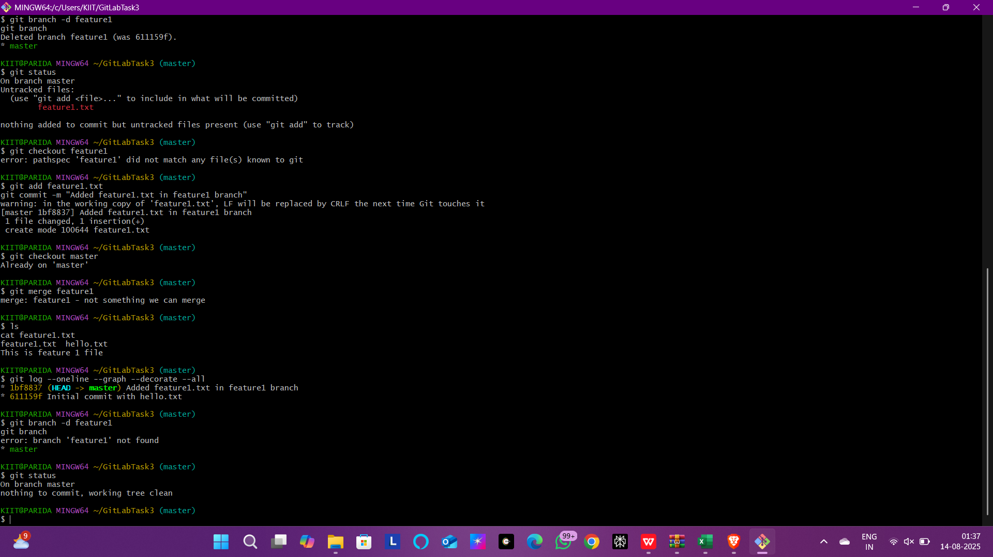

4.GIT-HOL

* Implement conflict resolution when multiple users are updating the trunk (or master) in such a way that it results into a conflict with the branch’s modification.

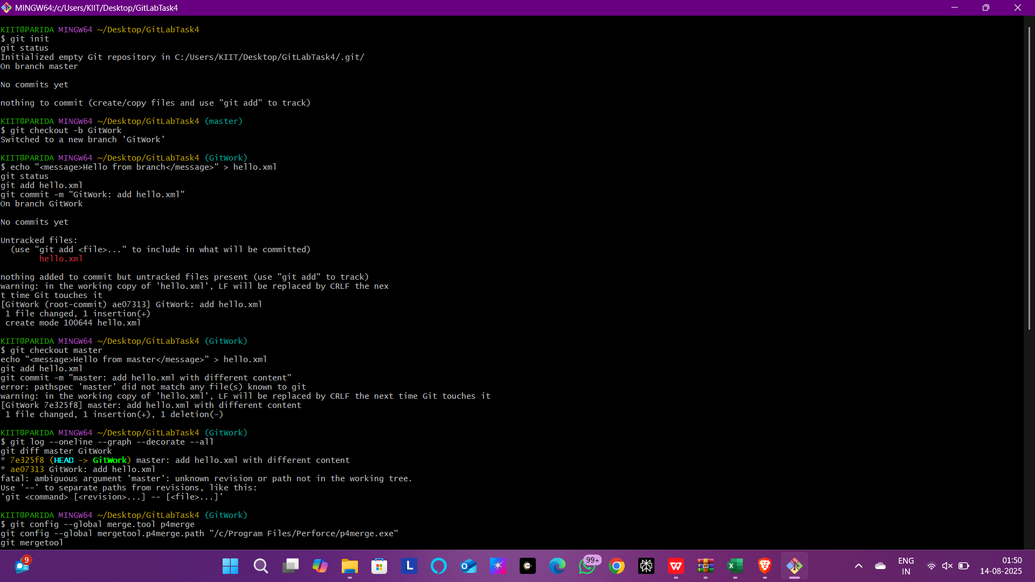

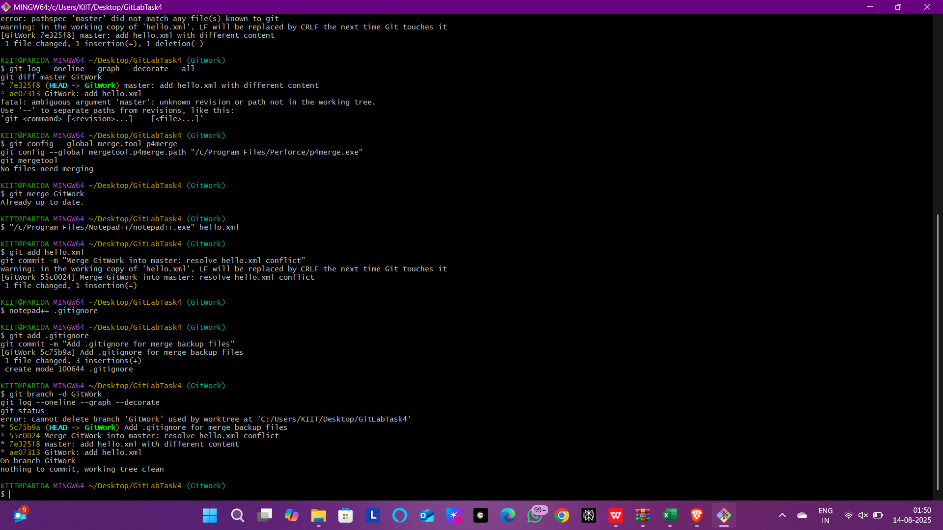

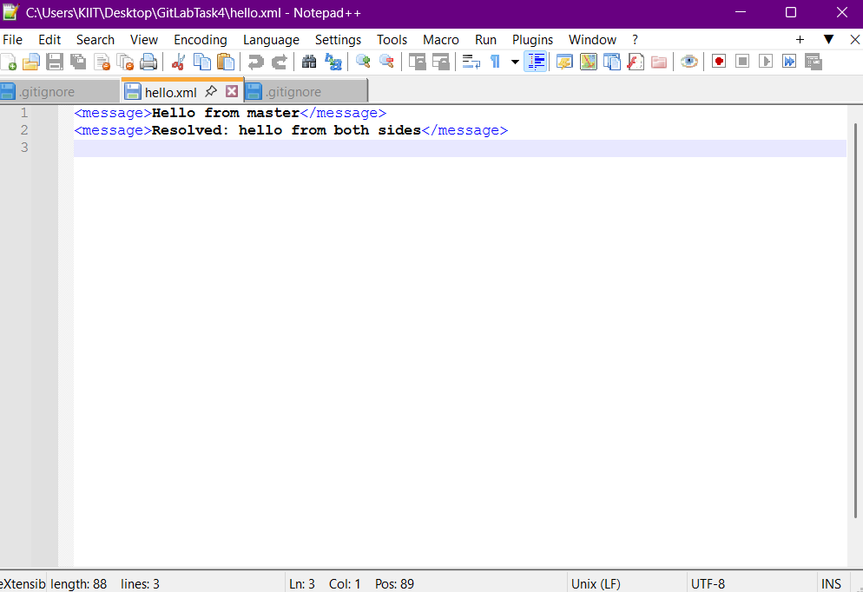

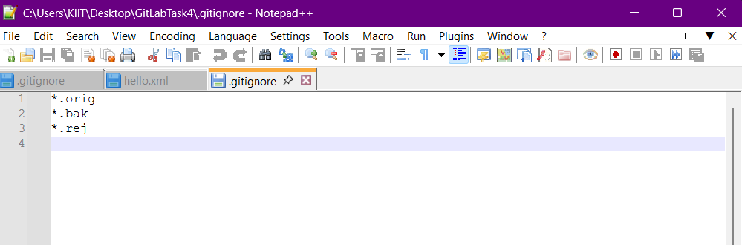

5.GIT-HOL

