FINAL YEAR B. TECH PROJECT SYNOPSIS
(Project Phase-I)
(Scheme-A)
Academic Year: 2026-27
Semester: VII
"CONTEXT-AWARE MULTI-MEANING SLANG CLASSIFICATION USING GRAPH THEORY"
Submitted By:
GROUP ID: CSE_(C)R_58_Scheme(A)
PRN | NAME OF THE STUDENT | DIVISION
22358010167 | Mehta Chiranjiv Vasudev | C
22358010174 | Payal Anil More | C
22358010166 | Aditya Harish Mehta | C
Under the Guidance of:
"Ms. Joytsena Borse"
Department of Computer Science & Engineering
School of Computational Sciences
Faculty of Science & Technology
JSPM University Pune

1. Title of the Project
"Context-Aware Multi-Meaning Slang Classification Using Graph Theory"

2. Domain / Area of the Project
Natural Language Processing (NLP), Machine Learning, Graph Theory, and Artificial Intelligence, with specific application to context-aware semantic disambiguation of informal and slang language.

3. Introduction
Informal digital communication - social media posts, chat messages, and online reviews - makes heavy use of slang words whose meaning changes entirely depending on the surrounding context. Words such as "fire," "sick," "cooked," "lit," and "ghost" can each refer to an actual physical phenomenon or an entirely figurative, colloquial meaning. Correctly identifying which meaning is intended is a non-trivial Natural Language Processing problem, since traditional dictionary or keyword-based systems cannot resolve this ambiguity.
This project proposes a hybrid system that combines NLP-based feature extraction with Graph Theory-based context modelling and Machine Learning classification to automatically detect slang words in a sentence and predict their intended meaning, along with a confidence score and a human-readable explanation of the reasoning.

4. Problem Statement
To design and develop a context-aware system that can automatically detect slang words within a sentence and accurately classify their intended meaning among multiple possible meanings, by representing sentence context as a graph and combining graph-based analysis with a machine learning classifier, while also providing an explainable justification for each prediction.

5. Objectives
- To build a labeled dataset of slang words that carry multiple context-dependent meanings.
- To design an NLP pipeline (using spaCy) for slang detection, lemmatization, and context feature extraction.
- To represent the context of a sentence as a graph and apply graph theory algorithms for meaning disambiguation.
- To develop a hybrid Machine Learning and Graph-based scoring model to classify the correct meaning with a confidence score.
- To generate explainable predictions that show which contextual relationships influenced the decision.
- To build a REST API and web-based interface for real-time slang meaning prediction and graph visualization.

6. Scope of the Project
The current scope covers a curated set of common English slang words, each with two or more possible meanings, classified using sentence-level context. The system is designed to be extensible to a larger slang vocabulary, additional languages and code-mixed text such as Hinglish, real-time social media and chat integration, and automatic discovery of new/emerging slang terms in future iterations.

7. Existing System (if any)
Existing approaches to handling slang and word-sense ambiguity include static online slang dictionaries (e.g. crowd-sourced slang glossaries) that simply list possible meanings without resolving which one applies; general-purpose sentiment analysis tools that classify overall sentence polarity but do not identify specific word meanings; and academic Word Sense Disambiguation (WSD) research, which is typically trained on formal-language corpora using embedding-based or transformer-based models.

8. Limitations of Existing System
- Dictionary-based systems return a list of possible meanings but do not resolve which meaning applies to a given context.
- General-purpose WSD models are trained mainly on formal text and perform poorly on informal, fast-evolving slang.
- Most deep-learning-based disambiguation approaches act as "black boxes" and do not explain their predictions.
- No widely available slang-specific solution uses an explicit graph-based structural representation of context.
- Limited or no support for code-mixed / regional slang such as Hinglish.

9. Proposed System
The proposed system is a hybrid NLP + Graph Theory + Machine Learning application that identifies slang words in an input sentence, extracts their surrounding context using NLP techniques, represents that context as a graph of words, concepts, topics and sentiment, applies graph algorithms to score each candidate meaning, and combines this graph-based score with a machine learning classifier's prediction to output the most likely intended meaning - along with a confidence score and an explanation of the contributing context.

10. Methodology / Proposed Approach
The system follows the pipeline: Input Sentence -> NLP Processing -> Slang Detection -> Context Extraction -> Context Graph Construction -> Graph Theory Analysis -> Meaning Classification -> Prediction with Confidence and Explanation. NLP processing (spaCy) performs tokenization, lemmatization, POS tagging and dependency parsing. Detected slang words and their context are converted into a graph using NetworkX/Neo4j, where nodes represent words, meanings, topics and sentiment, and edges represent relationships such as DESCRIBES, RELATED_TO, BELONGS_TO, HAS_CONTEXT and HAS_MEANING. Graph algorithms (BFS/k-hop neighborhood, shortest path, weighted relationship scoring, and graph similarity) generate a meaning score per candidate meaning, which is combined with a TF-IDF + Logistic Regression classifier's output for the final prediction.

11. System Architecture / Block Diagram
The diagram below illustrates the end-to-end flow of the system, from raw input sentence through NLP processing, slang detection, context extraction, graph construction and analysis, ML classification, and finally the explainable prediction served through the FastAPI backend and React/Cytoscape.js frontend.
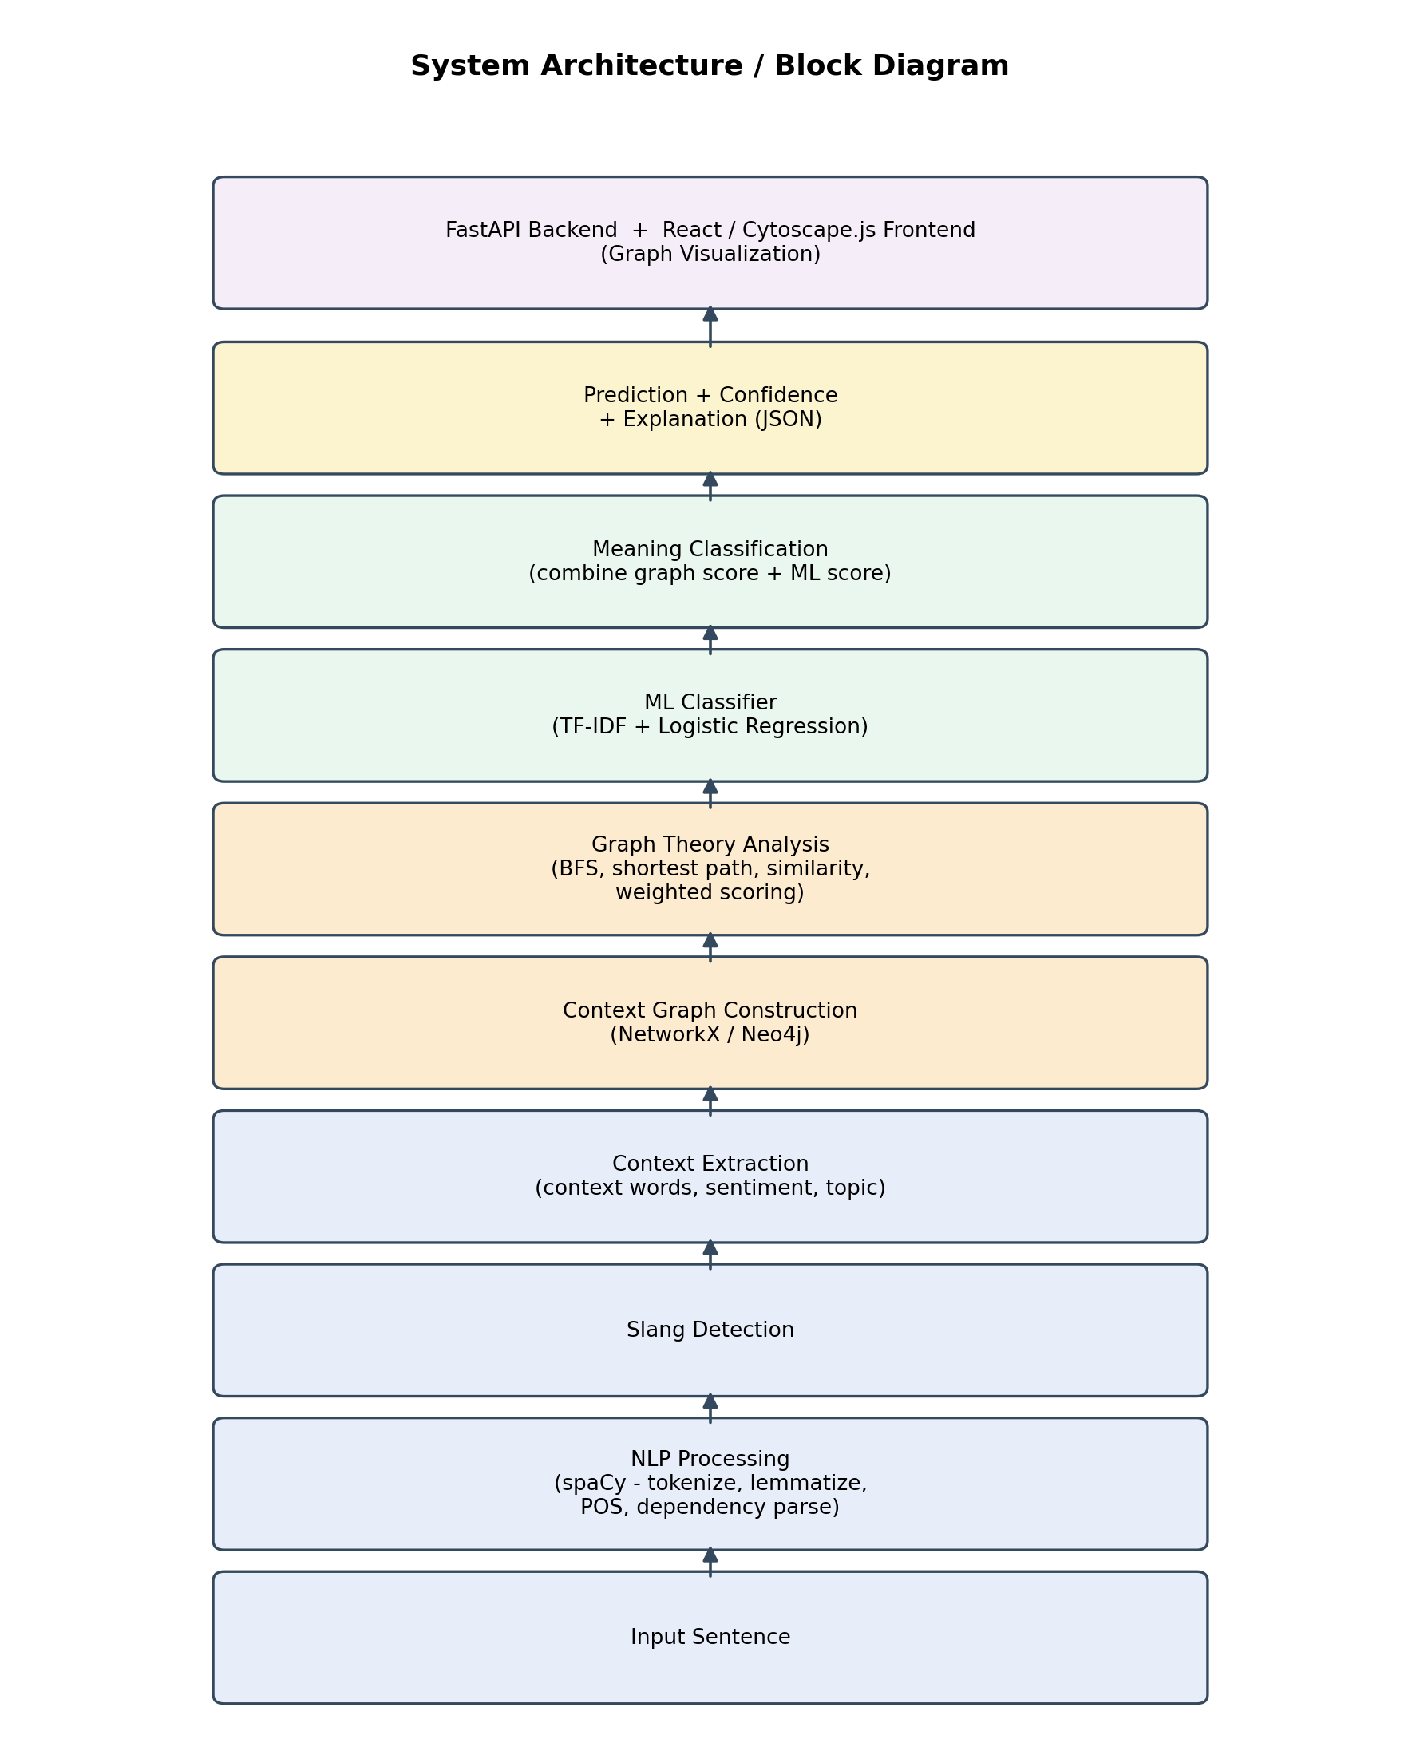

12. Functional Requirements
- The system shall accept a text sentence as input.
- The system shall detect known slang words within the sentence, including inflected forms (e.g. "ghosted" -> "ghost").
- The system shall extract contextual features - nearby words, dependency relations, topic and sentiment.
- The system shall construct a context graph from the extracted features.
- The system shall apply graph algorithms to score each candidate meaning of a detected slang word.
- The system shall classify the correct meaning using a combination of graph score and ML model output.
- The system shall output the predicted meaning, a confidence score, and an explanation.
- The system shall store slang knowledge (words, meanings, relationships) in a Neo4j graph database.
- The system shall provide a web interface to input a sentence and visualize the resulting context graph.

13. Non-Functional Requirements
- Performance: predictions should be returned within a few seconds for a single sentence.
- Usability: the web interface should be simple and intuitive for a non-technical user.
- Reliability: the system should degrade gracefully (e.g. fall back to ML-only prediction) if graph data is incomplete.
- Scalability: the Neo4j knowledge base should support growth in slang vocabulary without redesign.
- Maintainability: NLP, graph, and ML modules should be loosely coupled so each can be updated independently.
- Explainability: every prediction should be accompanied by a human-readable justification.

14. Hardware Requirements
- Processor: Intel i5 (or equivalent) or higher
- RAM: 8 GB minimum (16 GB recommended for model training)
- Storage: 10 GB free disk space
- Internet connectivity for package installation and (optional) cloud Neo4j/API hosting

15. Software Requirements
- Operating System: Windows / Linux / macOS
- Python 3.10 or above
- Node.js (for React frontend development)
- Neo4j Desktop / Neo4j AuraDB
- Code editor: VS Code
- Version control: Git and GitHub

16. Technology Stack
- Programming Language: Python, JavaScript
- NLP Library: spaCy
- Graph Library: NetworkX
- Graph Database: Neo4j (Cypher query language)
- Machine Learning: Scikit-learn (TF-IDF, Logistic Regression / Random Forest / XGBoost)
- Backend Framework: FastAPI
- Frontend Framework: React.js
- Graph Visualization: Cytoscape.js
- Supporting Libraries: Pandas, NumPy
- Tools: Docker, Git, GitHub

17. Modules of the Proposed System
- Dataset Module - curated, labeled dataset of slang words, meanings, and example sentences.
- NLP Processing Module - tokenization, lemmatization, POS tagging, dependency parsing (spaCy).
- Slang Detection Module - detects known slang words in a sentence, including inflected forms.
- Context Extraction Module - extracts context words, dependency relations, topic and sentiment.
- Context Graph Construction Module - builds a graph representation of sentence context (NetworkX/Neo4j).
- Graph Analysis & Scoring Module - applies BFS, shortest path, similarity and weighted scoring algorithms.
- ML Classification Module - TF-IDF + Logistic Regression model trained on extracted features.
- Prediction & Explanation Module - combines graph score and ML score into a final, explainable prediction.
- Backend API Module - FastAPI service exposing the end-to-end prediction pipeline.
- Frontend & Visualization Module - React + Cytoscape.js interface for input and graph visualization.

18. Advantages of the Proposed System
- Provides context-aware, accurate meaning prediction rather than a static list of possible meanings.
- Combines the strengths of Machine Learning and Graph Theory for improved accuracy over either approach alone.
- Produces explainable predictions, showing the contextual relationships that influenced the decision.
- Graph visualization helps users understand why a particular meaning was predicted.
- The Neo4j-based knowledge base makes the slang vocabulary easy to expand over time.
- Applicable across multiple domains: content moderation, chatbots, sentiment analysis, and translation.

19. Limitations (if any)
- Initial version is limited to English slang; code-mixed languages (e.g. Hinglish) are a future extension.
- Model accuracy depends on the size and quality of the labeled slang dataset, which is currently limited.
- Newly emerging slang terms require manual addition to the knowledge base and dataset.
- Graph construction and analysis introduce additional computational overhead compared to a pure ML approach.

20. References
- Jurafsky, D., & Martin, J. H., Speech and Language Processing, Pearson Education.
- Navigli, R., "Word Sense Disambiguation: A Survey," ACM Computing Surveys, 2009.
- spaCy Documentation - https://spacy.io
- NetworkX Documentation - https://networkx.org
- Neo4j Documentation - https://neo4j.com/docs
- FastAPI Documentation - https://fastapi.tiangolo.com
- React Documentation - https://react.dev
- Scikit-learn Documentation - https://scikit-learn.org

Date: ______________________
Place: JSPM University Pune
Name & Signature of  the Project Members | Name & Sign of Guide | Name & Sign of  Project Coordinator

