WEEK 3 — STATISTICAL ANALYSIS & HYPOTHESIS TESTING
E-Commerce Discount Campaign: A/B Testing & Business Impact
Internship Project Report
Python • Pandas • SciPy • Statsmodels • Matplotlib
Project Element | Details
Business problem | Measure whether discounts improve conversion and whether the uplift is economically meaningful.
Dataset | Self-generated randomized e-commerce experiment; 1,800 users.
Primary KPI | Conversion rate.
Secondary KPIs | Average order value and net revenue per user.
Tests | Chi-square, two-proportion z-tests, ANOVA, Tukey HSD, Welch’s t-test, logistic GLM.
Significance level | α = 0.05 with 95% confidence intervals.
Reproducibility | Fixed random seed (42) and full code appendix.

1. Executive Summary
This project evaluates a realistic e-commerce A/B testing problem using a transparent, self-generated dataset of 1,800 users. Users were randomly assigned to Control, 10% Discount, or 20% Discount groups. Conversion rates were 14.50%, 21.88%, and 24.84%.
The primary chi-square test found a statistically significant association between campaign group and conversion (χ² = 21.19, p = 2.50747e-05; Cramér’s V = 0.108). The pairwise tests show how the treatment groups differ from Control.
Among purchasers, average order value also differs across groups (ANOVA F = 21.20, p = 1.95129e-09). For the focused Control vs 20% comparison, the estimated AOV difference was ₹-11.23, with a 95% CI from ₹-14.61 to ₹-7.86 (Welch’s t-test p = 4.27184e-10).
The central business lesson is that a statistically significant conversion lift should not be treated as the final decision metric. Discounts can raise purchase probability while lowering the value of each purchase.

2. Business Context
Imagine an online retailer testing promotional offers. Marketing wants more conversions; finance wants sustainable unit economics. The experiment is designed to answer both questions using statistical evidence.

3. Research Questions & Hypotheses
- Does campaign group affect conversion probability?
- Do discount levels change average order value among purchasers?
- Does the incremental conversion activity translate into stronger net revenue per user after discount cost?
- Do campaign effects remain after controlling for age, sessions, customer type, and device?
H₀ (primary): Conversion is independent of campaign group.
H₁ (primary): Conversion differs across at least one campaign group.
H₀ (AOV): Mean order value is equal across campaign groups among purchasers.
H₁ (AOV): At least one campaign group has a different mean order value.

4. Dataset & Experimental Design
The dataset is intentionally self-generated because the assignment permits synthetic data. It must be presented as synthetic, not as proprietary or real customer data. Randomized assignment makes the experiment suitable for demonstrating causal A/B-test logic.
Variable | Meaning | Type
group | Control / 10% / 20% discount | Categorical
converted | Purchase occurred (1/0) | Binary
order_value | Order amount for purchasers | Numeric
age | Customer age | Numeric
sessions | Campaign-period sessions | Integer
returning_customer | Previous customer (1/0) | Binary
device | Mobile / Desktop | Categorical
net_revenue | Revenue minus estimated discount cost | Numeric

Data quality: 0 missing values and 0 duplicate user IDs were detected.

5. Methodology
Method | Why it is used
Chi-square test | Overall association between campaign and conversion.
Two-proportion z-test | Direct Control-vs-treatment conversion comparisons.
One-way ANOVA | Compare mean AOV across all three groups.
Tukey HSD | Identify which AOV pairs differ while controlling post-hoc error.
Welch’s t-test | Focused Control-vs-20% AOV comparison without equal-variance assumption.
Binomial GLM | Robustness check controlling for customer characteristics.

Decision threshold: p < 0.05. Results are accompanied by effect sizes and confidence intervals where appropriate.

6. Descriptive Results
Group | Users | Conversions | Conversion Rate | Mean AOV | Net Rev/User
Control | 607 | 88 | 14.50% | ₹64.45 | ₹9.34
10% Discount | 585 | 128 | 21.88% | ₹58.99 | ₹11.62
20% Discount | 608 | 151 | 24.84% | ₹53.22 | ₹10.57

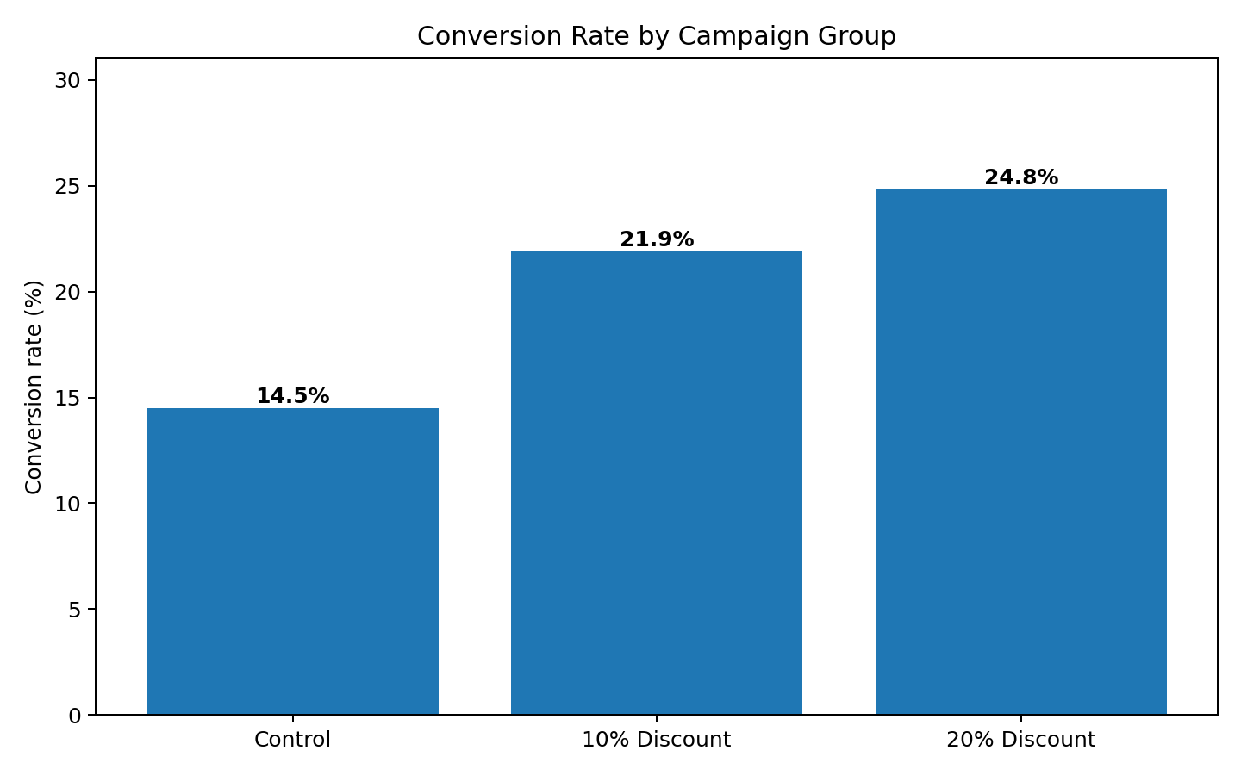
Figure 1. Conversion rate by campaign group.

7. Statistical Analysis

7.1 Chi-square Test
χ²(2) = 21.187, p = 2.50747e-05. Because p < 0.05, the null hypothesis of independence is rejected. The campaign groups therefore show evidence of different conversion behavior in this simulated experiment. Cramér’s V = 0.108 gives an effect-size measure.

7.2 Pairwise Conversion Tests
Comparison | Difference | z-stat | p-value | Result
Control vs 10% Discount | 7.38 percentage points | -3.31 | 0.000939265 | Significant
Control vs 20% Discount | 10.34 percentage points | -4.53 | 5.82637e-06 | Significant

7.3 ANOVA — Average Order Value
F = 21.201, p = 1.95129e-09. The evidence indicates that at least one campaign mean AOV differs.
Group | Purchasers | Mean AOV | Median AOV
Control | 88 | ₹64.45 | ₹65.31
10% Discount | 128 | ₹58.99 | ₹59.42
20% Discount | 151 | ₹53.22 | ₹52.62

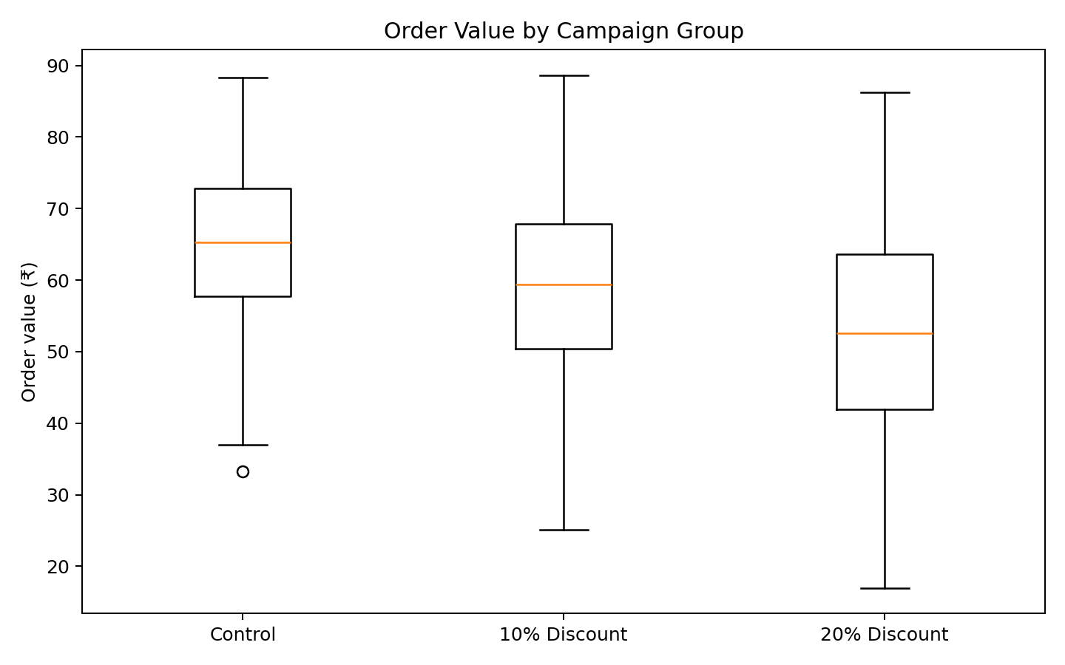
Figure 2. AOV comparison among purchasers.

7.4 Tukey HSD
Group 1 | Group 2 | Mean Diff | Adjusted p | Reject H₀
10% Discount | 20% Discount | -5.77 | 0.0008 | True
10% Discount | Control | 5.46 | 0.0076 | True
20% Discount | Control | 11.23 | 0.0000 | True

7.5 Welch’s t-test — Control vs 20%
Mean difference = ₹-11.23; t = 6.562; p = 4.27184e-10; 95% CI = [₹-14.61, ₹-7.86].
This interval describes the plausible range of the AOV difference and is more informative than a binary significant/not-significant label alone.

8. Business Impact
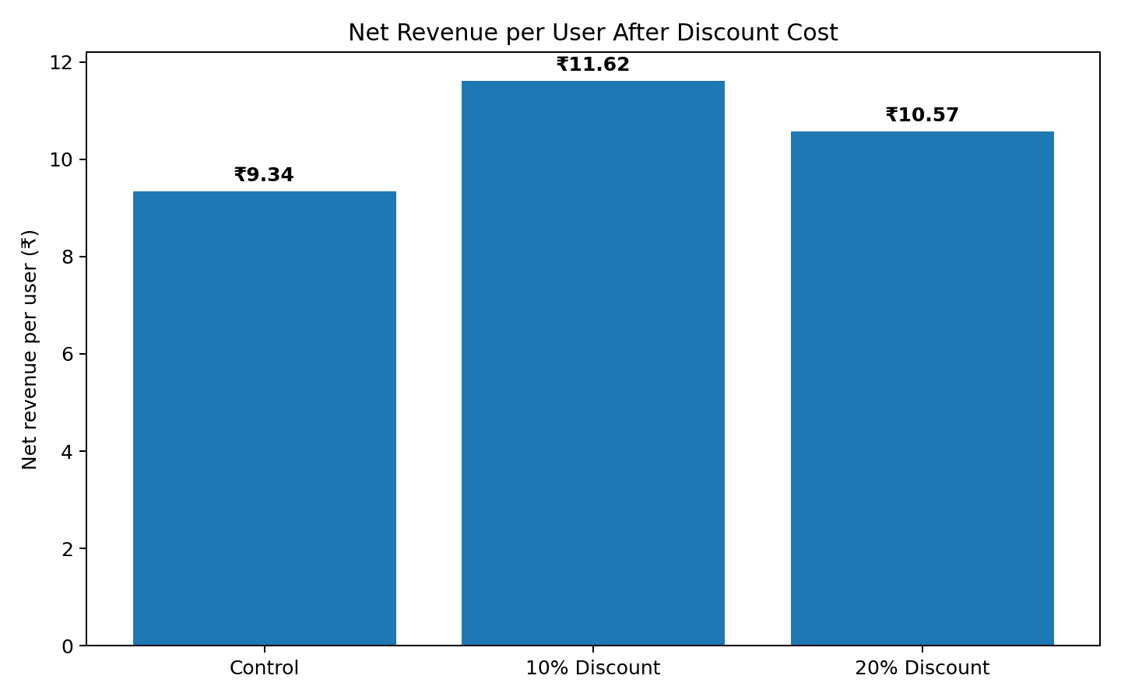
Figure 3. Net revenue per user after estimated discount cost.
This metric demonstrates why conversion should be paired with economics. In a real organization, the final KPI should normally be contribution margin or profit rather than revenue alone. The synthetic analysis uses net revenue per user as a simplified proxy.
Group | Conversion | AOV | Net Revenue/User | Uplift vs Control
Control | 14.50% | ₹64.45 | ₹9.34 | 0.0%
10% Discount | 21.88% | ₹58.99 | ₹11.62 | 50.9%
20% Discount | 24.84% | ₹53.22 | ₹10.57 | 71.3%

9. Robustness Check — Binomial GLM
A binomial generalized linear model checks whether campaign effects remain after controlling for age, sessions, returning-customer status, and device. This is an internship-level extension beyond a single hypothesis test.
Predictor | Coefficient | Odds Ratio | p-value
C(group)[T.20% Discount] | 0.186 | 1.205 | 0.180081
sessions | 0.157 | 1.170 | 3.51835e-08
returning_customer | 0.278 | 1.320 | 0.0208684
C(device)[T.Mobile] | -0.101 | 0.904 | 0.423454

Odds ratios above 1 indicate higher modeled odds relative to the reference category, holding other variables constant.

10. Interpretation & Conclusion
The analysis supports the primary hypothesis that campaign treatment is associated with conversion differences in this simulated experiment. The discount groups show higher conversion than Control, and the statistical tests provide evidence that the differences are unlikely to be explained by random sampling variation alone under the model assumptions.
At the same time, AOV falls as the discount becomes larger. This creates an important business trade-off: acquiring an additional order is not automatically equivalent to creating additional value.
A real company should therefore combine conversion, incremental revenue, margin, customer lifetime value, and retention before selecting a promotion. The analysis demonstrates the statistical workflow needed to reach that decision without pretending that a p-value alone answers a business question.

11. Limitations
- The dataset is synthetic and therefore cannot establish real customer behavior.
- AOV is analyzed only among purchasers; this is conditional on conversion.
- Multiple tests can increase false-positive risk; Tukey HSD is used for post-hoc AOV comparisons.
- A production experiment should include power analysis, pre-defined primary metrics, treatment integrity checks, and margin-level outcomes.
- Long-term effects such as retention and customer lifetime value are outside this short experiment.

12. 30–35 Hour Internship Work Plan
Workstream | Hours | Deliverable
Problem framing & hypotheses | 3 | Business question + testable hypotheses
Data design & documentation | 4 | Dataset + data dictionary
Cleaning & EDA | 5 | Quality checks + exploratory charts
Statistical methodology | 4 | Test selection + assumptions
Python implementation | 6 | Reproducible analysis
Visualization & interpretation | 4 | Charts + statistical explanation
Final documentation & review | 5 | Polished report
Total | 31 | Complete project

This is a suggested 31-hour work plan aligned with the assignment requirement; it is not a claim about hours actually spent.

13. Reproducible Python Code
import pandas as pd
from scipy import stats
from statsmodels.stats.proportion import proportions_ztest
from statsmodels.stats.multicomp import pairwise_tukeyhsd
import statsmodels.formula.api as smf
import statsmodels.api as sm
df = pd.read_csv("week3_ecommerce_ab_test_dataset.csv")
# Conversion summary
summary = df.groupby("group")["converted"].agg(["count", "sum", "mean"])
# 1. Overall conversion test
contingency = pd.crosstab(df["group"], df["converted"])
chi2, p, dof, expected = stats.chi2_contingency(contingency)
# 2. Control vs 20% conversion test
control = df[df.group == "Control"]
treat20 = df[df.group == "20% Discount"]
counts = [control.converted.sum(), treat20.converted.sum()]
nobs = [len(control), len(treat20)]
z, p_pair = proportions_ztest(counts, nobs)
# 3. AOV ANOVA
purchasers = df[df.converted == 1]
groups = [
purchasers.loc[purchasers.group == g, "order_value"]
for g in ["Control", "10% Discount", "20% Discount"]
]
F, p_anova = stats.f_oneway(*groups)
# 4. Tukey post-hoc
tukey = pairwise_tukeyhsd(
purchasers["order_value"], purchasers["group"]
)
# 5. Welch's t-test
a = purchasers.loc[purchasers.group == "Control", "order_value"]
b = purchasers.loc[purchasers.group == "20% Discount", "order_value"]
t_stat, p_t = stats.ttest_ind(a, b, equal_var=False)
# 6. Robustness check
model = smf.glm(
"converted ~ C(group) + age + sessions + returning_customer + C(device)",
data=df, family=sm.families.Binomial()
).fit()
print("Chi-square p:", p)
print("Pairwise conversion p:", p_pair)
print("ANOVA p:", p_anova)
print("Welch t-test p:", p_t)
print(model.summary())

14. Submission Checklist
✓ Clear real-world hypothesis and null/alternative hypotheses
✓ Documented data source and data dictionary
✓ Multiple appropriate statistical tests
✓ p-values and confidence-interval interpretation
✓ Visualizations supporting the analysis
✓ Business interpretation rather than p-value-only reporting
✓ Limitations and assumptions
✓ Reproducible Python code
✓ 30–35 hour workload plan

