WEEK 5
COMPREHENSIVE DATA SCIENCE PROJECT REPORT
From Statistical Evidence to Machine Learning and Strategic Decision-Making

Report Detail | Information
Internship Week | Week 5 – Final Comprehensive Project
Project Theme | Data-Driven Customer Conversion and Churn Analysis
Technical Areas | Statistics, Hypothesis Testing, Machine Learning, Visualization
Primary Tools | Python, Pandas, NumPy, Matplotlib, SciPy/Scikit-learn
Data | Self-generated synthetic datasets for reproducible internship analysis
Workload Plan | 33 hours
Prepared as an internship project submission

1. Executive Summary
This final-week project integrates the statistical analysis and machine learning work completed during the internship into one decision-oriented data science workflow. Two complementary business questions were studied: whether discount treatments produced measurable differences in customer conversion, and whether customer-level data could be used to identify customers at risk of churn.
In the A/B testing analysis, observed conversion increased from 14.50% in the control group to 21.88% with a 10% discount and 24.84% with a 20% discount. The overall chi-square test produced p ≈ 2.507 × 10⁻⁵. The one-way ANOVA and Welch t-test analyses also produced very small p-values for the comparisons examined. These results provide statistical evidence of differences within the synthetic experiment, but they do not by themselves establish which treatment is most profitable.
In the machine learning analysis, Logistic Regression and Decision Tree models were developed for customer churn classification. Logistic Regression achieved ROC-AUC 0.7277 and recall 0.7692, while the Decision Tree achieved ROC-AUC 0.6247 and recall 0.5769. The results demonstrate useful predictive signal while also showing the cost of false positives when recall is prioritized.
The strategic approach proposed in this report is therefore test-and-learn: measure incremental economics, use churn scores to prioritize retention activity, validate interventions with controlled experiments, and continuously monitor model quality. Because the datasets are synthetic, the findings demonstrate methodology and decision logic rather than claims about a real company.

2. Project Synthesis and Objectives
Previous weeks established capabilities in exploratory analysis, statistical hypothesis testing, visualization, and machine learning. Week 5 connects these skills into a single reporting framework that moves from problem definition to evidence and then to stakeholder action.
- Define practical business questions.
- Prepare and inspect data.
- Apply statistical tests to evaluate observed differences.
- Develop predictive models for an operational problem.
- Evaluate models using multiple complementary metrics.
- Translate quantitative evidence into measurable stakeholder actions.
- Document limitations, risks, and a future improvement roadmap.

2.1 Key Questions
- Do different discount treatments show statistically detectable differences in conversion?
- Can customer attributes and behavior provide useful information for predicting churn?
- Which evaluation metrics matter when missing a potential churner has a business cost?
- How can statistical and ML findings be converted into controlled, measurable experiments?

3. Methodology

3.1 Week 3 – Statistical Analysis
A synthetic e-commerce A/B testing dataset containing 1,800 observations was used. Users were assigned to Control, 10% Discount, or 20% Discount groups. Conversion, order value, revenue, sessions, device, and customer characteristics were analyzed.
Analysis | Purpose | Interpretation
Chi-square test | Test association between group and conversion | Whether conversion proportions differ
Two-proportion comparisons | Compare selected conversion rates | Direction and significance of pairwise differences
One-way ANOVA | Compare mean outcomes across three groups | Whether at least one mean differs
Welch t-test | Compare two means with weaker equal-variance assumptions | Evidence of a two-group difference
Cramér's V | Measure categorical association strength | Effect-size context beyond p-value

3.2 Week 4 – Machine Learning
A synthetic telecom-style customer dataset containing 2,200 records was used for churn prediction. Features included tenure, monthly charges, support tickets, usage hours, contract type, payment method, internet service, senior-customer status, and auto-pay status.
Stage | Implementation
Missing values | Median imputation for numerical variables; most-frequent imputation for categorical variables
Categorical encoding | One-hot encoding with unknown-category handling
Scaling | StandardScaler for numerical features
Split | Stratified 80/20 train-test split, random_state=42
Models | Logistic Regression and Decision Tree
Evaluation | Accuracy, Precision, Recall, F1 Score, ROC-AUC

4. Detailed Results and Findings

4.1 Conversion Experiment Findings
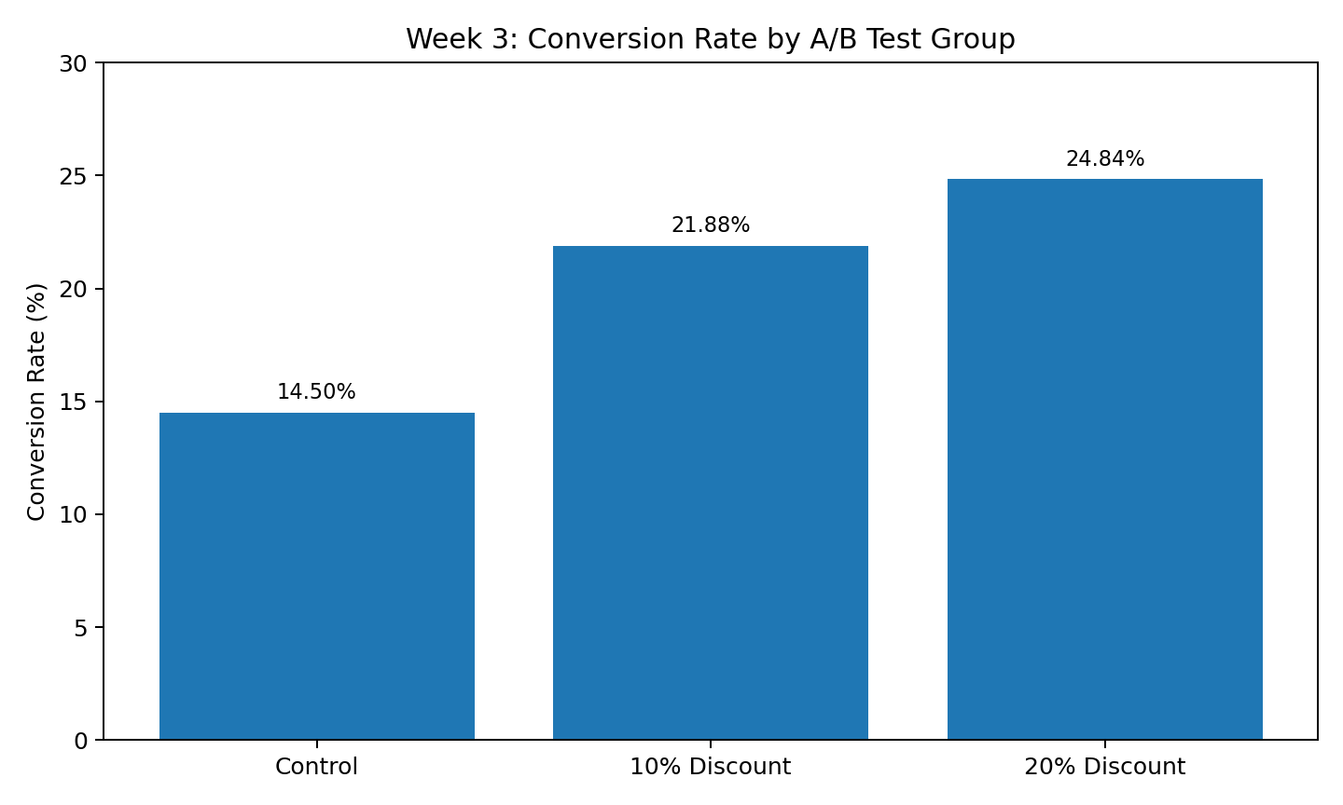
Figure 1. Conversion rates across the three discount groups.
The control group converted at 14.50%, compared with 21.88% for the 10% discount group and 24.84% for the 20% discount group. The chi-square test returned p ≈ 2.507 × 10⁻⁵, providing statistical evidence of an association between treatment group and conversion in this synthetic sample.
The one-way ANOVA result was approximately p ≈ 2 × 10⁻⁹, while the Welch t-test comparison examined in the project produced approximately p ≈ 4 × 10⁻¹⁰. These results support the presence of measurable differences in the simulated outcomes. However, statistical significance does not establish economic optimality; margin, discount cost, repeat purchase behavior, and customer lifetime value should be considered before any real-world rollout.

4.2 Churn Model Findings
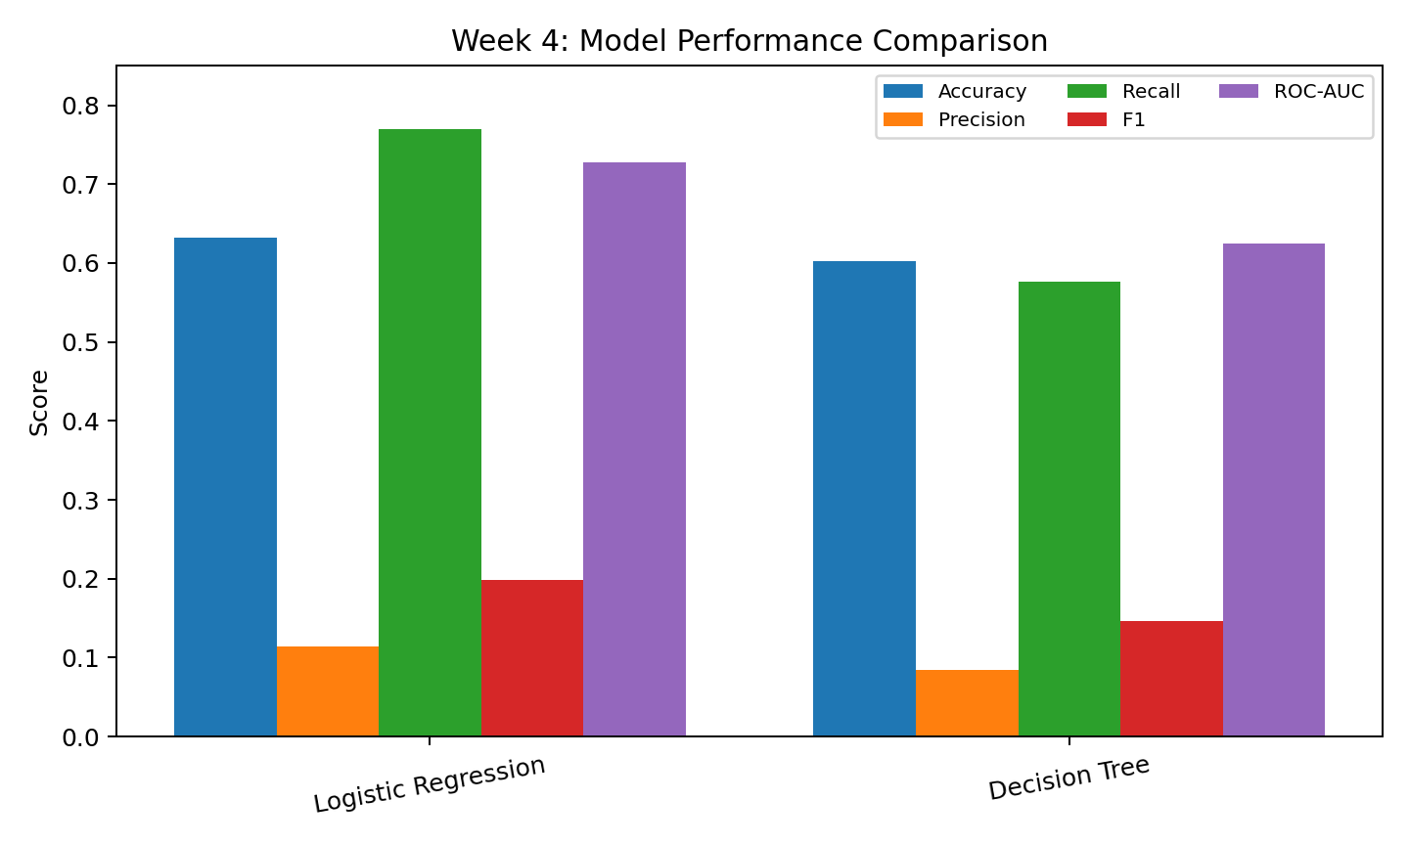
Figure 2. Comparison of classification metrics for the two Week 4 models.
Model | Accuracy | Precision | Recall | F1 | ROC-AUC
Logistic Regression | 0.6318 | 0.1136 | 0.7692 | 0.1980 | 0.7277
Decision Tree | 0.6023 | 0.0838 | 0.5769 | 0.1463 | 0.6247
The evaluation demonstrates why accuracy should not be used alone. Logistic Regression identified a relatively large share of actual churn cases, reflected by recall of 0.7692 and ROC-AUC of 0.7277. Its precision of 0.1136 also indicates that many flagged customers would not necessarily churn. In an operational setting, this creates a clear trade-off between catching more churners and spending resources on customers who would have stayed.
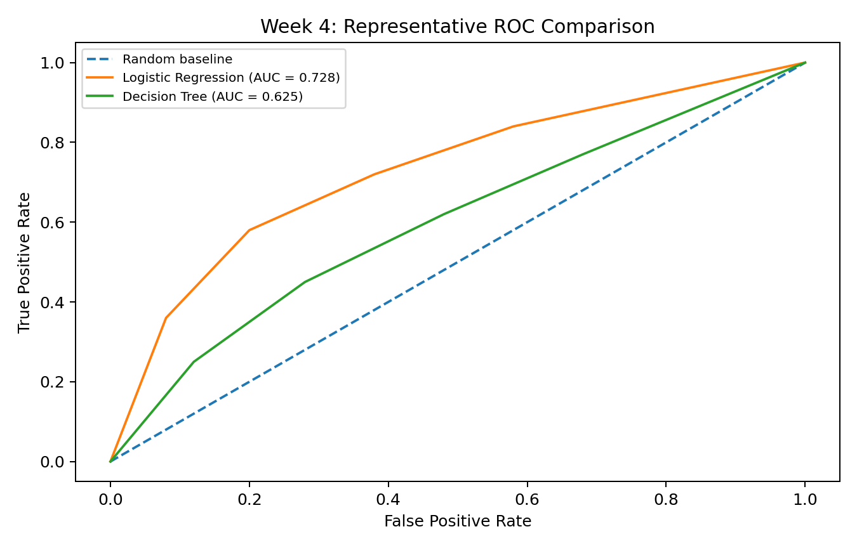
Figure 3. Representative ROC comparison used to communicate discrimination results.

4.3 Integrated Interpretation
The two analyses answer different questions but follow the same evidence-based principle. The experiment evaluates whether an intervention is associated with an outcome change, while predictive modeling estimates which future cases may deserve attention. Neither should be treated as an automatic decision engine.
- Statistical testing provides evidence for comparing interventions.
- Predictive modeling provides a prioritization mechanism.
- Business decisions require effect size and economics in addition to p-values.
- Prediction thresholds should reflect the relative cost of false positives and false negatives.
- Both approaches should be validated continuously on new data.

5. Strategic Recommendations
The recommendations below are framed as testable actions. They should be validated against real organizational data, financial constraints, operational capacity, and controlled experiments.

1. Evaluate promotions on incremental profit, not conversion alone.
The discount groups show higher conversion in the synthetic experiment. Before scaling a promotion, calculate incremental revenue, discount cost, contribution margin, repeat purchase rate, and customer lifetime value.

2. Use targeted rather than blanket retention outreach.
Use churn scores as a prioritization layer. Higher-risk customers can be reviewed first, while customer value, service history, and contact cost are considered before outreach.

3. Tune the classification threshold to the business objective.
The Logistic Regression model has relatively high recall but low precision. If missing a churner is costly, a recall-oriented threshold may be appropriate; if outreach capacity is limited, a higher threshold may reduce unnecessary contacts.

4. Run controlled experiments for recommended interventions.
For retention offers and discount campaigns, use randomized holdout groups where practical and measure incremental outcomes.

5. Establish model monitoring.
Track ROC-AUC, precision, recall, calibration, feature drift, and realized churn. Retraining should be tied to measurable degradation.

6. Potential Business Impact and Research Outcomes
Area | Potential Impact | Suggested KPI
Marketing | More disciplined promotion testing | Incremental profit per campaign
Customer Retention | Prioritized outreach to higher-risk customers | Churn rate / retention uplift
Operations | Better allocation of limited outreach capacity | Cost per retained customer
Analytics | Reusable experiment + ML reporting workflow | Experiment cycle time / monitoring coverage
Governance | Transparent evidence behind decisions | Documented assumptions and validation checks
A realistic deployment path would connect churn scores to a retention workflow while keeping a control group to estimate incremental impact. The same principle applies to promotions: optimize for profitable, sustained customer outcomes rather than short-term conversion alone.

7. Limitations
- Both datasets are synthetic and therefore demonstrate methodology rather than real business performance.
- Synthetic relationships may be cleaner or more stable than relationships in production data.
- The Week 4 model evaluation used a single train-test split; cross-validation would provide stronger generalization estimates.
- Metrics must be interpreted alongside class balance, confusion-matrix counts, and the cost of prediction errors.
- Real experiments require checks for randomization, independence, and other statistical assumptions.
- The analysis does not contain a complete financial model for discount margin, customer lifetime value, or retention campaign cost.
- Prediction from observational data does not prove that changing an attribute will cause churn to change.

8. Future Improvement Roadmap
- Replace synthetic data with approved anonymized production or public datasets.
- Add cross-validation and hyperparameter tuning.
- Compare additional ensemble and gradient-boosting models.
- Perform probability calibration and threshold optimization using explicit business costs.
- Add explainability methods such as SHAP for customer-level reasoning.
- Extend experiments with confidence intervals, effect sizes, power analysis, and longer-term outcomes.
- Build a dashboard for experiment KPIs, churn risk, model drift, and intervention outcomes.
- Create a documented monitoring and retraining policy.

9. Representative Code Documentation
The following excerpts show the core analytical logic used in the internship work. The complete Week 4 implementation contains the full preprocessing pipeline, model training, evaluation, and visualization workflow.
# Hypothesis testing: chi-square
from scipy.stats import chi2_contingency
contingency = pd.crosstab(df["group"], df["converted"])
chi2, p_value, dof, expected = chi2_contingency(contingency)
print("Chi-square statistic:", chi2)
print("p-value:", p_value)
Code Excerpt 1. Testing the relationship between discount group and conversion.
# Machine learning pipeline
preprocessor = ColumnTransformer([
("num", numeric_pipeline, numeric_features),
("cat", categorical_pipeline, categorical_features)
])
model = Pipeline([
("preprocessor", preprocessor),
("classifier", LogisticRegression(
max_iter=1000, class_weight="balanced"
))
])
model.fit(X_train, y_train)
pred = model.predict(X_test)
prob = model.predict_proba(X_test)[:, 1]
Code Excerpt 2. Reproducible preprocessing and Logistic Regression training.
# Multi-metric evaluation
metrics = {
"Accuracy": accuracy_score(y_test, pred),
"Precision": precision_score(y_test, pred),
"Recall": recall_score(y_test, pred),
"F1": f1_score(y_test, pred),
"ROC-AUC": roc_auc_score(y_test, prob)
}
Code Excerpt 3. Evaluating a classification model using multiple metrics.

10. Internship Workload Plan – 33 Hours
Activity | Hours | Output
Review and synthesize previous weeks | 4 | Integrated findings and project map
Data validation and exploratory review | 5 | Quality checks and analytical context
Statistical analysis review | 5 | Hypothesis-testing interpretation
ML evaluation review | 5 | Model metrics and error analysis
Visualization and evidence integration | 4 | Charts and annotated findings
Strategic analysis | 4 | Stakeholder recommendations
Report writing and formatting | 4 | Comprehensive DOC report
Final quality check and reproducibility | 2 | Submission-ready deliverable
TOTAL | 33 | Final Week 5 submission

11. Conclusion
This final project demonstrates how data science can move beyond isolated coding exercises and become a structured decision-support process. Statistical testing showed measurable differences between the simulated discount groups, while machine learning demonstrated how classification metrics can support churn-risk prioritization.
The key practical lesson is that analytical evidence must be connected to objectives, uncertainty, and cost. A statistically significant result is not automatically a profitable strategy, and a model with strong recall is not automatically useful unless an organization can act on its predictions. A responsible workflow is iterative: measure, test, validate, deploy carefully, monitor, and improve.
Because synthetic data was used, the main outcome is a reproducible end-to-end methodology demonstrating skills in statistical reasoning, machine learning, visualization, technical reporting, and strategic communication.

12. Final Submission Checklist
- Executive summary completed.
- Week 3 statistical findings integrated.
- Week 4 machine learning findings integrated.
- Visualizations and explanatory captions included.
- Representative Python code snippets included.
- Strategic recommendations connected to findings.
- Business impact and research outcomes discussed.
- Limitations and future improvements documented.
- 33-hour workload plan included.
- Synthetic-data limitation clearly stated.

